DW19E
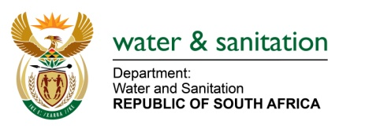
PROGRAMME / PROGRESS REPORT FOR THE IMPLEMENTATION OF THE RECOMMENDATIONS OF A DAM SAFETY EVALUATION / INSPECTION REPORT

NAME OF DAM

DWS REF No | 12/2/

NAME OF OWNER

Tel/Cel |  | E-Mail

No. | Description of Activity flowing from recommendations | APP  (Y/N)¹ | Planned or Actual Start Date | Actual Completion Date (only if completed)
1.Please indicate whether the work must be done under supervision of an approved professional person (APP) (“YES” OR “NO”)

…………………………………………………………………………. ………………………………………
Signature of owner OR person in control of the dam Date

