D10 WATER MANAGEMENT AREA 10: LOWER VAAL

D10.1 Introduction
The Lower Vaal water management area lies in the north-western part of South Africa and borders on Botswana in the north. Climate in the region is semi-arid to arid, with rainfall ranging from 500 mm to as low as 100 mm per year and evaporation reaching 2 800 mm per year towards the west. Streamflow characteristics are distinctly different for the three sub-areas shown on Fig. D10. Flow in the Vaal River is perennial, fed by high rainfall and regulation upstream, the Harts River is characterised by highly intermittent runoff, and the Molopo and Kuruman Rivers are endorheic and typically cease to flow after some distance due to infiltration into the river bed and evaporation.

Iron ore, diamonds and manganese are mined in the water management area. Farming activity ranges from extensive livestock production and rain fed cultivation to intensive irrigation enterprises at Vaalharts. Kimberley, which straddles the divide between the Lower Vaal and Upper Orange water management areas, is the largest urban centre in the area.

Utilisable surface water resources in the water management area are limited to those supplied by the Vaal and Harts Rivers, both of which are fully regulated. Barberspan, an off-channel pan in the upper reaches of the Harts River, is a Ramsar wetland site. More than 50 per cent of the yield from natural water resources in the tributary catchments within the water management area is supplied from groundwater. At Sishen, groundwater abstracted in the process of de-watering the mine is also used for water supply, although it is recognised as being controlled mining of groundwater. Other localised over-exploitation of groundwater occurs in some areas. Water quality is of special concern in the lower reaches of the Harts and the Vaal Rivers because of the high salinity of leach water from the Vaalharts irrigation scheme. To counter this problem, better quality water is transferred from the Orange River to the Douglas Weir in the lower reaches of the Vaal River for blending purposes.

There is limited potential for strong economic development in the region and future population projections show little change in the demographics of the water management area. Little change in water requirements is therefore foreseen.

Fig. D10: Base map of the Lower Vaal water management area
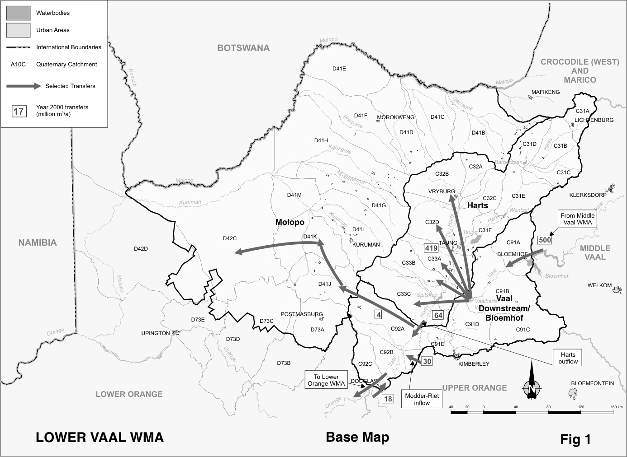
D10.2 Key statistics relevant to the Lower Vaal water management area
Tables D 10.1 to 10.6 contain a breakdown of the information given in Tables 2.1 to 2.6 of Chapter 2 for each sub-area of the Lower Vaal water management area. Data is derived primarily from the standardised database. Different information may be available from other sources.

Table D10.1: Natural mean annual runoff (MAR) and ecological Reserve (million m³/a)
Component/  Sub-area | Natural MAR¹ | Ecological Reserve^{1 ,2}
Harts | 138 | 15
Vaal d/s Bloemhof³ | 43 | 5
Molopo | 197⁴ | 29
Total for WMA | 181 | 49
- Quantities are incremental and refer to the sub-area under consideration only.
- The total volume is based on preliminary estimates, with impact on yield being a portion of this.
- d/s Bloemhof = downstream of the Bloemhof Dam.
- Estimated runoff from catchment, which is lost through evaporation and infiltration before reaching the Orange River. This runoff therefore does not add to the total for the water management area.

Table D10.2: Available yield in the year 2000 (million m³/a)
Component/  Sub-area |  | Natural resource |  |  |  |  | Usable return flow |  |  |  | Total local yield
Component/  Sub-area | Surface water¹ |  | Ground-water |  | Irrigation |  |  | Urban | Mining and bulk |  | Total local yield
Harts | 51 |  | 40 |  | 45 |  |  | 0 | 0 |  | 136
Vaal d/s Bloemhof² | ( 107) |  | 54 |  | 7 |  |  | 0 | 0 |  | ( 46)
Molopo | 2 |  | 31 |  | 0 |  |  | 0 | 2 |  | 35
Total for WMA | ( 54) |  | 125 |  | 52 |  |  | 0 | 2 |  | 125
- After allowance for the impacts on yield of the ecological component of Reserve, river losses, alien vegetation, dryland agriculture and urban runoff.
- d/s Bloemhof = downstream of the Bloemhof Dam.
Table D10.3: Water requirements for the year 2000 (million m³/a)
Sector/  Sub-area | Irrigation | Urban¹ | Rural¹ | Mining  and bulk industrial² | Power generation³ | Affores-  tation⁴ | Total local requirements
Harts | 452 | 23 | 19 | 0 | 0 | 0 | 494
Vaal d/s Bloemhof⁵ | 73 | 32 | 8 | 0 | 0 | 0 | 113
Molopo | 0 | 13 | 17 | 6 | 0 | 0 | 36
Total for WMA | 525 | 68 | 44 | 6 | 0 | 0 | 643
- Includes component of Reserve for basic human needs at 25 ℓ/c/d.
- Mining and bulk industrial water uses that are not part of urban systems.
- Includes water for thermal power generation only. (Water for hydropower, which represents a small portion of power generation in South Africa, is generally available for other uses as well.)
- Quantities refer to the impact on yield only.
- d/s Bloemhof = downstream of the Bloemhof Dam.

Table D10.4: Reconciliation of water requirements and availability for the year 2000 (million m³/a)
Component/  Sub-area | Local  yield | Transfers  in² | Local requirements | Transfers out² | Balance¹
Harts | 136 | 419 | 494 | 62 | ( 1)
Vaal d/s Bloemhof³ | ( 46) | 609 | 113 | 422 | 28
Molopo | 35 | 4 | 36 | 0 | 3
Total for WMA | 125 | 548 | 643 | 0 | 30
- Brackets around numbers indicate a negative balance. Surpluses are shown in the most upstream sub-area where they first become available.
- Transfers into and out of sub-areas may include transfers between sub-areas as well as transfers between WMAs. The addition of the quantities transferred per sub-area does therefore not necessarily correspond to total transfers into and out of the WMA. The same applies to Tables D10.5 and D10.6.
- d/s Bloemhof = downstream of the Bloemhof Dam.

Table D10.5: Reconciliation of water requirements and availability for the year 2025 base scenario (million m³/a)
Component/  Sub-area | Local  yield¹ | Transfers in | Local requirements² | Transfers out | Balance³ | Potential for develop-  ment
Harts | 137 | 419 | 496 | 60 | 0 | 0
Vaal d/s Bloemhof⁴ | ( 45) | 631 | 112 | 422 | 52 | 0
Molopo | 35 | 4 | 34 | 0 | 5 | 0
Total for WMA | 127 | 572 | 642 | 0 | 57 | 0
- Based on existing infrastructure and infrastructure under construction in the year 2000. Also includes return flows resulting from a growth in requirements.
- Based on a normal growth in water requirements as a result of population growth and general economic development. Assumes no general increase in irrigation.
- Brackets around numbers indicate a negative balance.
- d/s Bloemhof = downstream of the Bloemhof Dam.

Table D10.6: Reconciliation of water requirements and availability for the year 2025 high scenario (million m³/a)
Component/  Sub-area | Local  yield¹ | Transfers in | Local requirements² | Transfers out | Balance³ | Potential for develop-  ment
Harts | 137 | 419 | 504 | 52 | 0 | 0
Vaal d/s Bloemhof⁴ | ( 45) | 697 | 158 | 422 | 72 | 0
Molopo | 35 | 4 | 41 | 0 | ( 2) | 0
Total for WMA | 127 | 646 | 703 | 0 | 70 | 0
- Based on existing infrastructure and infrastructure under construction in the year 2000. Also includes return flows resulting from a growth in requirements.
- Based on a high growth in water requirements as a result of population growth and the high impact of economic development. Assumes no increase in irrigation.
- Brackets around numbers indicate a negative balance.
- d/s Bloemhof = downstream of the Bloemhof Dam.

D10.3 Key elements of the broad strategic perspectives for the Lower Vaal water management area
Irrigation dominates water requirements in the Lower Vaal water management area and represents 80 per cent of total water use. Virtually all of this use is concentrated in the Vaalharts irrigation scheme, which relies on Vaal River water transferred from the Upper Vaal and Middle Vaal water management areas. The Vaalharts irrigation scheme serves the purpose of beneficially utilising lower quality water discharged from the Upper Vaal water management area and thus prevents the build up of salinity in the lower reaches of the Lower Vaal water management area.

The total quantity of water transferred into the Lower Vaal area represents about 80 percent of the local water requirements, and only return flows and spilling flood flows are discharged from the water management area. The positive yield balance shown in Table D10.4 with respect to the Vaal River downstream of the Bloemhof Dam is as a result of irrigation return flows in the lower reaches of the Vaal River.

The key issues with regard to water resources management in the water management area are the following:
- Operational management of water abstractions from the Vaal River is handled in close co-operation with the Middle Vaal and Upper Vaal Catchment Management Agencies to ensure the efficient overall management of the Vaal River System and efficient flood control in the Orange-Vaal system.
- Management of water quality in the Vaal and Harts Rivers.
- Management of groundwater, both from an abstraction and a recharge perspective, to ensure sustainability of use.

Due consideration is also to be given to the implementation of appropriate demand management measures and to ensuring the most beneficial use of water.

Reservations will apply in respect of water transfers into and out of the Lower Vaal water management area.
- Currently 500 million m³/a is transferred from the Middle Vaal water management area to the Lower Vaal water management area and may as an upper scenario increase to about 555 million m³/a during the period of projection – reserved in the Middle Vaal water management area.
- A reservation also applies to the transfer of 18 million m³/a from the Upper Orange water management area to Douglas Weir in the Lower Vaal water management area – reserved in the Upper Orange water management area.

The Lower Vaal water management area forms part of the Vaal River System, which extends over several water management areas. As water resources management in this system impacts to some degree on water quantity and quality in all the interlinked water management areas, management of water resources in the Vaal River System is to be controlled at a national level.

