D11 WATER MANAGEMENT AREA 11: MVOTI TO UMZIMKULU

D11.1 Introduction
The Mvoti to Umzimkulu water management area lies along the eastern coast of South Africa, predominantly within the province of KwaZulu-Natal, and borders on Lesotho to the west. It is situated in a humid part of the country with a mean annual precipitation of 800 mm to 1 500 mm. The terrain is rolling, with the Drakensberg escarpment as the main topographic feature. Several parallel rivers drain the water management area, two of which originate in the Drakensberg Mountains at the border with Lesotho. Small coastal streams also abound, as shown in Fig. D11. Many of the estuaries are still in a relatively natural state.

Fig. D11: Base map of the Mvoti to Umzimkulu water management area

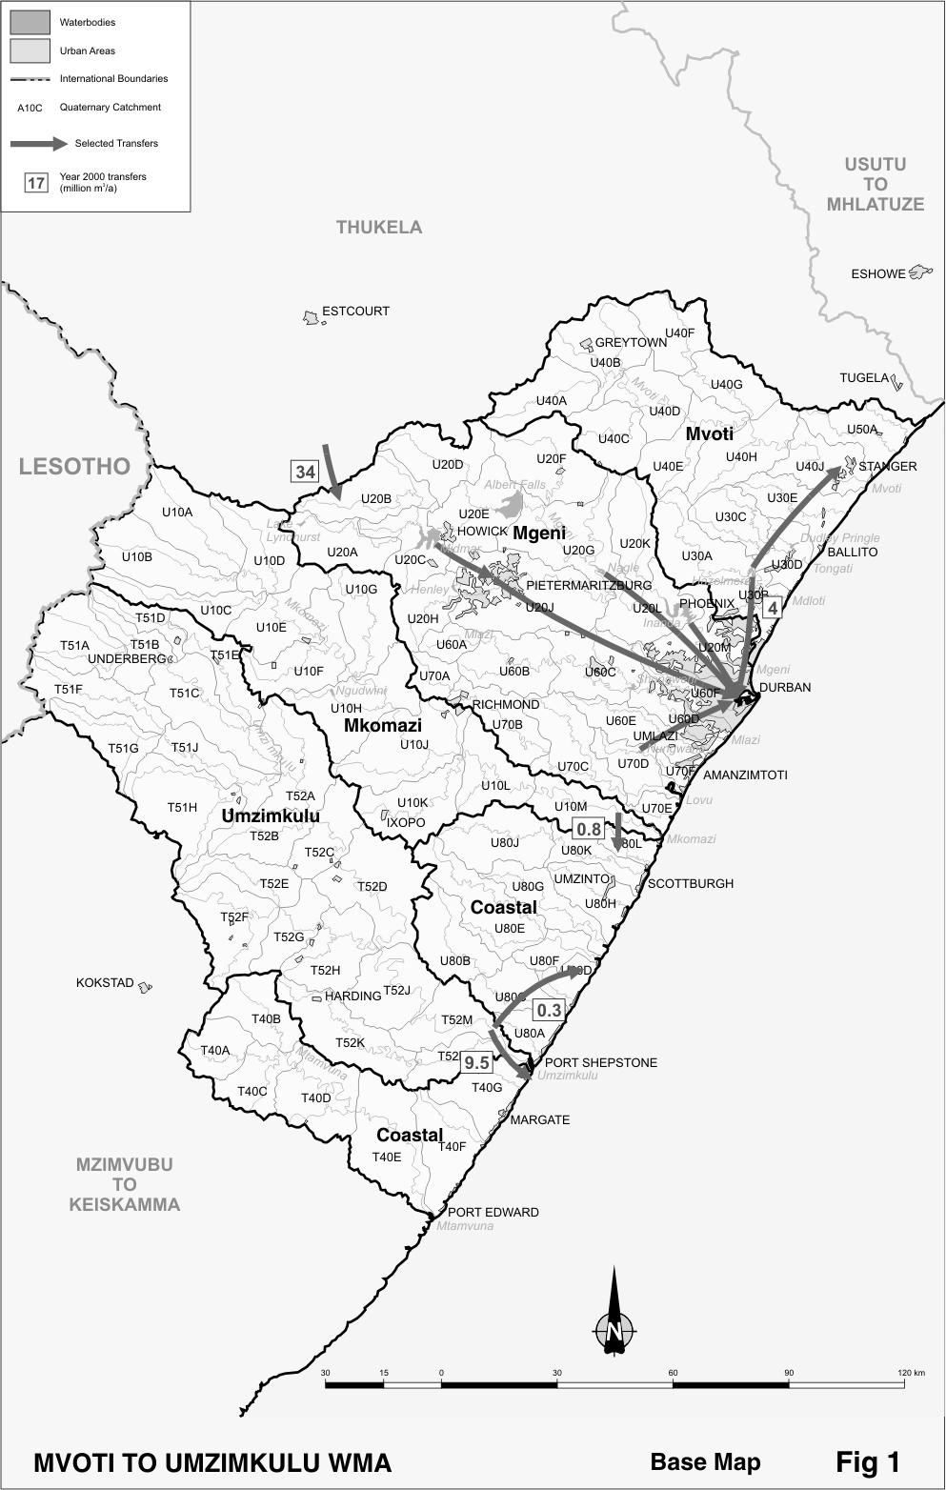

Economic activity in the water management area is diverse. The rural areas are characterised by both subsistence and commercial farming, with extensive cultivation of sugar cane along the coast and commercial forests in the higher rainfall areas. The Durban metropolitan area is the second largest commercial and industrial nucleus in the country, and is surrounded by satellite developments along the coast and inland towards Pietermaritzburg.

Large differences are noticeable in the degree to which water resources have been developed in the water management area. The Mgeni River, which is the main source of water for the Durban/Pietermaritzburg area, is fully regulated by several large dams in the catchment and is augmented with transfers from the Thukela water management area. In contrast, the potential of the Mkomazi and Umzimkulu Rivers remains largely undeveloped and various degrees of development apply to the remainder of the surface resources in the water management area. Because of the perennial nature of streamflow in the water management area, surface water, which includes springflow, is generally used for rural water supplies and there is only minimal abstraction of groundwater.

Strong population growth is projected for the Mgeni sub-area, commensurate with the expected economic growth in the Durban/Pietermaritzburg area as well as a general tendency towards urbanisation. It is anticipated that population in the rural areas will remain relatively unchanged, although there could be localised decreases.

D11.2 Key statistics relevant to the Mvoti to Umzimkulu water management area
Tables D11.1 to 11.6 contain a breakdown of the information given in Tables 2.1 to 2.6 of Chapter 2 for each sub-area of the Mvoti to Umzimkulu water management area. Data is derived primarily from the standardised data base. Different information may be available from other sources.

Table D11.1: Natural mean annual runoff (MAR) and ecological Reserve (million m³/a)
Component/  Sub-area | Natural MAR¹ | Ecological Reserve^{1,2}
Mvoti | 595 | 150
Mgeni | 992 | 187
Mkomazi | 1 080 | 295
Coastal | 758 | 211
Umzimkulu | 1 373 | 317
Total for WMA | 4 798 | 1 160
- Quantities are incremental and refer to the sub-area under consideration only.
- The total volume is based on preliminary estimates, with impact on yield being a portion of this.

Table D11.2: Available yield in the year 2000 (million m³/a)
Component/  Sub-area |  | Natural resource |  |  |  | Usable return flow |  |  |  | Total  local  yield
Component/  Sub-area | Surface water¹ |  | Ground-water |  | Irrigation |  | Urban | Mining and bulk |  | Total  local  yield
Mvoti | 68 |  | 1 |  | 8 |  | 5 | 4 |  | 86
Mgeni | 316 |  | 1 |  | 6 |  | 52 | 1 |  | 376
Mkomazi | 27 |  | 1 |  | 3 |  | 0 | 0 |  | 31
Coastal | 11 |  | 2 |  | 1 |  | 0 | 0 |  | 14
Umzimkulu | 11 |  | 1 |  | 3 |  | 0 | 1 |  | 16
Total for WMA | 433 |  | 6 |  | 21 |  | 57 | 6 |  | 523
- After allowance for the impacts on yield of the ecological component of the Reserve, river losses, alien vegetation, rain-fed sugar cane and urban runoff.
Table D11.3: Water requirements for the year 2000 (million m³/a)
Sector/  Sub-area | Irrigation | Urban¹ | Rural¹ | Mining  and bulk industrial² | Power generation³ | Affores-tation⁴ | Total local require-  ments
Mvoti | 76 | 9 | 10 | 11 | 0 | 8 | 114
Mgeni | 63 | 378 | 12 | 4 | 0 | 47 | 504
Mkomazi | 33 | 1 | 5 | 53 | 0 | 6 | 98
Coastal | 10 | 19 | 10 | 1 | 0 | 1 | 41
Umzimkulu | 25 | 1 | 7 | 4 | 0 | 3 | 40
Total for WMA | 207 | 408 | 44 | 73 | 0 | 65 | 797
- Includes component of Reserve for basic human needs at 25 ℓ/c/d.
- Mining and bulk industrial water uses that are not part of urban systems.
- Includes water for thermal power generation only. (Water for hydropower, which represents a small portion of power generation in South Africa, is generally available for other uses as well.)
- Quantities refer to the impact on yield only.

Table D11.4: Reconciliation of water requirements and availability for the year 2000 (million m³/a)
Component/  Sub-area | Local  yield | Transfers  in² | Local requirements | Transfers out² | Balance¹
Mvoti | 86 | 0 | 114 | 4 | ( 32)
Mgeni | 376 | 38 | 504 | 0 | ( 90)
Mkomazi | 31 | 0 | 98 | 1 | ( 68)
Coastal | 14 | 11 | 41 | 0 | ( 16)
Umzimkulu | 16 | 0 | 40 | 10 | ( 34)
Total for WMA | 523 | 34 | 797 | 0 | ( 240)
- Brackets around numbers indicate a negative balance. Surpluses are shown in the most upstream sub-area where they first become available.
- Transfers into and out of sub-areas may include transfers between sub-areas as well as transfers between WMAs. The addition of the quantities transferred per sub-area does therefore not necessarily correspond to the total transfers into and out of the WMA. The same applies to Tables D11.5 and D11.6.
Table D11.5: Reconciliation of water requirements and availability for the year 2025 base scenario (million m³/a)
Component/  Sub-area | Local  yield¹ | Transfers  in | Local require-ments² | Transfers  out | Balance³ | Potential for develop-  ment⁴
Mvoti | 90 | 0 | 122 | 4 | ( 36) | 47
Mgeni | 404 | 38 | 705 | 0 | ( 263) | 90
Mkomazi | 31 | 0 | 99 | 1 | ( 69) | 481
Coastal | 14 | 11 | 45 | 0 | ( 20) | 0
Umzimkulu | 16 | 0 | 40 | 10 | ( 34) | 400
Total for WMA | 555 | 34 | 1 011 | 0 | ( 422) | 1 018
- Based on existing infrastructure and infrastructure under construction in the year 2000. Also includes return flows resulting from a growth in requirements.
- Based on a growth in water requirements as a result of population growth and general economic development. Assumes no general increase in irrigation
- Brackets around numbers indicate a negative balance.
- Based on the raising of the Hazelmere and Midmar Dams, and construction of the Impendle, Smithfield and iSitungo Dams.

Table D11.6: Reconciliation of water requirements and availability for the year 2025 high scenario (million m³/a)
Component/  Sub-area | Local  yield¹ | Transfers  in | Local require-ments² | Transfers  out | Balance³ | Potential for develop-  ment⁴
Mvoti | 94 | 0 | 131 | 4 | ( 41) | 47
Mgeni | 459 | 38 | 1 103 | 0 | ( 606) | 90
Mkomazi | 31 | 0 | 100 | 1 | ( 70) | 481
Coastal | 14 | 11 | 62 | 0 | ( 37) | 0
Umzimkulu | 16 | 0 | 41 | 10 | ( 35) | 400
Total for WMA | 614 | 34 | 1 437 | 0 | ( 789) | 1 018
- Based on existing infrastructure and infrastructure under construction in the year 2000. Also includes return flows resulting from a growth in requirements.
- Based on a high growth in water requirements as a result of population growth and a high impact of economic development. Assumes no general increase in irrigation.
- Brackets around numbers indicate a negative balance.
- Based on the raising of the Hazelmere and Midmar Dams, and construction of the Impendle, Smithfield and iSitungo Dams.

D11.3 Key elements of the broad strategic perspectives for the Mvoti to Umzimkulu water management area
Water resource management in the Mvoti to Umzimkulu water management area is dominated by the Mgeni System, which serves the Durban/Pietermaritzburg area and its coastal environs. The requirements for water in this area already exceed its availability and further growth in requirements is anticipated. Deficits are also experienced in the Mvoti and Mkomazi sub-areas and parts of the Coastal sub-area. These deficits occur mainly during low-flow periods as a result of insufficient storage and will be exacerbated by implementation of the Reserve. The deficit shown in Table D11.4 for the Umzimkulu sub-area is also attributable to the provision for the Reserve, which is still to be implemented.

Water quality in the lower Mgeni River and in the Msunduze tributary is highly affected by urban return flows and wash-off from insufficiently serviced residential areas, a situation that is of particular concern.

Great success in reducing the requirements for water has already been achieved in the Durban metropolitan area by the application of water demand management and the increased re-use of effluent. Action is being taken to bring about further improvements. Other interventions that could be applied to ensure an adequate supply of water in the future are described in Section 2.5.

The following options are of specific relevance to the Mvoti to Mzimkulu water management area:
- Additional transfers of water from the Mooi River in the Thukela water management area. Plans have already been developed to increase the transfer capacity from the existing 100 million m³/a to 136 million m³/a by constructing the Springgrove Dam on the Mooi River and increasing the pumping capacity.
- Increased re-use of return flows from the Durban metropolitan area. Although about 15 per cent of the return flows are currently re-used, some indirectly or for environmental purposes, the bulk is still discharged to the ocean.
- The transfer of water from the Mkomazi River to the Mgeni River within the water management area. As a future option water may also be transferred from the Umzimkulu River.

In support of the first option a volume of 135 million m³ per year is reserved for transfer from the Mooi River in the Thukela water management area to the Mgeni River in the Mvoti to Umzimkulu water management area. The Springgrove Dam to be constructed on the Mooi River for the purpose of transferring water to the Mgeni River will therefore fall under national control – reserved in the Thukela water management area.

The Mkomazi River has been identified by planning studies as the most feasible next option for augmenting water supplies for the Durban/Pietermaritzburg area, and development of this river needs to be reserved for that purpose – reservation to apply within the Mvoti to Umzimkulu water management area.

