D13 WATER MANAGEMENT AREA 13: UPPER ORANGE

D13.1 Introduction
The Upper Orange water management area lies in the centre of South Africa and extends over the southern Free State and parts of the Eastern and Northern Cape provinces. It borders on Lesotho to the east, where the Orange River originates as the Senqu River (refer to Fig. D13). Draining the Highlands of Lesotho, the Senqu River contributes close to 60 per cent of the surface water associated with the Upper Orange water management area. The climate varies considerably over the region and rainfall ranges from over 1 000 mm/a in the foothills of the mountains to as little as 200 mm/a in the west. Vegetation is mainly grassland. Extensive sheep and cattle farming is characteristic throughout the area. Some dry-land cultivation occurs where the rainfall and soils are favourable, but sizeable areas are under irrigation below the main storage dams. Bloemfontein, as an administrative and commercial centre, is the only large urban development in the water management area.

Water resources management in the area mainly revolves around the Orange River. Two of the highest dams in Africa have been constructed in the Orange (Senqu) catchment in Lesotho for the purpose of transferring water to the Upper Vaal water management area. The Gariep and Vanderkloof Dams in the water management area, where the two largest conventional hydropower installations in the country are located, also command the two largest storage reservoirs in South Africa. From the Gariep Dam a major inter-water management area transfer occurs via the 80 km long Orange-Fish Tunnel to the Fish to Tsitsikamma water management area. A significant portion of the yield of the Orange River is also released down the river for use in the Lower Orange water management area and by Namibia. In total, close to 70 per cent of the yield realised in the Upper Orange water management area and in Lesotho is used in other water management areas. Even so, potential still exists for further large-scale development of the Orange River, with the most attractive sites for new dams being at the confluence of the Orange and Kraai Rivers, and at Mashai in Lesotho. The Modder and Riet tributaries have been fully developed. Significant quantities of groundwater are used in parts of the water management area.

Demographic projections show a small decline in rural population. As the expectations are that this will be balanced by population growth in the Bloemfontein area, little change in the total population of the water management area is anticipated within the period of projection. There are no strong stimulants for economic growth in the area.

Fig. D13: Base map of the Upper Orange water management area
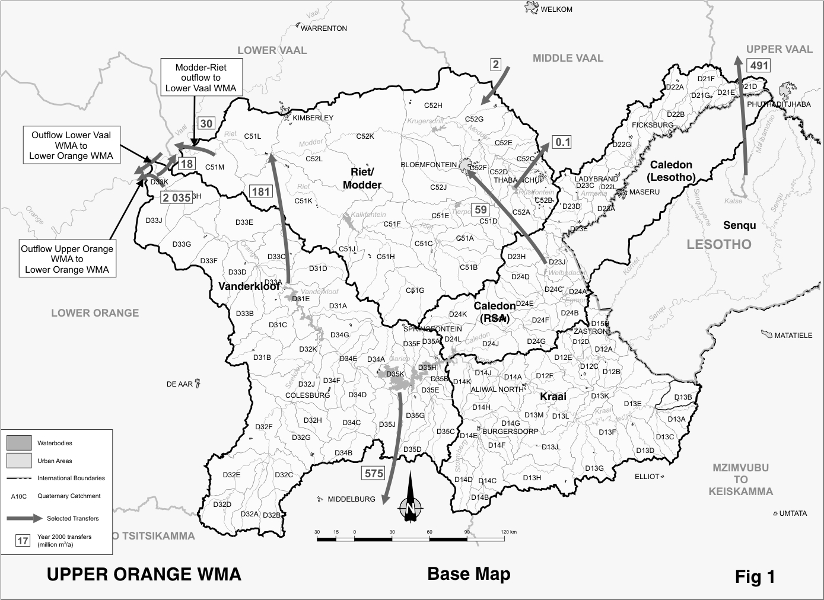
D13.2 Key statistics relevant to the Upper Orange water management area
Tables D13.1 to 13.6 contain a breakdown of the information given in Tables 2.1 to 2.6 of Chapter 2 for each sub-area of the Upper Orange water management area. Data is derived primarily from the standardised data base. Different information may be available from other sources.

Table D13.1: Natural mean annual runoff (MAR) and ecological Reserve (million m³/a)
Component/  Sub-area | Natural MAR¹ | Ecological Reserve^{1, 2}
Senqu Lesotho | 4 012 | 933
Caledon Lesotho | 753 | 92
Caledon RSA | 650 | 90
Kraai | 956 | 158
Riet / Modder | 407 | 45
Vanderkloof | 203 | 31
Total for WMA | 6 981 | 1 349
- Quantities are incremental and refer to the sub-area under consideration only.
- The total volume is based on preliminary estimates, with the impact on yield being a portion of this.

Table D13.2: Available yield in the year 2000 (million m³/a)
Component/  Sub-area |  | Natural resource |  |  |  | Usable return flow |  |  |  | Total  local  yield
Component/  Sub-area | Surface water¹ |  | Ground-water |  | Irrigation |  | Urban | Mining and bulk |  | Total  local  yield
Senqu Lesotho | 523 |  | 0 |  | 0 |  | 0 | 0 |  | 523
Caledon Lesotho | 28 |  | 1 |  | 0 |  | 2 | 0 |  | 31
Caledon RSA | 167 |  | 5 |  | 4 |  | 2 | 0 |  | 178
Kraai | 34 |  | 10 |  | 0 |  | 0 | 0 |  | 44
Riet / Modder | 85 |  | 6 |  | 13 |  | 33 | 0 |  | 137
Vanderkloof | 3 474 |  | 43 |  | 17 |  | 0 | 0 |  | 3 534
Total for WMA | 4 311 |  | 65 |  | 34 |  | 37 | 0 |  | 4 447
- After allowance for impacts on yield of the ecological component of the Reserve, river losses, alien vegetation, rain-fed sugar cane and urban runoff.

Table D13.3: Water requirements for the year 2000 (million m³/a)
Sector/  Sub-area | Irrigation | Urban¹ | Rural¹ | Mining  and bulk industrial² | Power generation³ | Affores-  tation⁴ | Total local requirements
Senqu Lesotho | 8 | 2 | 13 | 0 | 0 | 0 | 23
Caledon Lesotho | 12 | 22 | 6 | 0 | 0 | 0 | 40
Caledon RSA | 88 | 4 | 13 | 0 | 0 | 0 | 105
Kraai | 84 | 6 | 13 | 0 | 0 | 0 | 103
Riet / Modder | 252 | 87 | 10 | 2 | 0 | 0 | 351
Vanderkloof | 336 | 5 | 5 | 0 | 0 | 0 | 346
Total for WMA | 780 | 126 | 60 | 2 | 0 | 0 | 968
- Includes component of Reserve for basic human needs at 25 ℓ/c/d.
- Mining and bulk industrial water uses that are not part of urban systems.
- Includes water for thermal power generation only. (Water for hydropower, which represents a small portion of power generation in South Africa, is generally available for other uses as well.)
- Quantities refer to the impact on yield only.

Table D13.4: Reconciliation of water requirements and availability for the year 2000 (million m³/a)
Component/  Sub-area | Local  yield | Transfers  in² | Local requirements | Transfers out² | Balance¹
Senqu Lesotho | 523 | 0 | 23 | 491 | 9
Caledon Lesotho | 31 | 0 | 40 | 0 | ( 9)
Caledon RSA | 178 | 0 | 105 | 59 | 14
Kraai | 44 | 0 | 103 | 0 | ( 59) ³
Riet / Modder | 137 | 242 | 351 | 29 | ( 1)
Vanderkloof | 3 534 | 0 | 346 | 2 809 | 379
Total for WMA | 4 447 | 2 | 968 | 3 148 | 333
- Brackets around numbers indicate a negative balance. Surpluses are shown in the most upstream sub-area where they first become available.
- Transfers into and out of sub-areas may include transfers between sub-areas as well as transfers between WMAs. The addition of the quantities transferred per sub-area does therefore not necessarily correspond to the total transfers into and out of the WMA. The same applies to Tables D13.5 and D13.6.
- The negative balance for the Kraai sub-area is as a result of irrigation requirements that are not fully supplied from run-of-river.

Table D13.5: Reconciliation of water requirements and availability for the year 2025 base scenario (million m³/a)
Component/  Sub-area | Local yield¹ | Transfers  in | Local requirements² | Transfers out | Balance³ | Potential for development⁴
Senqu Lesotho | 867 | 0 | 23 | 835 | 9 | 300
Caledon Lesotho | 30 | 0 | 40 | 0 | ( 10) | 0
Caledon RSA | 273 | 0 | 104 | 118 | 51 | 0
Kraai | 45 | 0 | 138 | 0 | ( 93) | 0
Riet / Modder | 160 | 301 | 410 | 52 | ( 1) | 0
Vanderkloof | 3 359 | 0 | 347 | 2 883 | 129 | 600
Total for WMA | 4 734 | 2 | 1 062 | 3 589 | 85 | 900
- Based on existing infrastructure and infrastructure under construction in the year 2000. Also includes return flows resulting from a growth in requirements.
- Based on growth in water requirements as a result of population growth and general economic development. Water for a 5 000 ha expansion in irrigation farming in the Fish to Tsitsikamma WMA and an expansion of 4 000 ha each in the Upper and Lower Orange WMAs is to be sourced from the Upper Orange WMA. The water requirements of 36 million m³/a and 54 million m³/a for the Upper and Lower Orange respectively are provisionally allowed for under the Kraai sub-area and as a transfer from the Vanderkloof sub-area.
- Brackets around numbers indicate a negative balance.
- The potential of 900 million m³/a could be realised by constructing the Mashai Dam in Lesotho in conjunction with the Boskraai Dam at the confluence of the Orange and Kraai Rivers, or by constructing a larger Boskraai Dam on its own.

Table D13.6: Reconciliation of water requirements and availability for the year 2025 high scenario (million m³/a)
Component/  Sub-area | Local yield¹ | Transfers  in | Local requirements² | Transfers out | Balance³ | Potential for development⁴
Senqu Lesotho | 867 | 0 | 23 | 835 | 9 | 300
Caledon Lesotho | 30 | 0 | 40 | 0 | ( 10) | 0
Caledon RSA | 274 | 0 | 106 | 171 | ( 3) | 0
Kraai | 45 | 0 | 141 | 0 | ( 96) | 0
Riet / Modder | 180 | 354 | 463 | 72 | ( 1) | 0
Vanderkloof | 3 359 | 0 | 351 | 2 952 | 56 | 600
Total for WMA | 4 755 | 2 | 1 124 | 3 678 | ( 45) | 900
- Based on existing infrastructure and infrastructure under construction in the year 2000. Also includes return flows resulting from a growth in requirements.
- Based on growth in water requirements as a result of population growth and general economic development. Water for a 5 000 ha expansion in irrigation farming in the Fish to Tsitsikamma WMA and an expansion of 4 000 ha each in the Upper and Lower Orange WMAs is to be sourced from the Upper Orange WMA. The water requirements of 36 million m³/a and 54 million m³/a for the Upper and Lower Orange respectively are provisionally allowed for under the Kraai sub-area and as a transfer from the Vanderkloof sub-area.
- Brackets around numbers indicate a negative balance.
- The potential of 900 million m³/a could be realised by constructing the Mashai Dam in Lesotho in conjunction with the Boskraai Dam at the confluence of the Orange and Kraai Rivers, or by constructing a larger Boskraai Dam.

D13.3 Key elements of the broad strategic perspectives for the Upper Orange water management area
An apparent sizeable quantity of the yield of the Orange River is still unutilised, as shown for the Vanderkloof sub-area in Table D13.4. However, this will be substantially reduced once impoundment commences at the Mohale Dam in Lesotho. The deficits in some tributary sub-areas are as a result of provisions for the ecological component of the Reserve, which still needs to be implemented. Large potential for further development exists, partly in Lesotho and partly in the Vanderkloof sub-area. Key issues with regard to the management of water resources in the Upper Orange water management area will therefore relate to the allocation of the surplus that was available in 2000 and the realisation of development potential. These are highly dependent on developments in other water management areas, as well as in Lesotho and Namibia.

A major impact on the water management area is the Lesotho Highlands Water Project. Although South Africa and Lesotho have only committed to Phase 1 of the project, which includes the Katse and Mohale Dams and the Matsoku diversion, the Treaty between the countries provides for the possibility of further phases up to a maximum diversion capacity of 2 200 million m³/a. Because of the current dramatically lower population growth expectations for South Africa, combined with revised assessments of the hydrology and environmental water requirements, uncertainty exists about the feasibility of developing the Lesotho Highlands Water Project further. A final decision in this respect can only be taken after further investigations and in consultation with the other Orange River Basin countries. Another ongoing joint investigation concerns possible developments in the Caledon River catchment, which is shared by Lesotho and South Africa.

The development of 13 000 ha of new irrigated land for the purposes of rural development, poverty relief and the settlement of emerging farmers has in principle been sanctioned by the Minister of Water Affairs and Forestry. While these developments are to be located in the Upper Orange, Lower Orange and Fish to Tsitiskamma water management areas, most of the water will probably have to be sourced from the Upper Orange water management area. Other priorities are urban and industrial development in Bloemfontein/Botshabelo and the augmentation of supplies to the Port Elizabeth area in the Fish to Tsitsikamma water management area. Additional water may also have to be released from the Upper Orange water management area for use by Namibia. Water quality in the Riet River, as well as flood management in the Lower Orange water management area are also of importance. Although some surplus water is available in the Upper Orange water management area, this is likely to be fully taken up by the additional allowances for irrigation. Depending on the growth in requirements of other users, a deficit can easily result. Due consideration will therefore have to be given to appropriate demand management measures and to ensuring that the available water is used in the most beneficial manner.

Because of the Upper Orange water management area’s central location and its linkages to other water management areas, much of the area’s water resources are used in other water management areas. Accordingly specific reservations with regard to the use of water from the Upper Orange water management area are:
- The current transfer of 491 million m³/a from the Senqu River in Lesotho to the Upper Vaal water management area, which is to be increased to 835 million m³/a when Mohale Dam in Lesotho comes into operation by the year 2004 – reserved through Treaty with Lesotho.
In view of the reduced projections of water requirements from the Lesotho Highlands Water Project, it is imperative that the minimum quantity of water to be delivered, as specified in Annexure 2 of the Treaty on the Lesotho Highlands Water Project, is revised.
- In view of the reduced projections of water requirements from the Lesotho Highlands Water Project, it is imperative that the minimum quantity of water to be delivered, as specified in Annexure 2 of the Treaty on the Lesotho Highlands Water Project, is revised.
- The transfer of water to the Fish to Tsitsikamma water management area, up to the maximum capacity of the transfer tunnel of approximately 600 million m³/a, to serve current users as well as requirements for growth in the Port Elizabeth area – reserved in Upper Orange water management area.
- The transfer of 18 million m³/a from Marksdrift to Douglas Weir in the Lower Vaal water management area for water quality purposes – reserved in Upper Orange water management area.
- The release of water down the Orange River, currently about 2 035 million m³/a, to meet requirements in the Lower Orange water management area and for use by Namibia. A further 54 million m³/a for a possible 4 000 ha new irrigation project in the Lower Orange water management area must also be allowed for – reserved in Upper Orange water management area.
- The agreement with Eskom in respect of water for hydropower generation must be honoured. Revisions to the agreement are, however, required to address the impact of hydropower generation on the flow regime in the river and the impact of further resource developments on power generation more adequately – agreement at national level with Eskom imposes reservation on Upper Orange water management area.
- Large-scale water resource developments on the Orange River as well as on the Caledon and Kraai tributaries, that may impact on the above or on neighbouring countries (including the Senqu in Lesotho), will be subject to authorisation at national level – reservation applies to Upper Orange water management area.
- The allocation of all surplus water in the Upper Orange water management area will resort under national control as this water may be allocated to users in the Upper Orange or other water management areas.

