D14 WATER MANAGEMENT AREA 14: LOWER ORANGE

D14.1 Introduction
The geographic extent of the Lower Orange water management area largely corresponds to that of the Northern Cape Province. It is situated in the western extremity of South Africa and borders on Botswana, Namibia and the Atlantic Ocean (see Fig. D14). Climate over the region is harsh semi-desert to desert. Rainfall is minimal, ranging from 400 mm/a to a low of 20 mm/a and is characterised by prolonged droughts. With the exception of sparse and highly intermittent runoff from local tributaries and occasional inflows from the Fish River in Namibia, the Lower Orange water management area is totally dependent on flow in the Orange River from upstream water management areas. Because of the low rainfall, groundwater resources are also limited, although this source is well used for rural water supplies. Important conservation areas in the water management area include the Kgalagadi Transborder National Park, the Augrabies National Park, the Richtersveld National Park and a transboundary Ramsar wetland site at the Orange River mouth.

The largest contributions to the region’s economy are made by mining and irrigated agriculture. Mining activities consist mainly of the extraction of alluvial diamonds and a variety of other mineral resources from locations both inland and along the coast. Extensive irrigation occurs along the Orange River, where the tendency is increasingly towards the growing of high-value orchard crops. Namibia also abstracts water from the river for domestic, mining and irrigation purposes. Sheep and other livestock farming is practised where the climate is favourable.

Water resources in the water management area are fully developed. Owing to the fact that water has to travel a distance of 1 400 km from the point of release at Vanderkloof Dam to the most downstream point of use, large operational and transmission losses are incurred in the process of ensuring that the requirements of users are met. Opportunity exists for this situation to be improved by constructing a new dam in the Lower Orange River for the purpose of providing re-regulation storage. Such a dam could serve a secondary function of regulating spills from dams in upstream water management areas. An unique development in the southern tributary catchments is the use of “soomwalle”, or soil embankments that retain runoff from the land, as a means of rainfall harvesting.

Fig. D14: Base map of the Lower Orange water management area
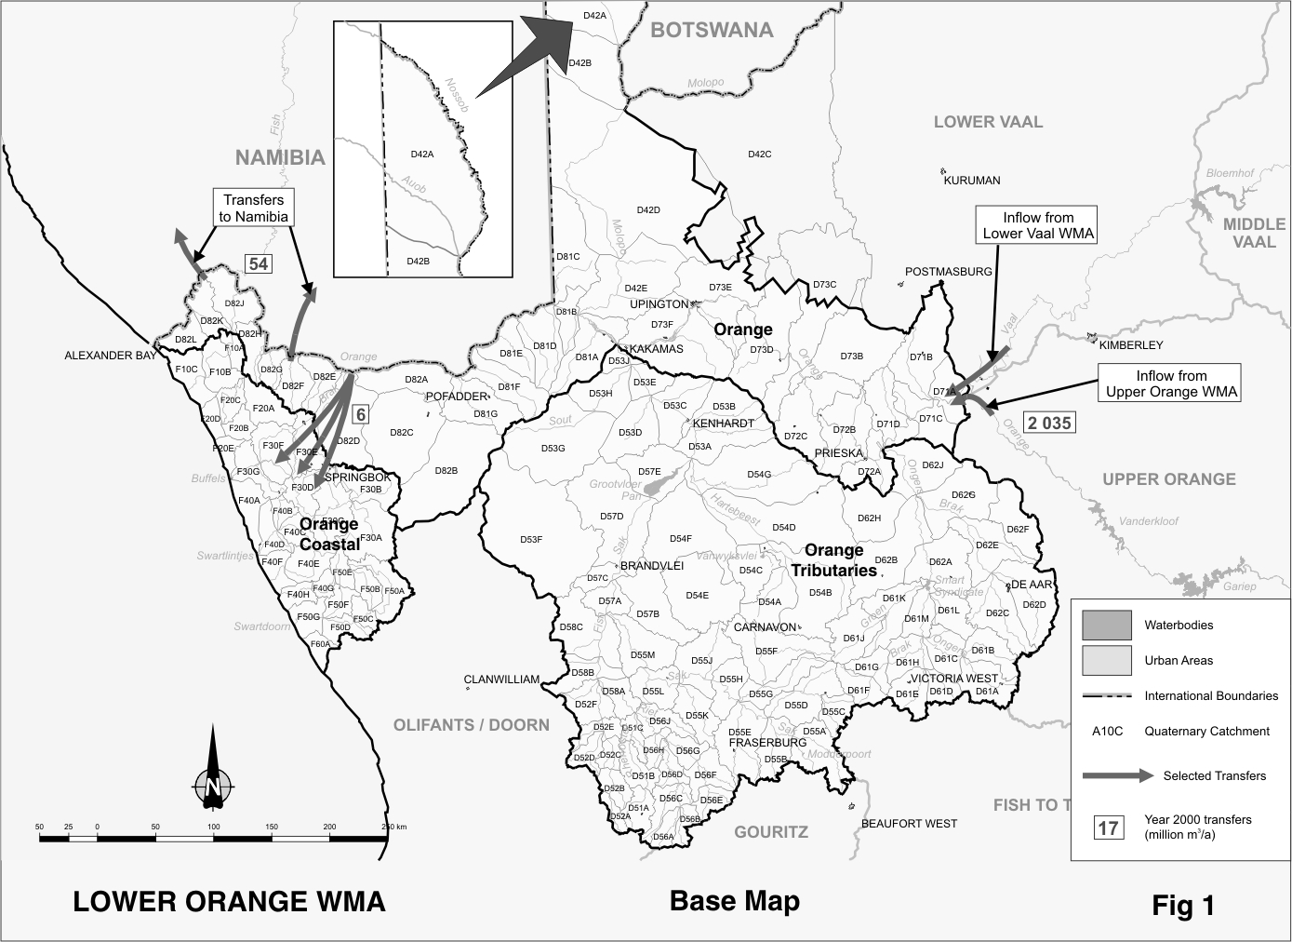
Demographic projections show a steady population decline in the water management area over the next 25 years. Economic activity is likely to remain dependent on mining and irrigation farming in the foreseeable future, with modest contributions from eco-tourism. The potential also exists for the development of up to 4 000 ha of new irrigation land for the settlement of emerging farmers and as a means of poverty relief. Water for this purpose will be made available from the Upper Orange water management area.

D14.2 Key statistics relevant to the Lower Orange water management area
Tables D14.1 to 14.6 contain a breakdown of the data given in Tables 2.1 to 2.6 of Chapter 2 for each sub-area of the Lower Orange water management area. Data is derived primarily from the standardised database. Different information may be available from other sources.

Table D14.1: Natural mean annual runoff (MAR) and ecological Reserve (million m³/a)
Component/  Sub-area | Natural MAR¹ | Ecological Reserve^{1, 2}
Orange³ | 198 | 32
Orange Tributaries | 280 | 35
Orange Coastal | 24 | 2
Total for WMA | 502 | 69
- Quantities are incremental and refer to the sub-area under consideration only.
- The total volume is based on preliminary estimates, with impact on yield being a portion of this.
- Does not include the MAR of 466 million m³/a of the Fish River in Namibia.

Table D14.2: Available yield in the year 2000 (million m³/a)
Component/  Sub-area |  | Natural resource |  |  |  | Usable return flow |  |  |  | Total local yield¹
Component/  Sub-area | Surface water |  | Ground-water |  | Irrigation |  | Urban | Mining and bulk |  | Total local yield¹
Orange | ( 1 092) |  | 9 |  | 96 |  | 1 | 0 |  | ( 986)
Orange Tributaries | 9 |  | 13 |  | 0 |  | 0 | 0 |  | 22
Orange Coastal | 0 |  | 3 |  | 0 |  | 0 | 0 |  | 3
Total for WMA | ( 1 083) |  | 25 |  | 96 |  | 1 | 0 |  | ( 961)
- After allowance for the impacts on yield of the ecological component of the Reserve, river losses, alien vegetation, rain-fed sugar cane and urban runoff.

Table D14.3: Water requirements for the year 2000 (million m³/a)
Sector/  Sub-area | Irrigation | Urban¹ | Rural¹ | Mining  and bulk industrial² | Power generation³ | Affores-tation⁴ | Total local require-ments
Orange | 961 | 12 | 9 | 7 | 0 | 0 | 989
Orange Tributaries | 16 | 8 | 7 | 0 | 0 | 0 | 31
Orange Coastal | 0 | 5 | 1 | 2 | 0 | 0 | 8
Total for WMA | 977 | 25 | 17 | 9 | 0 | 0 | 1 028
- Includes component of Reserve for basic human needs at 25 l/c/d.
- Mining and bulk industrial that are not part of urban systems.
- Includes water for thermal power generation only. (Water for hydropower, which represents a small portion of power generation in South Africa, is generally also available for other uses.)
- Quantities refer to the impact on yield only.

Table D14.4: Reconciliation of water requirements and availability for the year 2000 (million m³/a)
Component/  Sub-area | Local  yield | Transfers  in | Local requirements | Transfers  out | Balance¹
Orange | ( 986) | 2 035 | 989 | 60 | 0
Orange Tributaries | 22 | 0 | 31 | 0 | ( 9)
Orange Coastal | 3 | 6 | 8 | 0 | 1
Total for WMA | ( 961) | 2 035 | 1 028 | 54 | ( 8)
- Brackets around numbers indicate a negative balance. Surpluses are shown in the most upstream sub-area where they first become available.
- Transfers into and out of sub-areas may include transfers between sub-areas as well as transfers between WMAs. The addition of the quantities transferred per sub-area does therefore not necessarily correspond to total transfers into and out of the WMA. The same applies to Tables D14.5 and D14.6.

Table D14.5: Reconciliation of water requirements and availability for the year 2025 base scenario (million m³/a)
Component/  Sub-area | Local  yield¹ | Transfers in | Local requirements² | Transfers out | Balance³ | Potential for develop-  ment⁴
Orange | ( 981) | 2 082 | 1 042 | 60 | ( 1) | 150
Orange Tributaries | 22 | 0 | 29 | 0 | ( 7) | 0
Orange Coastal | 2 | 6 | 8 | 0 | 0 | 0
Total for WMA | ( 957) | 2 082 | 1 079 | 54 | ( 8) | 150
- Based on existing infrastructure and infrastructure under construction in the year 2000. Also includes return flows resulting from a growth in requirements.
- Based on normal growth in water requirements as a result of population growth and general economic development. Includes a 4 000 ha increase in irrigated farming land in the Orange sub-area, which will require 54 million m³/a.
- Brackets around numbers indicate a negative balance.
- Based on construction of the Vioolsdrift Dam.

Table D14.6: Reconciliation of water requirements and availability for the year 2025 high scenario (million m³/a)
Component/  Sub-area | Local  yield¹ | Transfers in | Local requirements² | Transfers out | Balance³ | Potential for develop-  ment⁴
Orange | ( 980) | 2 100 | 1 056 | 65 | ( 1) | 150
Orange Tributaries | 22 | 0 | 33 | 0 | ( 11) | 0
Orange Coastal | 2 | 11 | 13 | 0 | 0 | 0
Total for WMA | ( 956) | 2 100 | 1 102 | 54 | ( 12) | 150
- Based on existing infrastructure and infrastructure under construction in the year 2000. Also includes return flows resulting from a growth in requirements.
- Based on a high growth in water requirements as a result of population growth and the high impact of economic development. Includes a 4 000 ha increase in irrigated farming land in the Orange sub-area, which will require 54 million m³/a.
- Brackets around numbers indicate a negative balance.
- Based on construction of the Vioolsdrift Dam.

D14.3 Key elements of the broad strategic perspective for Lower Orange water management area
The Lower Orange water management area is without doubt the water management area most impacted upon by upstream development, since it lies furthest downstream of five water management areas covering the Orange/Vaal basin. There are extensive inter-catchment transfers between most of these areas. Water use in Lesotho, transfers from Lesotho to the Upper Vaal water management area, the need to share the river’s water with Namibia, and the negative yield of the river resulting from evaporation losses, as indicated in Table D14.4, are other factors to be taken into account. Furthermore, water quality along the Lower Orange River is affected by upstream developments and usage, while salinity in this stretch of the river is increased further by irrigation return flows within the water management area itself. Regular liaison with the other Orange River Basin water management areas on issues of common interest is therefore vital, as is the need for the Lower Orange to be managed in a systems context with the Upper Orange and Vaal River water management areas. Water quality management and management of the Orange River estuary in conjunction with Namibia need to receive special attention.

With over 90 per cent of water use in the water management area being for irrigation, it is prudent that specific attention is given to the improvement of irrigation practices, which is a continuous issue, and maximisation of the benefits derived from irrigation. Improved control over abstractions also has to be implemented. Of more localised importance is the development of a plan for the management of the “soomwalle” in view of the impact these have on water availability downstream.

The following reservations apply with regard to the management of the Lower Orange water management area:
- The transfer of water from the Upper Orange water management area, which currently amounts to about 2 035 million m³/a. The water requirement of 54 million m³/a for 4 000 ha of new irrigation development has been included in Tables D14.5 and D14.6 – reserved in Upper Orange water management area.
- The abstraction of water by Namibia and all water-related negotiations and agreements with Namibia are subject to national authorisation. The current arrangement is for Namibia to abstract a firm 50 million m³/a, plus an additional maximum quantity of 60 million m³/a under a temporary arrangement valid until 31st December 2007. However, in the year 2000 only a small portion of the additional allowance was abstracted – international agreement with Namibia imposes reservation on Lower Orange water management area.
- Flood management in the Orange/Vaal catchment will resort under national control because of the interdependence of the Orange/Vaal water management areas in this respect.
- Any new control infrastructure on the Orange River is subject to national authorisation because of its potential impact on Namibia and the requirements for managing the Orange River mouth. Apart from this, new infrastructure across much of the lower Orange River will involve Namibian territory – reservation applies to lower Orange water management area.

