D15 WATER MANAGEMENT AREA 15: FISH TO TSITSIKAMMA

D15.1 Introduction
The Fish to Tsitsikamma water management area is situated in the south-eastern part of South Africa, mainly within the Eastern Cape Province. The south-western part of the area is characterised by several mountain ranges lying parallel to the coast, with undulating terrain and localised massives inland. Climate over the water management area is strongly influenced by its location and topography. Typical arid Karoo climate prevails over most of the interior, where annual rainfall ranges from 600 mm to less than 200 mm. Small areas along the coast experience rainfall in excess of 1 000 mm/a. Several national parks and conservation areas are found in the water management area.

Sheep and mohair farming is the main land use, although intensive cultivation of irrigated land occurs along the main rivers. Subsistence farming is practised in the former Ciskei region and timber plantations occupy the high rainfall areas. The economy of the region is dominated by industrial activities in Port Elizabeth and Uitenhage.

Several dams have been constructed in the water management area, but because of the natural poor quality of water draining from the inland areas there is only limited potential for further water resources development. The waters of the Fish and Sundays Rivers (see Fig. D15) are of natural high salinity, and because of this large quantities of good quality water are transferred from the Orange River in the Upper Orange water management area for blending with local resources. Irrigation return flows reaching the main streams contribute to further deterioration of water quality. Groundwater is utilised extensively to supply towns and rural areas and over-exploitation occurs on a localised basis.

Economic growth in the water management area will for the foreseeable future be concentrated in the Port Elizabeth/Uitenhage area (the Algoa sub-area), although an increase in tourism is anticipated along the coast. A strong growth in population is projected for the industrial hub. Economic activity in the inland areas is expected to remain largely unchanged and a small decline in population is projected for these parts.

Fig. D15: Base map of the Fish to Tsitsikamma water management area
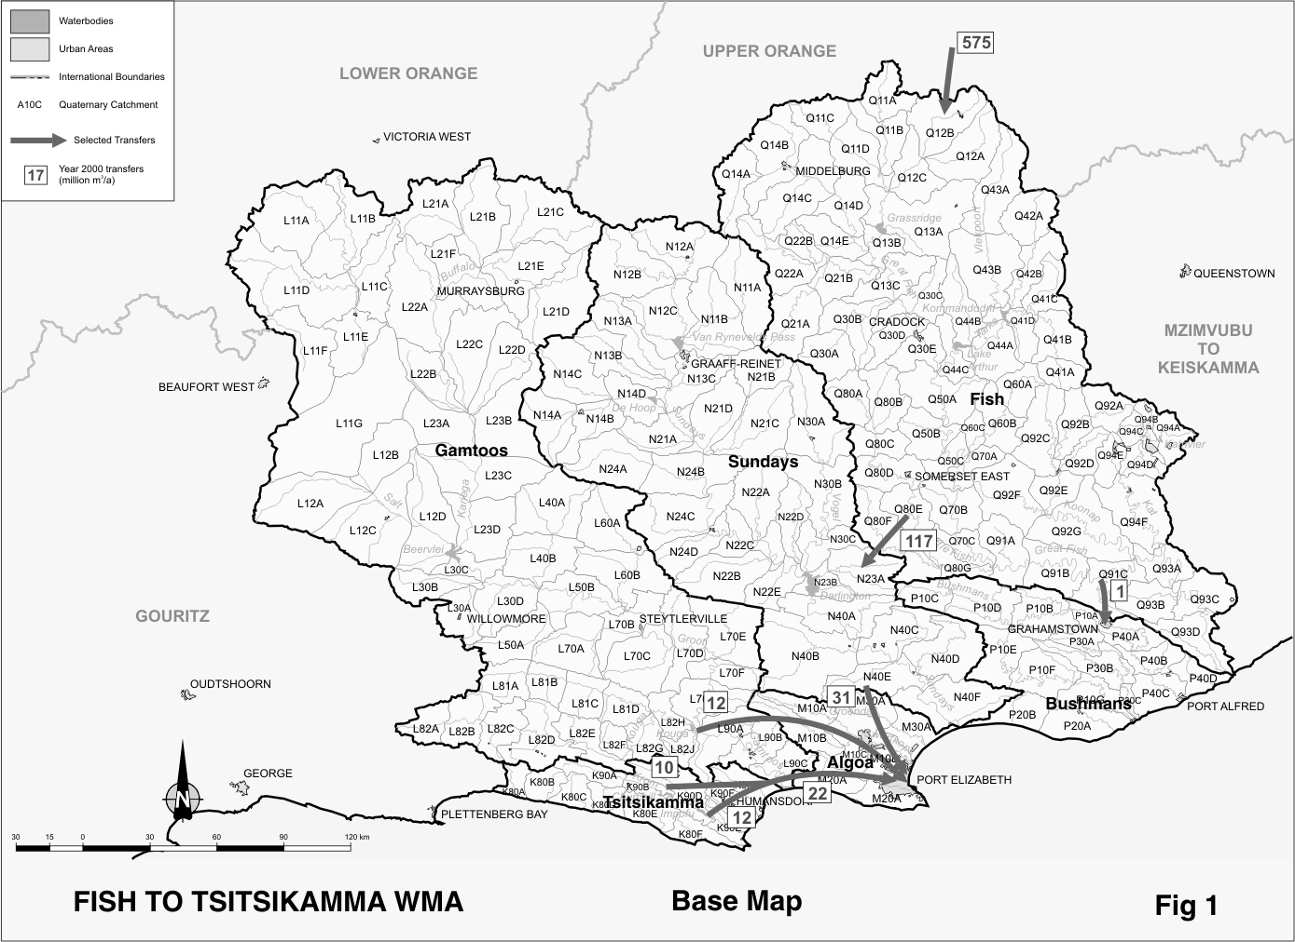
D15.2 Key statistics relevant to the Fish to Tsitsikamma water management area
Tables D15.1 to 15.6 contain a breakdown of the information given in Tables 2.1 to 2.6 of Chapter 2 for each sub-area of the Fish to Tsitsikamma water management area. Data is derived primarily from the standardised database. Different information may be available from other sources.

Table D15.1: Natural mean annual runoff (MAR) and ecological Reserve (million m³/a)
Component/  Sub-area | Natural MAR¹ | Ecological Reserve^{1, 2}
Fish | 518 | 47
Bushmans | 174 | 15
Sundays | 280 | 20
Gamtoos | 491 | 39
Algoa | 147 | 15
Tsitsikamma | 544 | 107
Total for WMA | 2 154 | 243
- Quantities are incremental and refer to the sub-area under consideration only.
- The total volume is based on preliminary estimates, with impact on yield being a portion of this.

Table D15.2: Available yield in the year 2000 (million m³/a)
Component/  Sub-area |  | Natural resource |  |  |  | Usable return flow |  |  |  | Total local yield
Component/  Sub-area | Surface water¹ |  | Ground-water |  | Irrigation |  | Urban | Mining and bulk |  | Total local yield
Fish | ( 4) |  | 6 |  | 77 |  | 5 | 0 |  | 84
Bushmans | 15 |  | 2 |  | 0 |  | 4 | 0 |  | 21
Sunday | 61 |  | 16 |  | 22 |  | 2 | 0 |  | 101
Gamtoos | 137 |  | 5 |  | 2 |  | 1 | 0 |  | 145
Algoa | 10 |  | 6 |  | 1 |  | 6 | 0 |  | 23
Tsitsikamma | 41 |  | 6 |  | 1 |  | 1 | 0 |  | 49
Total for WMA | 260 |  | 41 |  | 103 |  | 19 | 0 |  | 423
- After allowance for impacts on yield of the ecological component of the Reserve, river losses, alien vegetation, rain-fed sugar cane and urban runoff.

Table D15.3: Water requirements for the year 2000 (million m³/a)
Sector/  Sub-area | Irrigation | Urban¹ | Rural¹ | Mining  and bulk industrial² | Power generation³ | Affores-  tation⁴ | Total local requirements
Fish | 453 | 12 | 6 | 0 | 0 | 2 | 473
Bushmans | 11 | 9 | 2 | 0 | 0 | 0 | 22
Sunday | 174 | 5 | 3 | 0 | 0 | 0 | 182
Gamtoos | 104 | 3 | 3 | 0 | 0 | 1 | 111
Algoa | 12 | 78 | 1 | 0 | 0 | 0 | 91
Tsitsikamma | 11 | 5 | 1 | 0 | 0 | 5 | 22
Total for WMA | 765 | 112 | 16 | 0 | 0 | 8 | 901
- Includes component of Reserve for basic human needs at 25 ℓ/c/d.
- Mining and bulk industrial water uses that are not part of urban systems.
- Includes water for thermal power generation only. (Water for hydropower, which represents a small portion of power generation in South Africa, is generally is available for other uses as well.)
- Quantities refer to the impact on yield only.

Table D15.4: Reconciliation of water requirements and availability for the year 2000 (million m³/a)
Component/  Sub-area | Local  yield | Transfers  in² | Local requirements | Transfers  out² | Balance¹
Fish | 84 | 575 | 473 | 117 | 69
Bushmans | 21 | 1 | 22 | 0 | 0
Sunday | 101 | 117 | 182 | 31 | 5
Gamtoos | 145 | 0 | 111 | 12 | 22
Algoa | 23 | 64 | 91 | 0 | ( 4)
Tsitsikamma | 49 | 0 | 22 | 22 | 0
Total for WMA | 423 | 575 | 901 | 0 | 97
- Brackets around numbers indicate a negative balance. Surpluses are shown in the most upstream sub-area where they first become available.
- Transfers into and out of sub-areas may include transfers between sub-areas as well as transfers between WMAs. The addition of the quantities transferred per sub-area does therefore not necessarily correspond to the total transfers into and out of the WMA. The same applies to Tables D15.5 and D15.6.

Table D15.5: Reconciliation of water requirements and availability for the year 2025 base scenario (million m³/a)
Component/  Sub-area | Local yield¹ | Transfers  in | Local requirements² | Transfers out | Balance³ | Potential for develop-  ment⁴
Fish | 95 | 603 | 525 | 145 | 28 | 25
Bushmans | 25 | 1 | 29 | 0 | ( 3) | 0
Sunday | 102 | 145 | 184 | 59 | 4 | 0
Gamtoos | 146 | 0 | 112 | 12 | 22 | 60
Algoa | 36 | 92 | 118 | 0 | 10 | 0
Tsitsikamma | 52 | 0 | 24 | 22 | 6 | 0
Total for WMA | 456 | 603 | 992 | 0 | 67 | 85
- Based on existing infrastructure and infrastructure under construction in the year 2000. Also includes return flows resulting from a growth in requirements.
- Based on a high growth in water requirements as a result of population growth and the high impact of economic development. Includes a provision of 50 million m³/a for a 5 000 ha increase in irrigated farming land in the Fish sub-area, which may have to be sourced from the Upper Orange water management area.
- Brackets around numbers indicate a negative balance.
- Based on construction of the Foxwood and Guerna Dams. Unquantified potential also exists in the Tsitsikamma sub-area.

Table D15.6: Reconciliation of water requirements and availability for the year 2025 high scenario (million m³/a)
Component/  Sub-area | Local yield¹ | Transfers  in | Local requirements² | Transfers out | Balance³ | Potential for develop-  men⁴
Fish | 97 | 653 | 530 | 195 | 25 | 25
Bushmans | 25 | 1 | 33 | 0 | ( 7) | 0
Sunday | 102 | 195 | 185 | 109 | 3 | 0
Gamtoos | 146 | 0 | 113 | 12 | 21 | 60
Algoa | 28 | 142 | 169 | 0 | 1 | 0
Tsitsikamma | 52 | 0 | 27 | 22 | 3 | 0
Total for WMA | 450 | 653 | 1 057 | 0 | 46 | 85
- Based on existing infrastructure and infrastructure under construction in the year 2000. Also includes return flows resulting from a growth in requirements.
- Based on high growth in water requirements as a result of population growth and the high impact of economic development. Includes a provision of 50 million m³/a for a 5 000 ha increase in irrigated farming land in the Fish sub-area, which may have to be sourced from the Upper Orange water management area.
- Brackets around numbers indicate a negative balance.
- Based on construction of the Foxwood and Guerna Dams. Unquantified potential also exists in the Tsitsikamma sub-area.

D15.3 Key elements of the broad strategic perspectives for the Fish to Tsitsikamma water management area
The dominant feature in respect of water resource management in the Fish to Tsitsikamma water management area is the large transfer of water from the Upper Orange water management area into the catchments of the Fish and Sundays Rivers, equal to nearly 10 times the local surface water yield in these sub-areas. Furthermore, about 96 per cent of the water used in these sub-areas is for irrigation, which is virtually fully supported by water from the Orange River. Since most of the irrigation canals are unlined, large distribution losses are experienced and this contributes to large volumes of irrigation return flows. Management of water quality in the Fish and Sundays Rivers is also a particular priority.

Currently all water requirements can be supplied in full, including the provisions for the ecological component of the Reserve. Most of the surpluses shown in Table D15.4 result from return flows being discharged to the ocean and of which the salinity may be too high for direct application to most uses without blending or treatment.

Further growth in water requirements in this water management area will be concentrated in the greater Port Elizabeth area. Options for reconciling water requirements and availability are described in Section 2.5. Priority is to be given to water demand management. The best options for augmenting supplies are an increase in the use of water from the Orange River, as well as the possible construction of a new dam on the Kouga River. The Minister has also given approval in principle for the development of a maximum of 5 000 ha new irrigation for poverty relief and the settlement of emerging farmers. Water for this development is to be sourced from the Upper Orange water management area and the water requirement has been included in Tables D15.5 and D15.6.

Key elements in respect of the management of water resources in the Fish to Tsitsikamma water management area therefore relate to:
- the efficient use of transferred water and the proper management of water quality;
- the achievement of improved irrigation efficiencies and the maximisation of the benefits derived; and
- ensuring sufficient future water supplies to the Port Elizabeth area.

A reservation will apply to the Upper Orange water management area with regard to the transfer of up to a maximum of 600 million m³/a of water from the Upper Orange water management area to serve current allocations in the Fish to Tsitsikamma water management area. Additional water from the Orange River will be subject to national authorisation. A reservation is also placed on the Fish to Tsitsikamma water management area with respect to the construction of the proposed Guerna Dam, which will be subject to national authorisation because of its inter-dependence with transfers from the Orange River.

