D17 WATER MANAGEMENT AREA 17: OLIFANTS/DOORN

D17.1 Introduction
The Olifants/Doorn water management area lies on the west coast of South Africa along the Atlantic Ocean and is shared by the Western Cape and Northern Cape provinces. It is one of the most diverse water management areas in the country with respect to its natural characteristics and water resources. Prominent topographic features are the Cederberg range and the narrow Olifants River valley. Rainfall varies from over 1 000 mm/a in the extreme south to less than 100 mm/a in the north, and a harsh and arid climate prevails over most of the water management area.

Virtually all the surface flow originates from the small, high-rainfall area around the Cederberg and is carried to the ocean by the Olifants River and its main tributary, the Doring River (see Fig. D17). A unique flow and water quality regime is created by the natural characteristics of the region, which provides a habitat for aquatic species of high conservation importance.

Fig D17: Base map of the Olifants/Doorn water management area

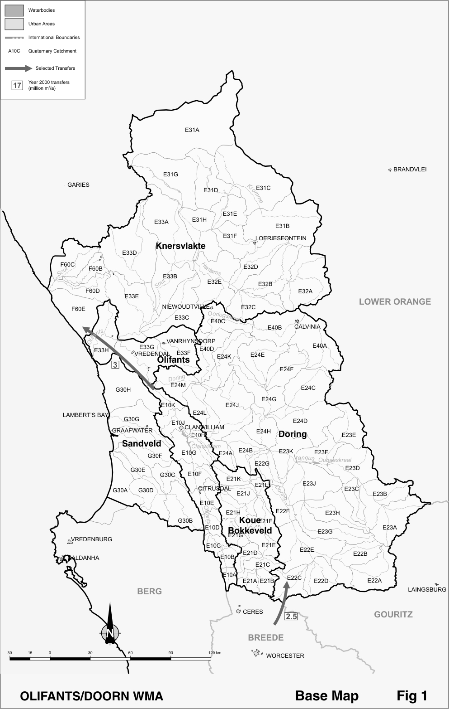

Economic activity in the water management area is centred on irrigated agriculture and 95 per cent of total water use is for irrigation. Intensive production of deciduous fruits, citrus and grapes occurs in the Koue Bokkeveld and along the Olifants River. The arid areas remote from the rivers are sparsely populated, with sheep and goat farming as the main activity. There are no large towns or urban areas in the water management area.

Surface water in the Olifants River is regulated by the Clanwilliam Dam and the Bulshoek Barrage. There are no large dams on the Doring River, although a large number of farm dams have been constructed on the upper tributaries. Significant potential for further water resource development exists, mainly on the Doring River, but is tempered by serious concerns about the potential impacts of such development on the sensitive ecosystems. Groundwater is used extensively in the water management area. In particular large quantities are abstracted for irrigation in the Sandveld area. The potential has also been identified for the possible abstraction of sizeable quantities of water from the deep Table Mountain Group aquifers.

Demographic projections show a future population decline in the water management area. Economic development is likely to be modest and will depend mainly on further irrigation development and the development of tourism.

D.17.2 Key statistics relevant to the Olifants/Doorn water management area
Tables D 17.1 to 17.6 contain a breakdown of the information given in Tables 2.1 to 2.6 of Chapter 2 for each sub-area of the Olifants/Doorn water management area. Data is derived primarily from the standardised database. Different information may be available from other sources.

Table D 17.1: Natural mean annual runoff (MAR) and ecological Reserve (million m³/a)
Component/  Sub-area | Natural MAR¹ | Ecological Reserve^{1, 2}
Koue Bokkeveld | 279 | 29
Sandveld | 60 | 8
Olifants | 514 | 77
Knersvlakte | 27 | 3
Doring | 228 | 39
Total for WMA | 1 108 | 156
- Quantities are incremental and refer to the sub-area under consideration only.
- The total volume is based on preliminary estimates, with impact on yield being a portion of this.

Table D 17.2: Available yield in the year 2000 (million m³/a)
Component/  Sub-area |  | Natural resource |  |  |  | Usable return flow |  |  |  | Total local yield
Component/  Sub-area | Surface water¹ |  | Ground-water |  | Irrigation |  | Urban | Mining and bulk |  | Total local yield
Koue Bokkeveld | 59 |  | 5 |  | 3 |  | 0 | 0 |  | 67
Sandveld | 2 |  | 30 |  | 0 |  | 0 | 0 |  | 32
Olifants | 196 |  | 4 |  | 19 |  | 2 | 0 |  | 221
Knersvlakte | 1 |  | 3 |  | 0 |  | 0 | 0 |  | 4
Doring | 8 |  | 3 |  | 0 |  | 0 | 0 |  | 11
Total for WMA | 266 |  | 45 |  | 22 |  | 2 | 0 |  | 335
- After allowance for the impacts on yield of the ecological component of the Reserve, river losses, alien vegetation, rain-fed sugar cane and urban runoff.

Table D 17.3: Water requirements for the year 2000 (million m³/a)
Sector/  Sub-area | Irrigation | Urban¹ | Rural¹ | Mining  and bulk industrial² | Power generation³ | Affores-tation⁴ | Total local requirements
Koue Bokkeveld | 65 | 0 | 1 | 0 | 0 | 0 | 66
Sandveld | 35 | 2 | 1 | 0 | 0 | 0 | 38
Olifants | 240 | 4 | 2 | 0 | 0 | 1 | 247
Knersvlakte | 3 | 0 | 1 | 3 | 0 | 0 | 7
Doring | 13 | 1 | 1 | 0 | 0 | 0 | 15
Total for WMA | 356 | 7 | 6 | 3 | 0 | 1 | 373
- Includes component of Reserve for basic human needs at 25 ℓ/c/d.
- Mining and bulk industrial water uses that are not part of urban systems.
- Includes water for thermal power generation only. (Water for hydropower generally is available for other uses as well.)
- Quantities refer to the impact on yield only.

Table D 17.4: Reconciliation of water requirements and availability for the year 2000 (million m³/a)
Component/  Sub-area | Local  yield | Transfers  in² | Local requirements | Transfers out² | Balance¹
Koue Bokkeveld | 67 | 0 | 66 | 0 | 1
Sandveld | 32 | 0 | 38 | 0 | ( 6)
Olifants | 221 | 0 | 247 | 3 | ( 29)
Knersvlakte | 4 | 3 | 7 | 0 | 0
Doring | 11 | 3 | 15 | 0 | ( 1)
Total for WMA | 335 | 3 | 373 | 0 | ( 35)
- Brackets around numbers indicate a negative balance. Surpluses are shown for the most upstream sub-area where they first become available.
- Transfers into and out of sub-areas may include transfers between sub-areas as well as transfers between WMAs. The addition of the quantities transferred per sub-area does therefore not necessarily correspond to total transfers into and out of the WMA. The same applies to Tables D17.5 and D17.6.

Table D 17.5: Reconciliation of water requirements and availability for the year 2025 base scenario (million m³/a)
Component/  Sub-area | Local yield¹ | Transfers in | Local requirements² | Transfers out | Balance³ | Potential for development⁴
Koue Bokkeveld | 67 | 0 | 66 | 0 | 1 | 0
Sandveld | 32 | 0 | 38 | 0 | ( 6) | 0
Olifants | 221 | 0 | 247 | 3 | ( 29) | 10
Knersvlakte | 4 | 3 | 7 | 0 | 0 | 0
Doring | 11 | 3 | 15 | 0 | ( 1) | 175
Total for WMA | 335 | 3 | 373 | 0 | ( 35) | 185
- Based on existing infrastructure and infrastructure under construction in the year 2000. Also includes return flows resulting from a growth in requirements.
- Based on a growth in water requirements as a result of population growth and general economic development. Assumes no general increase in irrigation.
- Brackets around numbers indicate a negative balance.
- Based on the raising of the Clanwilliam Dam and construction of the Melkboom Dam.

Table D 17.6: Reconciliation of water requirements and availability for the year 2025 high scenario (million m³/a)
Component/  Sub-area | Local yield¹ | Transfers in | Local requirements² | Transfers out | Balance³ | Potential for development⁴
Koue Bokkeveld | 67 | 0 | 65 | 0 | 2 | 0
Sandveld | 32 | 0 | 42 | 0 | ( 10) | 0
Olifants | 223 | 0 | 251 | 3 | ( 31) | 10
Knersvlakte | 4 | 3 | 7 | 0 | 0 | 0
Doring | 11 | 3 | 15 | 0 | ( 1) | 175
Total for WMA | 337 | 3 | 380 | 0 | ( 40) | 185
- Based on existing infrastructure and infrastructure under construction in the year 2000. Also includes return flows resulting from a growth in requirements.
- Based on a high growth in water requirements as a result of population growth and the high impact of economic development. Assumes no general increase in irrigation.
- Brackets around numbers indicate a negative balance.
- Based on the raising of the Clanwilliam Dam and construction of the Melkboom Dam.

D.17.3 Key elements of the broad strategic perspectives for the Olifants/Doorn water management area
The requirement for and availability of water are generally in balance over most of the water management area. Exceptions are in the Olifants River valley upstream of Clanwilliam Dam, where irrigation requirements have outstripped availability, and in the Sandveld area where some over-exploitation of groundwater is known to occur. The shortages in the Olifants River will be exacerbated by the implementation of the ecological component of the Reserve, which accounts for close to half of the deficit shown in Table D 17.4.

Options for reconciling water requirements and availability are described in Section 2.5. The following key aspects need to be considered in the management of the Olifants/Doorn water management area:
- The unique seasonal salinity regime of the Olifants/Doring River system and its importance to riverine species and fish breeding in the estuary. Much of the Doring River is still in a relatively pristine state and specific caution is warranted.
- Further research needs to be undertaken of the characteristics of the Sandveld aquifers to facilitate their proper management and to ensure that future priority requirements for water can be met.
- The deep Table Mountain Group aquifers may hold good potential for the abstraction of large quantities of groundwater. Many unknowns still exist, however, and these need to be clarified before any large-scale development can be embarked upon.

Water needs to be reserved in the Breede water management area with respect to the existing inter-water management area transfer to the Olifants/Doorn water management area. Currently this involves the transfer of 2.5 million m³/a to the Inverdoorn canal for irrigation purposes – reserved in the Breede water management area.

Considering the possible implications of climate change, and indications that its impacts may be manifest first in the south-western parts of the country, it is important that the hydrological parameters in the Berg and Breede water management areas are monitored closely. No development or investment decisions should be made that neglect to take into account the actual or potential affects of climatic change on water resources.

