D18 WATER MANAGEMENT AREA 18: BREEDE

D18.1 Introduction
The Breede water management area is the southern-most water management area in South Africa and lies entirely in the Western Cape Province. The climate in the area varies considerably. In the western mountainous regions rainfall can exceed 1 500 mm/a, while in the lower eastern parts of the area the rainfall decreases to about 300 mm/a. Rainfall occurs during the winter. The greater part of the water management area is drained by the Breede River and its main tributary, the Riviersonderend River (see Fig. D18). Several small coastal rivers drain the southern part of the water management area, while vleis with no outflow to the sea are found in the south-east. The lower Palmiet River and the vlei areas are of high conservation importance.

The economy of the region is mainly agriculture-based, with tourism at resort towns along the coast. Extensive vineyards and fruit orchards are grown under irrigation, fed by water from mountain streams and the Breede River as well as groundwater. Dryland wheat is cultivated between the Riversonderend and the coastal mountains, while livestock farming is practised throughout the region.

Several large dams, some of which are off-channel, and many farm dams have been constructed in the water management area. A unique feature is the operation of Theewaterskloof Dam. Water is transferred into the dam from the Berg water management area for seasonal storage and is then transferred back to that area during the dry season together with a larger quantity of additional water from the Breede water management area. Water is also transferred from the Palmiet River to the Berg water management area via the Palmiet Pumped Storage Scheme. Water in the lower Breede River is highly saline. This is attributable to natural mineralisation because of the geology of the region and irrigation return flows, which renders the water unfit for further irrigation use. Strong inter-dependence exists between groundwater and surface water in parts of the water management area. A sizeable potential for resource development remains in the area.

Demographic projections indicate population growth in the coastal areas, but a decline in inland areas, as a result of which the total population is anticipated to remain relatively constant. Because of the poor performance of the region’s agricultural sector in recent times, no significant economic growth is foreseen over the short term, but this may change.

Fig. D18: Base map of the Breede water management area
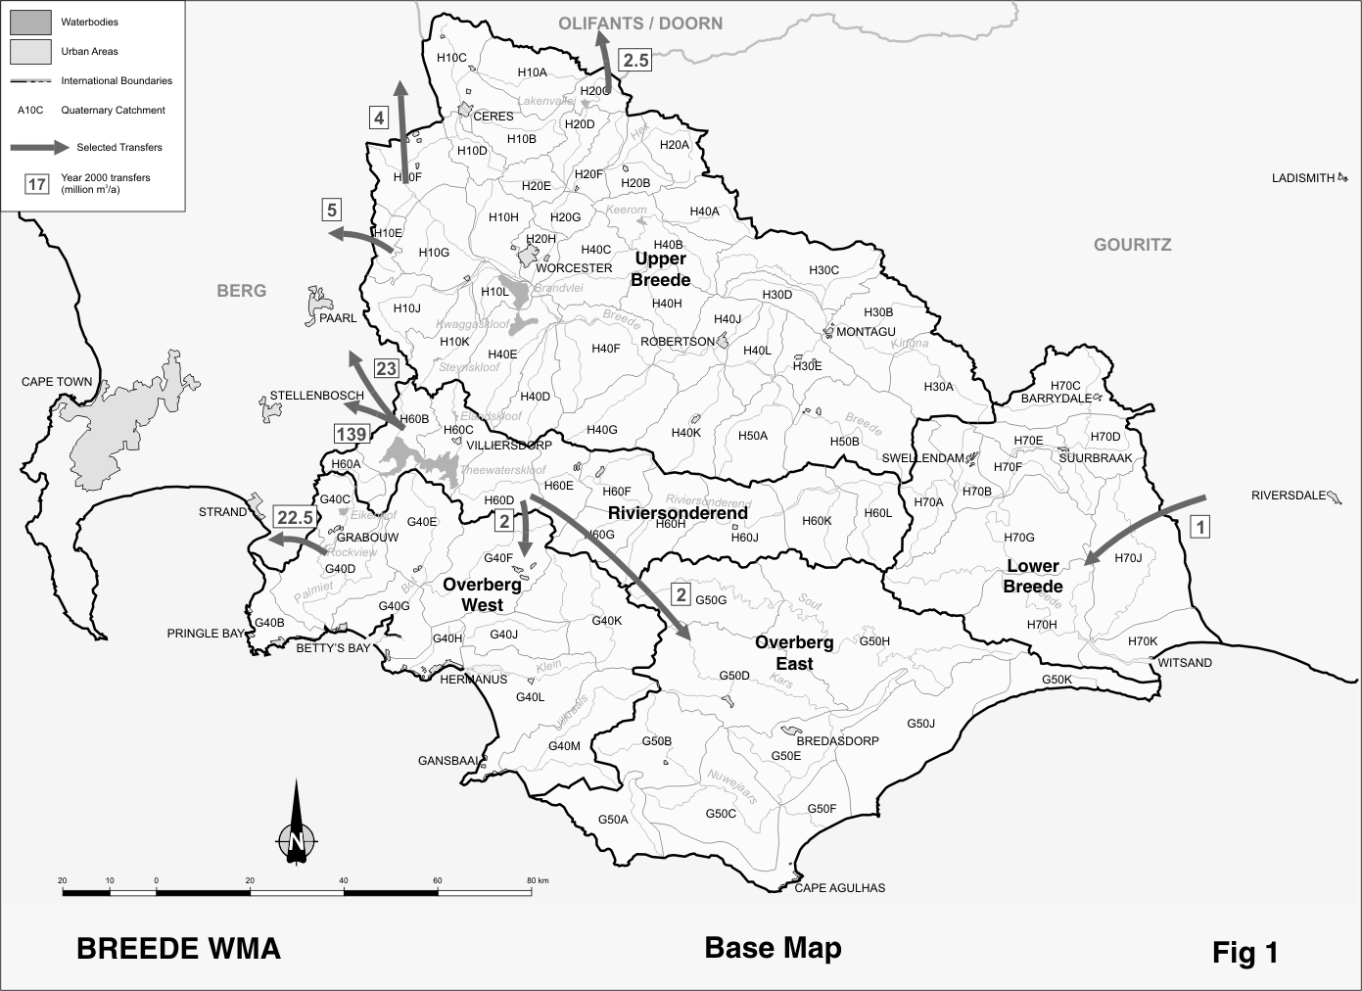
D18.2 Key statistics relevant to the Breede water management area
Tables D18.1 to D18.6 contain a breakdown of the information given in Tables 2.1 to 2.6 of Chapter 2 for each sub-area of the Breede water management area. Data is derived primarily from the standardised database. Different information may be available from other sources.

Table D18.1: Natural mean annual runoff (MAR) and ecological Reserve (million m³/a)
Component/  Sub-area | Natural MAR¹ | Ecological Reserve^{1,2}
Upper Breede | 1 212 | 178
Riviersonderend | 460 | 65
Lower Breede | 210 | 34
Overberg East | 110 | 13
Overberg West | 480 | 94
Total for WMA | 2 472 | 384
- Quantities are incremental and refer to the sub-area under consideration only.
- The total volume is based on preliminary estimates, with impact on yield being a portion of this.

Table D18.2: Available yield in the year 2000 (million m³/a)
Component/  Sub-area |  | Natural resource |  |  |  | Usable return flow |  |  |  | Total  local  yield
Component/  Sub-area | Surface water¹ |  | Ground-water |  | Irrigation |  | Urban | Mining and bulk |  | Total  local  yield
Upper Breede | 348 |  | 97 |  | 44 |  | 12 | 0 |  | 501
Riviersonderend | 220 |  | 4 |  | 2 |  | 0 | 0 |  | 226
Lower Breede | 30 |  | 4 |  | 1 |  | 1 | 0 |  | 36
Overberg East | 1 |  | 1 |  | 0 |  | 0 | 0 |  | 2
Overberg West | 88 |  | 3 |  | 6 |  | 2 | 0 |  | 99
Total for WMA | 687 |  | 109 |  | 53 |  | 15 | 0 |  | 864
- After allowance for the impacts on yield of the ecological component of the Reserve, river losses, alien vegetation, rain-fed sugar cane and urban runoff.

Table D18.3: Water requirements for the year 2000 (million m³/a)
Sector/  Sub-area | Irrigation | Urban¹ | Rural¹ | Mining  and bulk industrial² | Power generation³ | Affores-tation⁴ | Total local requirements
Upper Breede | 435 | 26 | 4 | 0 | 0 | 0 | 465
Riviersonderend | 49 | 1 | 2 | 0 | 0 | 1 | 53
Lower Breede | 28 | 2 | 1 | 0 | 0 | 0 | 31
Overberg East | 0 | 2 | 2 | 0 | 0 | 0 | 4
Overberg West | 64 | 8 | 2 | 0 | 0 | 5 | 79
Total for WMA | 576 | 39 | 11 | 0 | 0 | 6 | 632
- Includes component of Reserve for basic human needs at 25 ℓ/c/d.
- Mining and bulk industrial water uses that are not part of urban systems.
- Includes water for thermal power generation only. (Water for hydropower, which represents a small portion of power generation in South Africa, is generally available for other uses as well.)
- Quantities refer to the impact on yield only.

Table D18.4: Reconciliation of water requirements and availability for the year 2000 (million m³/a)
Component/  Sub-area | Local  yield | Transfers  in² | Local requirements | Transfers out² | Balance¹
Upper Breede | 501 | 0 | 465 | 35 | 1
Riviersonderend | 226 | 0 | 53 | 174 | ( 1)
Lower Breede | 36 | 33 | 31 | 0 | 38
Overberg East | 2 | 2 | 4 | 0 | 0
Overberg West | 99 | 2 | 79 | 23 | ( 1)
Total for WMA | 864 | 1 | 632 | 196 | 37
- Brackets around numbers indicate a negative balance. Surpluses are shown in the most upstream sub-area where they first become available.
- Transfers into and out of sub-areas may include transfers between sub-areas as well as transfers between WMAs. The addition of the quantities transferred per sub-area does therefore not necessarily correspond to total transfers into and out of the WMA. The same applies to Tables D18.5 and D18.6.

Table D18.5: Reconciliation of water requirements and availability for the year 2025 base scenario (million m³/a)
Component/  Sub-area | Local yield¹ | Transfers  in | Local requirements² | Transfers out | Balance³ | Potential for development⁴
Upper Breede | 503 | 0 | 467 | 35 | 1 | 79
Riviersonderend | 227 | 0 | 52 | 174 | 1 | 24
Lower Breede | 36 | 33 | 31 | 0 | 38 | 12
Overberg East | 3 | 2 | 3 | 0 | 2 | 0
Overberg West | 100 | 2 | 83 | 23 | ( 4) | 9
Total for WMA | 869 | 1 | 636 | 196 | 38 | 124
- Based on existing infrastructure and infrastructure under construction in the year 2000. Also includes return flows resulting from a growth in requirements.
- Based on a growth in water requirements as a result of population growth and general economic development. Assumed no general increase in irrigation.
- Brackets around numbers indicate a negative balance.
- Based on the construction of various schemes in the Breede WMA (Mitchells Pass diversion, Upper Molenaars diversion, Wit River Dam, the raising of the Buffeljags Dam, small schemes in the Breede catchment and Campanula Dam on the Palmiet River).

Table D18.6: Reconciliation of water requirements and availability for the year 2025 high scenario (million m³/a)
Component/  Sub-area | Local yield¹ | Transfers  In | Local requirements² | Transfers out | Balance³ | Potential for development⁴
Upper Breede | 525 | 0 | 513 | 11 | 1 | 79
Riviersonderend | 228 | 0 | 54 | 173 | 1 | 24
Lower Breede | 38 | 8 | 34 | 0 | 12 | 12
Overberg East | 3 | 2 | 7 | 0 | ( 2) | 0
Overberg West | 103 | 2 | 95 | 23 | ( 13) | 9
Total for WMA | 897 | 1 | 703 | 196 | ( 1) | 124
- Based on existing infrastructure and infrastructure under construction in the year 2000. Also includes return flows resulting from a growth in requirements.
- Based on a high growth in water requirements as a result of population growth and the high impact of economic development. Assumes no general increase in irrigation.
- Brackets around numbers indicate a negative balance.
- Based on the construction of various schemes in the Breede WMA (Mitchells Pass diversion, Upper Molenaars diversion, Wit River Dam, the raising of the Buffeljags Dam, small schemes in the Breede catchment and Campanula Dam on the Palmiet River).

D18.3 Key elements of the broad strategic perspectives for the Breede water management area
In general, there is sufficient yield available in the Breede water management area to meet all existing water requirements. Small surpluses currently exist in the Upper Breede and Riviersonderend catchments, but will be taken up with the implementation of the Reserve. Substantial potential for further water resources development exists.

With over 90 per cent of water used in the area being for irrigation, it would be prudent for specific attention to be given to the continuous improvement of irrigation practices and the maximisation of the benefits derived.

Priority considerations in respect of water resources management in the Breede water management area include:
- Improvement of irrigation efficiencies.
- The management of salinity levels in the Breede River.
- The improved management of groundwater abstraction. Greater knowledge is needed of aquifer and recharge characteristics, and in particular the interdependencies between groundwater and surface water.
- Additional transfers are likely to be required in future, possibly even within the period under consideration, to serve the greater Cape Town area in the Berg water management area. Although water does not specifically need to be reserved for this purpose at this stage, it would be prudent not to forfeit this option unintentionally by the development of less beneficial projects. Care must therefore be taken that the construction of any new large infrastructure does not prejudice future water transfer options to the Berg water management area.
- No further afforestation should be allowed without the impacts on the ecological component of the Reserve, groundwater recharge and the sensitive salinity balance having been determined and found acceptable.

Water that has to be reserved in the Breede WMA for transfers include the following:
- The transfer of water between the Breede and Berg water management areas via the Riviersonderend/Berg River Scheme. This involves a net transfer of 162 million m³/a to the Berg water management area.
- The transfer of a maximum of 50 million m³/a from the Palmiet River to the Berg water management area. The average transfer is about 22.5 million m³/a.
- Smaller transfers to the Berg water management area amounting to 9 million m³/a.
- The transfer of a maximum of 2.5 million m³/a to the Olifants/Doorn water management area through the Inverdoorn Canal.
- A maximum of 2 million m³/a is reserved in the Gouritz water management area for transfer to the Breede water management area for rural water supply.
- A reservation also applies to the Breede water management area with respect to any new large scale water resource developments which may impact on future transfers to the Berg water management area.

Considering the possible implications of climate change, and indications that its impacts may manifest first in the south-western parts of the country, it is important that the hydrological parameters in the Berg and Breede water management areas are monitored closely. No development or investment decisions should be made that neglect to take into account the actual or potential affects of climatic change on water resources.

