D19 WATER MANAGEMENT AREA 19: BERG

D19.1 Introduction
The Berg water management area commands the south-western corner of South Africa. The Berg River is the only major river in the water management area, although there are several smaller rivers and streams draining to the ocean, as shown in Fig. D19. High mountain ranges characterise the east and south-east of the water management area, from where most of the runoff originates, the most well-known being Table Mountain and the Cape Peninsula mountains in the south-west. Sandy lowlands, with minimal runoff, extend across the central and western part of the water management area. Rainfall occurs in winter and is highly varied, ranging from a high of over 3 000 mm/a in the mountains to less than 300 mm/a in the north-west. The Cape Fynbos represents a unique floral kingdom of World Heritage status.

A strong and diversified economy exists in the water management area, which is dominated by industrial and other activities in the Cape Town metropolitan area. However, a close interdependency, particularly with respect to tourism and agriculture, exists with the economic activities of the surrounding area and further inland.

Fig D19: Base map of the Berg water management area
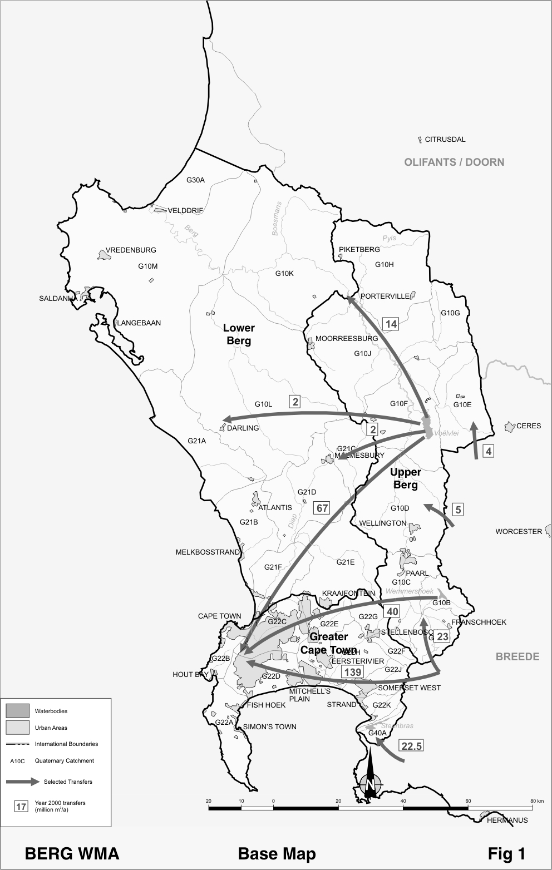

Intensive viticulture and fruit farming, under sophisticated irrigation, are found in the valleys and foothills of the mountains. This changes to extensive rain-fed wheat cultivation in the central regions.

Several large dams and numerous farm dams regulate the surface runoff from the water management area. Regulation will be increased by the addition of the new dam on the Berg River near Franschoek (the Berg Water Project), which has been approved for construction. Significant quantities of groundwater are also abstracted, mainly in the central and western parts of the water management area, with small-scale artificial recharge of groundwater being practised in the vicinity of Atlantis. Large quantities of water are transferred into the area from the Breede water management area via the Riviersonderend/Berg River Scheme and the Palmiet Pumped Storage Scheme (also refer to D18 - Breede water management area). Further potential for the development of water resources exists mainly with respect to the Berg River, although salinity in the lower reaches of the river is becoming a problem, largely as a result of irrigation return flows. Potential may also exist for the abstraction of significant quantities of groundwater from the Table Mountain Group aquifers in the foothills to the east.

Strong economic growth in the Cape Town metropolitan area and vicinity is expected in the foreseeable future. This area is thus likely to form the nucleus for population growth in the water management area.

D19.2 Key statistics relevant to the Berg the water management area
Tables D19.1 to 19.6 contain a breakdown of the information given in Tables 2.1 to 2.6 of Chapter 2 for each sub-area of the Berg water management area. Data is derived primarily from the standardised data base. Different information may be available from other sources.

Table D19.1: Natural mean annual runoff (MAR) and ecological Reserve (million m³/a)
Component/  Sub-area | Natural MAR¹ | Ecological Reserve^{1,2}
Greater Cape Town | 373 | 61
Upper Berg | 849 | 124
Lower Berg | 207 | 32
Total for WMA | 1 429 | 217
- Quantities are incremental and refer to the sub-area under consideration only.
- The total volume is based on preliminary estimates, with impact on yield being a portion of this.

Table D19.2: Available yield in the year 2000 (million m³/a)
Component/  Sub-area |  | Natural resource |  |  |  |  | Usable return flow |  |  |  | Total local yield
Component/  Sub-area | Surface water¹ |  | Ground-water |  | Irrigation |  |  | Urban | Mining and bulk |  | Total local yield
GreaterCape Town | 66 |  | 20 |  | 0 |  |  | 22 | 0 |  | 108
Upper Berg | 284 |  | 15 |  | 8 |  |  | 15 | 0 |  | 322
Lower Berg | 30 |  | 22 |  | 0 |  |  | 0 | 0 |  | 52
Total for WMA | 380 |  | 57 |  | 8 |  |  | 37 | 0 |  | 482
- After allowance for the impacts on yield of the ecological component of the Reserve, river losses, alien vegetation, rain-fed sugar cane and urban runoff.

Table D19.3: Water requirements for the year 2000 (million m³/a)
Sector/  Sub-area | Irrigation | Urban¹ | Rural¹ | Mining  and bulk industrial² | Power generation³ | Affores-tation⁴ | Total local require-ments
Greater Cape Town | 46 | 343 | 5 | 0 | 0 | 0 | 394
Upper Berg | 202 | 23 | 4 | 0 | 0 | 0 | 229
Lower Berg | 53 | 23 | 5 | 0 | 0 | 0 | 81
Total for WMA | 301 | 389 | 14 | 0 | 0 | 0 | 704
- Includes component of Reserve for basic human needs at 25 ℓ/c/d.
- Mining and bulk industrial water uses that are not part of urban systems.
- Includes water for thermal power generation only. (Water for hydropower, which represents a small portion of power generation in South Africa, is generally available for other uses as well.)
- Quantities refer to the impact on yield only.

Table D19.4: Reconciliation of water requirements and availability for the year 2000 (million m³/a)
Component/  Sub-area | Local  yield | Transfers  in² | Local requirements | Transfers out² | Balance¹
Greater Cape Town | 108 | 269 | 394 | 0 | ( 17)
Upper Berg | 322 | 32 | 229 | 125 | 0
Lower Berg | 52 | 18 | 81 | 0 | ( 11)
Total for WMA | 482 | 194 | 704 | 0 | ( 28)
- Brackets around numbers indicate a negative balance. Surpluses are shown in the most upstream sub-area where they first become available.
- Transfers into and out of sub-areas may include transfers between sub-areas as well as transfers between WMAs. The addition of the quantities transferred per sub-area does therefore not necessarily correspond to the total transfers into and out of the WMA. The same applies to Tables D19.5 and D19.6.

Table D19.5: Reconciliation of water requirements and availability for the year 2025 base scenario (million m³/a)
Component/  Sub-area | Local yield¹ | Transfers in | Local requirements² | Transfers out | Balance³ | Potential for develop-  ment⁴
Greater Cape Town | 111 | 350 | 508 | 0 | ( 47) | 27
Upper Berg | 405 | 32 | 235 | 206 | ( 4) | 100
Lower Berg | 52 | 18 | 87 | 0 | ( 17) | 0
Total for WMA | 568 | 194 | 830 | 0 | ( 68) | 127
- Based on existing infrastructure and infrastructure under construction in the year 2000. Also includes the Berg Water Project and return flows resulting from a growth in requirements.
- Based on a growth in water requirements as a result of population growth and general economic development. Assumes no general increase in irrigation.
- Brackets around numbers indicate a negative balance.
- Based on the raising of the Voëlvlei Dam, and potential diversions from Lourens River and Eerste River.

Table D19.6: Reconciliation of water requirements and availability for the year 2025 high scenario (million m³/a)
Component/  Sub-area | Local yield¹ | Transfers in | Local requirements² | Transfers out | Balance³ | Potential for develop-  ment⁴
Greater Cape Town | 124 | 350 | 913 | 0 | ( 439) | 27
Upper Berg | 422 | 32 | 270 | 206 | ( 22) | 100
Lower Berg | 56 | 18 | 123 | 0 | ( 49) | 0
Total for WMA | 602 | 194 | 1 306 | 0 | ( 510) | 127
- Based on existing infrastructure and infrastructure under construction in the year 2000. Also includes the Berg Water Project and return flows resulting from a growth in requirements.
- Based on a high growth in water requirements as a result of population growth and the high impact of economic development. Assumes no general increase in irrigation.
- Brackets around numbers indicate a negative balance.
- Based on the raising of the Voëlvlei Dam, and potential diversions from Lourens River and Eerste River.
D19.3 Key elements of the broad strategic perspectives for the Berg water management area
Water requirements in the greater Cape Town sub-area are already well in excess of water availability. Part of the deficits reflected in Table D19.4, however, is attributable to the provision made for the implementation of the ecological component of the Reserve at a later stage. With Cape Town as one of the main growth centres in the country, its strong economic and population growth is projected to continue and this will impact on the future requirements for water. Given the lucrative nature of irrigated agriculture in the water management area, continuous pressure also exists for more water to be made available for irrigation.

Ensuring the sufficient future supply of water to the Cape Town area should be the highest priority for water resource management in the Berg water management area. In an effort to alleviate the situation while implementation planning for the construction of the Berg Water Project is in progress, vigorous initiatives are being taken with regard to water demand management. There will nevertheless be an ongoing need to continue augmenting water resources, and options identified to meet future requirements include the further development of local surface water resources, the exploration of deep groundwater from Table Mountain Group aquifers, increased re-use of urban effluent, additional transfer of water from the Breede River water management area and desalination of sea water.

To facilitate a more accurate assessment of the extent to which local resources may still be developed, priority should be given to determining the ecological component of the Reserve. Until clarity has been gained on the most beneficial use of the remaining resource potential, consideration should be given to imposing a temporary embargo on the construction of new farm dams in the Berg River catchment and on increased pumping from the river. Investigations should also continue to improve knowledge on the potential for utilisation of groundwater from the Table Mountain Group aquifers.

Reservations will apply to the Breede water management area with respect to the transfer of water from the Breede to the Berg water management area. Current transfers are as follows:
- 162 million m³/a from the Riviersonderend catchment.
- 22.5 million m³/a on average from the Palmiet River, with a maximum capacity of 50 million m³/a.
- Smaller transfers from the Breede water management area amounting to 9 million m³/a.

The construction of any large new water infrastructure in the Breede water management area that may impact materially on future water transfers to the Berg water management area will be subject to national approval in order to ensure that options for future water transfers are not inadvertently jeopardized – a reservation in this respect applies to the Breede water management area.

Considering the possible implications of climate change, and indications that its impacts may manifest first in the south-western parts of the country, it is important that the hydrological parameters in the Berg and Breede water management areas are monitored closely. No development or investment decisions should be made that neglect to take into account the actual or potential affects of climatic change on water resources.

