D1 WATER MANAGEMENT AREA 1: LIMPOPO

D1.1 Introduction
The Limpopo water management area (see Fig. D1) is the northern-most water management area in the country and represents part of the South African portion of the Limpopo Basin, which is also shared by Botswana, Zimbabwe and Mozambique. The water management area borders on Botswana and Zimbabwe, where the Limpopo River demarcates the entire length of the international boundaries before flowing into Mozambique. The region is semi-arid and the mean annual rainfall ranges from 300 mm to 700 mm over most of the WMA. Economic activity is mainly centred on game, livestock and irrigation farming, while mining activity is increasing. Approximately 200 rural villages are scattered throughout the area, with little local economic activity to support these population concentrations.

Due to the aridity and flatness of the terrain few sites are available for the construction of major dams and the surface water potential has largely been fully developed. Relatively favourable formations for groundwater are found in the area and groundwater is therefore used extensively. However, overexploitation occurs in localised areas. Several inter-water management area water transfers exist, as shown on Fig. D1, all of which bring water into the Limpopo water management area.

Demographic scenarios indicate a small growth in population until 2005 and little change thereafter. Significant growth in water requirements is expected from mining developments in the mineral-rich Bushveld Igneous Complex, which extends across the south-eastern part of the area, while the further exploitation of coal reserves near Ellisras could also increase water requirements. Further growth in economic activity is likely at established urban centres.

Fig. D1: Base map of the Limpopo water management area and its sub-areas
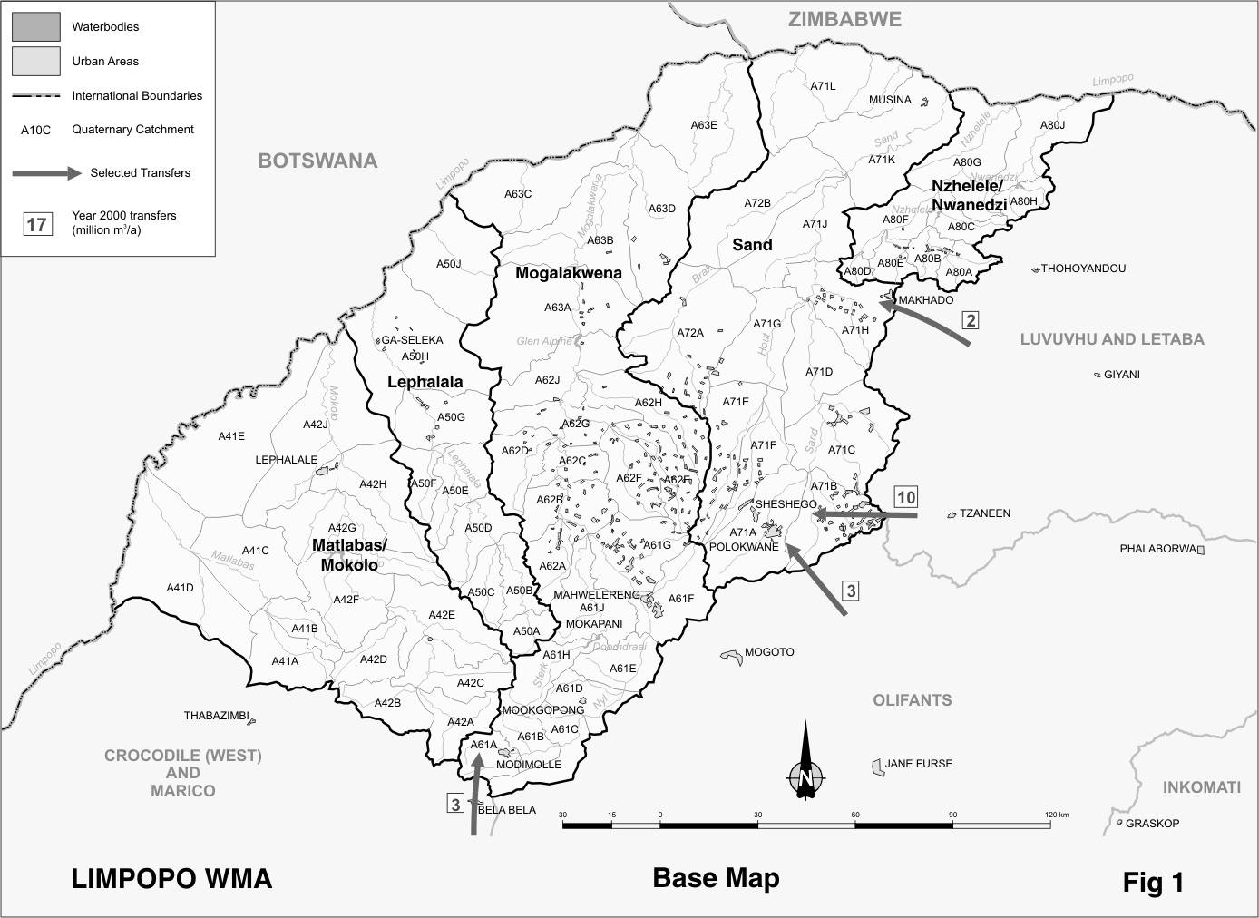

D1.2 Key statistics relevant to the Limpopo water management area
Tables D1.1 to D1.6 contain a breakdown of the information given in Tables 2.1 to 2.6 of Chapter 2 for each sub-area of the Limpopo water management area. Data is provided for the South African land area only and is derived primarily from the standardised data base. Different information may be available from other sources.

Table D1.1: Natural mean annual runoff (MAR) and ecological Reserve (million m³/a)
Component/  Sub-area | Natural  MAR¹ | Ecological Reserve^{1, 2}
Matlabas/Mokolo | 382 | 76
Lephalala | 150 | 17
Mogalakwena | 269 | 41
Sand | 72 | 10
Nzhelele/Nwanedzi | 113 | 12
Total for WMA³ | 986 | 156
- Quantities are incremental and refer to the sub-area under consideration only.
- The total volume is based on preliminary estimates, with impact on yield being a portion of this.
- Total for RSA tributaries to the Limpopo only, excluding the main stream.

Table D1.2: Available yield in the year 2000 (million m³/a)
Component/  Sub-area |  | Natural resource |  |  |  | Usable return flow |  |  | Total local yield
Component/  Sub-area | Surface  water¹ |  | Ground-water |  | Irrigation |  | Urban | Mining and bulk industrial | Total local yield
Matlabas/Mokolo | 35 |  | 7 |  | 3 |  | 1 | 0 | 46
Lephalala | 38 |  | 4 |  | 0 |  | 0 | 0 | 42
Mogalakwena | 50 |  | 15 |  | 3 |  | 4 | 0 | 72
Sand | 10 |  | 71 |  | 0 |  | 10 | 0 | 91
Nzhelele/Nwanedzi | 27 |  | 1 |  | 2 |  | 0 | 0 | 30
Total for WMA | 160 |  | 98 |  | 8 |  | 15 | 0 | 281
- After allowance for the impacts on yield of the ecological component of the Reserve, river losses, alien vegetation, rain-fed sugar cane and urban runoff.

Table D1.3: Water requirements for the year 2000 (million m³/a)
Sector/  Sub-area | Irrigation | Urban¹ | Rural¹ | Mining  and bulk industrial² | Power generation³ | Affore-  station⁴ | Total local require-ments
Matlabas/Mokolo | 48 | 2 | 2 | 4 | 7 | 0 | 63
Lephalala | 39 | 0 | 3 | 0 | 0 | 0 | 42
Mogalakwena | 56 | 8 | 9 | 6 | 0 | 0 | 79
Sand | 69 | 24 | 9 | 4 | 0 | 0 | 106
Nzhelele/Nwanedzi | 26 | 0 | 5 | 0 | 0 | 1 | 32
Total for WMA | 238 | 34 | 28 | 14 | 7 | 1 | 322
- Includes component of Reserve for basic human needs at 25 ℓ/c/d.
- Mining and bulk industrial water uses that are not part of urban systems.
- Includes water for thermal power generation only. (Water for hydropower, which represents a small portion of power generation in South Africa, is generally available for other uses as well.)
- Quantities refer to the impact on yield only.

Table D1.4: Reconciliation of water requirements and availability for the year 2000 (million m³/a)
Component/  Sub-area | Local  yield | Transfers  in² | Local requirements | Transfers  out² | Balance¹
Matlabas/Mokolo | 46 | 0 | 63 | 0 | ( 17)
Lephalala | 42 | 0 | 42 | 0 | 0
Mogalakwena | 72 | 3 | 79 | 0 | ( 4)
Sand | 91 | 15 | 106 | 0 | 0
Nzhelele/Nwanedzi | 30 | 0 | 32 | 0 | ( 2)
Total for WMA | 281 | 18 | 322 | 0 | ( 23)
- Brackets around numbers indicate a negative balance. Surpluses are shown in the most upstream sub-area where they first become available.
- Transfers into and out of sub-areas may include transfers between sub-areas as well as transfers between WMAs. The addition of the quantities transferred per sub-area therefore does not necessarily correspond to the total transfers into and out of the WMA. The same applies to Tables D 1.5 and D 1.6.

Table D1.5: Reconciliation of water requirements and availability for the year 2025 base scenario (million m³/a)
Component/  Sub-area | Local  yield¹ | Transfers  in | Local requirements² | Transfers out | Balance³ | Potential  for develop- ment⁴
Matlabas/Mokolo | 45 | 0 | 62 | 0 | ( 17) | 0
Lephalala | 42 | 0 | 43 | 0 | ( 1) | 0
Mogalakwena | 73 | 3 | 101 | 0 | ( 25) | 7
Sand | 92 | 15 | 107 | 0 | 0 | 0
Nzhelele/Nwanedzi | 29 | 0 | 33 | 0 | ( 4) | 1
Total for WMA | 281 | 18 | 346 | 0 | ( 47) | 8
- Based on existing infrastructure and infrastructure under construction in the year 2000. Also includes return flows resulting from a growth in requirements.
- Based on growth in water requirements as a result of population growth and general economic development. Assumes no general increase in irrigation. A provisional allowance of 20 million m³/a has been made for mining in the Mogalakwena catchment.
- Brackets around numbers indicate a negative balance.
- Based on raising the Glen Alpine and Mutshedzi Dams and construction of the Groenvley Dam.

Table D1.6: Reconciliation of water requirements and availability for the year 2025 high scenario (million m³/a)
Component /  Sub-area | Local  yield¹ | Transfers  in | Local requirements² | Transfers out | Balance³ | Potential  for develop- ment⁴
Matlabas/Mokolo | 46 | 0 | 64 | 0 | ( 18) | 0
Lephalala | 42 | 0 | 43 | 0 | ( 1) | 0
Mogalakwena | 76 | 3 | 108 | 0 | ( 29) | 7
Sand | 102 | 20 | 130 | 0 | ( 8) | 0
Nzhelele/Nwanedzi | 29 | 0 | 33 | 0 | ( 4) | 1
Total for WMA | 295 | 23 | 378 | 0 | ( 60) | 8
- Based on existing infrastructure and infrastructure under construction in the year 2000. Also includes return flows resulting from a growth in requirements.
- Based on a high growth in water requirements as a result of population growth and a high impact of economic development. Assumes no general increase in irrigation. A provisional allowance of 20 million m³/a has been made for mining in the Mogalakwena catchment.
- Brackets around numbers indicate a negative balance.
- Based on raising the Glen Alpine and Mutshedzi Dams and construction of the Groenvley Dam.

D1.3 Key elements of the broad strategic perspectives for the Limpopo water management area
Water resources in the Limpopo water management area, although on the verge of stress, are broadly in balance with the area’s water requirements. The deficits shown in Table D1.4 are attributable to the provision made for the ecological component of the Reserve. Of the total mean annual runoff of 986 million m³/a, an estimated 717 million m³/a on average still reaches the Limpopo River.

With only limited undeveloped resource potential remaining, the primary focus in the water management area should be directed towards more efficient, beneficial and equitable use of the water resources currently available. Some further development of groundwater may be possible, particularly in rural areas to supply basic human needs and for community gardens, but this should be preceded by appropriate investigations of the exploitable potential and be supported by improved management of the resource. New surface resource developments and inter-catchment transfers of water would most likely only be affordable for high value uses. Water to supply current deficits (including the ecological Reserve), as well as for rural development, poverty relief and to redress inequities, will therefore mostly have to be obtained from existing users.

Development of the rich, but largely unexploited mineral deposits of the Bushveld Igneous Complex holds the greatest potential for economic growth in the water management area. Although the timing and extent of development are still uncertain, it is prudent that water be reserved for this purpose. A provisional allowance of 20 million m³/a, an estimate based on current mining use in other areas, has therefore been included under the Mogalakwena sub-area for future mining development in this as well as in the Sand sub-area (refer to Tables D1.5 and D1.6.)

To ensure sufficient future availability of water for mining development and urban/industrial growth, while taking into account the options described in Section 2.5, the following water quantities must be held in reserve for transfer from other water management areas to the Limpopo water management area:
- Water from the Olifants River (Olifantspoort Weir) for transfer to Polokwane, up to the full capacity of the existing pipeline of 5,0 million m³/a – reserved in the Olifants water management area.
- The existing transfer of 18,5 million m³/a maximum capacity to Polokwane from the Ebenezer and Dap Naude Dams in the Luvuvhu and Letaba water management area – reserved in the Luvuvhu and Letaba water management area.
- The existing transfer of 2,4 million m³/a from Albasini Dam in the Luvuvhu and Letaba water management area to Makhado, supplemented by an additional 5 million m³/a from the Luvuvhu River – reserved in the Luvuvhu and Letaba water management area.
- About 45 million m³/a (assumed at half of Sasol II’s requirements) of the growth in effluent return flows to the Crocodile River may be required for the development of coal reserves in the Lephalale area. Since considerable uncertainty still surrounds this possibility, this requirement is not included in Tables D1.5 and D1.6, or in Tables D3.5 and D3.6 – reserved in the Crocodile (West) and Marico water management area.
- Water from the development of the Rooipoort Dam on the Olifants River mainly to supply possible new mining-related developments in the Olifants water management area and the Mogoto to Mokopane area as well as for Polokwane. Other developments that could have a negative impact on the Rooipoort development will not be allowed – reserved in the Olifants water management area.
- The development of new dams or large water resource projects will be subject to national authorisation because of their possible impact on neighbouring countries - reservation with respect to the Limpopo water management area.
- Small transfer from the Crocodile (West) and Marico water management area to Modimolle in the Limpopo water management area – reserved in the Crocodile (West) and Marico water management area.

