D2 WATER MANAGEMENT AREA 2: LUVUVHU AND LETABA

D2.1 Introduction
The Luvuvhu and Letaba water management area lies entirely within the Limpopo Province and borders on Zimbabwe and Mozambique. It forms part of the Limpopo Basin, which is shared by South Africa, Botswana, Zimbabwe and Mozambique. While the Luvuvhu River is a direct tributary of the Limpopo River, the Shingwedzi and Letaba Rivers flow into the Olifants River, which is a tributary of the Limpopo. A unique feature of this water management area is the Kruger National Park along its eastern boundary, which occupies approximately 35 per cent of the area and through which all the main rivers flow into Mozambique, as shown in Fig. D2. Due to the topography, rainfall varies from well over 1 000 mm/a to less than 300 mm/a. Economic activity is characterised by irrigation, afforestation, tourism and informal farming. Over 90 per cent of the area’s population of about 1.5 million live in rural communities.

Surface water mainly originates in the mountainous areas and is regulated by several dams in the upper and middle reaches of the rivers. The Nandoni Dam is under construction on the Luvuvhu River and other sites have been identified as being feasible for the construction of dams in the future. Groundwater is utilised extensively and limited potential remains for further development. Significant over-exploitation of groundwater occurs in parts of the water management area, particularly near Albasini Dam and in the vicinity of Thohoyandou. Water transfers occur from this water management area to both neighbouring water management areas and some inter-catchment transfers within the water management area also take place.

Current expectations are that population growth in the area will be moderate, probably at less than 0,8 per cent per annum. New mining developments are foreseen in the Tzaneen/Gravelotte area and coal mining could possibly commence near Tshikondeni. A water allocation has been reserved from Nandoni Dam for the irrigation of 1 100 ha of farmland to be set aside for the purposes of rural development and poverty relief. It is doubtful whether any further expansion of irrigation will be economically viable. No dramatic growth in future water requirements is therefore expected, with the possible exception of developments related to mining.

Fig. D2: Base map of the Luvuvhu and Letaba water management area
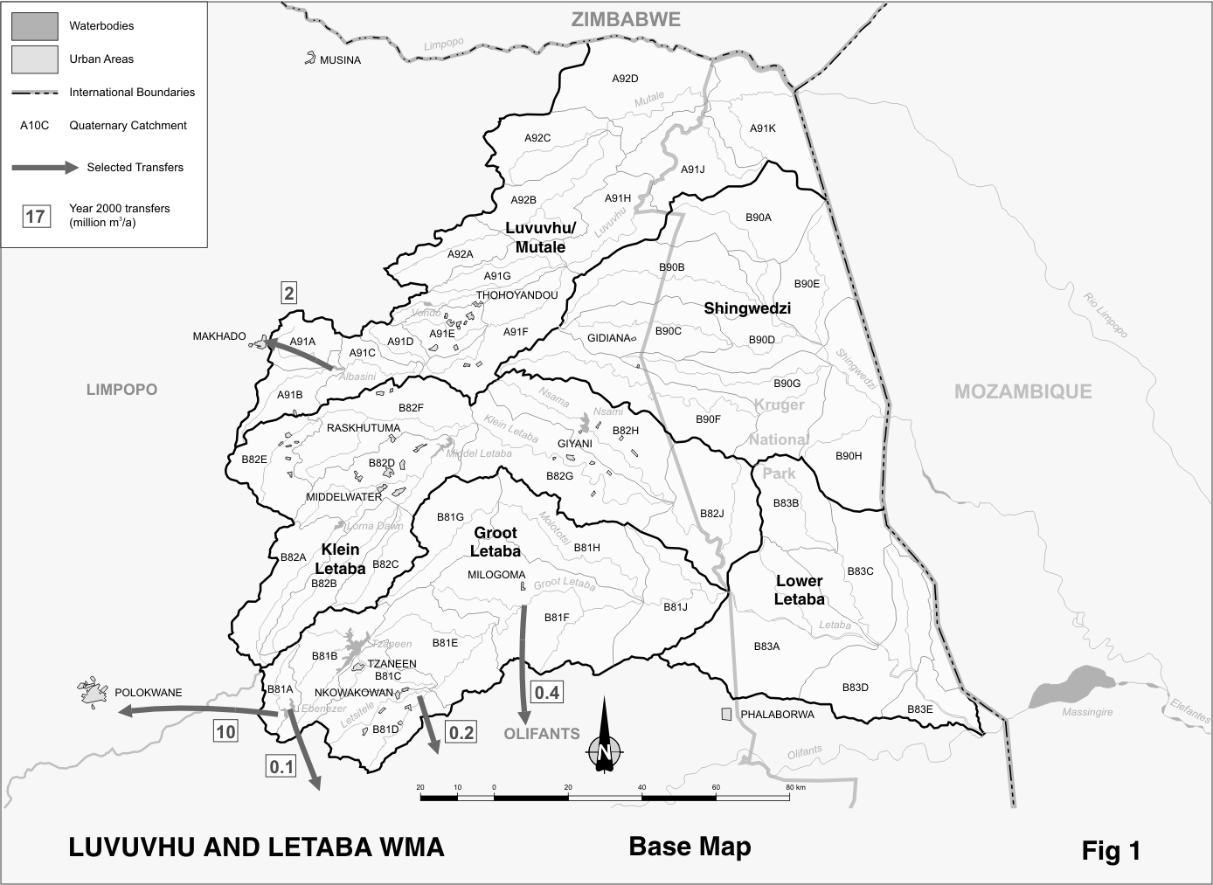
D2.2 Key statistics relevant to the Luvuvhu and Letaba water management area
Tables D2.1 to 2.6 contain a breakdown of the information given in Tables 2.1 to 2.6 of Chapter 2 for each sub-area of the Luvuvhu and Letaba water management area. The data is primarily derived from the standardised database and different information may be available from other sources.

Table D2.1: Natural mean annual runoff (MAR) and ecological Reserve (million m³/a)
Component/  Sub-area | Natural  MAR¹ | Ecological Reserve^{1,2}
Luvuvhu/Mutale | 520 | 105
Shingwedzi | 90 | 14
Groot Letaba | 382 | 72
Klein Letaba | 151 | 20
Lower Letaba | 42 | 13
Total for WMA | 1 185 | 224
- Quantities are incremental and refer to the sub-area under consideration only.
- The total volume is based on preliminary estimates, with the impact on yield being a portion of this.

Table D2.2: Available yield in the year 2000 (million m³/a)
Component/  Sub-area |  | Natural resource |  |  |  | Usable return flow |  |  |  | Total local yield
Component/  Sub-area | Surface water¹ |  | Ground-water |  | Irrigation |  | Urban | Mining and bulk |  | Total local yield
Luvuvhu/Mutale | 88 |  | 20 |  | 5 |  | 2 | 0 |  | 115
Shingwedzi | 1 |  | 2 |  | 0 |  | 0 | 0 |  | 3
Groot Letaba | 133 |  | 12 |  | 13 |  | 1 | 0 |  | 159
Klein Letaba | 21 |  | 9 |  | 1 |  | 1 | 0 |  | 32
Lower Letaba | 1 |  | 0 |  | 0 |  | 0 | 0 |  | 1
Total for WMA | 244 |  | 43 |  | 19 |  | 4 | 0 |  | 310
- After allowance for the impacts on yield of the ecological component of the Reserve, river losses, alien vegetation, rain-fed sugar cane and urban runoff.

Table D2.3: Water requirements for the year 2000 (million m³/a)
Sector/  Sub-area | Irrigation | Urban¹ | Rural¹ | Mining  and bulk industrial² | Power generation³ | Affores-tation⁴ | Total local requirements
Luvuvhu/Mutale | 97 | 4 | 10 | 1 | 0 | 7 | 119
Shingwedzi | 0 | 0 | 3 | 0 | 0 | 0 | 3
Groot Letaba | 126 | 3 | 10 | 0 | 0 | 35 | 174
Klein Letaba | 25 | 3 | 8 | 0 | 0 | 1 | 37
Lower Letaba | 0 | 0 | 0 | 0 | 0 | 0 | 0
Total for WMA | 248 | 10 | 31 | 1 | 0 | 43 | 333
- Includes component of Reserve for basic human needs at 25 ℓ/c/d.
- Mining and bulk industrial water uses that are not part of urban systems.
- Includes water for thermal power generation only. (Water for hydropower, which represents a small portion of power generation in South Africa, is generally available for other uses as well.)
- Quantities refer to the impact on yield only.

Table D2.4: Reconciliation of water requirements and availability for the year 2000 (million m³/a)
Component/  Sub-area | Local  yield | Transfers  In² | Local requirements | Transfers out² | Balance¹
Luvuvhu/Mutale | 115 | 0 | 119 | 2 | ( 6)
Shingwedzi | 3 | 0 | 3 | 0 | 0
Groot Letaba | 159 | 0 | 174 | 11 | ( 26)
Klein Letaba | 32 | 0 | 37 | 0 | ( 5)
Lower Letaba | 1 | 0 | 0 | 0 | 1
Total for WMA | 310 | 0 | 333 | 13 | ( 36)
- Brackets around numbers indicate a negative balance. Surpluses are shown in the most upstream sub-area where they first become available.
- Transfers into and out of sub-areas may include transfers between sub-areas as well as transfers between WMAs. The addition of the transfers per sub-area therefore does not necessarily correspond to the total transfers into and out of the WMA. The same applies to Tables D2.5 and D2.6.

Table D2.5: Reconciliation of water requirements and availability for the year 2025 base scenario (million m³/a)
Component/  Sub-area | Local  yield¹ | Transfers  in | Local requirements ² | Transfers out | Balance  (3) | Potential for develop-  ment⁴
Luvuvhu/Mutale | 208 | 0 | 129 | 2 | 77 | 60
Shingwedzi | 3 | 0 | 3 | 0 | 0 | 0
Groot Letaba | 160 | 0 | 177 | 11 | ( 28) | 42
Klein Letaba | 32 | 0 | 39 | 0 | ( 7) | 0
Lower Letaba | 1 | 0 | 0 | 0 | 1 | 0
Total for WMA | 404 | 0 | 348 | 13 | 43 | 102
- Based on existing infrastructure and infrastructure under construction in the year 2000 (Nandoni Dam). Also includes return flows resulting from a growth in requirements.
- Based on growth in water requirements as a result of population growth and general economic development. Irrigation of an additional 1100 ha from the Nandoni Dam has been allowed for in the Luvuvhu/Mutale sub-area. .
- Brackets around numbers indicate a negative balance.
- Based on raising the Tzaneen Dam, construction of the Nwamitwa Dam and the possible construction of a dam on the Mutale River.

Table D2.6: Reconciliation of water requirements and availability for the year 2025 high scenario (million m³/a)
Component/  Sub-area | Local yield¹ | Transfers  in | Local requirements² | Transfers out | Balance³ | Potential for develop-  ment⁴
Luvuvhu/Mutale | 208 | 0 | 129 | 2 | 77 | 60
Shingwedzi | 3 | 0 | 3 | 0 | 0 | 0
Groot Letaba | 161 | 0 | 179 | 11 | ( 29) | 42
Klein Letaba | 33 | 0 | 39 | 0 | ( 6) | 0
Lower Letaba | 1 | 0 | 0 | 0 | 1 | 0
Total for WMA | 406 | 0 | 350 | 13 | 43 | 102
- Based on existing infrastructure and infrastructure under construction in the year 2000 (Nandoni Dam). Also includes return flows resulting from a growth in requirements.
- Based on a growth in water requirements as a result of population growth and general economic development. Irrigation of an additional 1100 ha from the Nandoni Dam has been allowed for in the Luvuvhu/Mutale sub-area.
- Brackets around numbers indicate a negative balance.
- Based on raising the Tzaneen Dam, construction of the Nwamitwa Dam and the possible construction of a dam on the Mutale River.

D2.3 Key elements of the broad strategic perspectives for the Luvuvhu and Letaba water management area
From Table D2.4 it is evident that there is no surplus yield available in the water management area and that an over-commitment of resources is shown to occur. This is mainly attributable to the provision made for the future implementation of the ecological component of the Reserve. The deficits in parts of the water management area will be relieved once the Nandoni Dam is commissioned. A surplus will then exist downstream of the dam, part of which is intended for use by emerging farmers. Of the mean annual runoff of 1 185 million m³/a originating in the water management area, an estimated 790 million m³/a on average still flows into Mozambique.

With due consideration for the options described in Section 2.5, the general perspective is that current shortfalls and the future growth in requirements will be supplied from water freed up as a result of water demand management and the re-allocation of irrigation water. Some further development of groundwater may be possible, but this should be preceded by appropriate investigations of the exploitable potential and be supported by improved management of the resource. Options also exist for the raising of Tzaneen Dam and construction of the proposed nWamitwa Dam. However, the construction of new dams will probably only be affordable for high-value uses, such as mining and related developments, and under certain conditions for irrigation. Water for poverty relief and rural development should be re-allocated from existing irrigation.

Implementation of the Reserve is of special importance with respect to the Kruger National Park and priority should be given to implementation planning. Provision for the Reserve should preferably be incorporated into the planning of possible future developments, thereby minimising the socio-economic impact.

The following reservations with respect to developments and water resources will apply to the Luvuvhu and Letaba water management area:
- Development of all new dams or large water resource projects will be subject to national authorisation because of possible impacts on Mozambique.
- Water reserved in the Luvuvhu and Letaba water management area for transfer to users in neighbouring water management areas:
- The existing transfer of 2.4 million m³/a from the Albasini Dam to Makhado in the Limpopo water management area.
- An additional 5 million m³/a to be reserved from either the Albasini or the Nandoni Dam for possible transfer to Makhado in the Limpopo water management area.
- A maximum of 18.5 million m³/a per year to be available from the Ebenezer and Dap Naude Dams for transfer to Polokwane in the Limpopo water management area. (Existing)
- Existing transfers of approximately 0.7 million m³/a from the Groot Letaba River to Gravelotte and other users in the Olifants water management area.

