D4 WATER MANAGEMENT AREA 4: OLIFANTS

D4.1 Introduction
The Olifants River originates to the east of Johannesburg and initially flows northwards before gently curving eastwards towards the Kruger National Park (KNP), where it is joined by the Letaba River before flowing into Mozambique. As shown on Fig. D4, the Olifants water management area corresponds with the South African portion of the Olifants River catchment, excluding the Letaba River catchment, which is a tributary catchment to the Limpopo Basin shared by South Africa, Botswana, Zimbabwe and Mozambique. Distinct differences in climate occur; from cool Highveld in the south to subtropical east of the escarpment. Mean annual rainfall is in the range of 500 mm to 800 mm over most of the WMA.

Economic activity is highly diverse and ranges from mining and metallurgic industries to irrigation, dry land and subsistence agriculture, and eco-tourism. With one of the main rivers, the Olifants, flowing through the KNP, which is located at the downstream extremity of the water management area, the provision of water to meet ecological requirements is one of the controlling factors in the management of water resources throughout the water management area.

Most surface runoff originates from the higher rainfall southern and mountainous areas and is controlled by several large dams. The most promising options identified for the further development of surface water resources are the raising of Flag Boshielo Dam, the construction of a new dam at Rooipoort on the middle Olifants River and a dam on the Steelpoort River.

Large quantities of groundwater are abstracted for irrigation in the north-west of the water management area, as well as for rural water supplies throughout most of the area. Potential for increased groundwater utilisation has been identified on the Nebo Plateau north-east of Groblersdal. Substantial amounts of water are transferred into the water management area as cooling water for power generation, while smaller transfers are made to neighbouring water management areas.

Fig D4: Base map of the Olifants water management area
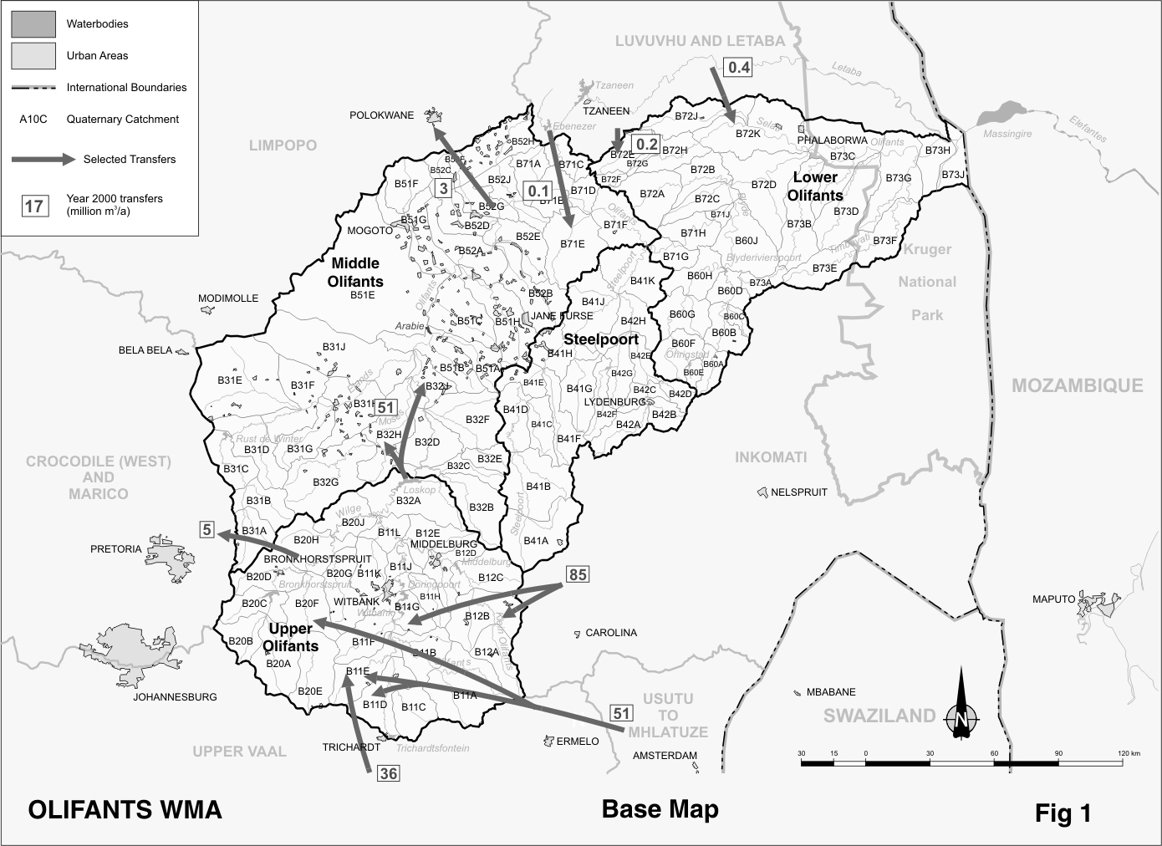
The scenarios for population growth show little if any increase in the rural areas beyond 2025. Economic growth and population increases are expected to be centred on the main industrial and mining towns of Witbank, Middelburg and Phalaborwa, as well as at new mining developments foreseen along the eastern limb of the Bushveld Igneous Complex in the Mogoto/Steelpoort area. Water requirements for power generation in the upper Olifants sub-area are also expected to increase. Water for mining developments in the Mokopane area (Limpopo water management area) may have to be supplied from the Olifants River.

D4.2 Key statistics relevant to the Olifants water management area
Tables D4.1 to D4.6 contain a breakdown of the information given in Tables 2.1 to 2.6 of Chapter 2 for each sub-area of the Olifants water management area. Data is primarily derived from the standardised data base. Different information may be available from other sources.

Table D4.1: Natural mean annual runoff (MAR) and ecological Reserve (million m³/a)
Component/  Sub-area | Natural MAR | Ecological Reserve¹
Upper Olifants | 465 | 83
Middle Olifants | 481 | 69
Steelpoort | 396 | 94
Lower Olifants | 698 | 214
Total for WMA | 2 040 | 460
- Quantities are incremental and refer to the sub-area under consideration only.
- The total volume is based on preliminary estimates, with impact on yield being a portion of this.

Table D4.2: Available yield in the year 2000 (million m³/a)
Component/  Sub-area |  | Natural resource |  |  |  | Usable return flow |  |  |  | Total local yield
Component/  Sub-area | Surface water¹ |  | Ground-water |  | Irrigation |  | Urban | Mining and bulk |  | Total local yield
Upper Olifants | 194 |  | 4 |  | 2 |  | 34 | 4 |  | 238
Middle Olifants | 100 |  | 70 |  | 34 |  | 5 | 1 |  | 210
Steelpoort | 42 |  | 14 |  | 3 |  | 1 | 1 |  | 61
Lower Olifants | 74 |  | 11 |  | 5 |  | 2 | 8 |  | 100
Total for WMA | 410 |  | 99 |  | 44 |  | 42 | 14 |  | 609
- After allowance for the impacts on yield of the ecological component of the Reserve, river losses, alien vegetation, rain-fed sugar cane and urban runoff.

Table D4.3: Water requirements for the year 2000 (million m³/a)
Sector/  Sub-area | Irrigation | Urban¹ | Rural¹ | Mining  and bulk industrial² | Power generation³ | Affores-  tation⁴ | Total local require-  ments
Upper Olifants | 44 | 62 | 6 | 20 | 181 | 1 | 314
Middle Olifants | 336 | 15 | 28 | 13 | 0 | 0 | 392
Steelpoort | 69 | 3 | 5 | 17 | 0 | 1 | 95
Lower Olifants | 108 | 7 | 5 | 43 | 0 | 1 | 164
Total for WMA | 557 | 87 | 44 | 93 | 181 | 3 | 965
- Includes component of Reserve for basic human needs at 25 ℓ/c/d.
- Mining and bulk industrial water uses that are not part of urban systems.
- Includes water for thermal power generation only. (Water for hydropower is generally available for other uses as well.)
- Quantities refer to the impact on yield only.

Table D4.4: Reconciliation of water requirements and availability for the year 2000 (million m³/a)
Component/  Sub-area | Local  yield | Transfers  in² | Local requirements | Transfers out² | Balance¹
Upper Olifants | 238 | 171 | 314 | 96 | ( 1)
Middle Olifants | 210 | 91 | 392 | 3 | ( 94)
Steelpoort | 61 | 0 | 95 | 0 | ( 34)
Lower Olifants | 100 | 1 | 164 | 0 | ( 63)
Total for WMA | 609 | 172 | 965 | 8 | ( 192)
- Brackets around numbers indicate a negative balance. Surpluses are shown in the most upstream sub-area where they first become available.
- Transfers into and out of sub-areas may include transfers between sub-areas as well as transfers between WMAs. The addition of the quantities transferred per sub-area therefore does not necessarily correspond to the total transfers into and out of the WMA. The same applies to Tables D4.5 and D4.6.

Table D4.5: Reconciliation of water requirements and availability for the year 2025 base scenario (million m³/a)
Component/  Sub-area | Local  yield¹ | Transfers  in | Local requirements² | Transfers out | Balance³ | Potential for develop-  ment⁴
Upper Olifants | 256 | 209 | 383 | 82 | 0 | 0
Middle Olifants | 212 | 77 | 430 | 2 | ( 143) | 152
Steelpoort | 62 | 0 | 96 | 0 | ( 34) | 87
Lower Olifants | 100 | 1 | 165 | 0 | ( 64) | 0
Total for WMA | 630 | 210 | 1 074 | 7 | ( 241) | 239
- Based on existing infrastructure and infrastructure under construction in the year 2000. Also includes return flows resulting from a growth in requirements.
- Based on a growth in water requirements as a result of population growth and general economic development, including an additional 25 million m³/a required for mining in the Middle Olifants sub-area. Assumes no general increase in irrigation.
- Brackets around numbers indicate a negative balance.
- Based on the raising of the Flag Boshielo Dam and construction of the Rooipoort and De Hoop Dams.
Table D4.6: Reconciliation of water requirements and availability for the year 2025 high scenario (million m³/a)
Component/  Sub-area | Local  yield¹ | Transfers  in | Local requirements² | Transfers out⁵ | Balance³ | Potential for develop-  ment⁴
Upper Olifants | 287 | 209 | 439 | 57 | 0 | 0
Middle Olifants | 213 | 52 | 433 | 8 | ( 176) | 152
Steelpoort | 63 | 0 | 98 | 0 | ( 35) | 87
Lower Olifants | 102 | 1 | 171 | 0 | ( 68) | 0
Total for WMA | 665 | 210 | 1 141 | 13 | ( 279) | 239
- Based on existing infrastructure and infrastructure under construction in the year 2000. Also includes return flows resulting from a growth in requirements.
- Based on growth in water requirements as a result of population growth and general economic development, including an additional 25 million m³/a required for mining in the Middle Olifants sub-area. Assumes no general increase in irrigation.
- Brackets around numbers indicate a negative balance.
- Based on the raising of the Flag Boshielo Dam and construction of Rooipoort and De Hoop Dams.
- Not including possible future transfers to the Limpopo WMA for Polokwane and Mokopane as described below.

D4.3 Key elements of the broad strategic perspectives for the Olifants water management area
From the reconciliation in Table D4.4, deficits are apparent along the whole of the Olifants River, except for the upstream reaches. This is attributable to the provision for the ecological component of the Reserve, without which the system could generally be regarded as being in balance. Savings of approximately 20 per cent will be required to meet current shortfalls and provide for the ecological component of the Reserve. To meet these requirements, water will therefore need to be freed up by means of compulsory licensing and supporting measures such as water demand management. Judicious assessment of the Reserve together with careful implementation planning to minimise possible social disruption will be required. Of the total mean annual runoff of 2 040 million m³/a, an estimated average of 1 137 million m³/a still flows into Mozambique.

Water quality is highly impacted upon by coal mining in the Upper Olifants sub-area. Special remedial measures have been implemented to control the discharge of mine leachate and wash-off to within the assimilative capacity of the natural streams. Priority attention will continue to be needed to contain pollution from mines, also after the discontinuation of operations.

Further resource development through the construction of new infrastructure will be very expensive and is unlikely to be affordable by irrigation farming. Water for irrigation as a means of rural development and poverty relief will therefore have to be sourced largely through re-allocation from existing users. With water resources in the Upper Olifants already fully developed and utilised, a growth in power generation requirements will have to be provided for by increased transfers of water.

Water for new mining development in the Middle Olifants and Steelpoort sub-areas (reflected in the tables under the Middle Olifants) can be provided by raising the Flag Boshielo Dam, the construction of a dam on the Steelpoort River, or from the proposed Rooipoort Dam.

With due consideration of the options available for reconciling the requirements for and the availability of water, as described in Section 2.5, the following reservations will apply with respect to the Olifants water management area:
- Water from the Rooipoort Dam to be developed in the main stem of the Olifants River is to be reserved in the Olifants water management area primarily for supplying future mining developments within the water management area and for possible transfers to Polokwane and Mokopane in the Limpopo water management area. Water resource developments elsewhere in the catchment that could have a significant negative impact on this will not be permitted.
- Similar reservation will apply with regard to a large dam to be constructed on the Steelpoort River, possibly at De Hoop, in the Olifants water management area.
- Currently, 172 million m³/a of water is transferred from the Inkomati, Usutu to Mhlatuze and Upper Vaal water management areas to the Olifants water management area for strategic use in power generation. A further 38 million m³/a is to be reserved in the Upper Vaal water management area for this purpose. The Upper Vaal water management area will in turn source this water from other water management areas. Details of the reservations are given in the descriptions of the relevant source water management areas.
- The transfer of water from the Olifantspoort Weir to Polokwane in the Limpopo water management area at the maximum pipeline capacity of 5.0 million m³/a.– reserved in the Olifants water management area.
- The existing water transfer from the Wilge tributary of the Olifants River to Cullinan and Premier Diamond Mine in the Crocodile (West) and Marico water management area – reserved in the Olifants water management area.
- The existing water transfer from the Letaba River in the Luvuvhu and Letaba water management area to users in the Olifants water management area – reserved in the Luvuvhu and Letaba water management area.
- All water resource developments that could have a possible impact on Mozambique will be subject to national authorisation – reservation applicable to Olifants water management area.

