D5 WATER MANAGEMENT AREA 5: INKOMATI

D5.1 Introduction
The Inkomati water management area is situated in the north-eastern part of South Africa and borders on Mozambique and Swaziland. As shown on Fig. D5, all the rivers from this area flow through Mozambique to the Indian Ocean. The Komati River flows into Swaziland and re-enters South Africa before flowing into Mozambique. Topographically the water management area is divided by the escarpment into a plateau in the west and a subtropical Lowveld in the east. Annual rainfall varies from close to 1 500 mm in the mountains to 400 mm in the lower-lying areas.

Economic activity is mainly centred on irrigation and afforestation, with related industries and commerce, and a strong eco-tourism industry. A key feature of the water management area is the renowned Kruger National Park. The Sabie River, which flows through the park, is ecologically one of the most important rivers in South Africa, while the Crocodile River forms the park’s southern boundary.

Dams have been constructed on all the main rivers or their tributaries, and surface water resources in the water management area are generally well regulated. An important feature is the joint management by South Africa and Swaziland of part of the water resources of the Komati River by the Komati Basin Water Authority (KOBWA). Potential for further water resource development exists in the Kaap tributary of the Crocodile River, the Komati River and the Sand tributary of the Sabie River, although such development will probably only be feasible for domestic and high value uses. Because of the well-watered nature of most of the area, groundwater utilisation is relatively small. Most of the present yield from the Komati River west of Swaziland is transferred to the Olifants water management area for power generation.

Future population growth in the area is expected to be moderate and to be concentrated in the urbanised areas. In some rural areas the population could decline. With about 90 per cent of total water requirements within the water management area being utilised by the irrigation and forestry sectors, only a small natural growth in overall water requirements is foreseen.

Fig. D5: Base map of the Inkomati water management area
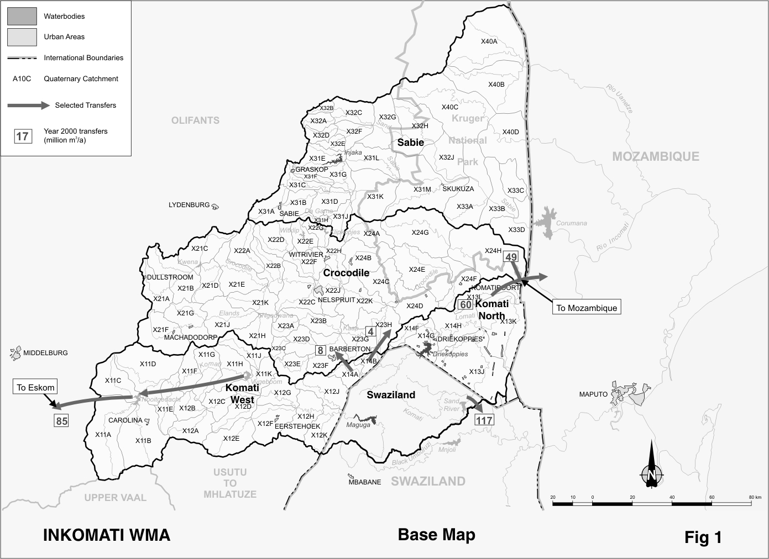
D5.2 Key statistics relevant to the Inkomati water management area
Tables D5.1 to D5.6 contain a breakdown of the information given in Tables 2.1 to 2.6 of Chapter 2 for each sub-area of the Inkomati water management area. Although the water management area is restricted to South Africa, information is included for Swaziland to provide a more comprehensive perspective. The data is derived primarily from the standardised data base. Different information may be available from other sources.

Table D5.1: Natural mean annual runoff and ecological Reserve (million m³/a)
Component/  Sub-area | Natural MAR¹ | Ecological Reserve^{1, 2}
Komati (W Swazi) | 749 | 239
Swaziland³ | 517 | 100
Komati (N Swazi) | 130 | 25
Crocodile | 1 277 | 328
Sabie⁴ | 866 | 316
Total for WMA | 3 539 | 1 008
- Quantities are incremental and refer to the sub-area under consideration only.
- The total volume is based on preliminary estimates, impact on yield being a portion of this.
- Includes the Komati and Lomati catchments in Swaziland.
- Includes the Uanetse and Mássintonto catchments in South Africa.

Table D5.2: Available yield in the year 2000 (million m³/a)
Component/  Sub-area |  | Natural resource |  |  |  | Usable return flow |  |  |  | Total local yield
Component/  Sub-area | Surface water¹ |  | Ground-water |  | Irrigation |  | Urban | Mining and bulk |  | Total local yield
Komati (W Swazi) | 116 |  | 1 |  | 0 |  | 1 | 0 |  | 118
Swaziland | 183 |  | 1 |  | 1 |  | 0 | 0 |  | 185
Komati (N Swazi) | 228 |  | 2 |  | 21 |  | 0 | 1 |  | 252
Crocodile | 202 |  | 2 |  | 26 |  | 6 | 10 |  | 246
Sabie | 87 |  | 3 |  | 5 |  | 0 | 0 |  | 95
Total for WMA | 816 |  | 9 |  | 53 |  | 7 | 11 |  | 896
- After allowance for the impacts on yield of the ecological component of Reserve, river losses, alien vegetation, rain-fed sugar cane and urban runoff. Includes Driekoppies Dam, but not the soon-to-be completed Maguga Dam.

Table D5.3: Water requirements for the year 2000 (million m³/a)
Sector/  Sub-area | Irrigation | Urban¹ | Rural¹ | Mining  and bulk industrial² | Power generation³ | Affores-tation⁴ | Total local require-ments
Komati (W Swazi) | 21 | 2 | 4 | 0 | 0 | 38 | 65
Swaziland | 35 | 1 | 6 | 0 | 0 | 25 | 67
Komati (N Swazi) | 215 | 3 | 6 | 1 | 0 | 7 | 232
Crocodile | 257 | 35 | 7 | 23 | 0 | 42 | 364
Sabie | 65 | 22 | 4 | 0 | 0 | 26 | 117
Total for WMA | 593 | 63 | 27 | 24 | 0 | 138 | 845
- Includes component of Reserve for basic human needs at 25 ℓ/c/d.
- Mining and bulk industrial water uses that are not part of urban systems.
- Includes water for thermal power generation only. (Water for hydropower, which represents a small portion of power generation in South Africa, is generally available for other uses as well.)
- Quantities only refer to the impact on yield.

Table D5.4: Reconciliation of water requirements and availability for the year 2000 (million m³/a)
Component/  Sub-area | Local  yield | Transfers  In² | Local requirements | Transfers out² | Balance¹
Komati (W Swazi) | 118 | 0 | 65 | 97 | ( 44)
Swaziland | 185 | 0 | 67 | 117 | 1
Komati (N Swazi) | 252 | 0 | 232 | 60 | ( 40)
Crocodile | 246 | 12 | 364 | 49 | ( 155)
Sabie | 95 | 0 | 117 | 0 | ( 22)
Total for WMA | 896 | 0 | 845 | 311 | ( 260)
- Brackets around numbers indicate a negative balance.
- Transfers into and out of sub-areas may include transfers between sub-areas as well as transfers between WMAs. The addition of the quantities transferred per sub-area therefore does not necessarily correspond to the total transfers into and out of the WMA. The same applies to Tables D5.5 and D5.6.

Table D5.5: Reconciliation of water requirements and availability for the year 2025 base scenario (million m³/a)
Component/  Sub-area | Local yield¹ | Transfers in | Local requirements² | Transfers out | Balance³ | Potential for development⁴
Komati (W Swazi) | 118 | 0 | 64 | 97 | ( 43) | 40
Swaziland | 250 | 0 | 95 | 156 | ( 1) | 0
Komati (N Swazi) | 252 | 39 | 233 | 60 | ( 2) | 0
Crocodile | 249 | 12 | 381 | 49 | ( 169) | 64
Sabie | 159 | 0 | 141 | 0 | 18 | 0
Total for WMA | 1 028 | 0 | 914 | 311 | ( 197) | 104
- Based on existing infrastructure and infrastructure under construction in the year 2000, including the Maguga and Inyaka Dams. Also includes return flows resulting from a growth in requirements.
- Based on growth in water requirements as a result of population growth and general economic development. Assumes no general increase in irrigation.
- Brackets around numbers indicate a negative balance.
- Based on the construction of Boekenhoutrand and Mountain View Dams.

Table D5.6: Reconciliation of water requirements and availability for the year 2025 high scenario (million m³/a)
Component/  Sub-area | Local yield¹ | Transfers in | Local requirements² | Transfers out | Balance³ | Potential for development⁴
Komati (W Swazi) | 119 | 0 | 67 | 97 | ( 45) | 40
Swaziland | 250 | 0 | 95 | 156 | ( 1) | 0
Komati (N Swazi) | 252 | 39 | 233 | 60 | ( 2) | 0
Crocodile | 256 | 12 | 423 | 49 | ( 204) | 64
Sabie | 159 | 0 | 139 | 0 | 20 | 0
Total for WMA | 1 036 | 0 | 957 | 311 | ( 232) | 104
- Based on existing infrastructure and infrastructure under construction in the year 2000, including the Maguga and Inyaka Dams. Also includes return flows resulting from a growth in requirements.
- Based on a high growth in water requirements as a result of population growth and the high impact of economic development. Assumes no general increase in irrigation.
- Brackets around numbers indicate a negative balance.
- Based on the construction of Boekenhoutrand and Mountain View Dams.

D5.3 Key elements of the broad strategic perspectives for the Inkomati water
management area
Of primary importance for the Inkomati water management area is the implementation of the Reserve and the release of minimum flows to Mozambique. Of the total mean annual runoff of 3 539 million m³/a that originates in the water management area and the Swaziland portion of the Komati River catchment, an estimated 1 857 million m³/a on average currently flows into Mozambique.

According to an agreement between South Africa, Swaziland and Mozambique, the first two are obliged to release a minimum flow of 109 million m³/a to Mozambique at Komatipoort (55 per cent from the Komati River and 45 per cent from the Crocodile River). Water requirements in South Africa have, however, grown to the extent that the total available yield from these rivers could be absorbed by local requirements. The deficits reflected in Table D5.4 are therefore about equal to the requirements of the ecological component of the Reserve and the obligations to Mozambique. No quantitative agreements exist for the other rivers shared with Mozambique.
The bulk of water use in the water management area is for irrigation and afforestation, and the expectation is that new resource development is likely to be too costly for the expansion of these uses. It is evident that, with due consideration of the available options for reconciling the requirements for and availability of water as described under Section 2.5, compulsory licensing will have to be applied to reapportion water use in the water management area. This is to be preceded by the detailed determination and careful assessment of the requirements for the ecological component of the Reserve.

The following reservations and national authorisations apply to the Komati water management area:
- The transfer of water to the Olifants water management area for power generation at the current capacity of approximately 100 million m³/a. The treaty between South Africa and Swaziland accommodates a transfer of 132 million m³/a out of the catchment, which must be reserved in the Komati water management area.
- Water supplied to South Africa by the Komati Basin Water Authority, which includes releases for environmental purposes – reserved by international agreement for use in the Komati water management area.
- Water to be released to Mozambique to honour international commitments. This currently amounts to 109 million m³/a – reserved in the Komati water management area.
- All water resource developments that may impact on neighbouring countries will be subject to national authorisation – reservation applies to the Komati water management area.

