D6 WATER MANAGEMENT AREA 6: USUTU TO MHLATUZE

D6.1 Introduction
The Usutu to Mhlatuze water management area falls predominantly within northern KwaZulu-Natal with a part in Mpumalanga, and bordering on Swaziland and Mozambique (refer to Fig. D6). Two rivers are shared with these countries. The Usutu River has its headwaters in South Africa and flows into Swaziland, while part of the Pongola River catchment lies in Swaziland. The two rivers flow together in South Africa just before entering Mozambique as the Maputo River. Climate in the region can be described as subhumid to humid, but varies considerably. Mean annual rainfall ranges between 600 mm and 1 500 mm. Economic activity is diverse and includes rain fed and subsistence farming, irrigation, afforestation, eco-tourism, and heavy industries in the Richards Bay/Empangeni area. Water resources in the Upper Usutu, Mkuze and Mhlatuze catchments have been well developed, while undeveloped potential exists in the Pongola and Mfolozi catchments. Ground water utilisation in most parts of the water management area is relatively small, and can thus be developed further.

Fig D6: Base map of the Usutu to Mhlatuze water management area
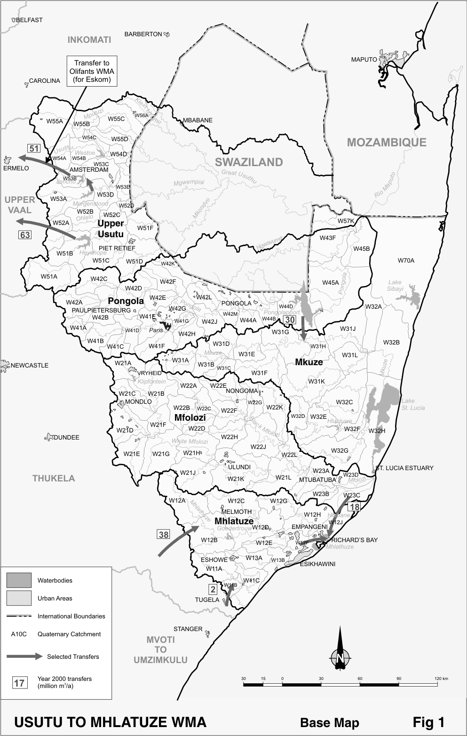

Strong interdependencies between surface and groundwater occur in many areas, with groundwater levels, together with surface flows, being particularly important to water balances in the ecologically sensitive coastal lakes and wetlands, some of which are internationally recognised conservation areas. Large quantities of water are transferred from the Upper Usutu to the Upper Vaal and Upper Olifants water management areas, and transfers are also made from the Thukela water management area to the Mhlatuze sub-area.

The expectations are that little change will occur in the overall population in the water management area within the period under consideration. A decline in rural population will likely be balanced by a growth in urbanisation in the Richards Bay/Empangeni area. Growth in water requirements will be dictated by the level of industrial activity in the Richards Bay area, which is difficult to estimate.

D6.2 Key statistics relevant to the Usutu to Mhlatuze water management area
Tables D6.1 to D6.6 contain a breakdown of the information given in Tables 2.1 to 2.6 of Chapter 2 for each sub-area of the Usutu to Mhlatuze water management area.

In contrast to the situation for the Komati River, little information is available concerning the portions of the Usutu and Pongola Rivers within Swaziland. No statistics in respect of Swaziland other than the mean annual runoff are therefore provided in the tables. The data is derived primarily from the standardised data base and different information may be available from other sources.

Table D6.1: Natural mean annual runoff (MAR) and ecological Reserve (million m³/a)
Component/  Sub-area | Natural MAR¹ | Ecological Reserve^{1, 2}
Upper Usutu³ | 901 | 328
Pongola⁴ | 1 344 | 200
Mkuze | 635 | 218
Mfolozi | 962 | 275
Mhlatuze | 938 | 171
Total for WMA | 4 780 | 1 192
- Quantities are incremental and refer to the sub-area under consideration only.
- The total volume is based on preliminary estimates, with impact on yield being a portion of this.
- Excludes the Usutu River in Swaziland (MAR = 1 320 million m³/a).
- Includes the Pongola and Ngwavuma Rivers in Swaziland (MAR = 213 million m³/a).

Table D6.2: Available yield in the year 2000 (million m³/a)
Component/  Sub-area |  | Natural resource |  |  |  | Usable return flow |  |  |  | Total local yield
Component/  Sub-area | Surface water¹ |  | Ground-water |  | Irrigation |  | Urban | Mining and bulk |  | Total local yield
Upper Usutu | 196 |  | 2 |  | 1 |  | 3 | 0 |  | 202
Pongola | 616 |  | 8 |  | 21 |  | 0 | 0 |  | 645
Mkuze | 15 |  | 12 |  | 6 |  | 0 | 0 |  | 33
Mfolozi | 36 |  | 5 |  | 5 |  | 4 | 1 |  | 51
Mhlatuze | 156 |  | 12 |  | 9 |  | 2 | 0 |  | 179
Total for WMA | 1 019 |  | 39 |  | 42 |  | 9 | 1 |  | 1 110
- After allowance for the impacts on yield of the ecological component of the Reserve, river losses, alien vegetation, rain-fed sugar cane and urban runoff.

Table D6.3: Water requirements for the year 2000 (million m³/a)
Sector/  Sub-area | Irrigation | Urban¹ | Rural¹ | Mining  and bulk industrial² | Power generation³ | Affore-station⁴ | Total local require-ments
Upper Usutu | 13 | 8 | 5 | 0 | 0 | 43 | 69
Pongola | 213 | 1 | 6 | 1 | 0 | 34 | 255
Mkuze | 61 | 1 | 10 | 0 | 0 | 6 | 78
Mfolozi | 51 | 12 | 11 | 4 | 0 | 2 | 80
Mhlatuze | 94 | 28 | 8 | 86 | 0 | 19 | 235
Total for WMA | 432 | 50 | 40 | 91 | 0 | 104 | 717
- Includes component of Reserve for basic human needs at 25 ℓ/c/d.
- Mining and bulk industrial water uses that are not part of urban systems.
- Includes water for thermal power generation only. (Water for hydropower, which represents a small portion of power generation in South Africa, is generally available for other uses as well.)
- Quantities refer to the impact on yield only.

Table D6.4: Reconciliation of water requirements and availability for the year 2000 (million m³/a)
Component/  Sub-area | Local  yield | Transfers  in² | Local requirements | Transfers out² | Balance¹
Upper Usutu | 202 | 0 | 69 | 114 | 19
Pongola | 645 | 0 | 255 | 30 | 360
Mkuze | 33 | 30 | 78 | 0 | ( 15)
Mfolozi | 51 | 0 | 80 | 18 | ( 47)
Mhlatuze | 179 | 58 | 235 | 0 | 2
Total for WMA | 1 110 | 40 | 717 | 114 | 319
- Brackets around numbers indicate a negative balance. Surpluses are shown in the most upstream sub-area where they first become available.
- Transfers into and out of sub-areas may include transfers between sub-areas as well as transfers between WMAs. The addition of the quantities transferred per sub-area therefore does not necessarily correspond to the total transfers into and out of the WMA. The same applies to Tables D6.5 and D6.6.

Table D6.5: Reconciliation of water requirements and availability for the year 2025 base scenario
(million m³/a)
Component/  Sub-area | Local  yield¹ | Transfers  in | Local requirements² | Transfers out | Balance³ | Potential for develop-  ment⁴
Upper Usutu | 203 | 0 | 74 | 114 | 15 | 0
Pongola | 646 | 0 | 257 | 30 | 359 | 95
Mkuze | 33 | 30 | 77 | 0 | ( 14) | 0
Mfolozi | 51 | 0 | 79 | 18 | ( 46) | 15
Mhlatuze | 180 | 58 | 241 | 0 | ( 3) | 0
Total for WMA | 1 113 | 40 | 728 | 114 | 311 | 110
- Based on existing infrastructure and infrastructure under construction in the year 2000. Also includes return flows resulting from a growth in requirements.
- Based on a growth in water requirements as a result of population growth and general economic development. Assumes no general increase in irrigation requirements.
- Brackets around numbers indicate a negative balance.
- Based on the construction of Embiane and Vaderland Dams. Additional potential may also be developed in the Upper Usutu catchment.

Table D6.6: Reconciliation of water requirements and availability for the year 2025 high scenario
(million m³/a)
Component/  Sub-area | Local yield¹ | Transfers in | Local requirements² | Transfers out | Balance³ | Potential for develop-  ment⁴
Upper Usutu | 205 | 0 | 79 | 114 | 12 | 0
Pongola | 646 | 0 | 257 | 30 | 359 | 95
Mkuze | 34 | 30 | 78 | 0 | ( 14) | 0
Mfolozi | 54 | 0 | 86 | 18 | ( 50) | 15
Mhlatuze | 185 | 58 | 312 | 0 | ( 69) | 0
Total for WMA | 1 124 | 40 | 812 | 114 | 238 | 110
- Based on existing infrastructure and infrastructure under construction in the year 2000. Also includes return flows resulting from a growth in requirements.
- Based on a high growth in water requirements as a result of population growth and a high impact of economic development. Assumes no general increase in irrigation requirements.
- Brackets around numbers indicate a negative balance.
- Based on the construction of Embiane and Vaderland Dams. Additional potential may also be developed in the Upper Usutu catchment.

D6.3 Key elements of the broad strategic perspectives for the Usutu to Mhlatuze water management area
Substantial surplus yield is available from the Pongolapoort Dam and there is potential for further water resource development in the upper reaches of the Pongola River. Suitable land is available downstream of the Pongolapoort Dam and the development of irrigation farming could make a substantial contribution to rural development and poverty eradication. However, concerns exist about the possible environmental impacts of such a venture. Undeveloped potential in the upper reaches of the Pongola River could also be used to augment shortfalls in the Vaal River System. It is prudent to ensure that future opportunities in this respect are not forfeited by more immediate, but less beneficial developments.

Although a surplus is shown in Table D6.4 in respect of the Upper Usutu catchment as a whole, a deficit will actually be experienced at the dams after implementation of the Reserve whilst a surplus will still exist downstream of the dams. As most of the yield from the Usutu dams is transferred to other water management areas, mainly for the strategic use of power generation, implementation of the Reserve could have significant impacts that may cascade down to other water management areas. Comprehensive implementation planning with respect to the Reserve will therefore be required.

The deficit reflected for the Mfolozi catchment is partly attributable to irrigation water requirements in excess of the yield, and partly due to the provision for the ecological component of the Reserve. The deficit shown in the Mkuze catchment is as a result of the provision for implementation of the Reserve, prior to which a surplus exists.

Of the mean annual runoff of 901 million m³/a originating from the upper Usutu River catchment, an estimated 592 million m³/a on average still flows into Swaziland. Of the mean annual runoff of 1 344 million m³/a arising in the Pongola River catchment, including that derived from the Swaziland catchment, it is estimated that 968 million m³/a on average currently flows into Mozambique.

A complex situation exists in the Mhlatuze catchment where current water use allowances for irrigation are well in excess of the actual quantity used. In the meantime water is transferred into the catchment from the Thukela water management area for urban and industrial use. Although the requirements for and availability of water in the sub-area as a whole are approximately in balance, some localised imbalances exist. Where necessary the situation will have to be rationalised by means of compulsory licensing, and transfer of water in the future will have to be optimised. Due consideration will also have to be given to the other options described in Section 2.5 for reconciling requirements and availability.

The following reservations will apply with respect to the Usutu to Mhlatuze water management area:
- Existing transfers from the Upper Usutu catchment to the Upper Vaal and Olifants water management areas up to the installed capacity of 114 million m³/a – reserved in the Usutu to Mhlatuze water management area.
- Current transfers from the Thukela River into the Mhlatuze sub-area of 40 million m³/a may be increased to a maximum of 94 million m³/a – reserved in the Thukela water management area.
Provisional planning has been completed for increasing water transfers from the Thukela to the Mhlatuze sub-area to about 252 million m³/a, which would be dependent on the construction of additional storage in the Thukela River. No reservation is required at this stage.
- The construction of new dams in the Pongola River catchment, as well as developments in the Upper Usutu catchment, which may negatively impact on possible further transfers of water to the Upper Vaal water management area and beyond, will be subject to approval at national level – reservations applicable to the Usutu to Mhlathuze water management area.
- Water resource developments that may impact on neighbouring countries will be subject to national authorisation – reservation applies to Usutu to Mhlathuze water management area.

