D7 WATER MANAGEMENT AREA 7: THUKELA

D7.1 Introduction
The Thukela water management area corresponds fully to the catchment area of the Thukela River and lies predominantly in the KwaZulu-Natal province. It is a funnel-shaped catchment, with several tributaries draining from the Drakensberg escarpment towards the Indian Ocean, as shown on the base map in Fig. D7. Parts of the Thukela water management area enjoy a high ecological status. It is characterised by mountain streams in the upper reaches, where several parks and conservation areas are located, as well as a number of important wetlands and vleis. Rainfall is highest near the mountains and along the coast, and the mean annual precipitation is in the range from 600 mm to 1 500 mm.

The Thukela water management area is predominantly rural in character with forestry, agriculture and eco-tourism as primary activities. Newcastle is the major industrial centre and the only other significant industrial activity at present is a large paper mill near Mandini.

Because of the high mean annual runoff and favourable topography, the Thukela basin offers some of the best opportunities for water resources development in South Africa. Although several large dams have already been constructed in the upper reaches of the Thukela River and on the main tributaries, substantial undeveloped resource potential remains. One of the largest inter-catchment transfer schemes in the country conveys water from the Upper Thukela River to the Upper Vaal water management area. Other water transfers are from the Mooi River to the Mgeni River in the Mvoti to Umzimkulu water management area, from the Buffalo River to the Upper Vaal water management area, and from the lower Thukela River to the Usutu to Mhlutuze water management area. Owing to the relatively well-watered nature of the catchment, only a small proportion of the water requirements is supplied from groundwater.

Expectations are that the area’s population will remain relatively stable over the period of projection, with small growth or declines in localised areas. There are no major economic centres or stimuli in the water management area.

Fig. D7: Base map of the Thukela water management area
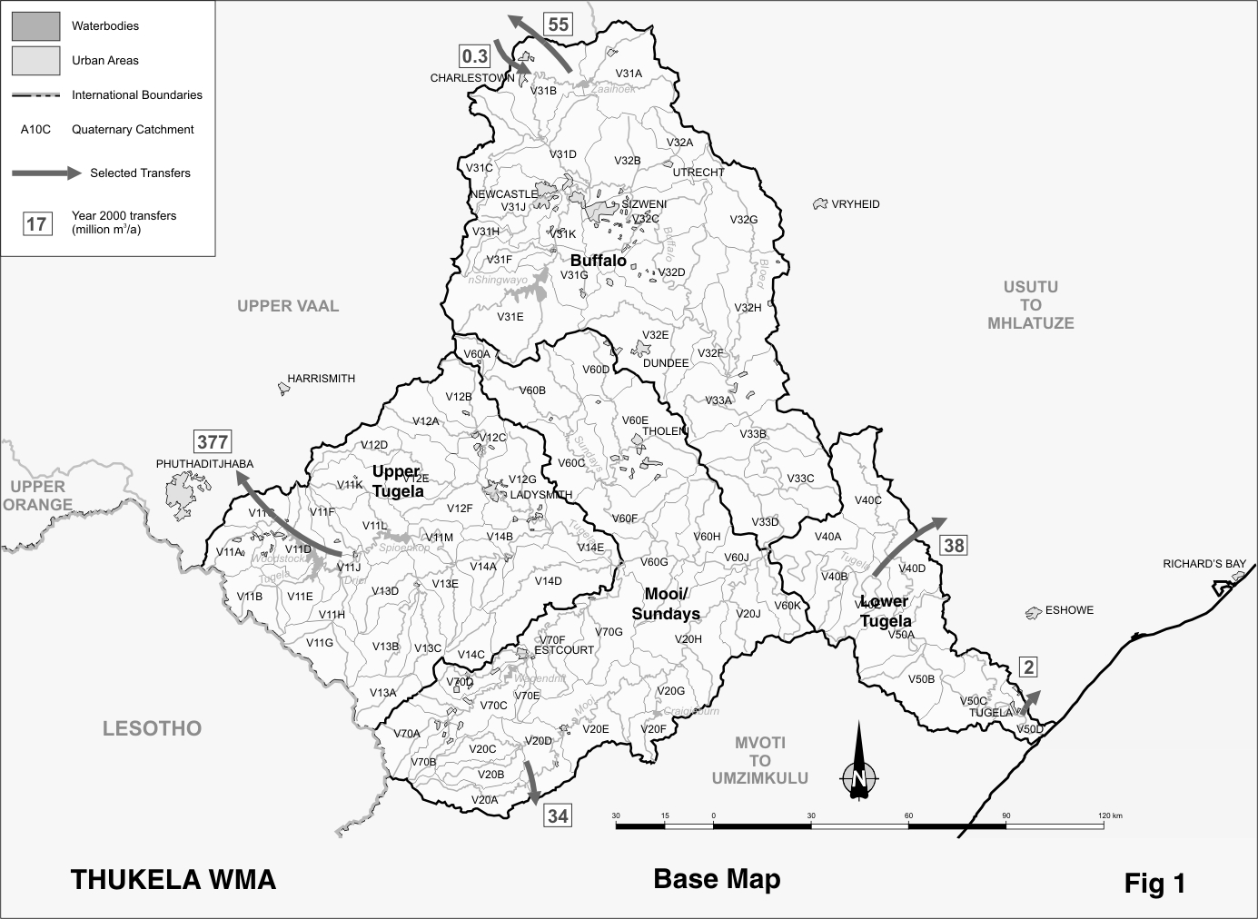
D7.2 Key statistics relevant to the Thukela water management area
Tables D7.1 to 7.6 contain a breakdown of the information given in Tables 2.1 to 2.6 of Chapter 2 for each sub-area of the Thukela water management area. Data is derived primarily from the standardised data base. Different information may be available from other sources.

Table D7.1: Natural mean annual runoff (MAR) and ecological Reserve (million m³/a)
Component/  Sub-area | Natural MAR¹ | Ecological Reserve^{1,2}
Upper Thukela | 1 502 | 392
Mooi/Sundays | 992 | 213
Buffalo | 941 | 182
Lower Thukela | 364 | 72
Total for WMA | 3 799 | 859
- Quantities are incremental and refer to the sub-area under consideration only.
- The total volume is based on preliminary estimates, with impact on yield being a portion of this.

Table D7.2: Available yield in the year 2000 (million m³/a)
Component/  Sub-area |  | Natural resource |  |  |  | Usable return flow |  |  |  | Total  local  yield
Component/  Sub-area | Surface water¹ |  | Ground-  water |  | Irrigation |  | Urban | Mining and bulk |  | Total  local  yield
Upper Thukela | 376 |  | 5 |  | 8 |  | 5 | 0 |  | 394
Mooi/Sundays | 110 |  | 3 |  | 8 |  | 6 | 1 |  | 128
Buffalo | 107 |  | 6 |  | 5 |  | 13 | 5 |  | 136
Lower Thukela | 73 |  | 1 |  | 2 |  | 0 | 3 |  | 79
Total for WMA | 666 |  | 15 |  | 23 |  | 24 | 9 |  | 737
- After allowance for the impacts on yield of ecological component of the Reserve, river losses, alien vegetation, rain-fed sugar cane and urban runoff.

Table D7.3: Water requirements for the year 2000 (million m³/a)
Sector/  Sub-area | Irrigation | Urban¹ | Rural¹ | Mining  and bulk industrial² | Power generation³ | Affore-  station⁴ | Total local requirements
Upper Thukela | 71 | 11 | 6 | 0 | 0 | 0 | 88
Mooi/Sundays | 76 | 13 | 9 | 4 | 0 | 0 | 102
Buffalo | 38 | 27 | 11 | 14 | 1 | 0 | 91
Lower Thukela | 19 | 1 | 5 | 28 | 0 | 0 | 53
Total for WMA | 204 | 52 | 31 | 46 | 1 | 0 | 334
- Includes component of Reserve for basic human needs at 25 ℓ/c/d.
- Mining and bulk industrial water uses that are not part of urban systems.
- Includes water for thermal power generation only. (Water for hydropower, which represents a small portion of power generation in South Africa, is generally available for other uses as well.)
- Quantities refer to the impact on yield only.

Table D7.4: Reconciliation of water requirements and availability for the year 2000 (million m³/a)
Component/  Sub-area | Local  yield | Transfers  in² | Local requirements | Transfers out² | Balance¹
Upper Thukela | 394 | 0 | 88 | 377 | ( 71)
Mooi/Sundays | 128 | 0 | 102 | 34 | ( 8)
Buffalo | 136 | 0 | 91 | 55 | ( 10)
Lower Thukela | 79 | 0 | 53 | 40 | ( 14)
Total for WMA | 737 | 0 | 334 | 506 | ( 103)
- Brackets around numbers indicate a negative balance. Surpluses are shown in the most upstream sub-area where they first become available.
- Transfers into and out of sub-areas may include transfers between sub-areas as well as transfers between WMAs. The addition of the quantities transferred per sub-area does therefore not necessarily correspond to total transfers into and out of the WMA. The same applies to Tables D7.5 and D7.6.

Table D7.5: Reconciliation of water requirements and availability for the year 2025 base scenario (million m³/a)
Component/  Sub-area | Local  yield¹ | Transfers in | Local requirements² | Transfers out | Balance³ | Potential for development⁴
Upper Thukela | 396 | 0 | 94 | 377 | ( 75) | 380
Mooi/Sundays | 131 | 0 | 107 | 34 | ( 10) | 218
Buffalo | 136 | 0 | 92 | 55 | ( 11) | 0
Lower Thukela | 79 | 0 | 54 | 40 | ( 15) | 0
Total for WMA | 742 | 0 | 347 | 506 | ( 111) | 598
- Based on existing infrastructure and infrastructure under construction in the year 2000. Also includes return flows resulting from a growth in requirements.
- Based on a growth in water requirements as a result of population growth and general economic development. Assumed no general increase in irrigation.
- Brackets around numbers indicate negative balance.
- Based on the construction of Jana, Mielietuin en Springgrove Dams.
Table D7.6: Reconciliation of water requirements and availability for the year 2025 high scenario (million m³/a)
Component/  Sub-area | Local  yield¹ | Transfers in | Local requirements² | Transfers out | Balance³ | Potential for development⁴
Upper Thukela | 401 | 0 | 104 | 377 | ( 80) | 380
Mooi/Sundays | 140 | 0 | 129 | 34 | ( 23) | 218
Buffalo | 155 | 0 | 133 | 55 | ( 33) | 0
Lower Thukela | 80 | 0 | 54 | 40 | ( 14) | 0
Total for WMA | 776 | 0 | 420 | 506 | ( 150) | 598
- Based on existing infrastructure and infrastructure under construction in the year 2000. Also includes return flows resulting from a growth in requirements.
- Based on a high growth in water requirements as a result of population growth and the high impact of economic development. Assumes no general increase in irrigation.
- Brackets around numbers indicate a negative balance.
- Based on the construction of the Jana, Mielietuin en Springgrove Dams.

D7.3 Key elements of the broad strategic perspectives for the Thukela water management area
The resources of the Thukela River are largely used to support water requirements in other parts of the country, with close to 70 per cent of the current yield being transferred out of the water management area. There are no strong economic drivers in the water management area to stimulate development, while water resource development for the sole purpose of irrigation is unlikely to be economically viable. Considering the anticipated continued strong growth in water requirements in the Upper Vaal, Crocodile (West) and Marico, Mvoti to Mzimkulu and Usutu to Mhlatuze water management areas, all of which have insufficient own resources and already receive part of their requirements from the Thukela water management area. it would be prudent that future large-scale water resource developments in the Thukela basin be under control of the Minister to ensure the best development in the interest of the country. High value urban/industrial application of the Thukela’s additional water resources would be the only use that would make such development viable, but it would have the subsidiary benefit of stimulating some concomitant local development.

The deficits indicated in Table D7.4 are all attributable to provisions made for implementation of the Reserve and do not reflect actual current shortages. Implementation of the Reserve should therefore be planned carefully as a priority and should form part of any future development planning. Due account also needs to be taken of the options for reconciling the requirements for and availability of water as described in Section 2.5.

A substantial portion of the water resources of the Thukela basin will be required for existing and future transfers to other water management areas. Reservations in the Thukela water management area for this purpose are:
- The transfer of a maximum of 630 million m³/a from the Upper Thukela River to the Upper Vaal water management area (equal to the current capacity). The average quantity transferred is about 530 million m³/a.
- The transfer of up to 55 million m³/a (current capacity) from the Assegaai tributary of the Buffalo River to the Upper Vaal water management area.
- The transfer from the Mooi River to the Mgeni River in the Mvoti to Umzimkulu water management area up to the current installed capacity of 100 million m³/a and up to 136 million m³/a with the addition of new infrastructure.
- The current transfer of 40 million m³/a to the Usutu to Mhlatuze water management area, which may be increased to a maximum of 94 million m³/a.
Development of large new water resources infrastructure will be under control of the Minister, as this resource may be required to supply additional water to the Usutu to Mhlatuze, Mvoti to Mzimkulu and Upper Vaal water management areas.

