D8 WATER MANAGEMENT AREA 8: UPPER VAAL

D8.1 Introduction
The Upper Vaal water management area lies in the eastern interior of South Africa. From a water resources management perspective it is a pivotal water management area in the country. Large quantities of water are transferred into the area from two neighbouring areas, as well as water sourced from the Upper Orange River via Lesotho. Similarly, large quantities of water are transferred out to three other water management areas, which are dependent on water from the Upper Vaal water management area to meet much of their requirements – see Fig. D8. The impacts of these transfers extend well beyond the four adjoining water management areas and eventually involve a total of ten water management areas and all the neighbouring countries of South Africa. Climate over the Upper Vaal water management area is fairly uniform, and the average rainfall varies between 600 mm and 800 mm per year.

Extensive urbanisation and mining and industrial activity, which relate to the rich gold and coal deposits in the area, occur in the northern part of the water management area. Similar mining and industrial development in the southern part of the Crocodile (West) and Marico water management area results in the two areas together producing 45 percent of South Africa’s Gross Domestic Product (GDP). Economic activity in the remainder of the Upper Vaal water management area mainly relates to livestock farming and rain fed cultivation.

Because of the high level of urbanisation and economic activity in the area and its pivotal role as a water transfer point to other water management areas, water resources in the area are highly developed and regulated, and only marginal potential for further development remains. The total yield transferred into the catchment is in excess of 120 per cent of the yield from local surface resources, while virtually the same quantity of water is again transferred out of the area. Groundwater is mainly used for rural domestic needs and for stock watering, while a substantial quantity of water is also abstracted from dolomitic aquifers for urban use.

Projections show that population and economic growth will remain strong in the urban and industrialised parts of the water management area. A significant decline in population is, however, foreseen in the Qwa Qwa region in the southern extremity of the water management area.

Fig. D8: Base map of the Upper Vaal water management area
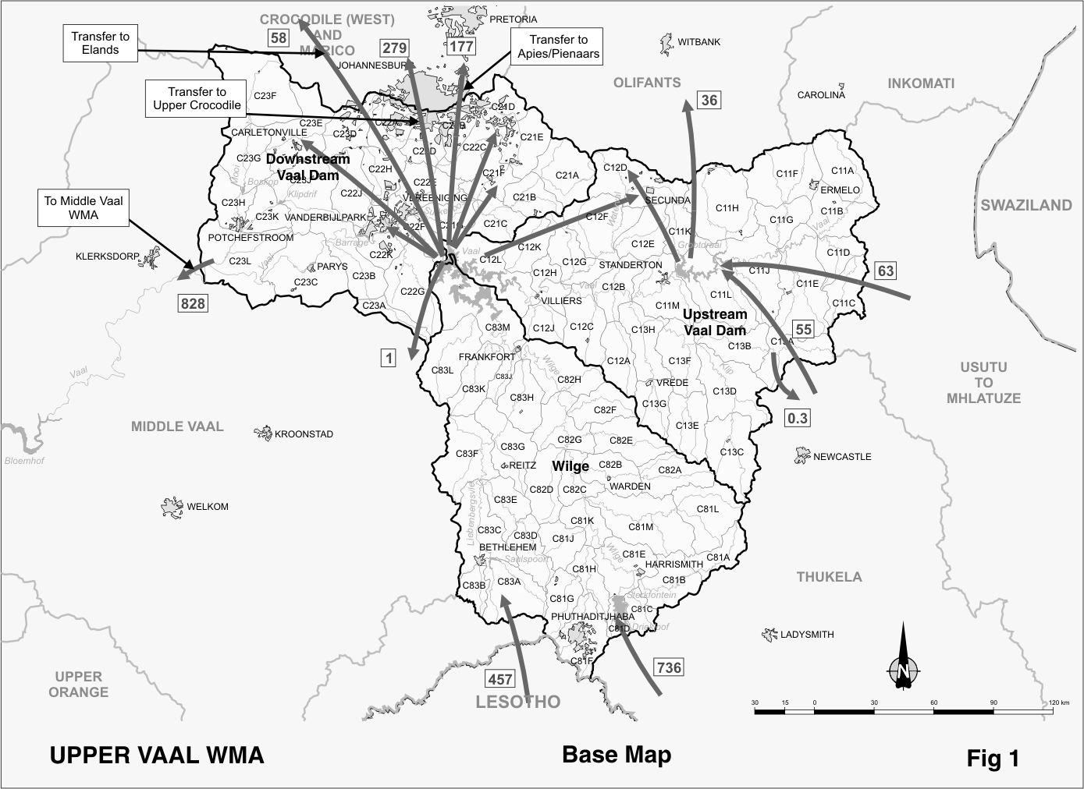

D8.2 Key statistics relevant to the Upper Vaal water management area
Tables D8.1 to 8.6 contain a breakdown of the information given in Tables 2.1 to 2.6 of Chapter 2 for each sub-area of the Upper Vaal water management area. Data is derived primarily from the standardised database. Different information may be available from other sources.

Table D8.1: Natural mean annual runoff (MAR) and ecological Reserve (million m³/a)
Component/  Sub-area | Natural MAR¹ | Ecological Reserve^{1, 2}
Wilge | 868 | 116
Vaal Dam - upstream | 1 109 | 126
Vaal Dam - downsream | 446 | 57
Total for WMA | 2 423 | 299
- Quantities are incremental and refer to the sub-area under consideration only.
- The total volume is based on preliminary estimates, with impact on yield being a portion of this.

Table D8.2: Available yield in the year 2000 (million m³/a)
Component/  Sub-area |  | Natural resource |  |  |  | Usable return flow |  |  |  | Total  local  yield
Component/  Sub-area | Surface water¹ |  | Ground-water |  | Irrigation |  | Urban | Mining and bulk |  | Total  local  yield
Wilge | 46 |  | 4 |  | 2 |  | 7 | 0 |  | 59
Vaal Dam - upstream | 154 |  | 8 |  | 3 |  | 11 | 8 |  | 184
Vaal Dam - downstream | 399 |  | 20 |  | 7 |  | 325 | 138 |  | 889
Total for WMA | 599 |  | 32 |  | 12 |  | 343 | 146 |  | 1 132
- After allowance for the impacts on yield of the ecological component of Reserve, river losses, alien vegetation, rain-fed sugar cane and urban runoff.

Table D8.3: Water requirements for the year 2000 (million m³/a)
Sector/  Sub-area | Irrigation | Urban¹ | Rural¹ | Mining  and bulk industrial² | Power generation³ | Affores-tation⁴ | Total local require-  ments
Wilge | 18 | 27 | 15 | 0 | 0 | 0 | 60
Vaal Dam - upstream | 29 | 32 | 17 | 99 | 39 | 0 | 216
Vaal Dam - downstream | 67 | 576 | 11 | 74 | 41 | 0 | 769
Total for WMA | 114 | 635 | 43 | 173 | 80 | 0 | 1 045
- Includes component of Reserve for basic human needs at 25 ℓ/c/d.
- Mining and bulk industrial water uses that are not part of urban systems.
- Includes water for thermal power generation only. (Water for hydropower is generally available for other uses as well.)
- Quantities refer to the impact on yield only.

Table D8.4: Reconciliation of water requirements and availability for the year 2000 (million m³/a)
Component/  Sub-area | Local yield | Transfers in² | Local requirements | Transfers out² | Balance¹
Wilge | 59 | 0 | 60 | 0 | ( 1)
Vaal Dam - upstream | 184 | 118 | 216 | 67 | 19
Vaal Dam - downstream | 889 | 1 224 | 769 | 1 343 | 1
Total for WMA | 1 132 | 1 311 | 1 045 | 1 379 | 19
- Brackets around numbers indicate a negative balance. Surpluses are shown in the most upstream sub-area where they first become available.
- Transfers into and out of sub-areas may include transfers between sub-areas as well as transfers between WMAs. The addition of the quantities transferred per sub-area does therefore not necessarily correspond to total transfers into and out of the WMA. The same applies to Tables D8.5 and D8.6.

Table D8.5: Reconciliation of water requirements and availability for the year 2025 base scenario (million m³/a)
Component/  Sub-area | Local yield¹ | Transfers in | Local require-  ments² | Transfers  out | Balance³ | Potential for develop-  ment⁴
Wilge | 58 | 0 | 56 | 0 | 2 | 0
Vaal Dam - upstream | 184 | 118 | 256 | 74 | ( 28) | 50
Vaal Dam - downstream | 987 | 1 513 | 957 | 1 561 | ( 18) | 0
Total for WMA | 1 229 | 1 630 | 1 269 | 1 634 | ( 44) | 50
- Based on existing infrastructure and infrastructure under construction in the year 2000. Also includes return flows resulting from a growth in requirements.
- Based on normal growth in water requirements as a result of population growth and general economic development. Assumes no general increase in irrigation.
- Brackets around numbers indicate a negative balance.
- Based on the construction of Klip River Dam.

Table D8.6: Reconciliation of water requirements and availability for the year 2025 high scenario (million m³/a)
Component /  Sub-area | Local yield¹ | Transfers in | Local require-ments² | Transfers out | Balance³ | Potential for develop-  ment⁴
Wilge | 64 | 0 | 78 | 0 | ( 14) | 0
Vaal Dam – upstream | 190 | 118 | 272 | 74 | ( 38) | 50
Vaal Dam - downstream | 1 232 | 1 513 | 1 391 | 2 067 | ( 713) | 0
Total for WMA | 1 486 | 1 630 | 1 741 | 2 140 | ( 765) | 50
- Based on existing infrastructure and infrastructure under construction in the year 2000. Also includes return flows resulting from a growth in requirements.
- Based on a high growth in water requirements as a result of population growth and the high impact of economic development. Assumes no general increase in irrigation.
- Brackets around numbers indicate a negative balance.
- Based on the construction of Klip River Dam.

D8.3 Key elements of the broad strategic perspectives for the Upper Vaal water management area
The Upper Vaal water management area is highly developed and impacted upon by human activity. The quantities of water transferred into and out of the area are largely dictated by the population needs and economic activity in this as well as similar needs in other recipient water management areas. It should be noted that the balance reflected in Table D8.4 for the sub area downstream of Vaal Dam will become a temporary surplus when the transfer of water from Mohale Dam in Lesotho is commissioned, and based on the assumption that all the transfers into the water management area are operated at nominal yield capacity. In practice, however, only the quantities of water actually required are transferred. (For simplicity, the transfers from Lesotho and the Upper Thukela are shown to be received in the sub-area downstream of Vaal Dam, where the water is actually used or from where it is transferred onwards). It is important to note that while large quantities of water are transferred into the Upper Vaal water management area, the yield available at Grootdraai Dam is limited by the existing infrastructure, and deficits may develop at that point.

Water quality in the Vaal River and in some tributaries downstream of Vaal Dam is seriously affected by urban and industrial and mining return flows and the intensive mining activity. The water resources are therefore carefully managed to maintain acceptable water quality standards. Particular attention is also to be given to the impacts that closure of mines may have on both surface and groundwater.

As the resources within the water management area essentially fully developed, future growth in the requirements for water will have to be met by increased water transfers from other water management areas. The successful implementation of water conservation and demand management measures are of particular importance in this area. The main water resource development options available in this regard are additional transfers from the Thukela water management area and the Orange River, the latter through additional transfers from Lesotho or from the Upper Orange water management area. Recent investigations have shown that a new dam on the Klip River could possibly be the best option to meet additional requirements in the sub-area upstream of Vaal Dam. Due consideration, however, must be given to all the options for reconciling water requirements and availability, as described in Section 2.5.

The following reservations apply with respect to the transfer of water into and out of the water management area, and the provision of water for future growth:
- The existing transfer of 491 million m³/a from Lesotho, which is to be increased to 835 million m³/a after the commissioning of Mohale Dam in Lesotho. – reserved by international agreement for use in and transfer from the Upper Vaal water management area.
- Existing transfers from the Thukela water management area up to the installed capacity of 630 million m³/a. The yield benefit in the Vaal System is 736 million m³/a – reserved in the Thukela water management area.
- Future large-scale water resources development on the Thukela River is reserved mainly for transfer to the Upper Vaal water management area. Current planning allows for an additional transfer of 475 million m³/a – reserved in the Thukela water management area.
- Existing transfer of 55 million m³/a from the Buffalo River in the Thukela water management area to the Upper Vaal water management area – reserved in the Thukela water management area.
- Transfers from the Usutu to Mhlatuze water management area at the current capacity of 63 million m³/a – reserved in the Usutu to Mhlatuze water management area.
- Existing transfers from the Upper Vaal water management area to the Olifants water management area of 36 million m³/a for power generation, plus an allowance of 38 million m³/a for future growth. (Included in Tables D8.3 to D8.6.) – reserved in the Upper Vaal water management area.
- Transfers from the Upper Vaal water management area through the Rand Water distribution system to meet requirements in the Crocodile (West) and Marico water management area which are in excess of the capacity of the local resources in the Crocodile (West) and Marico water management area. Currently this amounts to 514 million m³/a and is projected to increase to 723 million m³/a. As an upper high growth scenario, transfers may need to increase to 1 125 million m³/a. (Figures included in Tables D 8.5 and D 8.6.) – reserved in the Upper Vaal water management area.
- Releases from the Upper Vaal water management area along the Vaal River to users in the Middle Vaal and Lower Vaal water management areas to meet their realistic needs that cannot be supplied from own resources. Little change is expected from the current transfer of 828 million m³/a, although it may increase to about 910 million m³/a in 2025 under the high growth scenario – reserved in the Upper Vaal water management area.
- Current surplus transfer capacity into the Upper Vaal water management area is to be reserved for growth in urban, industrial and mining water requirements in the Upper Vaal and Crocodile (West) and Marico water management areas, and is not to be used for commercial irrigation.
- The allocation of surplus yield in the Upper Vaal water management area will be subject to national authorisation as it can be allocated to users in the Upper, Middle, Lower Vaal as well as Crocodile (West) and Marico and Olifants water management areas.
- The Upper Vaal water management area forms the central component of the Vaal River System, which extends over several water management areas. As water resources management in the Vaal River System impacts to some degree on the water quantity and quality in all the interlinked water management areas, management of the Vaal River System is to be controlled at a national level.

