D9 WATER MANAGEMENT AREA 9: MIDDLE VAAL

D9.1 Introduction
The Middle Vaal water management area is situated in the Free State and North West Provinces in the central part of South Africa. It covers the middle reaches of the Vaal River, between the Upper Vaal and Lower Vaal water management areas (see Fig. D9). Rainfall is relatively low and ranges from 400 mm to 700 mm per year, while evaporation can be as high as 1 900 mm per year.

Fig. D9: Base map of the Middle Vaal water management area

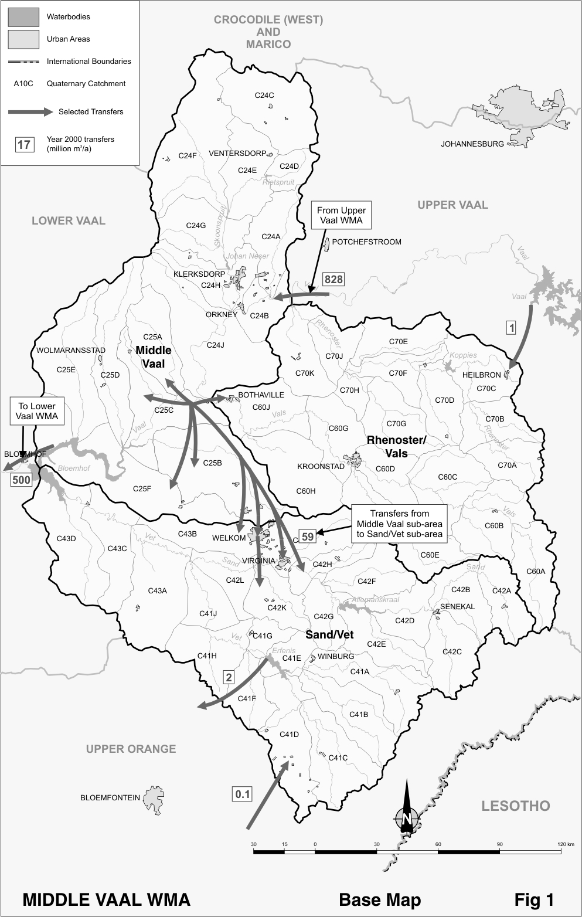

There are no distinct geographic or topographic features and surface runoff is low. Activity in the water management area is typically extensive livestock farming and rain fed cultivation, with some irrigation farming. Economic activity, though, is dominated by gold mining in the vicinity of Klerksdorp and Welkom, which as a single sector contributes about 45 per cent of the Gross Domestic Product (GDP) in the water management area.

Dams have been constructed on all the main tributaries of the Vaal River. Any unregulated runoff is controlled by the Bloemhof Dam on the Vaal River in the Lower Vaal water management area immediately after the river exits the Middle Vaal water management area. No realistic potential for further development of surface water exists. Extensive use of groundwater for rural domestic and village supplies is made throughout the water management area. Large dolomitic aquifers are found in the northern part of the water management area, which extend into the adjoining water management areas and support large areas under irrigation.

Water along the Vaal River is highly saline and generally of poor quality as a result of the large quantities of effluent and urban runoff that is discharged into the river in the Upper Vaal water management area. Water quality is carefully managed by blending fresh water with the effluent.

Because of a decline in gold mining activity, a small decrease in population is projected for the area, with concomitant effects on economic activity. Little change in water requirements is therefore expected.

D9.2 Key statistics relevant to the Middle Vaal water management area
Tables D9.1 to 9.6 contain a breakdown of the information given in Tables 2.1 to 2.6 of Chapter 2 for each sub-area of the Middle Vaal water management area. Data is derived primarily from the standardised database. Different information may be available from other sources.

Table D9.1: Natural mean annual runoff and ecological Reserve (million m³/a)
Component/  Sub-area | Natural MAR¹ | Ecological Reserve^{1,2}
Rhenoster-Vals | 295 | 35
Middle Vaal | 170 | 29
Sand-Vet | 423 | 45
Total for WMA | 888 | 109
- Quantities are incremental and refer to the sub-area under consideration only.
- The total volume is based on preliminary estimates, with impact on yield being a portion of this.

Table D9.2: Available yield in the year 2000 (million m³/a)
Component/  Sub-area |  | Natural resource |  |  |  | Usable return flow |  |  |  | Total local yield
Component/  Sub-area | Surface water¹ |  | Ground-water |  | Irrigation |  | Urban | Mining and bulk |  | Total local yield
Rhenoster-Vals | 22 |  | 12 |  | 3 |  | 7 | 0 |  | 44
Middle Vaal | ( 201) |  | 25 |  | 3 |  | 15 | 16 |  | ( 142)
Sand-Vet | 112 |  | 17 |  | 10 |  | 7 | 1 |  | 147
Total for WMA | ( 67) |  | 54 |  | 16 |  | 29 | 17 |  | 49
- After allowance for the impacts on yield of the ecological component of the Reserve, river losses, alien vegetation, rain-fed sugar cane and urban runoff.

Table D9.3: Water requirements for the year 2000 (million m³/a)
Sector/  Sub-area | Irrigation | Urban¹ | Rural¹ | Mining  and bulk industrial² | Power generation³ | Affores-  tation⁴ | Total local require-ments
Rhenoster-Vals | 26 | 20 | 8 | 0 | 0 | 0 | 54
Middle Vaal | 33 | 35 | 13 | 48 | 0 | 0 | 129
Sand-Vet | 100 | 38 | 11 | 38 | 0 | 0 | 187
Total for WMA | 159 | 93 | 32 | 86 | 0 | 0 | 370
- Includes component of Reserve for basic human needs at 25 ℓ/c/d.
- Mining and bulk industrial water uses that are not part of urban systems.
- Includes water for thermal power generation only. (Water for hydropower, which represents a small portion of power generation in South Africa, is generally available for other uses as well.)
- Quantities refer to the impact on yield only.

Table D9.4: Reconciliation of water requirements and availability for the year 2000 (million m³/a)
Component/  Sub-area | Local  yield | Transfers  in² | Local requirements | Transfers out² | Balance¹
Rhenoster-Vals | 44 | 1 | 54 | 0 | ( 9)
Middle Vaal | ( 142) | 828 | 129 | 559 | ( 2)
Sand-Vet | 147 | 59 | 187 | 2 | 17
Total for WMA | 49 | 829 | 370 | 502 | 6
- Brackets around numbers indicate a negative balance. Surpluses are shown in the most upstream sub-area where they first become available.
- Transfers into and out of sub-areas may include transfers between sub-areas as well as transfers between WMAs. The addition of the quantities transferred per sub-area does therefore not necessarily correspond to total transfers into and out of the WMA. The same applies to Tables D9.5 and D9.6.

Table D9.5: Reconciliation of water requirements and availability for the year 2025 base scenario (million m³/a)
Component/  Sub-area | Local  yield¹ | Transfers in | Local requirements² | Transfers out | Balance³ | Potential for develop-  ment
Rhenoster-Vals | 44 | 1 | 53 | 0 | ( 8) | 0
Middle Vaal | ( 136) | 837 | 142 | 560 | ( 1) | 0
Sand-Vet | 147 | 59 | 187 | 2 | 17 | 0
Total for WMA | 55 | 838 | 382 | 503 | 8 | 0
- Based on existing infrastructure and under construction in the year 2000. Also includes return flows resulting from a growth in requirements.
- Based on normal growth in water requirements as a result of population growth and general economic development. Assumes no general increase in irrigation requirements.
- Brackets around numbers indicate a negative balance.

Table D9.6: Reconciliation of water requirements and availability for the year 2025 high scenario (million m³/a)
Component /  Sub-area | Local  yield¹ | Transfers  in | Local requirements² | Transfers out | Balance³ | Potential for develop-  ment
Rhenoster-Vals | 49 | 2 | 65 | 0 | ( 14) | 0
Middle Vaal | ( 131) | 910 | 152 | 628 | ( 1) | 0
Sand-Vet | 149 | 72 | 200 | 2 | 19 | 0
Total for WMA | 67 | 911 | 417 | 557 | 4 | 0
- Based on existing infrastructure and infrastructure under construction in the year 2000. Also includes return flows resulting from a growth in requirements.
- Based on a high growth in water requirements as a result of population growth and the high impact of economic development. Assumes no general increase in irrigation requirements.
- Brackets around numbers indicate a negative balance.

D9.3 Key elements of the broad strategic perspectives for the Middle Vaal water management area
The Middle Vaal water management area is dependent on releases from the Upper Vaal water management area for meeting the bulk of the water requirements of its urban, mining and industrial sectors. Releases from the Upper Vaal water management area in support of the Lower Vaal water management area are transferred via the Middle Vaal water management area to the Bloemhof Dam, which is the uppermost control structure in the Lower Vaal area. Management of water quantity and quality in the Middle Vaal water management area is therefore integrally linked to both the Upper Vaal and Lower Vaal water management areas and commensurate management approaches will have to be followed in these water management areas. It is appropriate therefore that these aspects are managed at a national level.

The negative contribution from surface resources in the Middle Vaal sub-area, as reflected in Table D9.2, is a result of evaporation losses along this reach of the Vaal River being in excess of the yield from local tributaries. Owing to the intermittent nature of flow in the tributary rivers, provision for the ecological component of the Reserve has relatively little impact on the yield from the Rhenoster/Vals and Sand/Vet sub-areas.

Since no meaningful growth in requirements is foreseen in this water management area, the main issue of concern will be the management of water quality, which could be severely affected by further urban and industrial development in the Upper Vaal water management area, where the main sources of impact on water quality are located.

Due consideration must also be given to the implementation of appropriate demand management measures and to ensuring the most beneficial use of water.

The following quantities of water need to be reserved for transfers in to and out of the Middle Vaal water management area:
- Transfers from the Upper Vaal water management area for use in the Middle Vaal and Lower Vaal water management areas. Currently this amounts to 828 million m³/a and may under a high growth scenario increase to 910 million m³/a – reserved in the Upper Vaal water management area.
- Transfers from the Middle Vaal water management area to the Lower Vaal water management area. The current volume is 500 million m³/a, which under a high growth scenario may increase to about 555 million m³/a – reserved in the Middle Vaal water management area.
- Small existing transfers for domestic use from Vaal Dam in the Upper Vaal water management area to Heilbron in the Middle Vaal water management area – reserved in the Upper Vaal water management area.
- Small existing transfers for domestic use from Erfenis Dam in the Middle Vaal water management area to users in the Upper Orange water management area – reserved in the Middle Vaal water management area.

