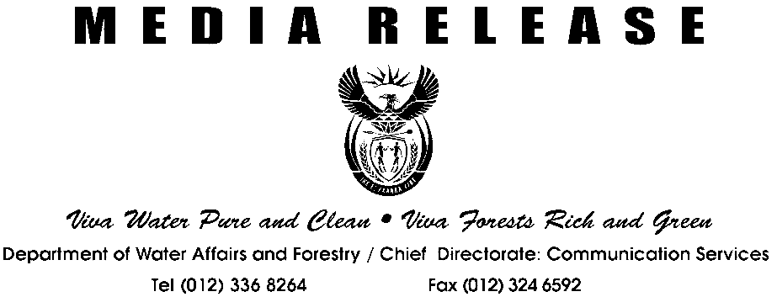
MEDIA STATEMENT BY MINISTER RONNIE KASRILS, MP
Viva Water Pure and Clean Viva Forests Rich and Green
Department of Water Affairs and Forestry - Chief Directorate: Communication Services
Tel (012) 336 8264Fax (012) 324 6592
MEDIA RELEASE
NATIONAL WATER WEEK 2003

We celebrate National Water Week in South Africa from the 17-23 March with a deep realisation of the role that water must play in achieving the vision of a prosperous South Africa. It is a week that sees us launch the International Year of Freshwater in South Africa as well as coinciding with the Third World Water Forum in Japan. With the theme “Water is our future”, this year’s celebrations focuses on protecting and respecting the country’s water resources. It is a call to all people living in South Africa to maintain and improve the quality and quantity of freshwater available for current and future generations.

This call to action comes at a time when the availability of clean water is one of the most important issues facing our country – some 6 million people living in South Africa still do not have access to safe clean water while nearly 16 million are still without adequate sanitation. The continuous pollution of rivers and streams as well as the growing future demands for water calls for all those living in South Africa to re-assess their attitudes to our vital water resources. This comes at a time when the United Nations has indicated that water use in the 20th century has grown at twice the rate of the population. It comes at a time in South Africa when access to clean, safe water and water-borne diseases continue to threaten the health and quality of life for many.

Beginning with the Water Week celebrations, the Department is focusing on moving beyond simply raising awareness to that of focusing on current and future challenges in order to ensure a better quality of life for present and future generations. The increasing demands, pollution, changing climatic patterns as well as the challenge of ensuring that everyone has access to water and sanitation services creates a need for a concerted effort by all to maintain and improve the quality and quantity of water in South Africa.

Our goal for the week and the year is to inspire actions in meeting these challenges. As in the past years Government, communities, non-governmental organisations, youth groups, business, industry and the media will be playing active roles in highlighting on local, regional, national and international issues. The intention is to achieve the following:

- Working towards eradicating the backlog with regard to water and sanitation services
- Ensuring the cleanliness and integrity of our water resources
- Ensuring long term sustainability of our water resources
- Highlighting the crucial link between water and health with the objective of preventing water-borne diseases
- Empowering communities, especially women and children, in managing and improving their living conditions
- Ensuring access to water resources for economic development
- Developing an aware and responsible South African society.

Our efforts during the week are not just limited to South Africa. Following the Presidents call to make this the African Century, we have focussed considerable attention on addressing the water needs in Africa. We have taken an active role in promoting NEPAD, and as such will be strongly represented at the Third World Water Forum from the 16-22 March in Kyoto, Japan. We will be monitoring commitments made at the Johannesburg Summit and discussing strategies for implementation.

Our participation at the Third World Water Forum is not about presenting papers, it is about sharing our experiences and best practices with the rest of the water world and learning from them. A priority for us will be to promote dialogue and interaction with the numerous participants and in doing so contribute to finding solutions to Africa’s and the worlds water problems.

As we contribute at the international stage in Japan, I will like to encourage all South African’s to focus on the need to restore and preserve the integrity of this precious resource, water. We must take responsibility to make sure this scarce resource is managed in an effective and sustainable manner.

Two key national events during this period will be the Baswa le Meetse Awards (Youth in Water Awards) and the Women in Water Awards. These awards are part of the ongoing programme of the Department to acknowledge the role of women and the youth as well as focus on how water can transform the lives of children and women.

The Women in Water Awards highlight and promote the participation of professional and community-based women in water resource management. It also acknowledges the key role that women play in poverty eradication, education and other related issues around resource management and sustainable development in both the urban and rural contexts.

The Baswa le Meetse Award (Northern Sotho for Youth in Water) will be awarded to learners who produce and convey inspiring educational messages to the public about water and sanitation through theatre and arts (drama, cultural music, poems and praise singing). Baswa le Meetse forms part of the National Water Week activities from 2003 and it is envisaged that it will be an annual competition.

Activities during the week will also focus on increasing the awareness of South Africa’s “blueprint for survival”, the National Water Resource Strategy (to finalised in June after intensive consultations) which has demonstrated that it is possible to meet the water needs of the increasingly prosperous South Africa which we are building if we use our resources wisely.

The Department of Water Affairs and Forestry sees 2003 as the year that all people living in South Africa focus their attention on protecting and respecting our water resources. A year in which we raise the importance of water in our quest to build a better life for all.

Let us join forces, as in the past few years, and celebrate the successes, as well as re-commit ourselves to finding solutions for the challenges.

Enquiries: Themba Khumalo
Tel: 012-3368270
Cell: 082 802 3432

