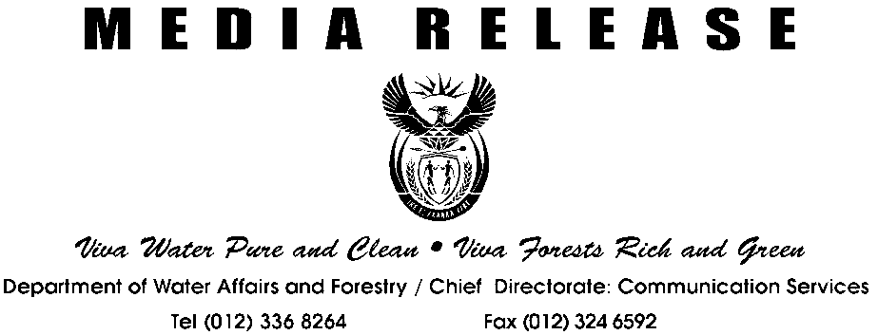
MEDIA STATEMENT BY MINISTER RONNIE KASRILS, MP
Viva Water Pure and Clean Viva Forests Rich and Green
Department of Water Affairs and Forestry - Chief Directorate: Communication Services
Tel (012) 336 8264Fax (012) 324 6592
MEDIA RELEASE
Viva Water Pure and Clean Viva Forests Rich and Green
Department of Water Affairs and Forestry - Chief Directorate: Communication Services
Tel (012) 336 8264Fax (012) 324 6592
MEDIA RELEASE

NATIONAL WATER WEEK 2004

WATER: WASHING AWAY POVERTY

“Water washing away poverty” is this year’s slogan for National Water Week, which will take place from 22-28 March. The 2004 Water Week is especially significant as it coincides with Government’s 10 years of democracy celebrations and International Water Day on 22 March.

The focus of National Water Week is on raising awareness among all South Africans of the responsibility they have to use water wisely and sparingly. This year we also celebrate the success of Government’s water delivery programme and management during the first decade of democracy. This is a particularly important achievement given the backlog inherited in 1994.

A decade ago, around 14 million people did not have access to safe drinking water and some 21 million people did not have access to a basic level of sanitation.

In the ten years since democracy, the Department of Water Affairs and Forestry has provided almost 10 million South Africans with access to clean water. South Africa has more than achieved the rate of delivery required to meet the millennium targets set by the Heads of State at the United Nations in 2000. At that meeting President Thabo Mbeki together with 100 other Heads of State, committed to halving the proportion of people lacking safe water in the world by 2015.

Although the goal is to eradicate the backlog of access to water (5 million) and adequate sanitation (16 million) by 2008 and 2010 respectively, this is not enough for the Government or the Department. Our vision for the next ten years is to move people up the Water Ladder, from communal taps to the convenience and dignity of water in people’s own yards with each household having its own toilet and even, in time hot and cold running water inside their homes.

The provision of access to water, particularly for rural communities is about improving their lives beyond mere subsistence. Apart from avoiding the hardship of carting water over long distances there are also other benefits that result directly from having easy access to clean water, improved hygiene and better sanitation, such as health benefits from reduced transmission of water borne and other diseases.

The Department has spearheaded the Free Basic Water Policy which, when implemented by Local Government, ensures households receive up to 6 000 litres of clean water every month at no cost. Many South Africans, even though they may have access to clean water, cannot afford to pay for a service that is so essential to their health and basic needs. Already more than 27,6 million people are benefiting from the policy.

The “blueprint for survival”, the National Water Resource Strategy to be launched during 2004 will ensure that the objectives of the Constitution and the Water Act are met. South Africa is a water-stressed country and this strategy describes the ways in which the country’s water resources will be protected, used, developed, conserved, managed and controlled.

Major events taking place during National Water Week include the Women in Water Awards on 19 March, the Johannesburg Water Festival on 23 March and the Baswa le Meetse (Youth in Water) Awards on 26 March.
The Women in Water Awards honours both professional and community-based women who are involved in water management. It aims to recognise the key role that women play in poverty eradication, education and sustainable development in both the urban and rural context.
Eskom Generation Division is the sole corporate sponsor for Women in Water 2004. Eskom is a major strategic water user in South Africa and is committed to advancing the role women play in the water sector.
The Baswa le Meetse awards are presented to schoolchildren who produce and convey inspiring messages to the public about water and sanitation through theatre and arts (drama, cultural music, poems, praise-singing and drawing).

Other countrywide celebrations will include:
- A community event at the Midmar Dam in KwaZulu-Natal on 22 March;
- The official handover of the Makapanstadt Water Supply and Reticulation project in the North West on 23 March;
- The official launch of the Japanese funded Rural Water Projects in Umtata on 24 March;
- The official launch of the Mapela Water Works in Limpopo on 25 March;
- The official launch of the Fika Phatsoe Purification Plant in the Free State on 27 March; and
- The official opening of the Rietpoort Water Supply Project in the Western Cape on 28 March.

Ends

Enquiries: Themba Khumalo
Tel: (012) 336 8270
Cell: 082 802 3432

