REFERENCE FREQUENCY OF OCCURRENCE OF FISH SPECIES IN SOUTH AFRICA

CJ KLEYNHANS
Department of Water Affairs & Forestry, Resource Quality Services, Pretoria
MD LOUW
Water for Africa, Pretoria
J MOOLMAN
Department of Water Affairs & Forestry, Resource Quality Services, Pretoria

REFERENCE FISH FREQUENCY OF OCCURRENCE
REPORT STATUS | FINAL
DATE | April 2007
APPROVED for water for africa

……………………………………..
MD Louw
PROJECT LEADER
approved for the water research commission

……………………………………..
dr sA mitchell
wrc director: water-linked ecosystems (ksa 2)
APPROVED for the DEPARTMENT OF WATER AFFAIRS AND FORESTRY: Directorate RESOURCE DIRECTED MEASURES

……………………………………..
MR b madikizela
acting senior manager: resource quality services

references

Kleynhans CJ, Louw MD, Moolman J. 2007. Reference frequency of occurrence of fish species in South Africa. Report produced for the Department of Water Affairs and Forestry (Resource Quality Services) and the Water Research Commission

ACKNOWLEDGEMENTS

The Southern African Institute of Aquatic biodiversity and the Albany Museum for the distribution database of South African fish species.

The following persons contributed information and attended workshops to establish the FROC fish reference database:

Mr J Alletson Alletsons Ecologicals
Mr M Angliss LEDET
Ms M Avenant University of the Free State
Mr S Buthulezi Gauteng Nature Conservation
Dr A Bok Anton Bok Aquatic Consultants cc
Dr J Cambray Allbany Museum
Mr M Coke Private
Dr A Deacon SANParks
Mr P de Villiers Private
Dr J Engelbrecht Mpumalanga Parks Board
Mr P Fouche University of Venda
Mr A Hoffman Mpumalanga Parks Board
Mr D Impson Cape Nature
Dr N Kleynhans DWAF, RQS
Ms S Koekemoer Koekemoer Aquatic Services
Dr P Kotze Clean Stream Biological Services
Mr S Lamberth Private
Ms D Louw Water for Africa
Ms S Louw Water for Africa
Dr S Mitchell Water Research Commission
Mr B Paxton Freshwater Research Unit
Mr F Roux Mpumalanga Parks Board
Dr E Schwartz South African Institute of Aquatic Biodiversity

Structure of the document

This report explains the background and process to formulate a fish reference Frequency of Occurrence (FROC) database. This database is included on a CD as an Excel spreadsheet.

PURPOSE OF THE REFERENCE FROC

Provide consistent reference FROC for more than 700 fish sites in South Africa.

HOW SHOULD THE DATA BASE BE USED?

To apply
- the FRAI
- procedures that requires a reference fish assemblage (eg extrapolation from known sites to unknown sites)

NOTE: It is strongly recommended that the users participate in training courses and/or contact the authors of this document when using the database.

executive summary
BACKGROUND

Fish is considered to be one of the important indicators of river health and their responses to modified environmental conditions are measured in terms of the Fish Response Assessment Index (FRAI) (Kleynhans 1999; Kleynhans et al. 2005). This index is based on a combination of fish species habitat preferences as well as intolerance to habitat changes, and the present frequency of occurrence of species compared to the reference frequency of occurrence.

Various guidelines can be provided to enable assessors to derive the expected reference list of species and their reference frequency of occurrence at a monitoring site. However, variation in the interpretation of different assessors may potentially cause different reference conditions being set for a particular site or section of river.

PURPOSE OF THE STUDY

- Stipulate fish reference frequency of occurrence attributes for each of the 638 national RHP sites as was specified for each of the 19 Water Management Areas in South Africa.
- Stipulate fish reference of occurrence attributes for additional fish sampling sites.

THE FROC IN THE FRAI

The list of species is based on species that are known to be present or to have been present under close to reference habitat conditions. Species that are derived to have been present under relatively recent reference habitat conditions are also identified. The resulting species reference list is a combination of both of the above approaches

The rating of the FROC refers to the reference fish frequency of occurrence (FROC) in a particular ecologically defined reach of a river. Ratings are scored from 1 to 5. For example, if a species under natural reference conditions occurs at 3 out of 5 sites, its frequency of occurrence would be 60%, this would relate to a frequency of occurrence rating of 4 (present at most sites; >50-75% of sites).

PROCESS TO DETERMINE THE FROC

The process is summarised as follows:
- Coordinators were identified to collate information in different parts of the country.
- This information was used to initiate the compiling of the database.
- The reference species list were compiled for each site and biophysical information for sites identified.
- Maps were produced illustrating the localities of the sites.
- Workshops were held where the reference species list was refined and the FROC ratings supplied.
- The database was verified and the results documented in this report.

THE RESULTS

The reference lists of fish species and the maps showing the sites are provided in this document. The FROC is provided in the Excel database which is attached to the report.

___________________________________________________________________

TABLE OF CONTENTS

references ii
ACKNOWLEDGEMENTS ii
Structure of the document iii
executive summary iv
1 TABLE OF CONTENTS vi
2 INTRODUCTION 2-1
2.1 BACKGROUND 2-1
2.2 PURPOSE OF THIS REPORT 2-2
3 frequency of occurrence 3-1
3.1 REFERENCE CONDITIONS 3-1
3.2 FRAI AND THE FROC 3-1
3.2.1 Reference list of fish species 3-1
3.2.2 Rating of the reference fish FROC 3-1
4 PROCESS 4-3
5 results 5-1
6 references 6-1

LIST OF TABLES

Table 3.1 Sheet 1 (WMA**) of the .xls spreadsheet used to collate data. 3-3
Table 3.2 Collated format of sheet: FROC (cf. Table 3.1) for use during workshops 3-4

LIST OF FIGURES

Figure 2.1 Illustration of the FROC interpretation in a river reach 2-2

INTRODUCTION

BACKGROUND

The River Health Programme (RHP) forms part of the National Aquatic Ecosystem Health Monitoring Programme (NAEHMP). The RHP aims to assess the health of rivers based on the response of biota (instream and riparian) to anthropogenic changes of physical drivers (i.e., hydrology, geomorphology, and physico-chemical variables) which relates to changes in habitat integrity (Kleynhans et al. 2005)

The response of biota to altered environmental conditions can only be assessed in comparison to the reference condition. Reference conditions can be derived based on, modelling, expert knowledge and historical data. This includes distribution data as well as information on the habitat conditions under reference conditions. The deviation of the condition of the biota from the reference condition, functions as an indication of the health of a river (Kleynhans et al. 2005).

Fish is considered to be one of the important indicators of river health and their responses to modified environmental conditions are measured in terms of the Fish Response Assessment Index (FRAI) (Kleynhans 1999; Kleynhans et al. 2005). This index is based on a combination of fish species habitat preferences as well as intolerance to habitat changes, and the present frequency of occurrence of species compared to the reference frequency of occurrence.

Various guidelines can be provided to enable assessors to derive the expected reference list of species and their reference frequency of occurrence at a monitoring site. However, variation in the interpretation of different assessors may potentially cause different reference conditions being set for a particular site or section of river. Consequently it was decided to:
- Stipulate fish reference frequency of occurrence attributes for each of the 638 national RHP sites as was specified for each of the 19 Water Management Areas in South Africa (Dallas 2005). This information will eventually be used to “customize” the FRAI models for each WMA.
- Stipulate fish reference of occurrence attributes for additional fish sampling sites. These sites are considered to be important for assisting in setting reference conditions for sites that can be used for Provincial Monitoring purposes, ad hoc assessments, as well as for reserve determination and monitoring purposes. This information will eventually be incorporated in FRAI model versions for each WMA.

This project forms part of the National Inception Phase of the River Health Programme

PURPOSE OF THIS REPORT

The purpose of the report is to document the process followed to establish the reference frequency of occurrence (FROC) for specified sites for use in the FRAI and to provide a database of results in a spreadsheet format and on maps.

frequency of occurrence

REFERENCE CONDITIONS

Reference conditions broadly refer to “expectations on the state of aquatic biological communities in the absence of human disturbance and pollution” (www.epa.gov). In the context of this report, it refers specifically to the fish species present in a particular river reach and their frequency of occurrence under reference habitat conditions.

Although the national RHP sites refer to specific sites, the purpose of these sites is to be representative of a particular reach or section of river.

FRAI AND THE FROC

The information required for the operation of the FRAI (Kleynhans et al. 2005) is provided in the sections below.

Reference list of fish species

The list of species is based on species that are known to be present or to have been present under close to reference habitat conditions. This would include information from historical sites within a particular river reach

Species that are derived to have been present under relatively recent reference habitat conditions are also identified. This is based on the presence of species in neighbouring catchments (including upstream and downstream reaches) with more comprehensive fish distribution data. However, expert knowledge and judgment are required to ensure that it is ecologically reasonable to make conclusions on the presence or absence of a species. This includes consideration of the diversity of habitats available under reference conditions as well as consideration of the degree to which habitat have been changed from the reference situation.

Usually the resulting species reference list is a combination of both of the above approaches

Rating of the reference fish FROC

This refers to the reference fish frequency of occurrence (FROC) in a particular ecologically defined reach of a river. This means that FROC ratings are derived based on conditions at the particular site as well as the available habitat in the reach for species expected under reference conditions.

Basic habitat conditions that were considered in terms of the FROC of species are based on intolerance and preference rating as contained in the FRAI (Kleynhans et al. 2005). The presence and abundance of habitat features such as velocity-depth classes, cover types (including substrate) and the characteristics of the natural flow regime (especially the degree of perenniality) in a river reach under reference conditions formed the basis for the expert judgment of the FROC.

For example, if a species under natural reference conditions occurs at 3 out of 5 sites, its frequency of occurrence would be 60%, this would relate to a frequency of occurrence rating of 4 (present at most sites; >50-75% of sites) (Table 3.2).

FROC as used for this assessment does not refer to the frequency of occurrence of species at a site at different sampling points at a site. As indicated above, the FROC refers to the number of sites (under reference conditions) where a species would be expected to occur given the available habitat for the species and its habitat preferences and intolerances. This is illustrated in Figure 2.1.

The FROC also does not refer to the abundance of a species as such (although the abundance generally has a direct relationship with the frequency of occurrence).

Figure 2.1 Illustration of the FROC interpretation in a river reach

PROCESS
The following process was applied:
- Five coordinators (fish specialists) were identified that were tasked with consulting with key fish specialists in different regions of the country to obtain and collate data in a prescribed format. The data sources available to these specialists included personal observations, expert knowledge, and regional (e.g., Provincial) databases. The fish distribution database of the Albany Museum and the South African Institute of Aquatic Biodiversity (SAIAB) were also kindly made available and were provided to the coordinators.
- A spreadsheet was devised to capture data. This spreadsheet consists of two sheets:
- Sheet 1 (WMA**): Information on the biophysical information at the site were captured here and were provided to the coordinators (Table 3.1). The information received from the coordinators were collated and used to compile maps of each WMA (or subWMAs) which indicated EcoRegions, Quaternary Catchments and geomorphic zones, RHP sites as well as all other fish sampling sites.

Table 3.1 Sheet 1 (WMA**) of the .xls spreadsheet used to collate data.

FIELD NAME (ROW TITLE IN SPREADSHEET) | DESCRIPTION
FROC Site Code | The RHP site code as used in Dallas (2005), or a code that indicates the WMA number followed by the first letter of the WMA name, F (for fish) and a unique site number.
INCORPORATED SITES | Sites that were combined to contribute to the RHP Site Code information
WMA | Official DWAF number of the WMA assessed
QUAT | Quaternary catchment code according to WR90 (Midgley et al. 1994)
LATITUDE | Decimal degrees
LONGITUDE | Decimal degrees
MAJOR RIVERS | Main river
TRIBUTARY | If site is situated in a tributary of a larger river.
ECOREGION | Level 2 EcoRegion as indicated in Kleynhans (et al. 2005)
GEOMORPH ZONE | Longitudinal geomorphic zone (Rowntree & Wadeson 1999)
ALTITUDE | Altitude above mean sea level (m)
FISH | List of fish species (native and introduced), four letter code used as indicated in Kleynhans et al. (2005):  - 1=indicates spp. that can be referred to collected specimens,  - 2=indicates spp. that have been sampled and positively identified at a site,  - 3=indicates spp. that are derived to be present, or that could have been present under reference conditions

- Sheet 2 (FREQ): The information from sheet: WMA** was converted to the format indicated in Table 2. This sheet was provided for use by participants during the workshop to indicate the frequency of occurrence rating for species.

Table 3.2 Collated format of sheet: FROC (cf. Table 3.1) for use during workshops

FIELD NAME (COLUMN TITLE IN SPREADSHEET) | DESCRIPTION
FROC Site Code | Cf. Table 1.
SPP | Cf. Table 1: species indicated as 1 & 2
XSPP | Species indicated as 3 in Table 1, as well as other species suspected to be present under reference conditions.
FROC | Fish frequency of occurrence rating:  1=Present at very few sites (<10% of sites)  2=Present at few sites (>10-25%)  3=Present at about >25-50 % of sites  4=Present at most sites (>50- 75%)  5=Present at almost all sites (>75%)
CONFIDENCE | The confidence in the frequency of occurrence rating:  1=Low confidence  2=Low to moderate  3=Moderate  4=Moderate to high  5=High
RELATIVE ABUNDANCE | It is assumed that assessment is done during a year when a suitable base flow is present. Rating:  1=1-5 individuals  2=6-50 individuals  3 >50 individuals  Or  1=Rare  2=Moderate  3=Abundant  Due to the high variability in natural abundance of fish, his rating was only applied where an assessor had high confidence in the rating. The rating is not used in the FRAI and is considered as supplementary information.
COMMENT | Any comment that the assessor felt was relevant and important.

- Workshops: Key fish specialists in the country was invited to three workshops. The regions were dealt with as follows:
- Cape Town workshop: Eastern Cape and Western Cape, WMA 12, 15, 16, 17, 18 and 10
- Pretoria workshop: FreeState and Northern Cape, WMAs 1, 2, 3, 4, 5, 6, 7 and 11.
- Hazyview: Mpumalanga, Limpopo, Northwest, Kwazulu-Natal, WMA 8, 9, 10, 13 and 14.
- At each workshop, key specialists were grouped to address specific WMAs which they know well. The prepared spreadsheets and maps were provided to the specialists.

- The specialist checked and verified the reference species and adjusted and the FROC, confidence and abundance rated where necessary.
- The results of the workshops: The spreadsheets emanating from the workshops were checked and verified on GIS to ensure that the correct information was provided for each site. And sites that did not plot correctly was taken out of the spreadsheet and stored separately. The final (FROC) sites was printed on the maps provided in this report.

The verified spreadsheets (database) for each WMA are included as an electronic appendix to this report.

results
The results are provided as described below:

- The site geo-referencing and physical characteristics information as well as the fish reference species list are provided in the tables below for each WMA. This represents the first sheet of the database as illustrated in Table 3.1.
- Maps are provided of each WMA showing the sites used.
- Electronic database: The database is provided in the attached CD.

WMA 1: LIMPOPO
- WMA 01 LIMPOPO CONTINUED
- WMA 01 LIMPOPO CONTINUED
- WMA 01 LIMPOPO CONTINUED
- WMA 01 LIMPOPO CONTINUED
- MAP OF WMA 1 (LIMPOPO) FISH SITES

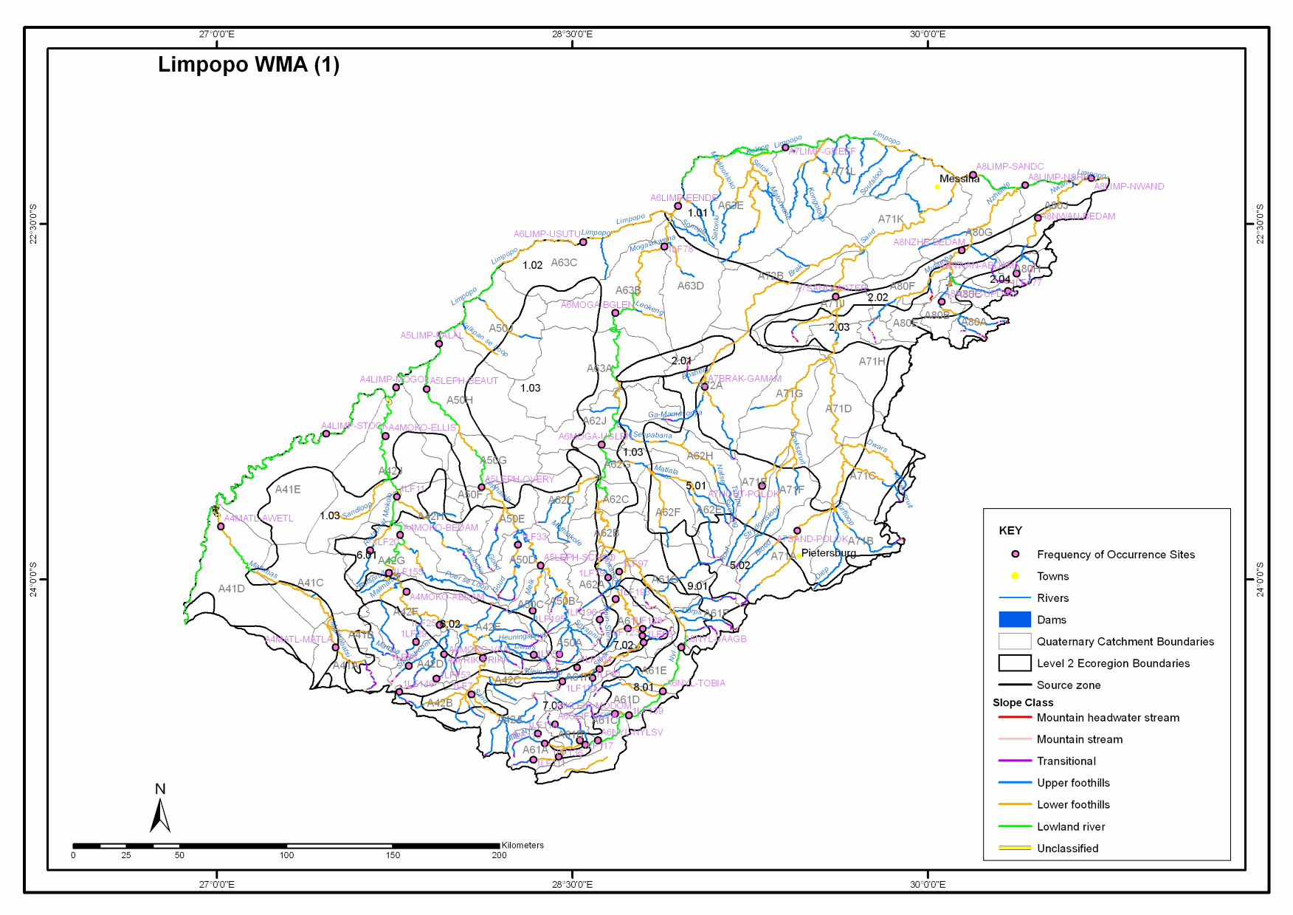
- WMA 2: LUVUVU TO LETABA
- WMA 2: LUVUVU TO LETABA CONTINUED
- WMA 2: LUVUVU TO LETABA CONTINUED
- MAP OF WMA 2 (LUVUVU TO LETABA) FISH SITES
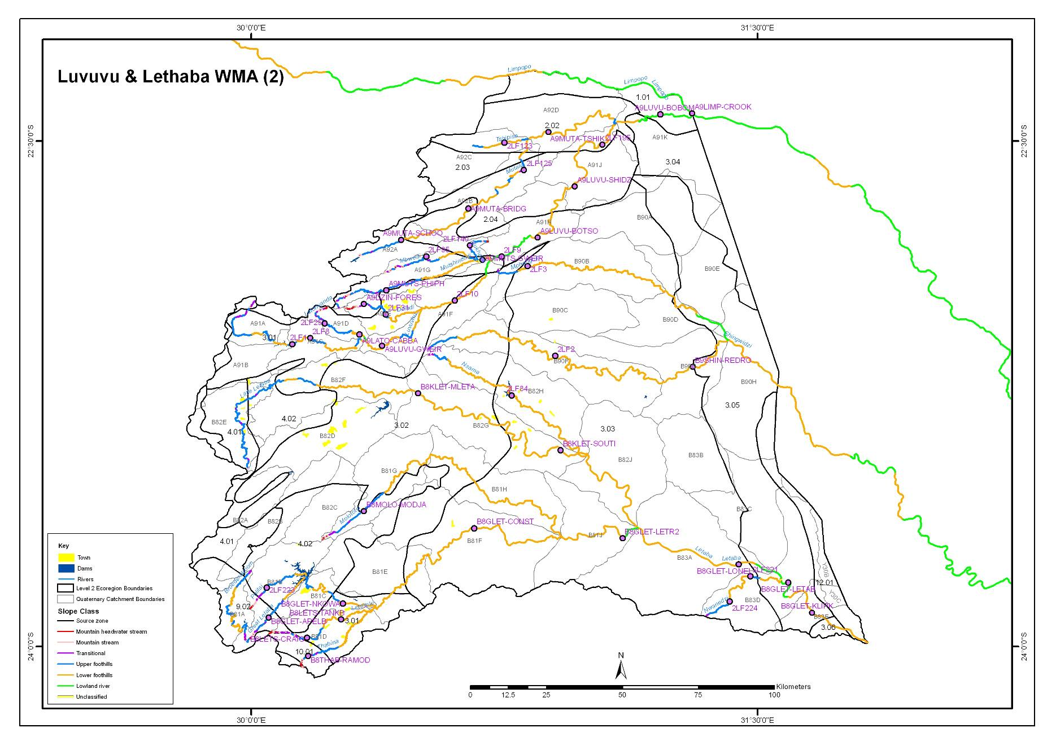
- WMA 3 CORCODILE (WEST) & MARICO
- WMA 3 CORCODILE (WEST) & MARICO CONTINUED
- WMA 3 CORCODILE (WEST) & MARICO CONTINUED
- WMA 3 CORCODILE (WEST) & MARICO CONTINUED
- WMA 3 CORCODILE (WEST) & MARICO CONTINUED
- MAP OF WMA 3 (CROCODILE (WEST) & MARICO) FISH SITES
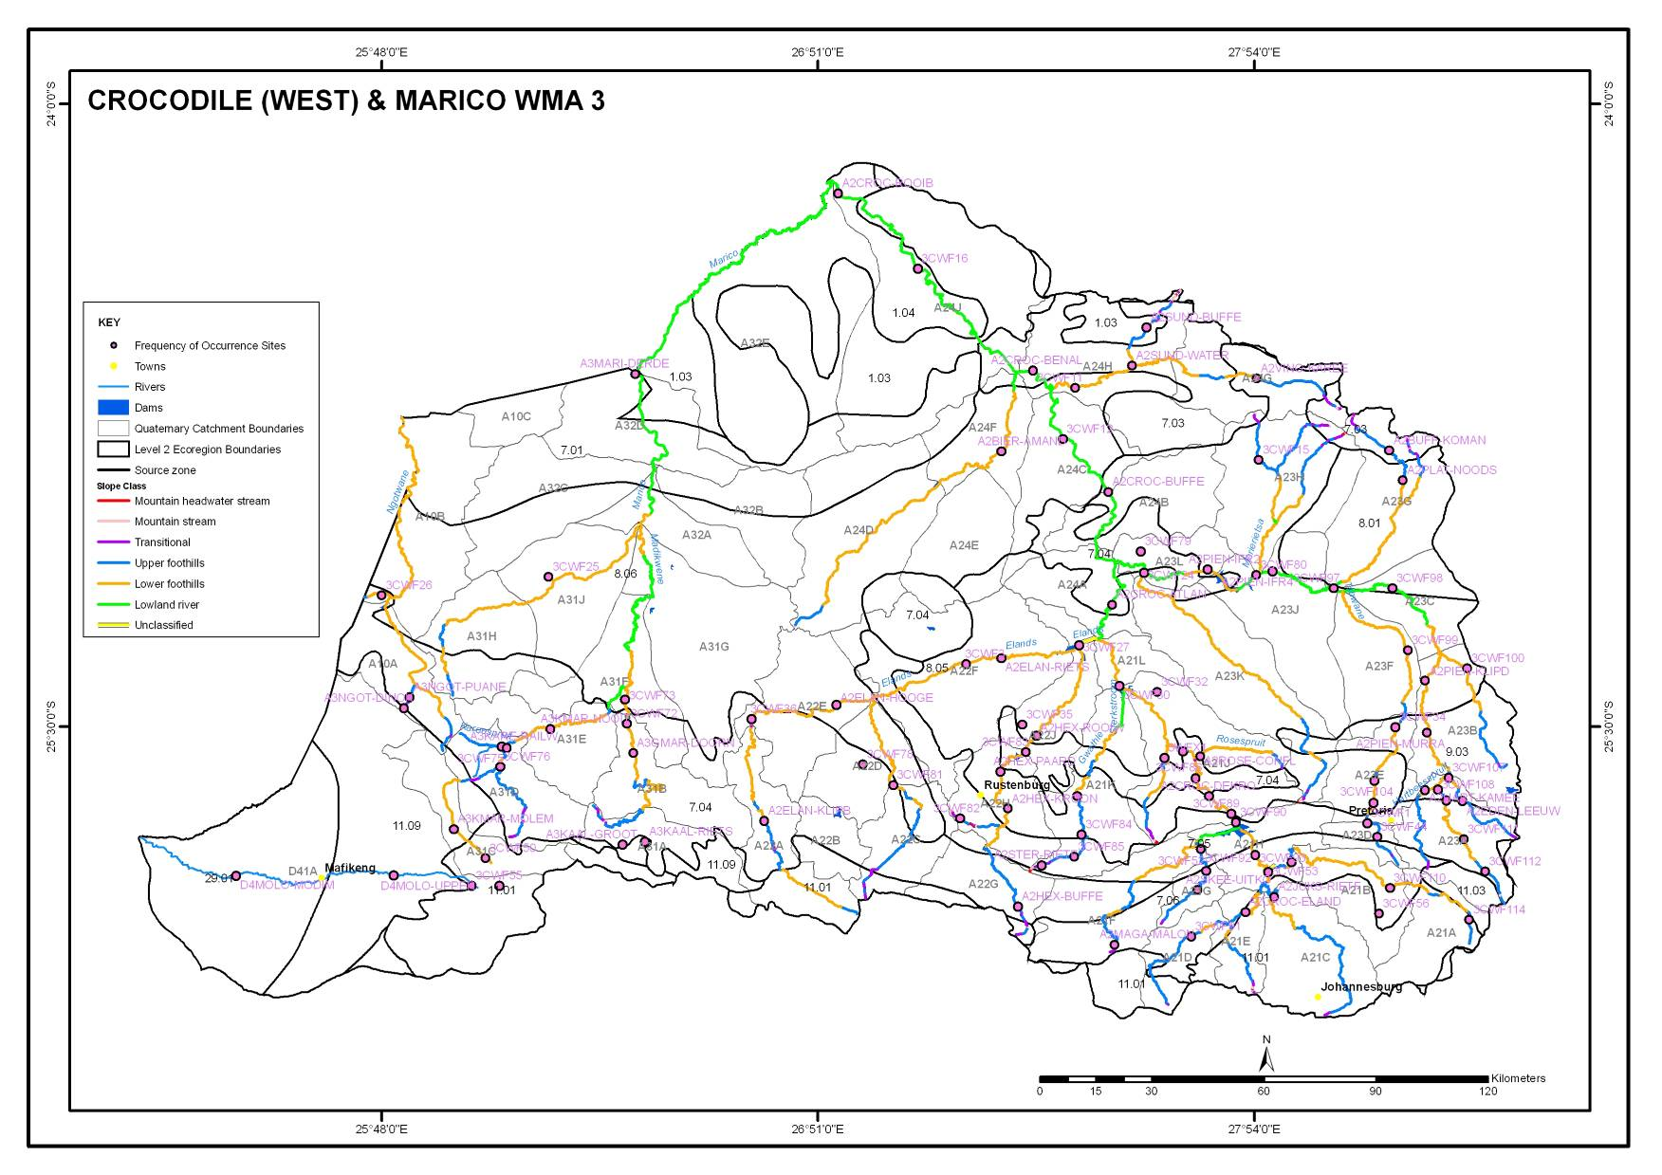
- WMA 4 OLIFANTS
- WMA 4 OLIFANTS CONTINUED
- WMA 4 OLIFANTS CONTINUED
- WMA 4 OLIFANTS CONTINUED
- MAP OF WMA 4 (OLIFANTS) FISH SITES 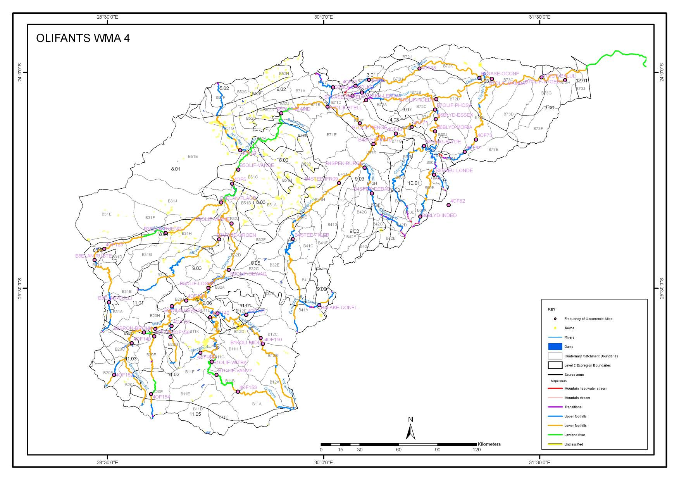
WMA 5 INKOMATI
Please note the following: The sites coded in colour are included in the database. Reference species list were identified for them, however due to time constraints the FROC was not undertaken.
- WMA 5 INKOMATI CONTINUED
- WMA 5 INKOMATI CONTINUED
- WMA 5 INKOMATI CONTINUED
WMA 5 INKOMATI CONTINUED
- WMA 5 INKOMATI CONTINUED
- WMA 5 INKOMATI CONTINUED
WMA 5 INKOMATI CONTINUED
- WMA 5 INKOMATI CONTINUED
- WMA 5 INKOMATI CONTINUED
- MAP OF WMA 5 (INKOMATI) FISH SITES (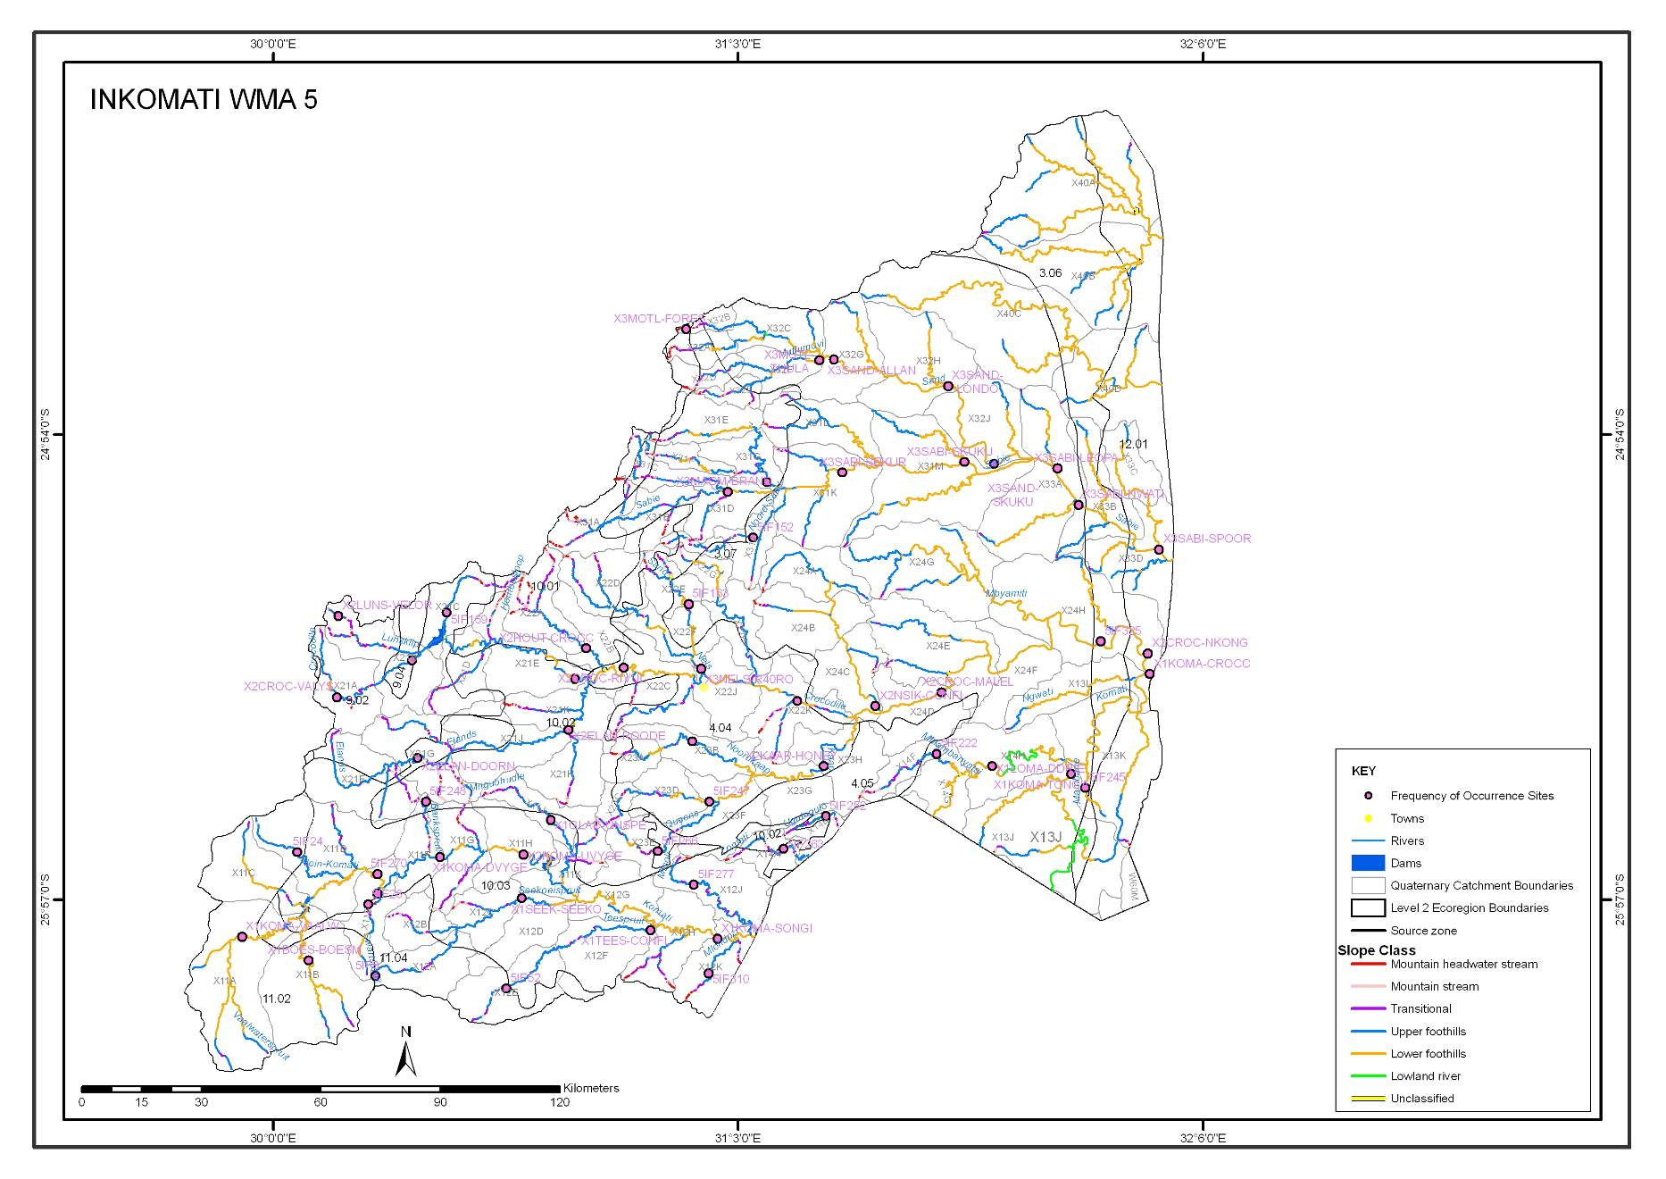
- WMA 6 USUTU TO MHLATUZE
- WMA 6 USUTU TO MHLATUZE CONTINUED
- WMA 6 USUTU TO MHLATUZE CONTINUED
- MAP OF WMA 6 (USUTU TO MHLATUZE) FISH SITES 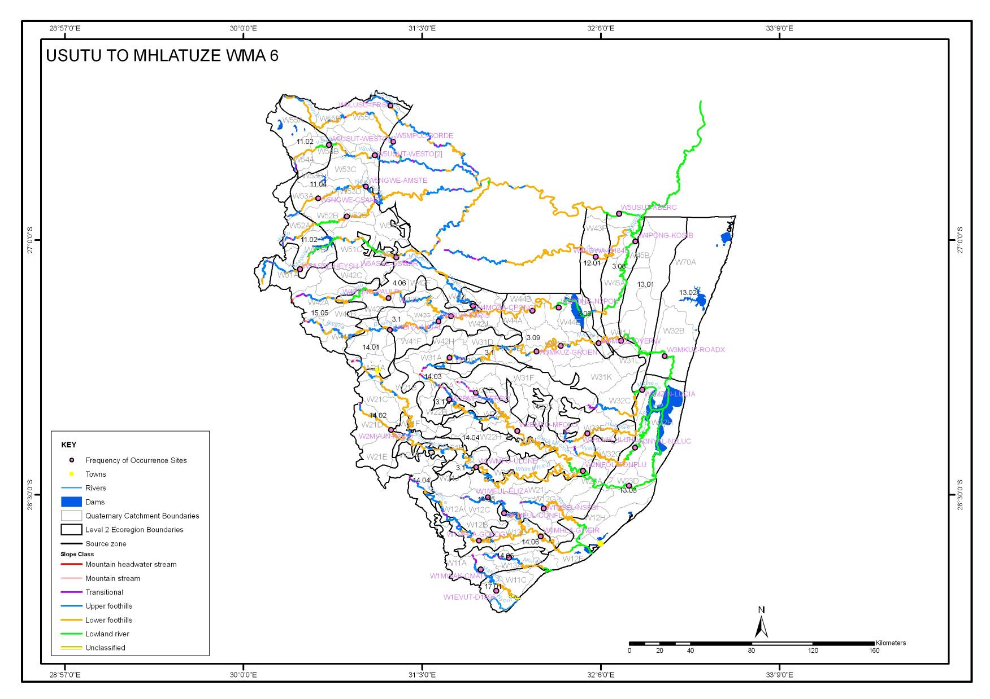
- WMA 7 THUKELA
- WMA 7 THUKELA CONTINUED
- MAP OF WMA 7 (THUKELA) FISH SITES 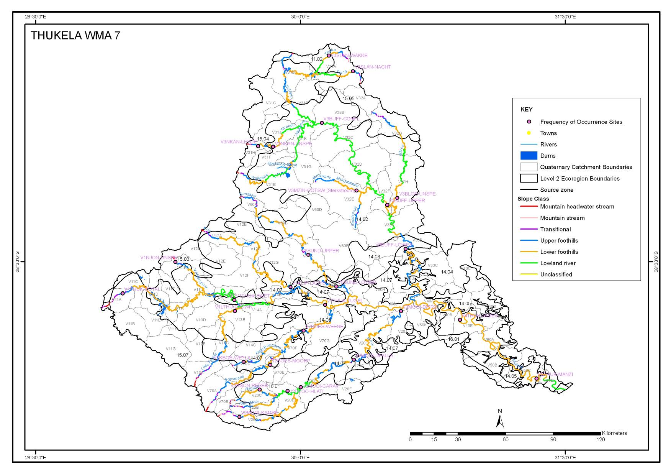
- WMA 8 UPPER VAAL
- WMA 8 UPPER VAAL CONTINUED
- WMA 8 UPPER VAAL CONTINUED
- WMA 8 UPPER VAAL CONTINUED
- MAP OF WMA 8 (UPPER VAAL) FISH SITES 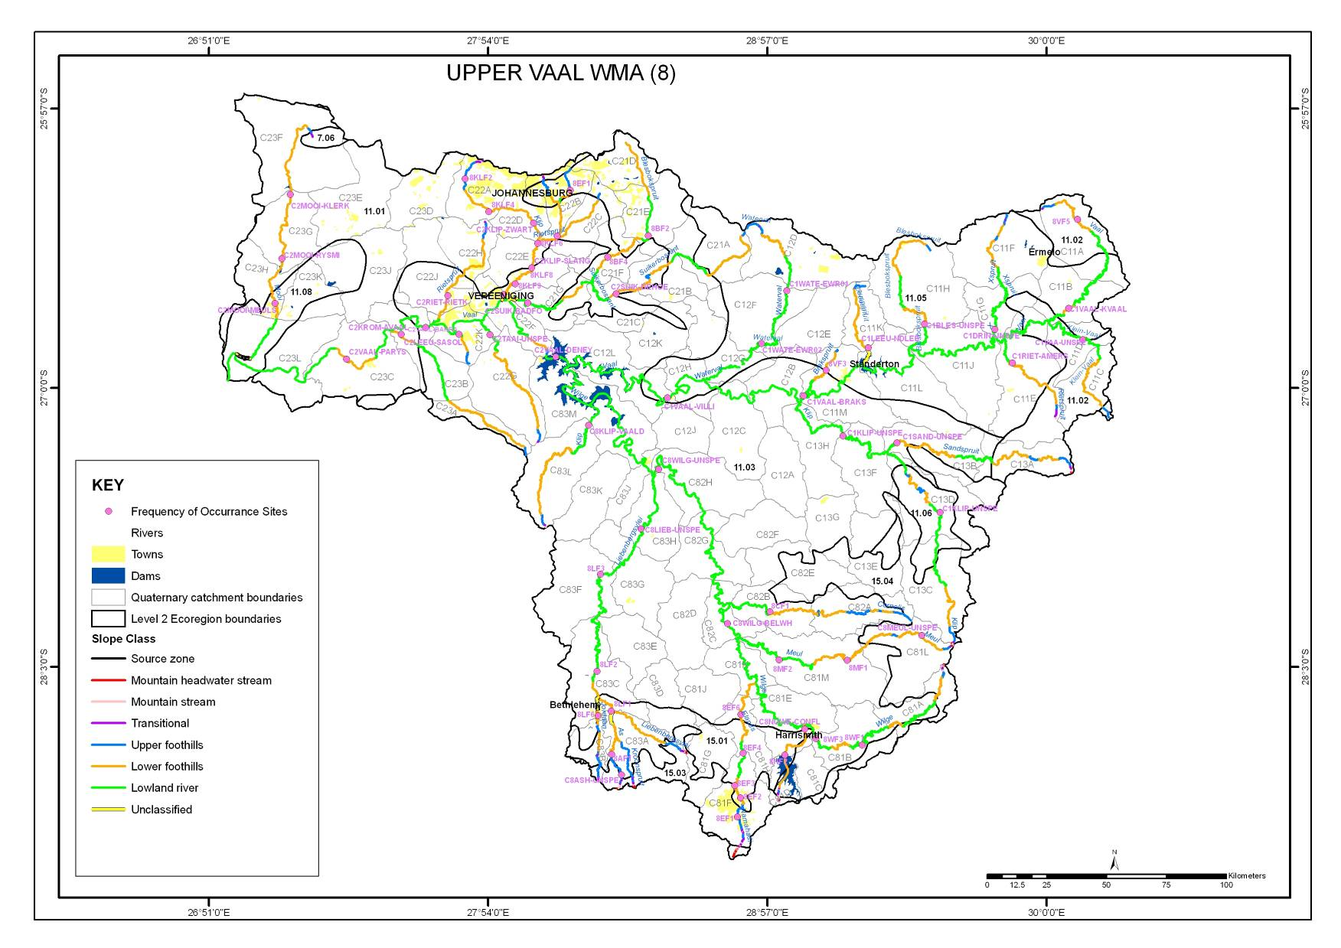
- WMA 9 MIDDLE VAAL
- WMA 9 MIDDLE VAAL CONTINUED
- MAP OF WMA 9 (MIDDLE VAAL) FISH SITES
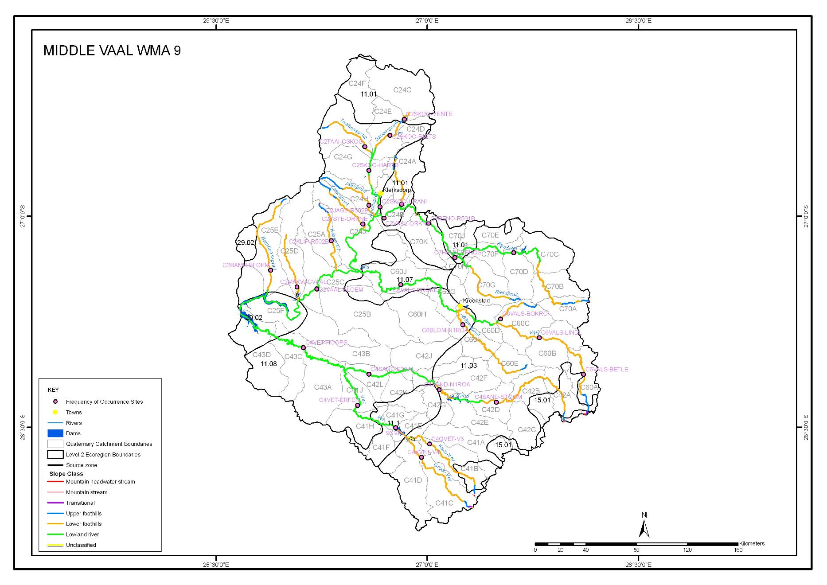
- WMA 10 LOWER VAAL
- MAP OF WMA 10 (LOWER VAAL) FISH SITES 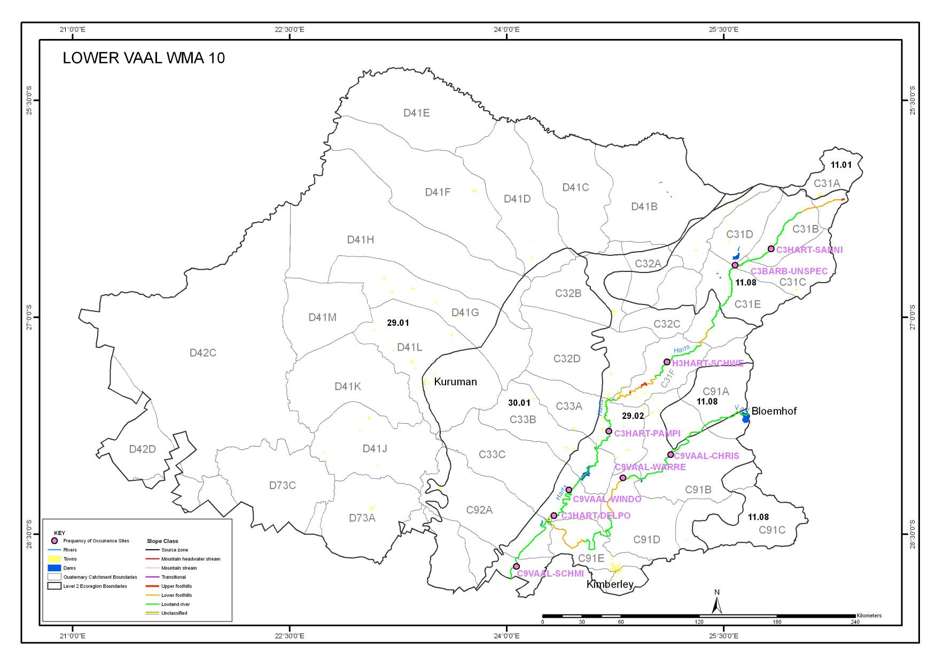
- WMA 11 MVOTI TO MZIMKULU
- WMA 11 MVOTI TO MZIMKULU CONTINUED
- MAP OF WMA 11 (MVOTI TO MZIMKULU) FISH SITES 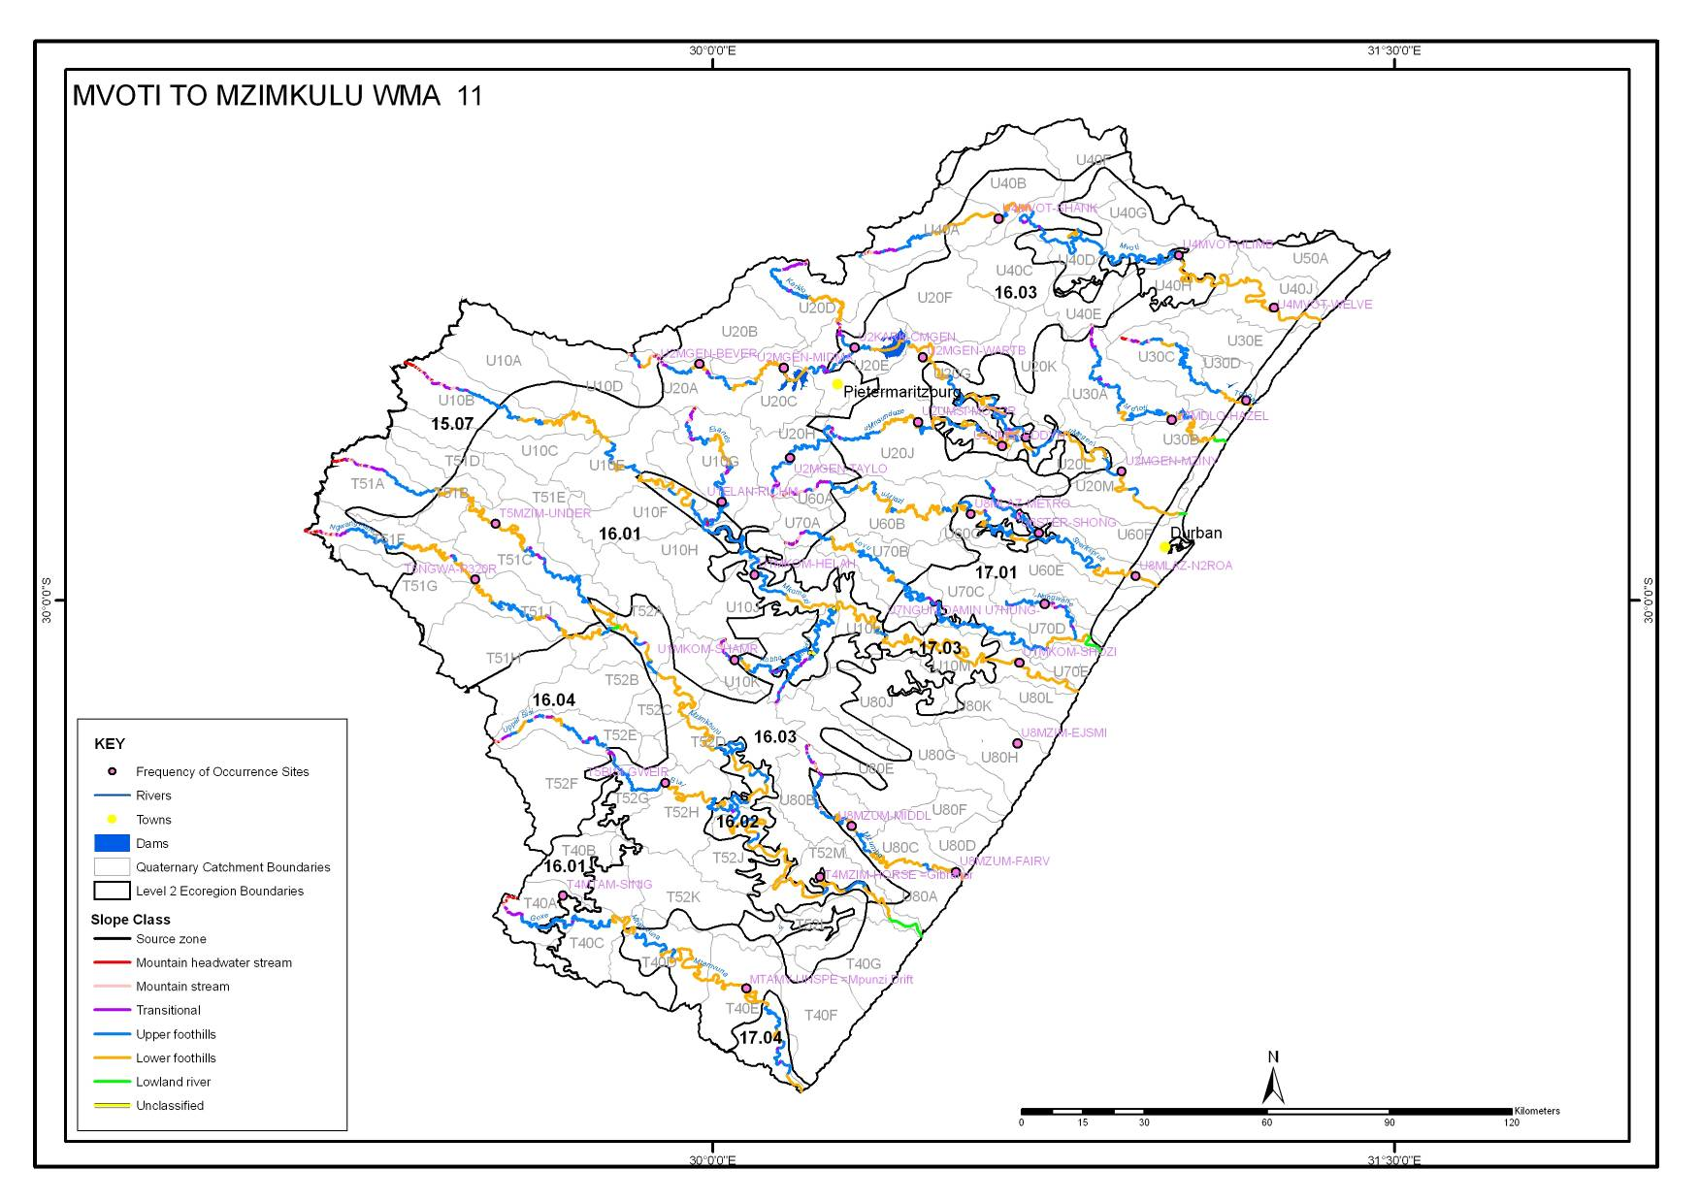
- WMA 12 MZIMKULU TO KEISKAMMA
- WMA 12 MZIMKULU TO KEISKAMMA CONTINUED
- WMA 12 MZIMKULU TO KEISKAMMA CONTINUED
- MAP OF WMA 12 (MZIMKULU TO KEISKAMMA) FISH SITES 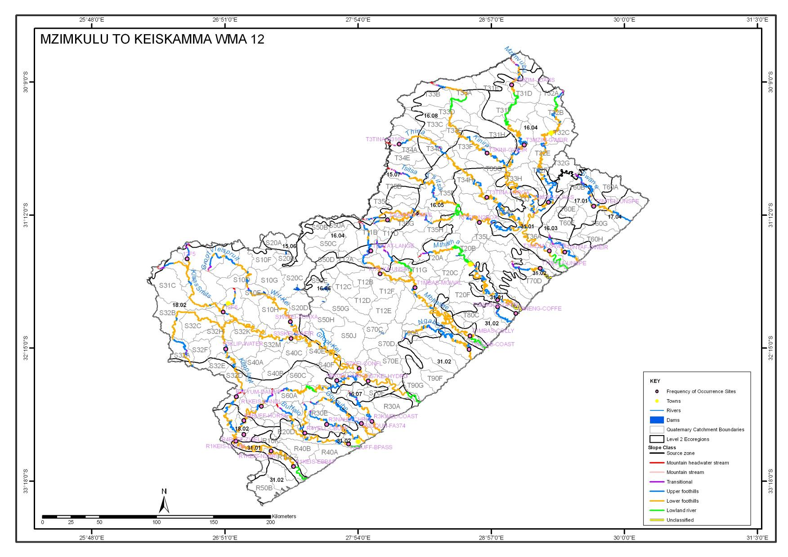
- WMA 13 UPPER ORANGE
- WMA 13 UPPER ORANGE CONTINUED
- WMA 13 UPPER ORANGE CONTINUED
- WMA 13 UPPER ORANGE CONTINUED
- MAP OF WMA 13 (UPPER ORANGE) FISH SITES 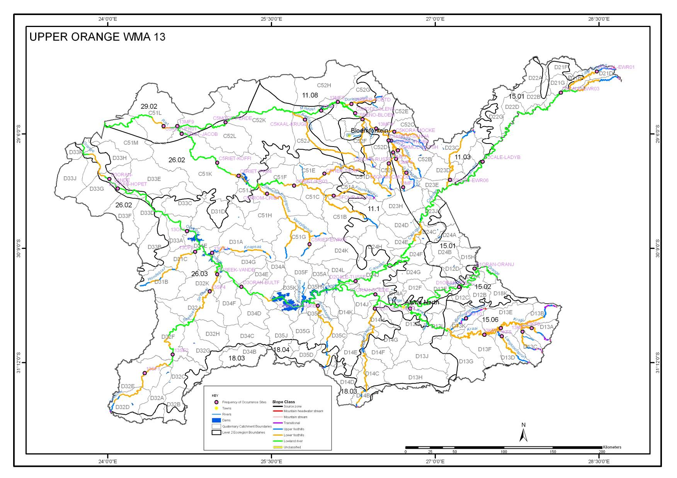
- WMA 14 LOWER ORANGE
- MAP OF WMA 14 (LOWER ORANGE) FISH SITES 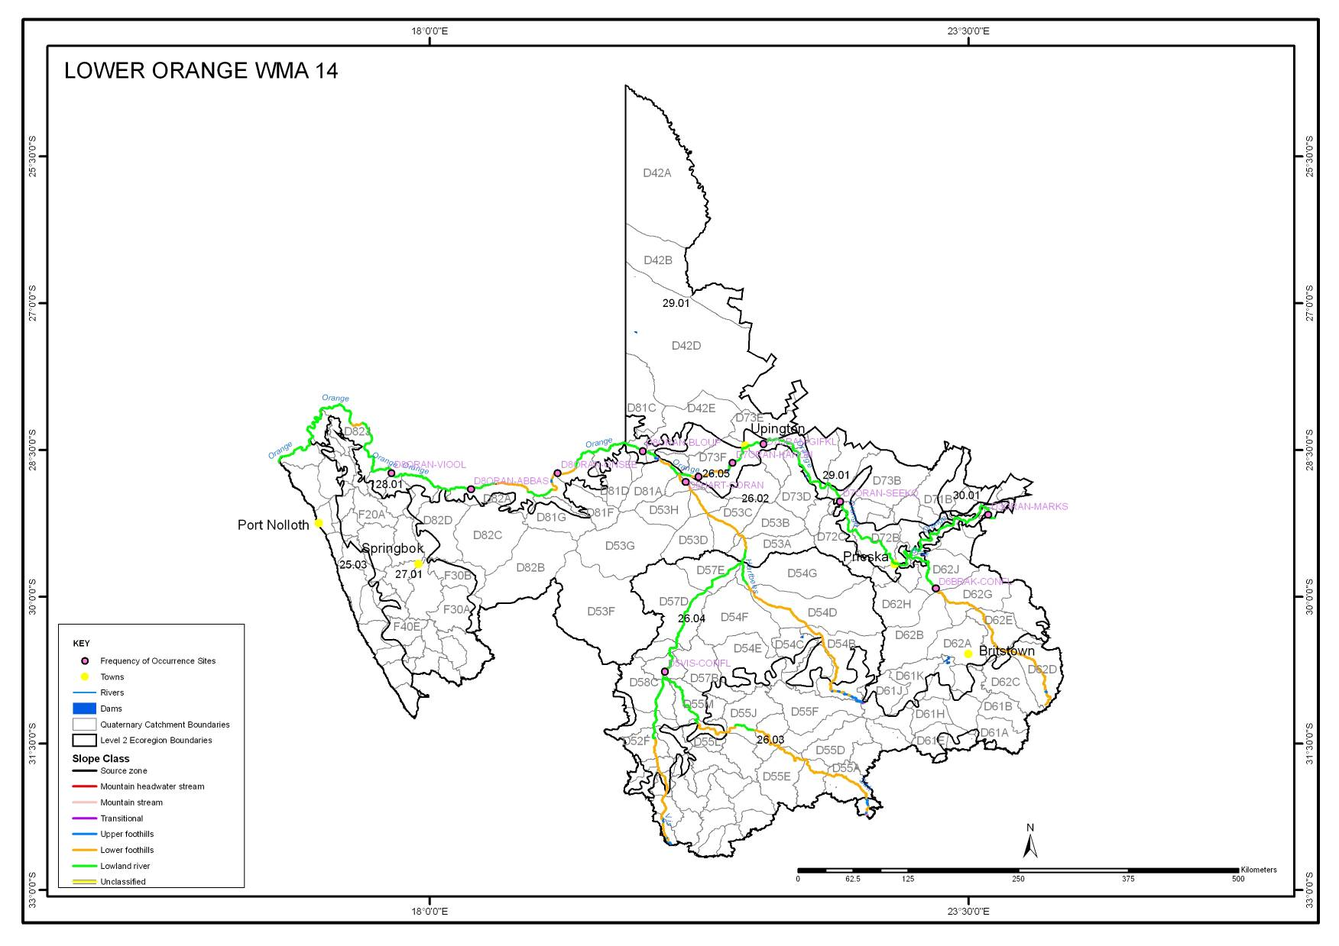
- WMA 15 FISH TO TSITSIKAMA
- WMA 15 FISH TO TSITSIKAMA CONTINUED
- WMA 15 FISH TO TSITSIKAMA CONTINUED
- MAP OF WMA 15 (FISH TO TSITSIKAMA) FISH SITES 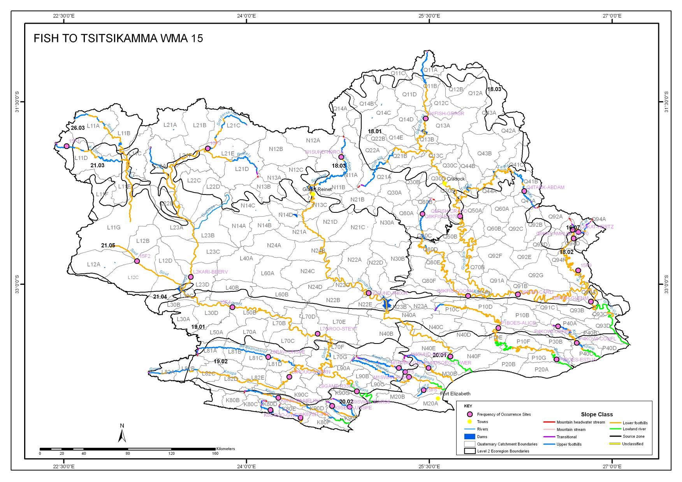
- WMA 16 GOURITZ
- WMA 16 GOURITZ CONTINUED
- WMA 16 GOURITZ CONTINUED
- MAP OF WMA 16 (GOURITZ) FISH SITES
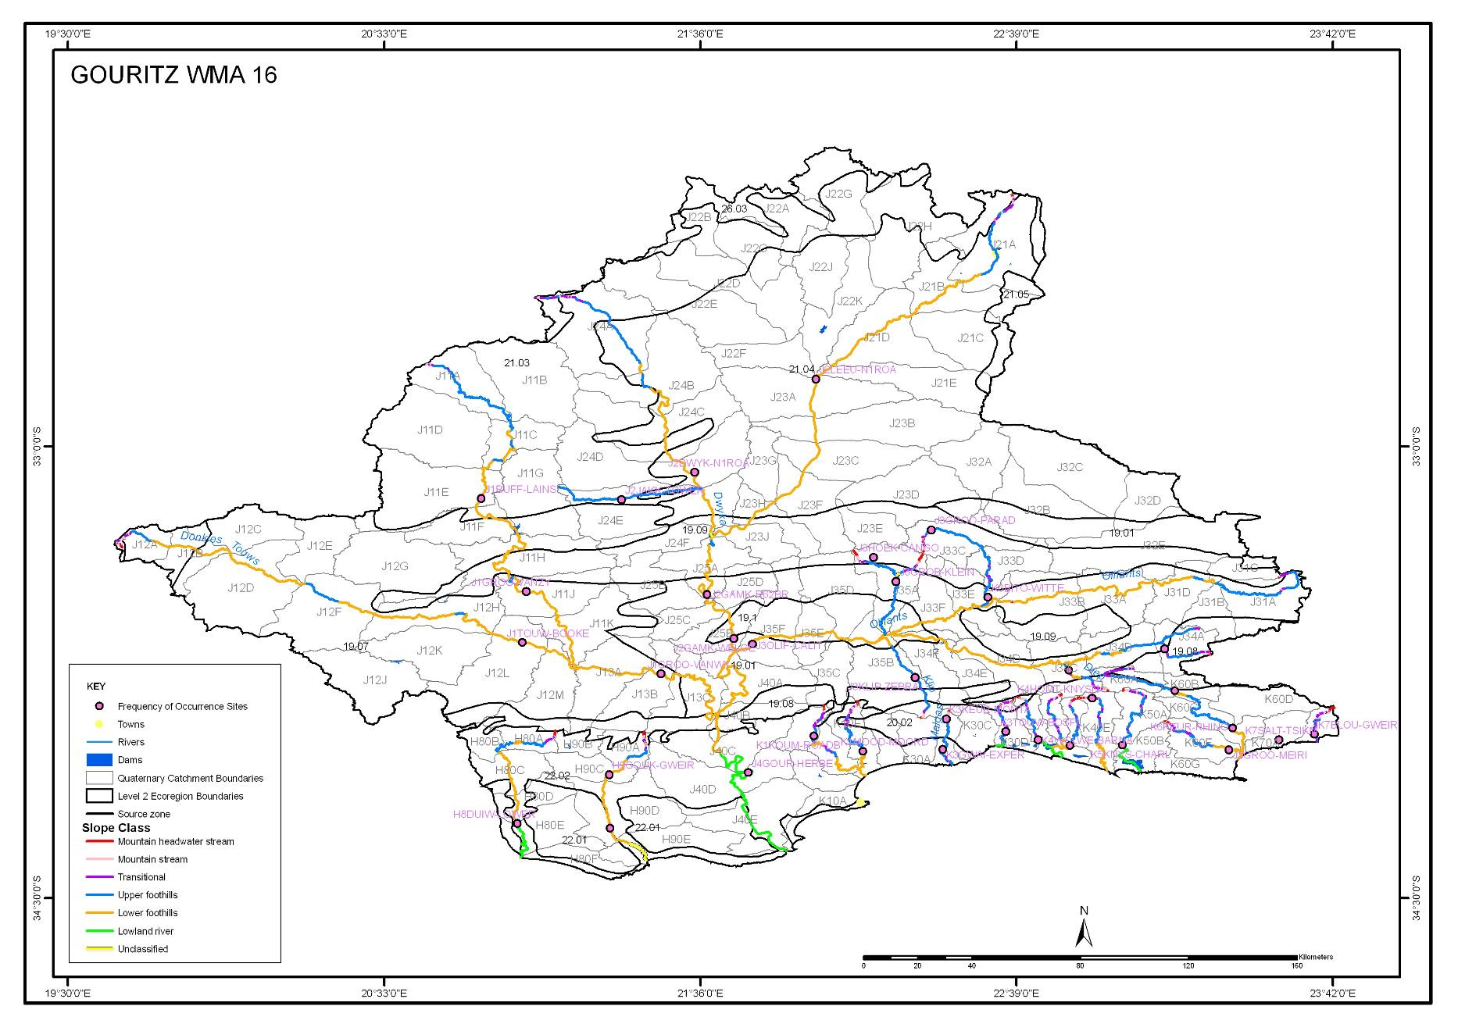
- WMA 17 OLIFANTS DORING
- WMA 17 OLIFANTS DORING CONTINUED
- WMA 17 OLIFANTS DORING CONTINUED
- MAP OF WMA 17 (OLIFANTS DORING) FISH SITES
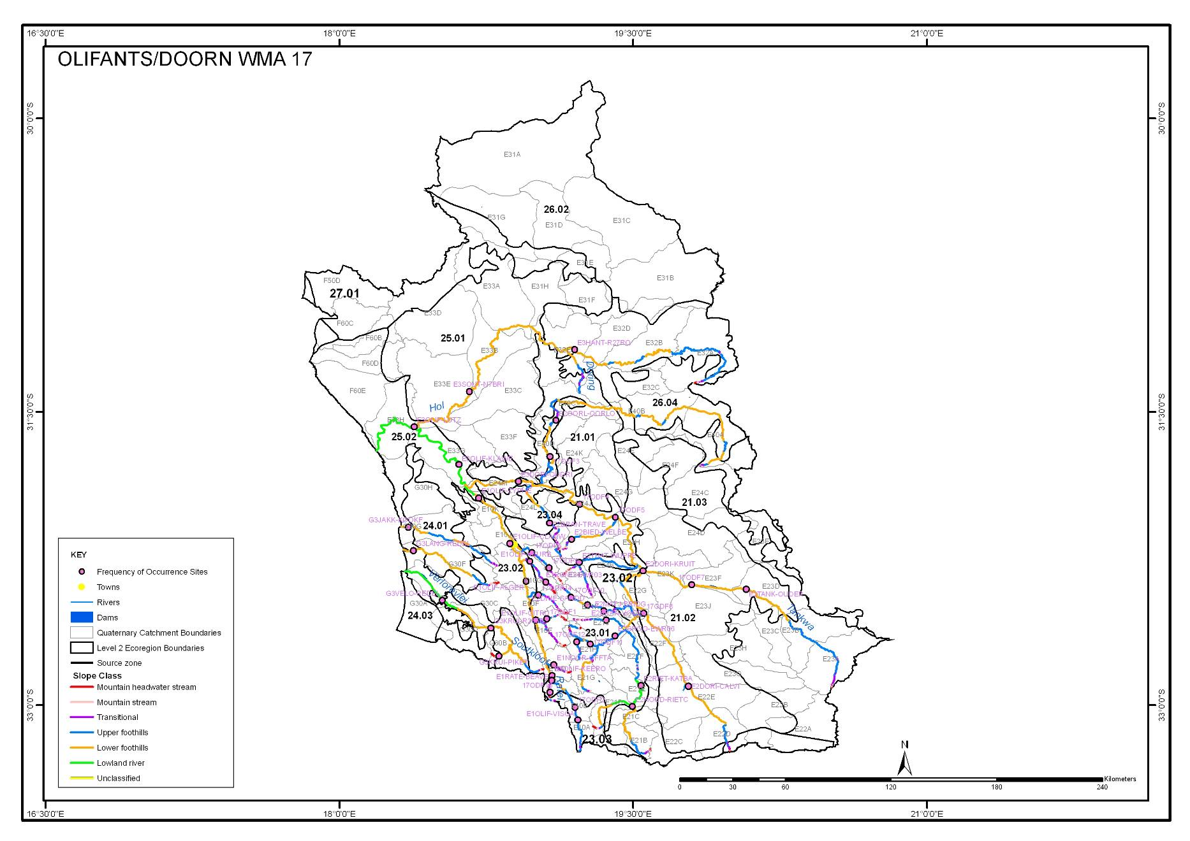
- WMA 18 BREEDE
- WMA 18 BREEDE CONTINUED
- WMA 18 BREEDE CONTINUED
- WMA 18 BREEDE CONTINUED
- MAP OF WMA 18 (BREEDE) FISH SITES 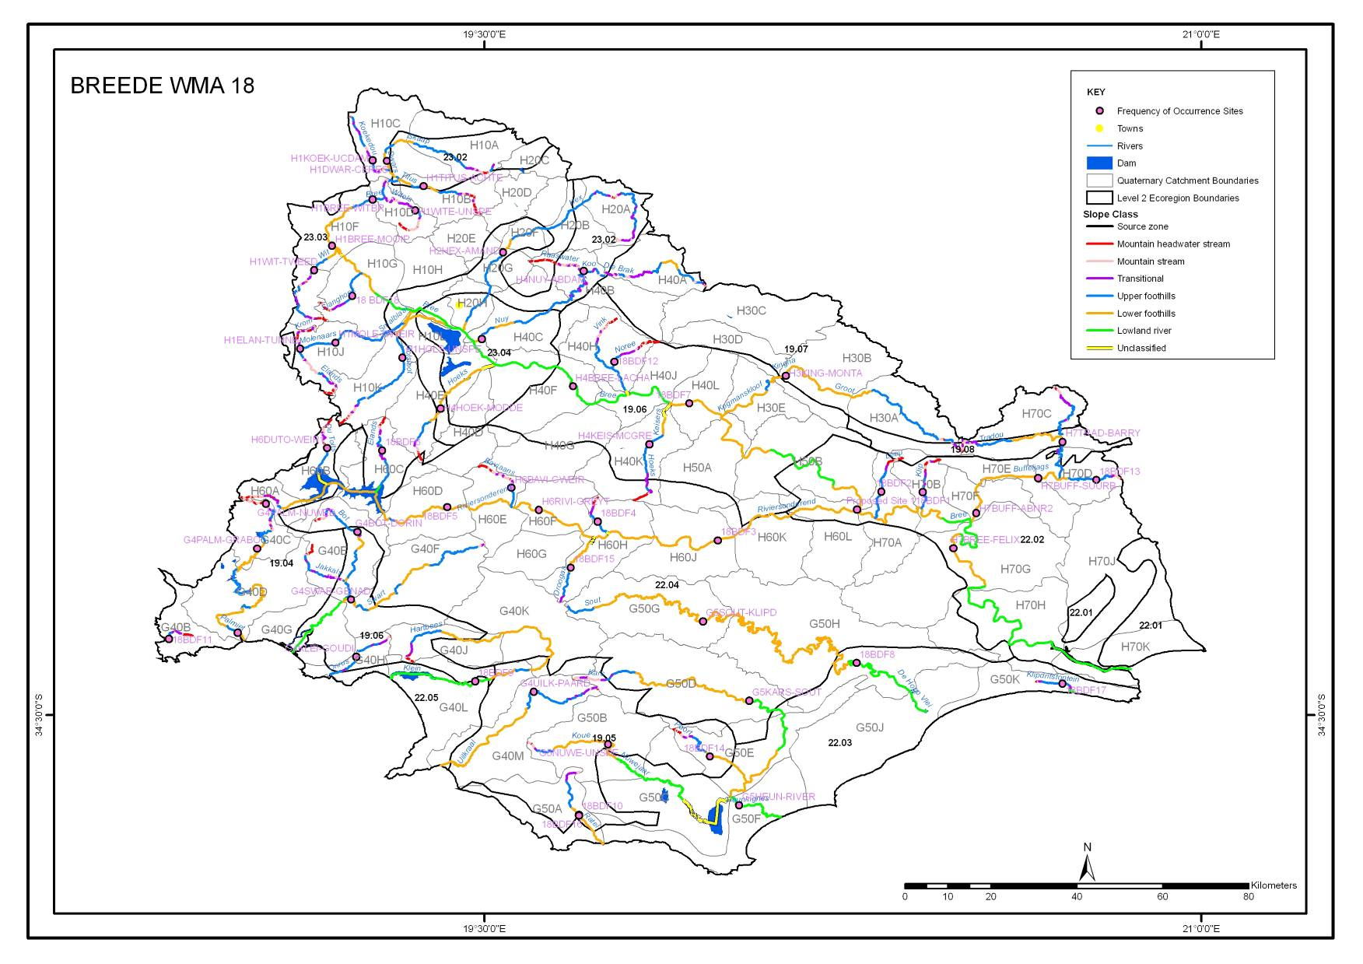
- WMA 19 BERG
- WMA 19 BERG CONTINUED
- WMA 19 BERG CONTINUED
- MAP OF WMA 19 (BERG) FISH SITES 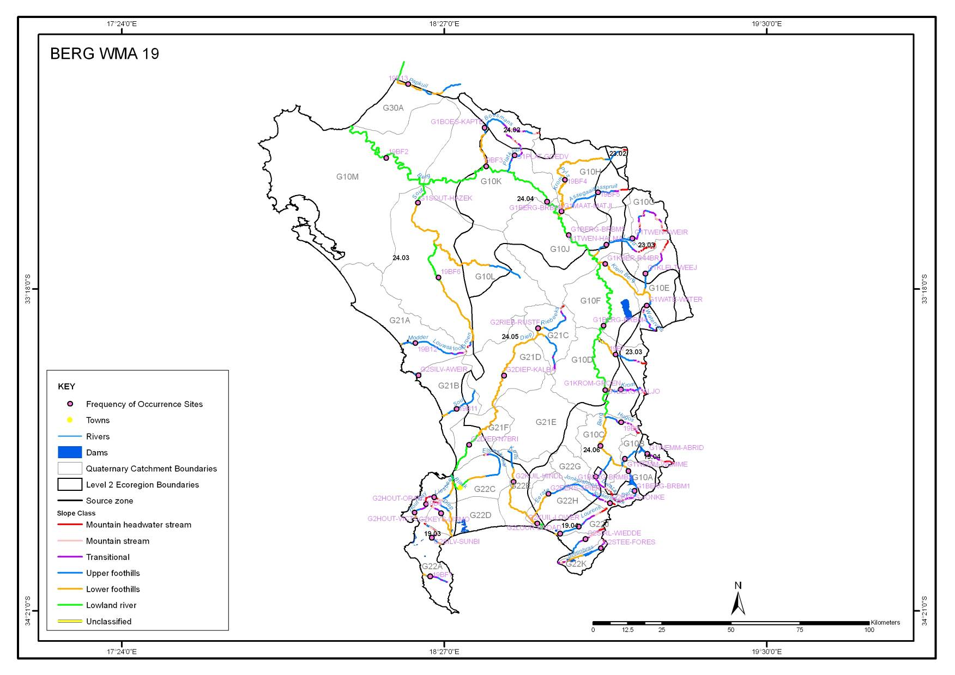

references
Kleynhans, CJ, Louw, MD, Thirion, C, Rossouw, NJ, and Rowntree, K (2005). River EcoClassification: Manual for EcoStatus determination (Version 1). Joint Water Research Commission and Department of Water Affairs and Forestry report. WRC Report No. KV 168/05

H.F. Dallas 2005. Inventory of National River Health Programme Monitoring sites volume 1. The Freshwater Consulting Group / Freshwater Research Unit University of Cape Town Prepared for: Environmentek (CSIR) and Resource Quality Services, Department of Water Affairs and Forestry.

Midgley DC, Pitman WV and Middleton BJ (1994) The Surface Water Resources of South Africa 1990. Volumes 1 to 6. Report Numbers 298/1.1/94 to 298/6.1/94 (text) and 298/1.2/94 to 298/6.2/94 (maps), Water Research Commission, Pretoria.

Rowntree, K.M. & Wadeson, R.A., 1999: A Hierarchical Geomorphological Model for the Classification of Selected South African Rivers, WRC Report No. 497/1/99, WRC, Pretoria.

