National Aquatic Ecosystem
Biomonitoring Programme

Rivers database: A user manual
NAEBP Report Series No 11




Department of Water  Affairs and Forestry | Department of Environmental Affairs and Tourism | Water Research Commission

Published by the

Department of Water Affairs and Forestry

March 2000

All enquiries should be addressed to:

The Director: Institute for Water Quality Studies
Private Bag X313
PRETORIA 0001
Republic of South Africa

Tel: (012) 808-0374

Copyright reserved
This report should be cited as:

Fowler, J, H Dallas and P Janssens. 2000. Rivers database: A user manual.
NAEBP Report Series No 11. Institute for Water Quality Studies,
Department of Water Affairs and Forestry, Pretoria, South Africa.

Compiled by:

J. Fowler, H. Dallas & P. Janssens*
Southern Waters Ecological Research and Consulting cc
Freshwater Research Unit
University of Cape Town
CAPE TOWN
South Africa

And

Soft Craft Systems*
P O Box 30169
TOKAI
South Africa

Table of Contents

1. INTRODUCTION 1
1.1 Background 1
1.2 Current data 1
1.3 Maintenance and future links to the Water Management System (WMS) 1
1.4 User control and data security 1
1.5 Layout of the manual 2
1.6 Current status of the Rivers Database 2
2. STRUCTURE OF THE DATABASE AND VIEWING DATA 2
2.1 Viewing information in Tree View 4
2.1.1 Filtering the Tree View 4
2.1.2 Navigating to sites 4
2.1.3 Adding a new river, subregion or segment 5
2.2 Site and Site Visit information 6
2.2.1 Adding a new site 7
2.2.2 Viewing data in Section A 7
2.2.3 Adding site data to Section A 10
2.2.4 Viewing Site Visit data in Section B 11
2.2.5 Adding Site Visit data to Section B 12
2.2.6 Viewing Site Visit data in Section C 12
2.2.7 Adding Site Visit data in Section C 16
2.2.8 Reference Condition 17
3. Query Centre 17
3.1 Step-by-step Instructions on using the Query Data Designer 17
Query Notes 19
3.2 Setting Criteria 19
3.2.1 Operators and Wildcards 19
3.2.2 More about criteria 20

4. Technical information 21
4.1 Software and Hardware Requirements 21
4.1.1 Application Architecture 21
4.2 Installing the Rivers Database application 22
4.3 Starting the Rivers Database Application 22
4.4 Synchronising and replicating the database 22
4.4.1 Replicating or backing up the database 23
Creating a Backup Replica 23
4.4.2 Creating a replica to send to the Central Authority
23
4.4.3 Synchronising a user replica with the central Master File 24
4.5 Troubleshooting tips 24
4.6 Utilities 25
5. user Support for the Rivers Database 25
6. References 26

Appendix 1. Glossary of terms used in this manual 27
Appendix 2. Screen dumps of the different forms in each section of the Rivers Database 29
Appendix 3. A step-by-step example of a query setting specific criteria 45

- INTRODUCTION

  - Background
The development of the Rivers Database was initiated as a small component of the Ecological Reference Condition project which began in August 1997 within the national River Health Programme (RHP). Initially, the purpose of the Rivers Database was to store data collected for the derivation of ecological reference conditions for Mpumalanga. However, during the course of this project, the need for a system which would ensure the efficient storage and management of all ecological information collected as part of the RHP became evident. Consequently, the Rivers Database project was expanded to include all aspects of general importance to the RHP thereby providing a standard biomonitoring data protocol for the collation and management of data on a national scale.

  - Current data
Besides its basic framework for the inclusion of biomonitoring data, the Rivers Database currently houses a considerable amount of data. In particular, data collected as part of the pilot study from the Mpumalanga region for the final design phase of the RHP (Roux 1999), together with historic data for primary catchments B and X are included in the database [Institute for Water Quality Studies (IWQS), Department of Water Affairs & Forestry (DWAF)]. Using existing spatial information captured in Geographic Information Systems (GIS), basic information regarding rivers and their subregions was extracted for the design of the tree view. Also, basic site information such as longitude/latitude, geological- and vegetation-type has been extracted from GIS covers. Most of the biological data that are available relate to invertebrate taxa (using SASS), water chemistry and habitat characteristics collected for water quality assessments undertaken by IWQS since 1993.

  - Maintenance and future links to the Water Management System (WMS)
It is envisaged that a central body such as DWAF would maintain the national “Rivers Database”, with each province or authority having their own regional “Rivers Database”. Although mechanisms of updating the “Rivers Database” at provincial and national levels are being explored, the exact process of data transferral has not yet been finalised. However, it is likely that the “Rivers Database” will link up with the Water Management System (WMS) which is being developed by DWAF and will ultimately house all water resource related data. Discussions are currently underway with the database architects of the WMS to determine the most efficient means of transferring data between the “Rivers Database” and the WMS.

  - User control and data security
It will be the responsibility of each regional authority or "champion" to facilitate and regulate the capture of data at regional level. All authorities applying the RHP (or components thereof) and who wish their data to contribute to the national database will need to work through their regional "champion". For security purposes all users will need to register and will be allocated a user name and password. All users will be able to view the data, but only the "owner" of a particular data-set will be able to edit data that has been added under their user name. A site transaction form tracks changes made to site level components of the database and enables a detailed record to be kept of such changes.

  - Layout of the manual
This manual has been written as a guide to users of the Rivers Database application. It is divided into the following sections:
- General structure of the database, viewing and editing data, and adding new data
- Querying the database
- Technical Information

Terms used in this manual are described in the glossary appended (Appendix 1). Additional details are available in the manual written for the ecological reference condition project (Dallas 2000) and on which the Rivers Database is based.

  - Current status of the Rivers Database
This manual accompanies the Rivers Database currently distributed on CD. Most components of the database are finalised with the exception of the riparian vegetation and fish indices. Both of these indices require testing and further refinement. It is likely that additional components such as hydrological and geomorphological indices may be incorporated in subsequent phases of the Rivers Database. Further development on the reference condition aspect of the database is also planned for future phases.

STRUCTURE OF THE DATABASE AND VIEWING DATA

The Rivers Database is divided into two broad components as follows:
- Editing and viewing the data - this facilitates the entry and viewing of data via a hierarchical Tree View.
- Querying the data - this allows for the extraction of data already entered in the database.
A schematic diagram of the database structure and the various components is given in Figure 2.1. The different forms from each section are displayed in Appendix 2. Note: Neither the riparian vegetation or fish components are populated with real data and forms displayed are therefore merely fictitious examples.
(Assessed during each site visit)
Tree View: Rivers: "parent" and tributaries
Sites
Subregions: geomorphological zones
Section A
General information
Geo-reference
Location details
Physical characteristics and geomorphology
Site transaction record
Photographs
Section B
Catchment and land-use
Water quality impacts
Channel condition
Channel morphology
Present status
Section C
General
Site Visit information
Stream dimensions
Substratum composition
Invertebrates
Biotopes
Invertebrate taxa
Habitat assessment
Water chemistry
Chemistry - general
Chemistry - data
Riparian vegetation
Riparian zone description
Vegetation cover
Invasion of riparian zone
Riparian vegetation species list
Abundance and ranking of riparian vegetation
Riparian vegetation index
Fish
Fish samples
(Assessed during initial site visit and checked during each subsequent site visit)
Reference condition (data from relevant components are compared with historical or reference data)
Riparian vegetation
Invertebrates (still to be established)
Fish (separate fish database, only for Mpumalanga region at present)

Adding River(s) and subregion(s) via the Tree View
Adding a new site via the Tree View or Section A: General Information

Figure 2.1 Schematic diagram showing the various components included in the Rivers Database
  - Viewing information in Tree View
The purpose of the Tree View is to allow one to efficiently navigate to rivers, their tributaries and subregions or segments either to view sites on rivers already entered into the database or to add new sites or new site visits to existing sites (see section 2.2.3).

The Tree View is divided into two sections as follows:
- all existing “parent” rivers and their tributaries are viewed in the left hand block.
- subregions and site codes are viewed in the right hand block.

    - Filtering the Tree View
A searching function has been added to the Tree View to enable the user to navigate and locate sites within a specific region (political, bioregion, ecoregion), catchment (secondary or quaternary), subregion, hydrological type, rainfall region, or by river, site code, map reference or DWAF gauging station code.

Once a selection has been made using the drop-down lists in the fields "Filter trees for" and "=", all parent rivers and associated tributaries in which the selected criteria are met and returned. Matching sites are returned and may be viewed in the drop-down list "Matching sites". The navigational sequence to the selected site is displayed and includes: the name(s) of all rivers above it in the hierarchy together with the subregion in which the site occurs.

To clear the selection criteria, click the "Clear" button and refresh screen to view all rivers.

    - Navigating to sites
- Click the cross to the left of the river name of a given “parent” river to expand the tributaries of that river. (To reverse the operation and contract the tributaries click on the minus sign next to the appropriate river).
- Select the desired sort order of rivers and their tributaries by selecting either the “alphabetical” order or “sequential” order which sorts the rivers and their tributaries either alphabetically or in the order of occurrence from "source to sea" along a parent river respectively.
- Continue clicking the cross to the left of each river in the hierarchy until the desired river has been found.
- Highlight the desired river by clicking on the river name.
- Select the desired “navigational” sequence by selecting either “subregions” or “segments” at the bottom left hand side of the tree view. All subregions (or segments, depending on the desired sequence selected) of the highlighted river will automatically appear in the block on the right of the Tree View in order of their occurrence from source to its confluence with the parent river.
- Click the cross to the left of the subregion (or segment) to view the site codes (see section 2.2. for an explanation of the site codes) of all existing sites in that subregion (or segment).
- Double click the site code or click “go” to view detailed site information. This action opens “Section A”, “Section B” and “Section C” which houses all site and site visit information.
- Click "Refresh" to return the screen to the original form of the Tree View.
- Click "Rebuild Tree" to incorporate changes made to the Tree View.
- Click "River/Subregion" to add, edit or delete rivers or subregions (see Section 2.1.3)
- "Picklist Options" is an administrative function whereby drop-down lists etc. are edited. Access to this is strictly controlled.
- Click "Exit" to close the database.

    - Adding a new river, subregion or segment
With the exception of the Mpumalanga region, users will need to enter information at the river, subregion and segment (if appropriate) level before entering information for specific sites. The process of adding a new river and subregions or segments to the Tree View is explained in this section.

To add a new river:
- Click "River/Subregion"
- Type in the name of the new river to be added. If it is a tributary of a river which already exists in the database then select the relevant river from a drop-down list which appears when the down arrow to the right is selected. If the new river is a parent river then the “is a tributary of” box is left blank but the “parent river” box is ticked by clicking in the relevant box.
- Select the secondary catchment code into which that river falls from the existing dropdown list.
- Type in the order of occurrence of a river if it is a tributary of another river in the “Sort Order” box. E.g. if the Klip River is the 23rd tributary of the Blyde River by counting tributaries from the source of the Blyde River to its confluence with the Olifants River, then type 23 in this box. If the sort order is unknown, then the rivers and their tributaries are automatically sorted alphabetically in the tree view.
- Click the “Add Record” button.

To add a new subregion:
- Choose the river to which a new subregion will be added from the drop-down list at the top of the form.
- Once the details of that river appear on the form select the “subregions” tab.
- Select a subregion from the drop-down list and enter its sequence from the source of the river. The same subregion may be added more than once with a different number indicating the sequence each time.
- If the subregion is unknown, select the “unspecified” option from the drop-down list.
- Click the “Add Record” button.

To add a new segment:
Repeat the steps outlined above for adding a new subregion to the tree view but select the “segment” tab. Once all new details have been added, return to the Tree View by clicking the “Close Form” button.

  - Site and Site Visit information
Sections A, B and C of the Rivers Database form the main body of the database for the inclusion of information which both characterises a site and provides information for the assessment of the condition of a river at a particular site at a given time. The field datasheets for the collection of biomonitoring data form the basis for the design of this component of the Rivers Database and a full description of some of the information included in the database has been taken from the associated field manual (Dallas 2000). Each section varies with regard to the nature of information entered and the frequency of assessment as follows:

 | TYPE OF INFORMATION | FREQUENCY OF ASSESSMENT
SECTION A | Site specific information | Entered during or after the first site visit
SECTION B | Site visit information | Entered during the first site visit and is checked and reassessed on each site visit
SECTION C | Site visit information | Assessed during each site visit

The basic layout for all 3 sections is as follows:
- The active bar with separate buttons for “Section A”, “Section B”, “Section C” and the Reference Condition and Admin sections. Click these buttons to list the forms which are included within each section.
- A header with information about the current user, the organisation to which the user is affiliated and the "owner" of the data. The site code selected in the Tree View is displayed, and the user is able to switch to another site within the same river and subregion by selecting the appropriate site from the drop-down list. To show all sites, regardless of river or subregion, click the "Show All Sites" button. In the case of Sections B and C, the date of the site visit is displayed. In Section C, a drop-down list enables Section C to be divided into subcategories, namely general, invertebrates, water chemistry, riparian vegetation and fish. Details of each section are given in sections 2.2. to 2.2.4 respectively.

    - Adding a new site
A new site can be added by clicking the "Add Site" button which appears in both the Tree View form and the General Site Information form of Section A. To add a site on the Tree View form:
- Navigate to the river and subregion into which a site needs to be added (see section 2.1.3).
- Click the "Add Site" button. This opens the general site information form.
- Type in the new site code.
- Click the "Add Site" button on the form. This will update the site code in the header and populate the drop-down list with the new site code. Note: If the "Add Site" button is clicked again at this point, the site code box will be cleared and a new site may be added to the same river and subregion.
- The river name is confirmed by checking the drop-down list of river name, together with the secondary catchment code, tributary of, subregion and tributary sequence. All additional site information is added into the appropriate text or numeric fields directly or using the drop-down lists.
- To add a site to a different river or subregion, return to the Tree View form, navigate to the appropriate river and subregion and repeat this process.

    - Viewing data in Section A
Section A contains five forms which display general information about a site and a sixth form which summarises any changes made to this information. The following procedure outlines the steps taken when viewing data for a specified site code selected in the Tree View.
- Click “Section A” to view all forms which apply to this section.
- Double click “General” to open the general site information.
- Repeat step 2 to view each separate form in the section.
Details pertaining to each form are given below. The process by which a new site is added is described in section 2.2.1.

- General Site information
General site information spans two forms, and includes information which characterises the site. Each field is described briefly below and the reader is referred to the glossary or Dallas (2000) if additional clarification is required. In all cases data are either added directly as text or by selecting from the appropriate drop-down list. Note: The red asterisks indicate those components which must be entered as a minimum requirement.
Site Code: A standardised unique site code is allocated to each site. A duplicate site code will not be accepted and will require the user to modify the site code by changing the location component of the code when adding a new site. (The date on which the site code was entered automatically appears below the site code once it has been entered for the first time).
River name: name of river assessed. This will appear automatically in the correct box based on the navigation sequence followed in the tree view. By clicking the drop-down list to the right, the river name, together with the secondary catchment code, tributary of, subregion and tributary sequence will appear. This allows one to check whether the correct river has been entered in this box. Note: This is particularly important in cases where river names are common and rivers of the same name may occur in different catchments. Once the river name has been entered, the information described above automatically appears on the right hand side of the form.
Subregion: This appears automatically since the user has to specify the subregion within which the site falls. An "unspecified" option is given if the subregion is not known.
Segment: Based on the subdivision of rivers into homogenous stretches in terms of fish habitat as defined by Kleynhans (1999).
Description: details of site location, e.g. farm name, road, bridge, village, etc.
Map Reference: either 1: 250 000 or 1: 50 000 .
Site Length: length of river being assessed.
Political Region: one of seven regions.
BioRegion: one of 18 bioregions as identified in Brown et al. (1996).
Ecoregion: one of 18 as identified in Kleynhans et al. (1998).
WQ Region: one of seven water quality regions as identified in Day et al. (1998).
Secondary Catchment Code: DWAF secondary drainage region.
Catchment Area: area (km²) of the secondary catchment.
Quaternary Catchment Code: DWAF Quaternary drainage region.
Comment: Any additional information which may be pertinent to the site which has not been included in the forms.
Source Distance: distance from source of river estimated from 1: 50 000 map.
Contour Range: altitude range within which site falls estimated off 1:50 000 map (50 m intervals).
Stream Order: order estimated of 1: 50 000 map using the Strahler method.
Slope/gradient: calculated as the vertical difference between contours (m) divided by horizontal distance between contours, estimated from 1: 50 000 map.
Geological Type: based on Vegter's (1995) simplified lithostratigraphic units.
Vegetation Type: based on Low and Rebelo's (1996) potential natural vegetation of South Africa, Lesotho and Swaziland.
Hydrological Type: based on the following types: perennial, seasonal or ephemeral.
Rainfall Region: season in which the majority of rain falls.
DWAF Gauging Station: the presence of a DWAF gauging station is indicated. If present, the greyed boxes becomes active and the DWAF Code and estimated distance upstream or downstream of the site is recorded.
Associated System: important systems associated with the site or river (e.g. wetlands or estuaries), together with distance from the site, are shown.

- Geo-reference
Three different formats for longitude and latitude co-ordinates are available in the database. i.e. conventional format (degree/minutes/seconds), GPS format (degrees and minutes+seconds) and GIS format (decimal degrees). Data may be entered via any format by selecting the desired format after which the other formats are calculated automatically. Records are stored by clicking the “Save” button.

- Location Detail
This form provides a text box for entering a relatively detailed description of how to find the site and whose land must be traversed to access the site. Provision is made to indicate whether or not a permit is required, where to obtain the permit, whether or not a key is needed and where to obtain the key. This is a descriptive form to facilitate future access to the site for monitors who may not have visited the site previously.

- Physical Characteristics and Geomorphology
Five components, namely "Valley Form", "Lateral Mobility", "Channel Form", "Channel Pattern" and "Channel Type" are included. Selection and descriptions of these geomorphological components are taken from Rowntree and Wadeson (1998) and are summarised in the field manual for the collection of biomonitoring data (Dallas 2000). One or more "Valley Form" features may be present, but only one type is selected for "Lateral Mobility", "Channel Form", "Channel Pattern" and "Channel Type". When the "Channel Type" selected is alluvial, the "Dominant Type"(s) of substratum are recorded.

- Site Transaction
The “site transaction” form is an inventory of all changes that are made to the information entered in Section A. When a user changes information that was entered on a previous occasion in Section A, the user is asked to confirm whether the change should be made. If the user confirms these changes then the database automatically updates the Site Transaction form with these changes. The following information is recorded on this form: the field which has been changed, the information that was initially recorded for that field, the new information added to that field, the date that the changes were made, the user who is responsible for making the changes and the organisation to which the user is affiliated. In this way, a complete record is kept of any changes that may be made to the site information. Although the information included in Section A is site specific and therefore should not change over time, it is important to allow changes to be made for e.g. if land ownership changes or improved GPS technology allows more accurate geo-referencing of a site.

- Photographs
Photographs of the upstream, downstream or bankside views or specific features at the site are stored on a website which is linked to the database. Each photograph has a unique “Photographic ID Code” which consists of basic site code plus the letter “u” for upstream, “d” for downstream, "b" for bankside or “s” for a specific feature and then the site visit date. The date is specified using the convention "ddmmyyyy" to indicate the day, month and year.

    - Adding site data to Section A
Most information is added directly into the text boxes or using the drop-down lists. Specifics are as follows:
Adding general site information data: Populate each field from the drop-down lists or by typing in the free text boxes.
Adding geo-reference data: Select the format of the co-ordinates to be entered (i.e. conventional, GPS or GIS) and enter the values in the appropriate fields.
Adding location details: Add text directly to the appropriate fields. Certain free text boxes only become active when the appropriate tick boxes are ticked, including the "Permit Required", "Permit Acquired" and "Key Needed" fields.
Adding physical characteristics and geomorphology data: Add "Valley Form Detail" using the "Add Valley Form" drop-down list. Several valley forms may be added for each site. Use drop-down lists to add other information. If "Alluvial with Dominant Types" is selected as the "Channel Type", then "Dominant Types" becomes active and is populated using the drop-down lists in the "Add Dominant Types". Several types may be added for each site.
Site transaction: This form is automatically updated and cannot be edited.
Adding photographs: The area or feature photographed is selected from a drop-down list and the “spool number” and “photo number” are entered to a keep a record of user-specific photographs. A unique “Photographic ID Code” is allocated to each photograph. This ID Code consists of the Site Code combined with the first letter of area photographed combined with the date of the site visit (e.g. X2SABI-HOXAN-U-28111999).

    - Viewing Site Visit data in Section B
Section B consists of five forms which include fields that relate to catchment condition and channel features. Components of this section are checked and reassessed if necessary and therefore the information is site visit specific, i.e. the information is related to a specific sampling date. The following procedure outlines the steps taken when viewing data for a specified site code and date.
- Click “Section B” in the active bar to view all forms which apply to this section.
- To view site visit data, select a "Site Visit" from the drop-down list on the right hand side of the form.
- Click “Catchment and Land Use” in the active bar to view details for the first form in this section.
- Repeat step 3 to view details for each separate form within Section B. The details of each form in Section B are summarised below.

- Catchment and Land Use
This form includes features regarding the condition of the local catchment and land-use within the catchment. The presence and extent of each land-use "within" and "beyond 5m" is given with specific details included if relevant.

- Water Quality Impacts
Water quality impacts are linked to the land-uses specified in the previous form. Each impact present at a site is listed and rated according to the extent of the impact on the receiving water body. If the impact originates from a point source it is ticked in the associated box.

- Channel Condition
In-channel and bank modifications are listed, the extent of their impact both upstream and downstream of the site is rated, and the distance of each modification upstream or downstream specified. Four erosional and four depositional features are listed and rated according to the extent of each at the site. This is modified from a report of Rowntree and Ziervogel (1999) and is detailed in Dallas (2000).

- Channel Morphology
Additional information related to channel morphology may be added in this form. It is based on a diagram from Kemper (1999) and is particularly relevant for interpretation of the riparian index. The presence of each cross-section feature is noted for both the left and right banks by clicking the appropriate box.

- Present Status
Scores allocated to each instream and riparian component are displayed and "Instream Status", "Riparian Status", "Overall Status" are automatically calculated and displayed together with the associated "Present Status Class". Details of the methodology are given in Dallas (2000).

    - Adding Site Visit data to Section B
To add a new site visit, click the "Add New Site Visit" button and enter the date in the following format "dd/mm/yy". You are prompted to confirm the new site visit date, which when confirmed enables one to add additional site visit data for that date. Additional data are added as follows:
Adding catchment and land-use data: One or several land-uses are selected from the drop-down list and the extent of each “within 5 m” and “beyond 5 m” rated depending on the level of the impact. Any specific information about each entry can be included in the free text box titled “detail” on the form.
Adding water quality impact data: The impact of each land-use is automatically added to this form from the previous section. It may be altered if necessary via the drop-down list. The extent of impact is rated and whether or not the impact is from a point source is indicated by clicking the appropriate box. Any specific comments about the impacts can be included in the free text box.
Adding channel condition data: In-channel and bank modifications are selected from the drop-down list, the extent of each upstream and/or downstream of the site rated and the distance upstream or downstream specified. Comments about the impact can be included in the free text box next to each modification. The extent of each erosion and deposition feature is rated from the drop-down list.
Adding channel morphology data: The presence of each cross-sectional feature is noted for both the left and right banks by clicking the appropriate box.
Adding present status data: Scores for each factor used in the calculation of present status are added directly in the numeric field (use "tab" to move down the column). The Instream Status, Riparian Status, Overall Status and Present Status Class are calculated automatically.

Note: When adding a second site visit, the user is notified that all fields in section B for the new site visit are automatically updated using the previous site visit's data. If certain aspects have changed since the last site visit, for example land-use, the user must go to the appropriate form and field and update the record.

    - Viewing Site Visit data in Section C
- General
- General Site Visit Information
This form provides information pertaining to each site visit or sampling occasion. All users may view the data but only the Owner may edit the data linked to the particular site visit. Each field is described briefly below and the reader is referred to the glossary or Dallas (2000) if additional clarification is required. Details of each field are given below.
Note: If data in this section is collected on different dates but which is still considered to be part of the same site visit, then the earliest date should be used. For example, if SASS data was collected on 06/06/1999 and fish data on 07/06/1999 both should be entered as 06/06/1999. This is necessary to enable subsequent queries to be linked to common site visits.
Date Visited: date (dd mmm yyyy) of site visit
Time: time ( hh.mm) of assessment
Assessor: name of assessor
Organisation: organisation to which assessor is affiliated
Water Level: water level at time of sampling (dry, isolated pools, low flow, moderate flow, high flow, flood)
Rainfall in the last 4 days? Indicates the presence and extent of any rainfall event preceding the site visit
Water Turbidity: the colour and degree of visibility is indicated (clear, discoloured, opaque or silty)
Vegetation Sampling Instructions: details of the exact position at which the riparian vegetation assessment was conducted
Canopy Cover: extent of canopy cover (open, closed, partially open)
Impact on channel flow: rate of the impact on channel flow of coarse woody debris or any other obstruction. Specify if the source is local or upstream and add additional comments in the text box.
- Stream Dimensions
Macro-channel, active channel and water surface widths, left and right bank heights, and minimum, maximum and average depths of the available deep- and shallow-water biotopes are given. The type of deep- or shallow-water biotope can also be detailed if necessary. Details of the methodology are given in Dallas (2000).
- Substratum Composition
The relative percentage contribution of each substratum type (bedrock, boulder, cobble, pebble, gravel, sand and silt/mud) is given for the bed and bank. These substratum types, together with an additional substratum type, soil, is assessed for the riparian zone (Kemper 1999). The degree of embeddedness is also provided. Details of the methodology are given in Dallas (2000).

- Invertebrates
- Biotopes
Biotopes have been included at two levels, namely SASS biotopes (e.g. SIC, SOOC, marginal vegetation, aquatic vegetation, gravel, sand, mud/silt) and specific biotopes (e.g. cobble riffle, bedrock rapid, backwater, Palmiet, etc.). The presence of each is recorded and relative percentage estimated for each level. Details of the methodology are given in Dallas (2000).

- Invertebrate Taxa
SASS data for invertebrates is given at either the site visit level or the biotope level depending on whether biotopes were sampled separately or not. To view taxa from each biotope, the appropriate biotope is selected from the drop-down list. A "<Site Visit>" option is included to view all SASS data at the level of site visit. SASS4 Score, Number of Taxa and ASPT are calculated automatically for all taxa, as are the scores for air-breathing taxa.
- Habitat Assessment
Three habitat assessments are included, namely Habitat Assessment Matrix (HAM), Habitat Quality Index (HQI) and Invertebrate Habitat Assessment System (IHAS). Only one of these per site visit is given and scores for each are calculated below the entry data. Sub-components of the IHAS score are given in the various tabs at the bottom of the form. Details of the methodology are given in Dallas (2000).

- Water Chemistry
The water chemistry information is divided into two sections, namely chemistry-general and chemistry-data. "General" includes sampling process details and information related to water condition, whilst "data" tabulates actual chemistry data collected in the field or analysed in the laboratory.
- Chemistry-general
Fastest flow? Were the meters positioned in the fastest flowing section of the stream.
Samples collected? Details of the filtering, freezing, preservation and analysis method.
Macrophytes and algae: The presence and percentage cover of each is estimated and additional details such as species is recorded in the comment text field.
- Chemistry data
All chemistry data for the site visit is given together with the standard units of measurement and values.

- Riparian Vegetation
The riparian vegetation component has been developed by Kemper (1999) and details pertaining to the method are described in Kemper (1999). Six forms constitute the riparian vegetation component of the database. Details for viewing information within each form are as follows:
- Riparian Zone Description
Vegetation cover and width of the riparian zone on the left and right bank of the active channel and islands are recorded together with disturbances to the riparian zone rated in terms of severity. Extent of Vegetation Cover (EVC) scores 1 and 2 are calculated automatically.

- Vegetation cover
Percentage contribution of grasses, sedges, reeds, shrubs and trees, as well as bare ground, is given, together with the relevant distribution pattern of each, i.e. clumped, continuous, scattered, sparse. The reason for the current distribution pattern, relative to the natural condition at the site (i.e. land-use) and the "problem" score or rate (low, medium, high and very high), is also recorded. A Structural Intactness (SI) score is automatically calculated according to a comparison matrix between the present day and reference state (see Section 2.2.8 for a description of the reference condition component).
- Vegetation invasion
The extent of the invasion of the riparian zone (bank, bed, island and bars) by exotic, reeds and terrestrial vegetation is recorded. An exotic Percentage Cover of Indigenous Species (PCDI) and a terrestrial (PCDI) score are calculated.
- Vegetation Species List
A list of species present is given together with the type (tree, reed, shrub, forb or sedge) and status (exotic, introduced or native). For each species both the number of individuals in each height class and the abundance measured (low, medium, high and very high) for each height class is recorded.
- Vegetation Abundance
The dominant vegetation types are ranked on the basis of either recruitment, biomass or abundance. The Recruitment of Desirable Indigenous species (RDI) is rated.
- Vegetation Index
All scores calculated for the vegetation section are displayed, including EVC, PCDI, SI and RDI. From these sub-scores the Riparian Vegetation Index (RVI) is calculated.

- Fish
The fish component has been developed by Kleynhans (1999) and details pertaining to the method are described in Kleynhans (1999). Currently one form is available for this component.
- Fish samples
Data are given for different combinations of depth and flow, including deep slow, shallow slow, deep fast and shallow fast. Fish species collected (using established fish codes) via each of three sampling methods (cast net, seine net or shock apparatus) are recorded, together with sampling effort. The extent of aquatic vegetation, overhanging vegetation, stream substratum and undercut bank and roots is rated.

    - Adding Site Visit data in Section C
- General
- General Site Visit Information
Data is added directly in the text boxes or using the drop-down lists. Date and time formats are specified (see section 2.2.6) and tick boxes are used for some fields.
- Stream Dimensions
Values for each of the fields may be added directly within each field and additional comments may be added. The type of deep- or shallow-water habitat may also be detailed.
- Substratum Composition
An estimate of the relative percentage contribution of each substratum type (bedrock, boulder, cobble, pebble, gravel, sand and silt/mud) is entered for bed and bank cover. An additional substratum type is available for the riparian zone cover, namely soil. The degree of embeddedness is selected from the drop-down list.

- Invertebrates
- Biotopes: To enter data:
- Click the boxes of the SASS biotopes present.
- Add a percentage for each. Note the total should be 100%.
- Position the mouse on the SASS biotope for which specific biotope data need to be added.
- Select specific biotopes from the drop-down list and enter the percentage of each.

- Invertebrate Taxa: To enter data:
- Select a biotope or "Site Visit" from the drop-down list.
- Click on the first field in the taxon column.
- Type the first letter of the invertebrate taxon and then select the appropriate taxon from the drop-down list.
- Press tab to move the cursor to the abundance column and enter abundance (A, B, C or D).
- Repeat until all taxa have been entered.
- Repeat step 1 to 5 for the next biotope if appropriate.
- Click "Site Visit Taxa" if site visit scores are desired.

- Habitat Assessment: To enter data:
- Select habitat assessment method (HAM, HQI or IHAS) from the drop-down list.
- Click "Add Habitat Assessment".
- Position mouse in the first field under the "Score" column and enter value.
- Tab down and click "Calculate" to return score(s).
- To remove an assessment, select the appropriate habitat assessment from the drop-down list and click "Remove Habitat Assessment".

- Water Chemistry
- Chemistry-general
To add data click the appropriate boxes and enter data into the associated text boxes. Note that some fields only become active once the preceding box has been clicked.
- Chemistry data: To enter data:
- Position the cursor in first field of the chemistry column.
- Type the first letter of the chemistry code and scroll down until the correct variable is highlighted.
- Press tab to move the cursor to the value column and enter value.
- Tab to comment field and add text if necessary.
- Tab to chemistry and repeat process until all chemistry variables have been added.

- Riparian Vegetation
Data are entered using the appropriate drop-down lists, text boxes and tick boxes.

- Fish
Data are entered using the appropriate drop-down lists, text boxes and tick boxes.

    - Reference Condition
Reference or historical conditions are in the process of being developed for each of the major components, namely invertebrates, riparian vegetation and fish. They are all in different stages of development but all aim to facilitate comparisons between monitoring sites and a baseline or benchmark data set derived in a component-specific way. Thus far, a historical fish database has been developed for the Mpumalanga region (Kleynhans 1999) and a riparian component has been included (Kemper 1999).

Query Centre

The Query Centre is a tool which allows the end-user to construct user-defined queries by combining the available attributes (fields) of registered data components (pre-defined queries), sort and/or aggregate and set criteria on these attributes to control the data that is returned by the query.

  - Step-by-step Instructions on using the Query Data Designer
- To create a new query, click on “New Query”.
- Select a Data Joiner. To return data relevant to a site only, select “site-linked data”. To return data relevant to a site visit or to both a site and a site visit, select “site visit-linked data”. Click on “Next” to view all the available components that are linked via the selected data joiner.
- Select one or more components (at least one component should be a General Component) in the list of "Available Components" by first selecting the component and then clicking on the Right Arrow to place your selection in the “Select Components” list box. To unselect any component, highlight that component in the "Select Components" list box and click on the Left Arrow.
- Select the fields that are desired to appear in the query from the "Available Fields" list box. This is achieved by first selecting all the desired fields and then by clicking on the Down Arrow to place the selection in the "Select Fields" list box. To unselect any field, highlight the field in the "Select Fields" list box and click on the Up Arrow.
Note: Data from only one of the specific components can be included in the final query.
- Set the order in which the fields should appear in the query by selecting a field and moving it up or down by clicking on the Up or Down Arrow.
- The data in the query can now be sorted or aggregated. To sort the data, select the field by which the data is to be sorted, click on Down Arrow of the first drop-down box to see the available options, i.e. None, Asc (Ascending), Desc (Descending). It is possible to sort according to more than one field. To aggregate the data, select the field by which to apply an aggregate function and click on the Down Arrow of the second drop-down box to see the available options, i.e. Avg, Count, Sum, etc.
- It is possible to supply different aliases (column headings) for each of the selected fields.
- To set criteria for a query, e.g.. “only return records for province of Mpumalanga”, select the appropriate provincial field from the Available Fields list box, and click on “Edit”.
- Choose the field again on the keypad, e.g. [Province]
- Choose an operator e.g. =
- Click on “Refresh” under the Values List Box to see the distinct, available data items, and choose a value e.g. Mpumalanga by clicking on “Add”.
- You should now see “[Province] = ‘Mpumalanga’
If data are being aggregated, the user has the option to filter the returned data based on the value of this aggregation (e.g. to only return sites where the average pH for all collected data >7.5).
The use of different operators and wildcards is described in section 3.2.
- The Query Data Designer will now indicate that all the necessary data required to generate the query has been collected.
- Click on "View Results" to run a spot check on the resulting data. If no data is returned, an error may have occurred during the specification of criteria. The user may return and re-specify criteria in the query.
- Click on “Finish” to view your "Query Result" in a query datasheet within the Microsoft Access Application.
- Go to “File”, then “Office links” to link the query results to either Microsoft Word or Microsoft Excel for futher manipulation.
An example of running a query is outlined in Appendix 3.

Query Notes
- Because great care has been taken to ensure that no inadvertent duplication of data occurs during the querying process, certain queries may take a very long time to complete. Such cases should be reported to the technical support.
- Additional query components can then be generated to improve the performance of the query. A good example of this is the difference in performance that can be obtained by querying against the specific component (A) that returns invertebrate data in rows (many taxa per site visit), versus the component (B) that returns one record of invertebrate data per site visit (each taxon cross-tabulated into a column). For example: returning chemistry data per chemistry code, with avg, min, max, and count of value, when setting criteria simultaneously against data from the invertebrate component: i.e. where Taxon = "Aeshnidae". The query against component B completes in a fraction of the time that component A does.

  - Setting criteria

    - Operators and wildcards

Below is a short explanation of the different operators that can be used to set criteria:

AND This key is normally used to test whether two or more conditions are true i.e.[RiverRegion] = 'North West' AND 'North' this will return all records where the requested data can be found in both regions;

BETWEEN This key will return all fields which have values between those specified for that criteria i.e. [Chem Value] BETWEEN '5' AND '8' and includes both 5 and 8;

OR This key is normally used to test which conditions are true i.e. [RiverRegion] = 'North West' OR 'North' OR 'East' this will return all records where the river can be found in any one of the regions;

LIKE This key is normally used to compare two strings i.e. [RiverName] LIKE 'Limpopo' will return all records for Rivers with that name;

NOT This key can be used with LIKE to exclude certain strings from the search [RiverName] NOT LIKE 'Limpopo' will return records for all rivers with names that are not ‘Limpopo’;

<> This key works in the same way as NOT LIKE and means that something IS NOT EQUAL TO something else i.e. [RiverName] <> 'Limpopo' will return all rivers except for those associated with 'Limpopo';

= This key is used to select one value or item i.e. [RiverName] = 'Limpopo' will return all records for the ‘Limpopo River’ (compared with the use of “IN”);

IN This key is used when searching for more than one item. All selected items should be between square brackets using inverted commas, and separated by commas i.e. [RiverName] IN ['Limpopo','Vaal','Orange'] will return all records for the rivers with these names (compare with the use of “=”);

<, > These keys are used to return all records where the specified field has values or items either “smaller than” or “greater than” a given value or an item where the records are sorted on a numerical or alphabetical basis respectively. i.e. [RiverName] < 'Limpopo'. This will return all river names starting with any letter below than L in the alphabet.

The use of wildcards to return fields:

Whereas most programmes use the “*” key to indicated a wildcard, Microsoft Access relies on the “%” key to set wildcards. Therefore in order to return all records for river names starting with “A”, set the criteria as follows: [RiverName] LIKE 'A%.

    - More about Criteria

Please note that it is possible to set criteria on more than one field and on fields that are not displayed in the query result.

Specifying criteria enables the user to:
- Find records that meet one criteria and/or another criteria for the same or different fields
- Find records containing values between, greater or less than, equal to, or not equal to specified values
- Find records with values that start or end with certain characters or words, or contain certain characters or words
- Find records that do not match a value
- Find records that contain a value, not blanks (Null values)
- Find records that do not contain a value
- Find records that contain one value from a list of possible values
- Limit records involved in a calculation

Feedback, in writing, on technical aspects of the application, use of the Query Centre, and technical documentation of these features will be welcomed by the technical support for the database (see Section 4.4).

- Technical information

  - Software and Hardware Requirements
- Operating System: preferably Windows NT 4, Windows 2000. Windows 95/98 are also supported.
- Memory: minimum of 64 MB RAM.
- Software: Microsoft Office Professional 97, with service release 2b.
- Note: deploying the application under MS Office Professional 2000 is not supported at the moment.
- Minimum Screen Resolution: 800 x 600.
- Regional Settings: Ensure that your short date format, in Control Panel: Regional Settings is set to display an acceptable date format, e.g. dd/mm/yyyy.

    - Application Architecture
The rivers database application consists of two main Microsoft Access database files: rivers.mdb, containing the majority of the user-interface components (the ‘front-end’), and rivdat.mdb containing the actual stored data tables (the ‘back-end’). The Query Centre is shipped as a separate file (qryctr.dll) which is invoked from within the front-end and is an independent component object, created using Visual Basic.

  - Installing the Rivers Database application
- Insert the CD
- Start Windows Explorer
- Browse to the CD, change folders to the ‘ActiveBarSetup’. Double-click on Setup.exe. Follow the instructions, and accept all defaults (this installs a custom ActiveX control used by the rivers application)
- Run setup.exe in the ODEsetup folder (this installs the main Microsoft Access front-end file and supporting files)
- Run setup.exe in the Query Data Designer folder (this installs the Query Centre COM files, and MDAC 2.1)
- Copy the Data file from the Data File folder to c:\riverdbase, or to another convenient location (please note where you place the file, e.g. on a central share on your network)
- From Windows Explorer, Right-click on the rivdat.mdb file, click on properties, and uncheck the read-only property.
- Install Service Pack 2b which is an update of the Microsoft Office 97 installation. If Service Pack 1 has not been installed previously, it will be necessary to install this first. These files can be found under the folders ‘\Support\Off97\Sr1\Sr1patch\’ and ‘\Support\Off97\Sr2b\’.
Please note that if you need to reboot your PC at any stage in the process (e.g. to update certain files on your system), it is necessary to restart the appropriate setup program that was busy running.

  - Starting the Rivers Database Application
- Click on Start: Programs: Rivers: Rivers.
- The application will prompt the user to browse to the folder containing the data file. This prompt will appear every time at start-up, if the application cannot find the data file (e.g. if you placed the file on a network drive and you have lost your drive mapping, if your network is down, or if you have physically moved (as opposed to copied) the rivdat.mdb file to a new location).
- Log in by choosing your organisation from the list, and using your supplied username.
- Click on login.
- Enter password.

  - Synchronising and replicating the database
The Rivers Database has been developed in such a way that several users are able to add data to their version of the database (rivdat.mdb). Once modified, these individual copies of the database need to be incorporated into the Master File by the Central Authority (provisionally Southern Waters) so that global updates of the database can then be distributed to users. This process is termed replication and sychronisation.

    - Replicating or backing up the database
Within the application there is a utility to create a backup replica of the application. It is very important that the data file is restored from a backup replica (see Replication Manager). If the data file becomes corrupted, it is important to replace the file with the last good backup replica.

If you compact a replica that is corrupted, it will lose its replicable status (and Design Master status if it's the Design Master). Compacting a corrupted replica causes the replica to return to a normal, non-replicated database. You will not be able to transfer any new data in any easy way into the master file.

Creating a Backup Replica
- Select ‘Replication Manager’ from ‘Rivers Function’ on the Menu Bar.
- Click on ‘Create a Backup Replica’.
- Select a folder in which to store the new replica in.
- Click OK.
This backup replica ("rivdat.mdb") serves as a local backup as well as a copy that will subsequently be sent to the Central Authority for synchronising with the Design Master.

    - Creating a replica to send to the Central Authority
The following procedure should be adhered to prior to sending the modified database to the Central Authority.
- Synchronise your database with your backup replica.
- Select ‘Replication Manager’ from ‘Rivers Function’ on the Menu Bar.
- Click ‘Synchronize with a backup Replica’ (see previous section).
- Select the folder in which the replica is found.
- Click OK.
- Compact the data file.
- Select ‘Replication Manager’ from ‘Rivers Function’ on the Menu Bar.
- Click ‘Compact Database’.
- Compress the data file using a compression utility such as WinZip 7 (supplied on the installation CD).
- If you do not have a CD-writer, you will have to use compression with the disk-spanning option (e.g. onto formatted 3.5 inch stiffies).
- Send the compressed file to Southern Waters (an FTP site will be available later where the compressed data file can be placed – instructions to follow).

The Central Authority will, on receipt:
- Uncompress your file.
- Run a number of checks on the replica you have sent.
- Synchronise your changes into the Master File.

When all participating replicas have been received by the Central Authority and applied to the central Master File, the Central Authority will:
- Compact the master file twice.
- Compress the file.
- Create a CD containing the replica of the Master File.
- Send it to the users.

    - Synchronising a user replica with the central Master File
Each user will synchronise their replica of the Rivers Database with the Central Master File on receipt of the CD.
- Create a backup replica (see previous section).
- Uncompress the master file from the supplied media (DO NOT OVERWRITE your data file!).
- Synchronise your data file with this master file.
- You will now have all updates made by other users in addition to changes made to your own data.

  - Troubleshooting tips
Novell networks
One problem could be that the client computer is running Windows or Windows NT® and using the Novell Client. If so, then load the Microsoft Client. If the Microsoft Client is installed, then make sure to get the SR1 patch for Windows 95, which includes an updated version of the Microsoft Client for Novell Networks. On the network side, be sure the number of record locks per connection is set to 10,000 and the Max record locks that the server can handle is set to 200,000.

Database corruption problems
Microsoft Access does not handle data collisions well. Make sure your network is not faulty because this will cause your database to crash and to become corrupted. Once a replica is corrupted, it cannot participate in synchronization.

Should I use backup utilities with my replicas?
You don't really need to – replication itself is a good mechanism for creating backups. Use another replica member on another physical drive or computer to back up your replicas. Synchronize on a regular basis to ensure a minimum amount of downtime should you ever need to restore from the backup replica. Should a replica member become corrupted or lost due to media theft or failure, simply create a new replica from another replica in the replica set.

Replication
You cannot create a backup replica using the button on the Replication Manager form if you have Office 2000 installed. Please contact technical support for information on a workaround.

  - Utilities
Winzip 7.0
- Start Windows Explorer.
- Enter directory containing Winzip70.exe and execute program (by double-clicking on winzip70.exe).
- Click “Setup” button to begin installation.
- Select a folder in which Winzip will be installed and click OK.
- After agreeing to licensing select Winzip Classic and then Express Setup.
- Click Finish to complete installation.

CuteFTP
This utility is supplied to eventually enable you to fetch and place your transfer replicate onto an FTP site on the central authority’s Internet FTP server.

- user Support for the Rivers Database
Version 1 of the Rivers Database has been distributed to all provincial champions and other relevant authorities known to be doing biomonitoring work in South Africa. It is likely, during the course of using the database, that problems and suggestions for improvement will be noted. Users are encouraged to send comments to one of the two following organisations.

Southern Waters Ecological Research & Consulting  Contact: Justine Fowler or Helen Dallas  Fax: +27 21 650 3887  Tel: +27 21 650 3633  Email: jfowler@botzoo.uct.ac.za; hdallas@botzoo.uct.ac.za | Soft Craft Systems cc (Technical Support)  Contact: Pierre Janssens  Fax: +27 21 713 0977  Tel: +27 21 713 0976  email: pierre@SoftCraft.co.za

6 References

Brown, C.A., S. Eekhout, & J.M. King. 1996. National Biomonitoring programme for riverine ecosystems: Technical considerations and protocol for the selection of reference and monitoring sites. NBP Report Series No 3. Institute for Water Quality Studies, Department of Water Affairs and Forestry, Pretoria.
Dallas, H.F. 2000. Ecological reference condition project: Field-manual. General Information, catchment condition, invertebrates and water chemistry. NAEBP Report Series No 10. Institute for Water Quality Studies, Department of Water Affairs and Forestry, Pretoria, South Africa.
Day, J.A., H.F. Dallas & A. Wackernagel. 1998. Delineation of management regions for South African rivers based on water chemistry. Aquatic Ecosystem Health and Management 1: 183-197.
Kemper, N.P. 1999. RVI: Riparian Vegetation Index. Draft report to the Water Research Commission. WRC Project No. K5/850
Kleynhans, C.J. 1999. The development of a fish index to assess the biological integrity of South African rivers. Water SA. 25(3):265-278.
Kleynhans, C.J., M. Silberbauer & N. Kemper. 1998. Preliminary ecoregion level 1 classification for South Africa. Draft document for the Institute for Water Quality Studies, Department of Water Affairs & Forestry.
Low, A.B. & A.G. Rebelo. 1996. Vegetation of South Africa, Lesotho and Swaziland. Dept. Of Environmental Affairs & Tourism, Pretoria.
Matthews, R.A., A.L. Buikema, J.Jr Cairns & J.H. Rodgers 1982. Biological monitoring. Part IIA. Receiving system functional methods, relationships and indices. Water Research 16: 129-139.
Reynoldson, T. B., R. H. Norris, V. H Resh., K. E. Day & D. M. Rosenberg. 1997. The reference condition: a comparison of multimetric and multivariate approaches to assess water-quality impairment using benthic macroinvertebrates. J. N. Am. Benthol. Soc. 16(4): 833-852.
Roux, D.J. (Ed.) 1999. Development of procedures for the implementation of the National River Health Programme in the province of Mpumalanga. Draft report to the Water Research Commission on the project "Development of procedures for the Regional implementation and maintenance of the national River Health programme.
Rowntree, K.M. & R.A. Wadeson 1998. A hierarchical geomorphological model for the classification of selected South African rivers. Final report to the Water Research Commission.
Rowntree, K.M. & G. Ziervogel. In prep. Geomorphological Index: User's field guide. Draft report for the River Health Programme, Department of Geography, Rhodes University.
Vegter, J.R. 1995. Geology map of South Africa with simplified lithostratigraphy for geohydrological use. (Simplified lithostratigraphy digitised by A Havenga, Council for Geosciences, 1994). Water Research Commission TT 74/95 .
Appendix 1. Glossary of terms used in this manual

“Navigational” sequence The hierarchical sequence of Parent Rivers, their tributaries, subregions and sites can be sorted either alphabetically, or according to the sequence of occurrence from source to sea. The navigational sequence is therefore the "map" of the route to navigate to a site.
Biomonitoring “The systematic use of biological responses to evaluate (primarily anthropogenic) changes in the environment with the intent to use this information in a quality control programme” (Matthews et al.1982).
Criteria The conditions that control which records to display in a query; the words or values used to determine the data that appears in a data list.
Data "owner" The person responsible for either site or site visit information which is entered into the database. The “ownership” of data is automatically assigned to the user who enters the data into the database. Information can only be altered or changed when the user and owner are the same.
Data “user” The person who is logged on to the Rivers Database according to a predetermined user name and password.
Data Joiner The Data Joiner defines a common link between the different data components that have been defined.
Design Master The copy of the database that acts as a template for the other replicates. Changes to the database structure of the design master will automatically be propagated to the replica during the process of synchronisation.
Drop-down list A predetermined list of options for a text box which limits the user to select one of these text options.
Ecological Reference Condition This is the condition that is representative of a group of "least-impacted" or minimally disturbed habitats organised by selected physical, chemical and biological attributes (Reynoldson et al. 1997). It acts as a bench mark with which monitoring information can be compared thereby providing a means of estimating the degree of degradation or deviation from natural conditions.
Free text box A box which allows the user to type whatever text is desired within that box. See drop-down list for a comparison.
Geological-type Simplified lithostratigraphic units as defined by Vegter (1995).
Hydrological-type Can be one of three types based on the occurrence of flowing water in the system i.e. perennial: flows continuously all year round; seasonal: flows annually at a predictable time of year, but ceases to flow for some time each year; and ephemeral: flows periodically every few years (Dallas 2000).
Parent river The central or common river into which all rivers within a catchment flow.
Quaternary catchment code A code for each quaternary drainage region as classified for South Africa by DWAF.
Replica A replica is a copy of the database. A replica is a member of a replica set and can be synchronized with other replicas in the set. Changes to the data in a replicated table in one replica are sent and applied to the other replicas and the Design Master.
Replication Replication is the process of creating and synchronizing replicas in separate locations. Replication ensures that changes made to the data of a database are sent and applied to all the members of the replica set.
Secondary catchment code A code for secondary drainage regions as classified for South Africa by DWAF.
Segment A length of river which is regarded as uniform in terms of the integrity of habitat for fish as defined by Kleynhans (1999).
Site level components All information which is specific to a site but does not vary over time. i.e. information which is spatially defined rather then temporally defined.
Site visit components All information which is specific to the date of collection of such information. i.e. information about a site which may vary over time.
Subregion The geomorphological zones of river channels based on channel gradient as defined by Rowntree et. al. (1996).
Synchronization The process of updating a pair of replicas: all modifications and additions to data are exchanged.
Tick boxes A box which is ticked when a positive action is recorded.
Tree-View A form showing the hierarchical sequence of Parent Rivers and their triburaries as well as their subregions and site codes.
Vegetation-type The potential natural vegetation of South Africa, Lesotho and Swaziland according to Low and Rebelo (1996).
Appendix 2. Screen dumps of the different forms in each section of the Rivers Database

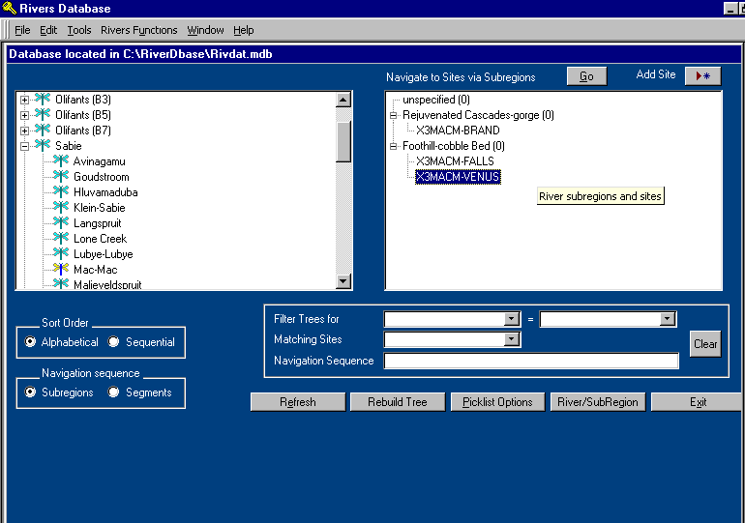
Tree-View
Parent rivers and their tributaries
Rivers Menu Bar

Section A
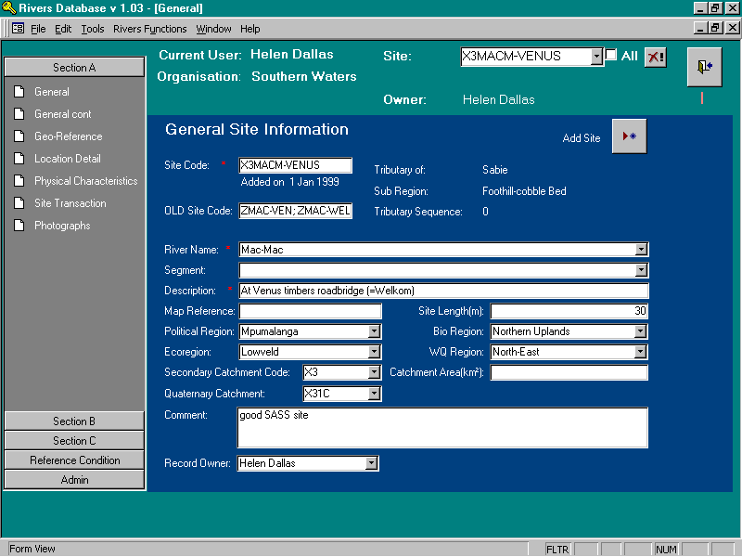
Delete Site
Show all sites
Section A. Cont.
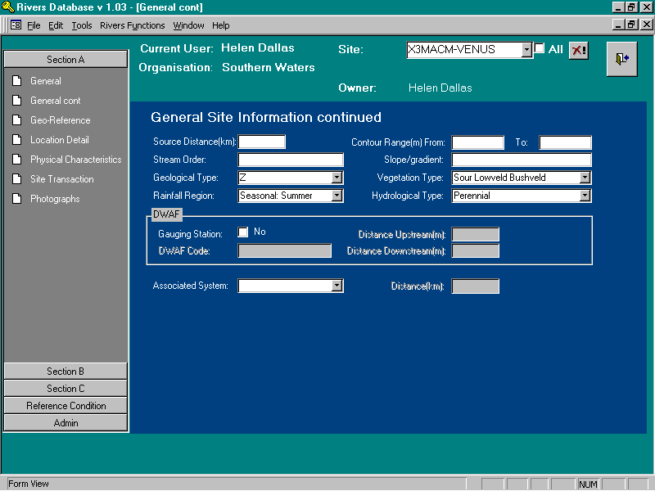
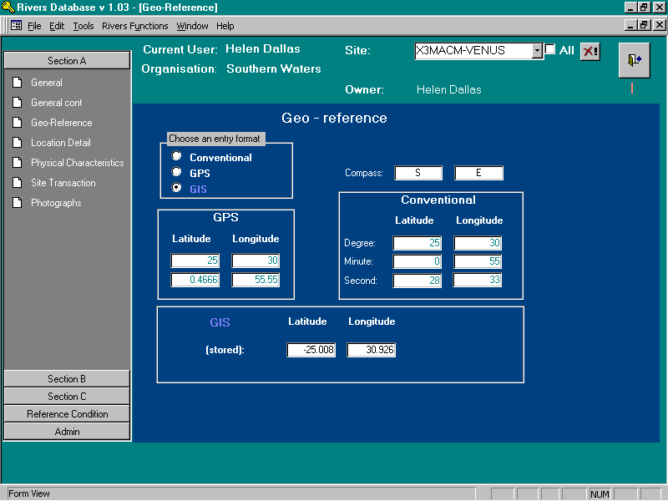
Active Bar
Close Form
Section A. Cont.
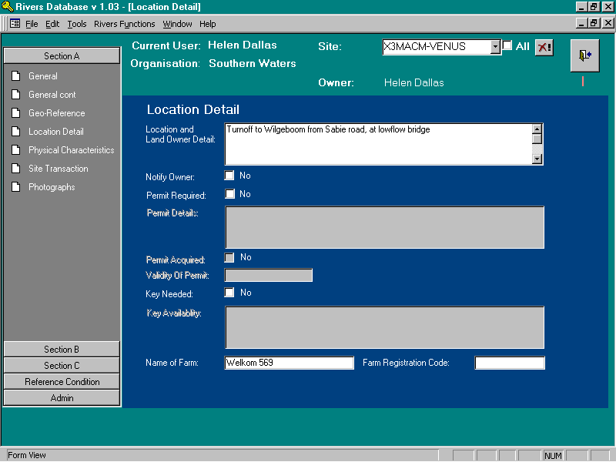
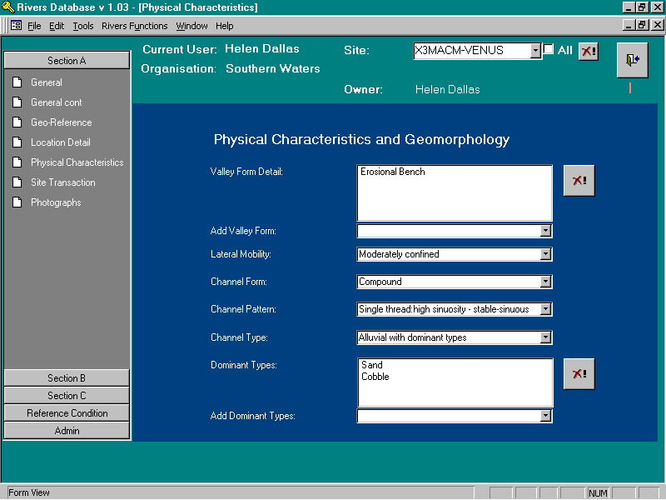
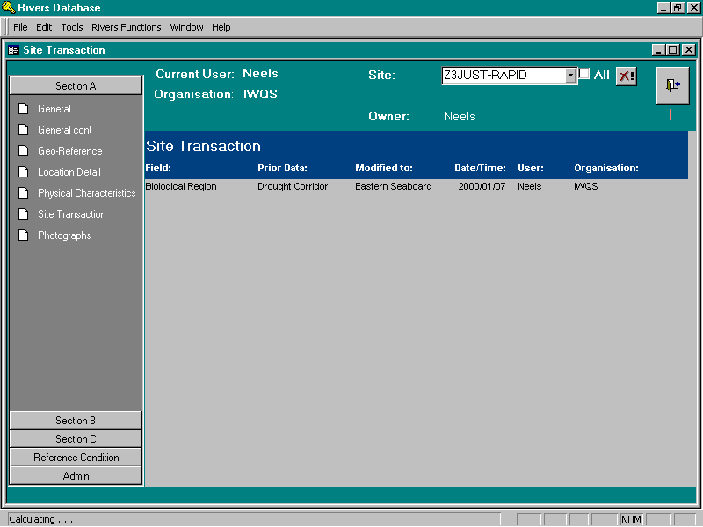
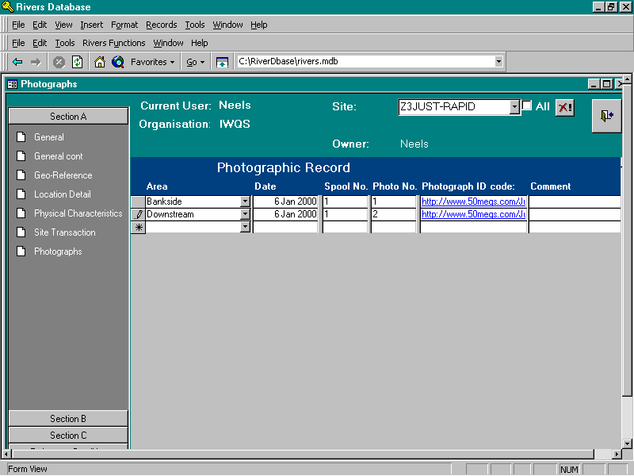
Section A. Cont.
Section B
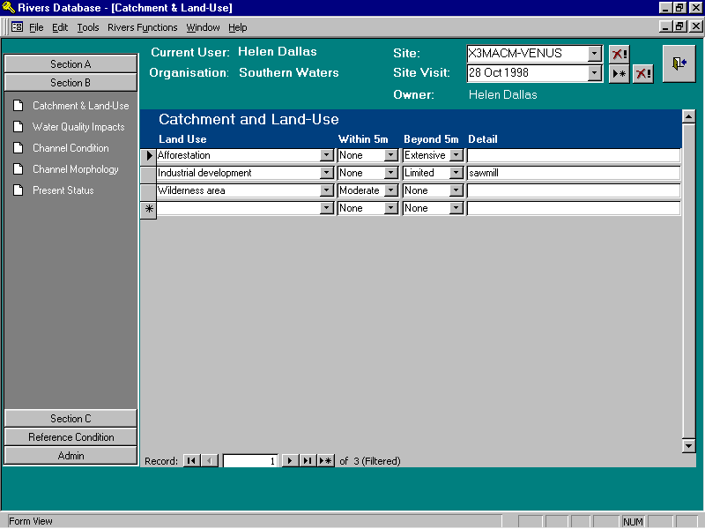
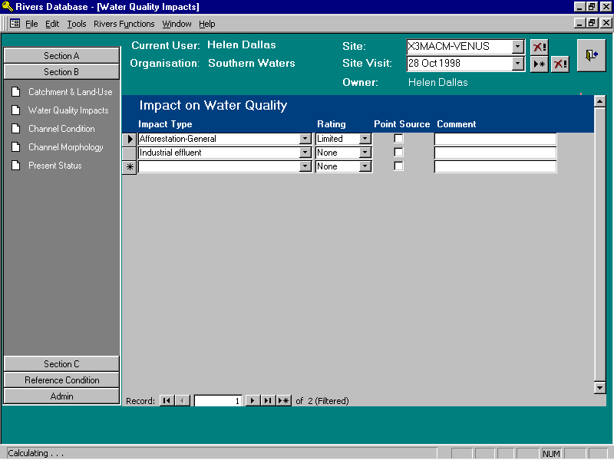
Section B . Cont.
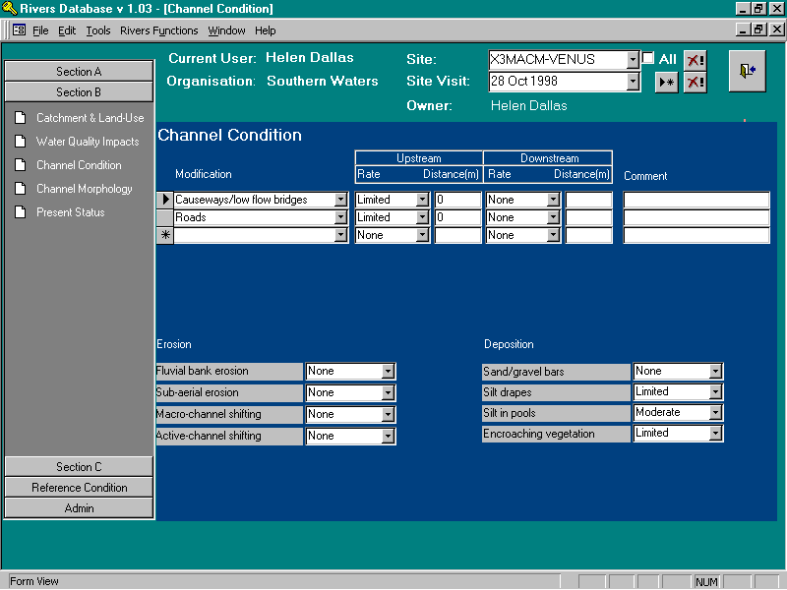
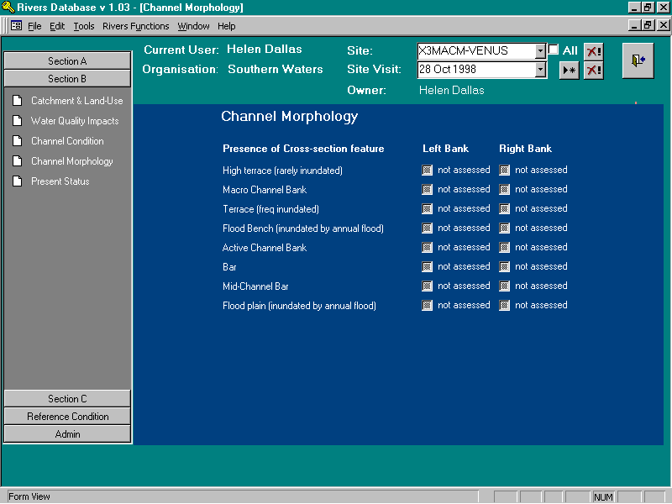
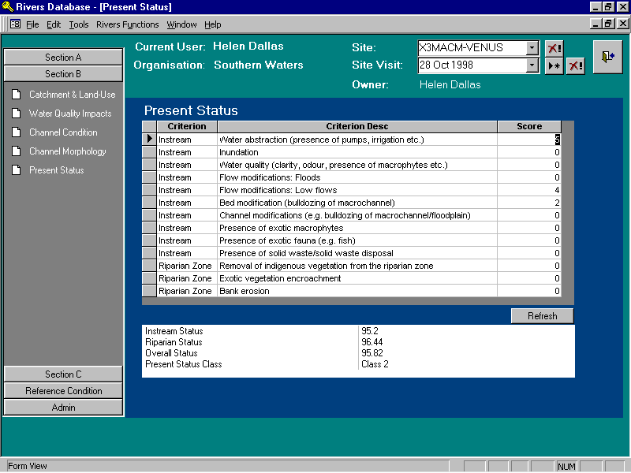
Section B . Cont.
Section C. General
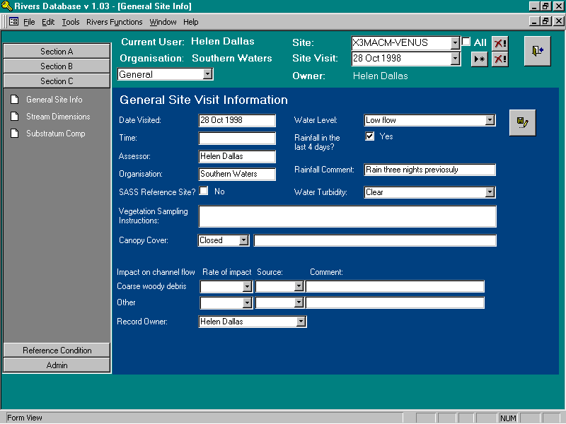
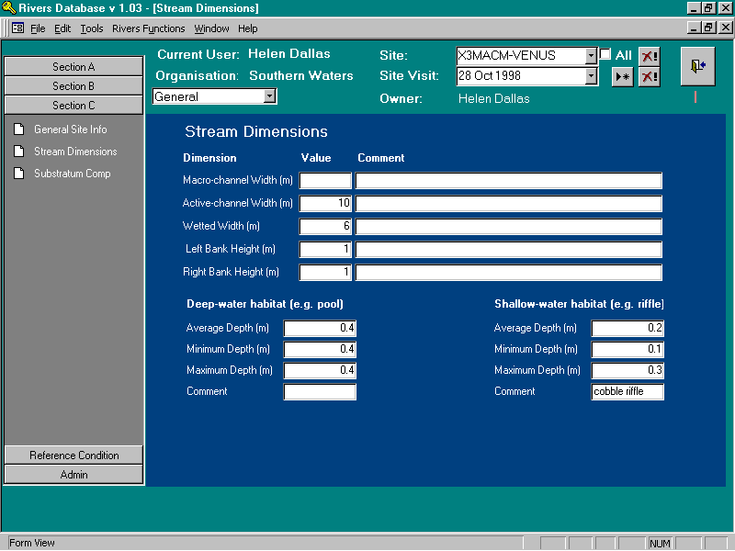
Section C. General
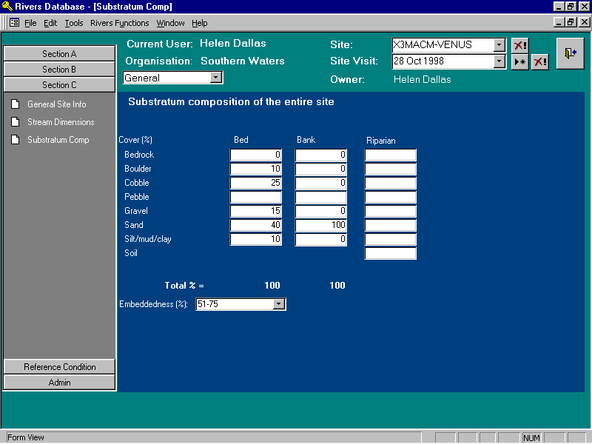

Section C. Invertebrates
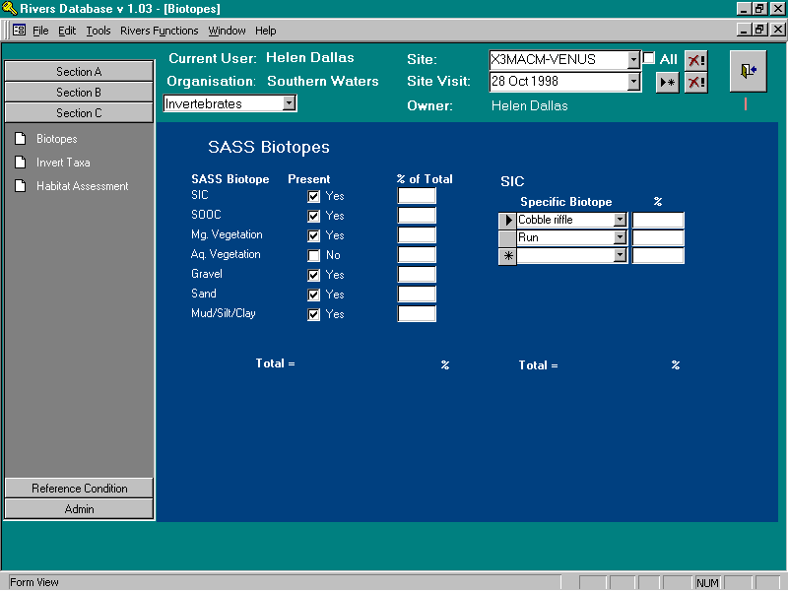
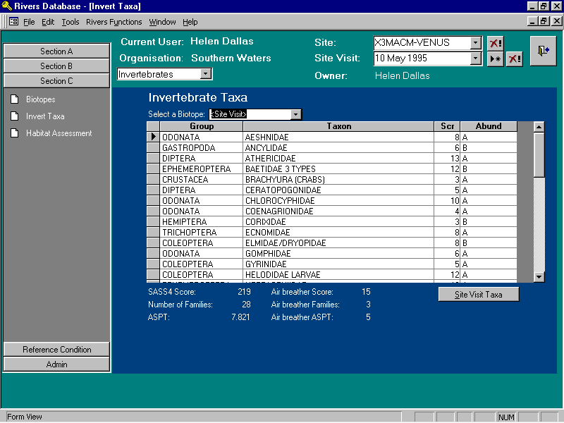
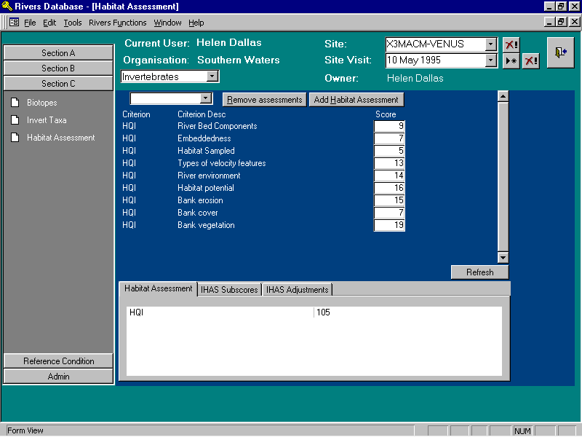
Section C. Invertebrates Cont.
Section C. Chemistry
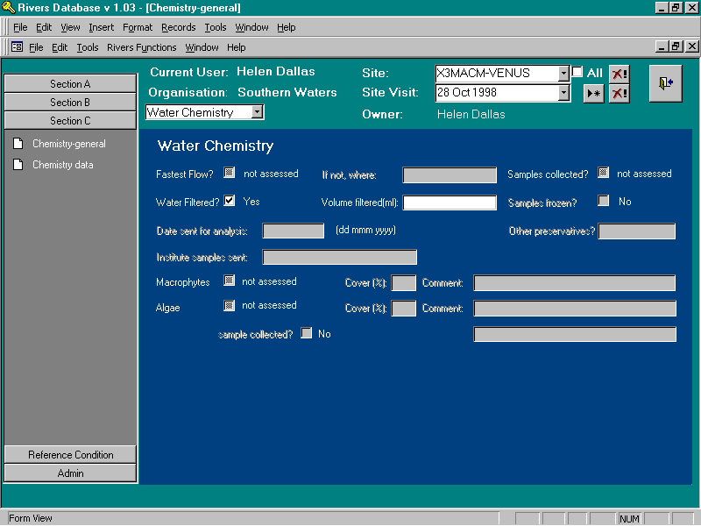
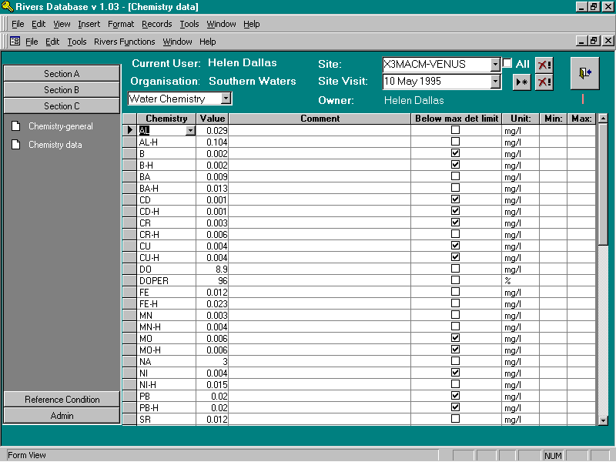
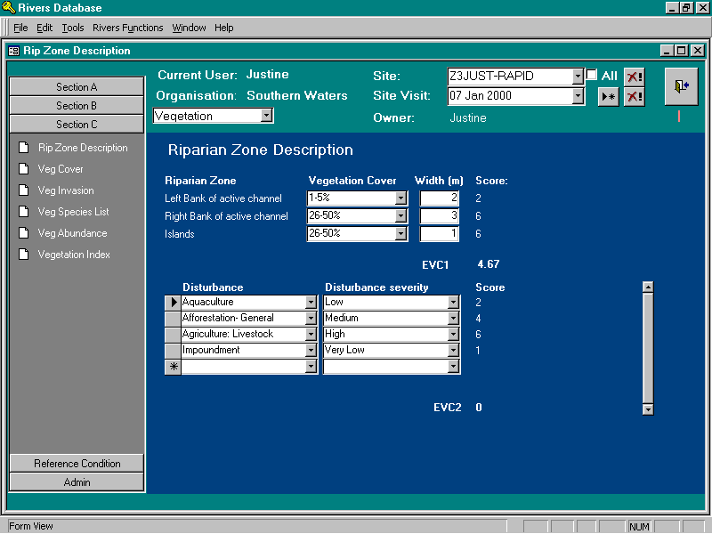
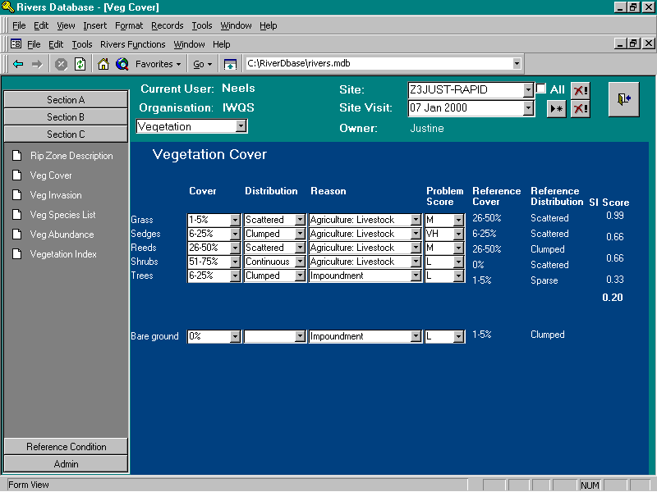
Section C. Riparian Vegetation
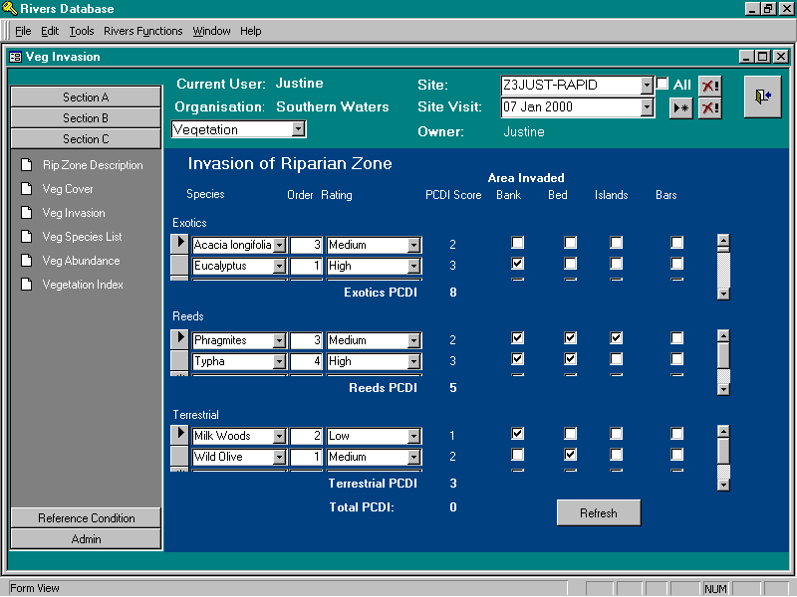
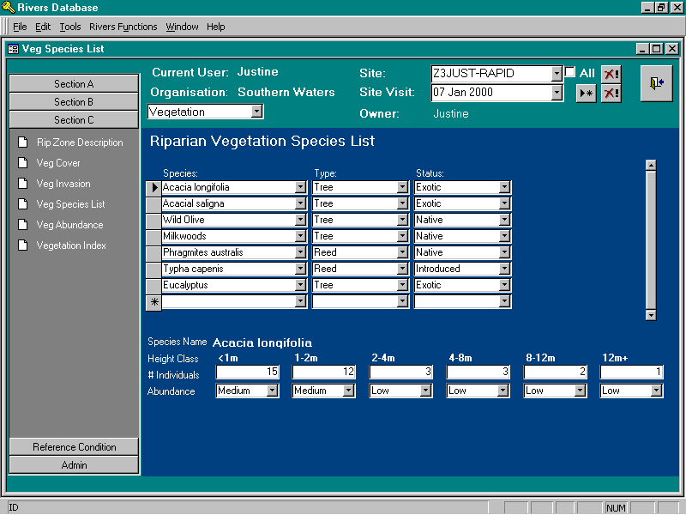
Section C. Riparian Vegetation Cont.
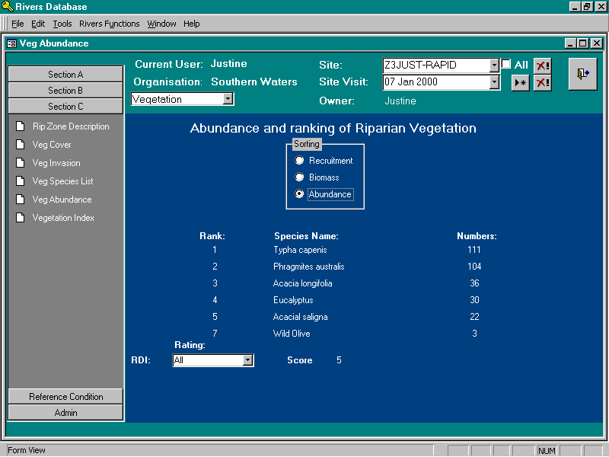
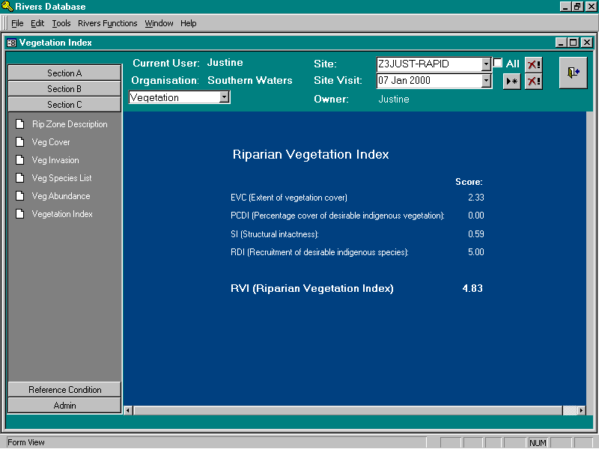
Section C. Riparian Vegetation Cont.

Section C. Fish
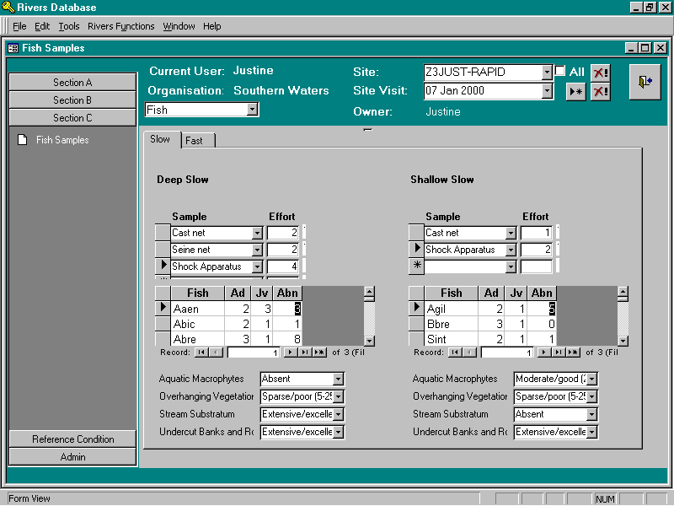

Appendix 3: A step-by-step example of a query setting specific critera.

Requirements: Provide SASS4 scores, ASPT scores and the Number of taxa for all site visits on all rivers which fall within secondary catchments B1, B2, and B3, where the pH is greater than 4. This query must reveal geo reference information so that the sites can be displayed in GIS. Table A3.1 gives an indication of the data that should be returned in the final query output to satisfy these requirements.

Table A3.1 The desired query output for the specific query outlined in this section.

Site code | Sampling Date | Secondary catchment code | GIS Longitude | GIS Latitude | SASS4 Score | ASPT | Number of Taxa

Once the query centre has been opened, the steps below are followed to extract the data required to meet the specifications oulined above for this example.
- Select the correct data joiner. In this example, the “site visit-linked data” is selected because both site specific data (i.e. the site code, secondary catchment code and the longitude and latitude) and site visit specific data (i.e. sampling date, SASS4 score, ASPT and total number of taxa as well as information about the pH ) are needed to satisfy the requirements.
- The following components are selected:
- General Site Information (contains site code, secondary catchment code)
- General Site Visit Information (contains sampling date)
- Geo reference (contains GIS Longitude and GIS Latitude)
- SASS scores (contains SASS4 score, ASPT and Nr of families)
- Chemistry (to select the specific criteria, in this case, pH>4)
Click “next”
- The specific component with fields to be displayed in the final query output is selected because only fields from one specific component can be returned in a given query. In this case, select “SASS scores”.
Click “next”
- The actual fields to be returned in the query are then selected from the components selected in 2 above i.e.:
- Site code;
- Secondary catchment code
- GIS Longitude
- GIS Latitude
- SASS4 Score
- ASPT
- Nr of families
Click “Next”
- The fields do not need to be aggregated or sorted therefore click “next”
- This example specifies that data for secondary catchments B1, B2 and B3 must be returned and that data for site visits where the pH is greater than 4 must be returned. Therefore we must set criteria on:
- Secondary Catchment Code
- Chemistry code
- Chemistry value
Go to “Secondary Catchment” and click “edit”. This opens the “Field criterion” form, which allows you to select the secondary catchment codes for which data should be returned. In this example we want data from sites in secondary catchments B1, B3 and B4 therefore:
- click on the [Secondary Catchment Code] button;
- Click the “IN” key;
- Click the “refresh” key to show all available fields;
- Using the keys on the right select B1, B3 and B4 so that the text in the criterion box reveals the following:
[Secondary Catchment Code] IN [‘B1’, ‘B3’, ‘B4’]
- Click “OK”
Go to “Chem Code” and click “edit”. This opens the “Field criterion” form, which allows you to select the specific chemistry parameter for specifying criteria. In this case, pH.
- Click on the [Chem code] button;
- Click the “=” key;
- Click the “refresh” key to show all available fields;
- Select “pH” so that the text in the criterion box reveals the following:
[Chem code] = ‘pH’
- Click “OK”
Go to “Chem Value” and click “edit”. This opens the “Field criterion” form, which allows you to select the pH range or limitations for which data should be returned in the query output. In this case, data should only be returned for sampling visits where the pH was greater than 4.
- Click on the [Chem Value] button;
- Click the “>” key;
- Type 4 (note: no inverted commas are necessary when setting criteria using numbers) so that the text in the criterion box reveals the following:
[Chem Value] > 4
- Click “OK”
- Once all the criteria have been set, click “next”.
- To view the query results, click “View Results”.

Note: If you are dissatisfied with the query output and would like to make changes then click “back”. Once you select “finish”, it is not possible to back-track through the steps in the query and you will be required to start the query building process from the beginning.

- Finally, click finish to reveal the final query output. The final query output should be similar to the structure indicated in Table A3.1.
- Go to “file” in the main menu bar and select “MS Office Links” then select “Analyse it with MS Office”. MS Office will automatically open with a new file containing the data from the query output where it can be saved as an MS excel file and analysed further.

The Data Joiner defines a common link between the different data components that have been defined.
The conditions that control which records to display in a query; the words or values used to determine the data that appears in a data list.

