Water Reconciliation Strategy for the
Western Cape

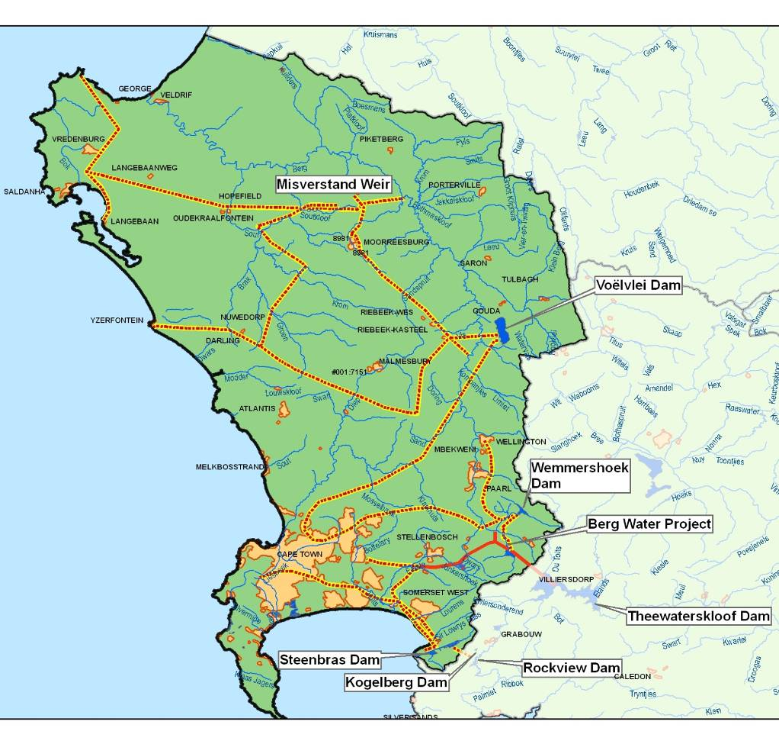
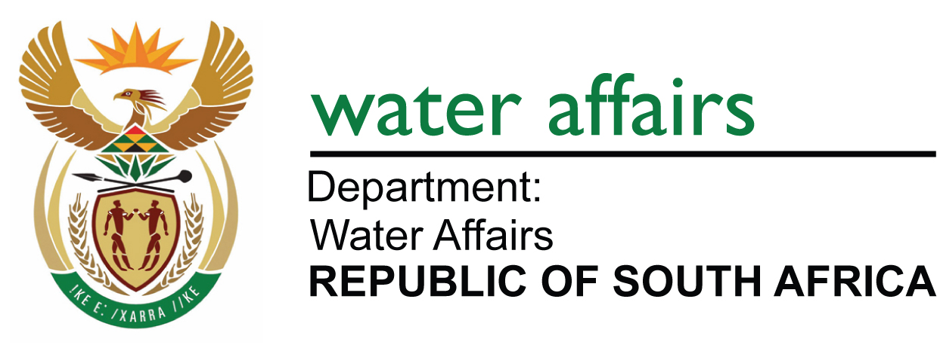

The Western Cape Water Supply System (WCWSS) is an intricate system of dams, pipelines and tunnels which is cooperatively managed by the DWA’s National Water Resource Infrastructure Branch (Southern Regions) and the CCT. The underlying principle is to optimise available water resources by drawing preferentially from dams that might spill, thus ensuring that sufficient water is available for all users during periods when water requirements are high (summer) and/or droughts.

The WCWSS serves more than 3 million people and provides water to the communities residing in the City of Cape Town (CCT) and in certain Overberg, Boland, West Coast and Swartland towns. Included are the irrigators along the Berg, Eerste and Sonderend Rivers, and the rural and stock-watering schemes in the West Coast, Swartland and Overberg areas. The main storage dams of the WCWSS are the Theewaterskloof, Voëlvlei, Berg River, Wemmershoek, Upper Steenbras and Lower Steenbras dams. These dams are operated as an integrated system in order to optimise the supply of water to the users and to minimize spills.

This area is the second largest contributor to the national economy and houses the third largest population concentration in the country. It is the economic hub of the Western Cape; with agricultural exports being a significant component.

The increase in the water requirements of the area is driven by population and economic growth within all sectors. This necessitated the development of a strategy that could be used as a support framework for making timeous and informed decisions on those interventions that should be implemented to meet the future water requirements. A Strategy Steering Committee (refer to next page) ensures that the strategy is implemented, updated and being adhered to, and makes strategic recommendations to the relevant authorities.

The Reconciliation Strategy Study for the Western Cape Water Supply System was developed over three years of close cooperation between the Department of Water Affairs (DWA) and the City of Cape Town (CCT), and was completed in 2007. The aim was to investigate the reconciliation of future water requirements with the supply from the Western Cape Water Supply System for a 25-year planning horizon. The Strategy provides a decision support framework that facilitates timeous decision-making for the implementation of appropriate water resource development interventions that are necessary to ensure that future water requirements can be met on a sustainable basis. These include water conservation and water demand management interventions.

On the completion of the Reconciliation Strategy Study a Strategy Steering Committee (SSC) was formed in September 2007. The SSC’s main functions are to:
  - monitor the implementation of strategy recommendations;
  - monitor the growth in water requirements in the System against the available supply;
  - make recommendations on further strategies and studies needed to ensure the continued reconciliation of water availability and requirements;
  - make recommendations to the decision makers on which interventions to implement; and
  - update the strategy as and when necessary.

The Strategy Steering Committee consists of the following representatives:
- all provincial government departments involved in water resources management;
- organised agriculture;
- the Catchment Management Agencies operational within the WCWSS;
- the CCT;
- the West Coast and Winelands District Municipalities;
- the Drakenstein, Saldanha, Stellenbosch and Witzenberg local authorities; and
- the DWA’s regional and national offices.

Meetings are convened every six months. The SSC has made sure that the various stakeholders start with the necessary studies required, that water use is monitored and that progress with the implementation of WC/WDM measures receives high-level attention. The SSC is very effective in that it provides a forum where all relevant roleplayers interact to ensure the sustainable supply and water quality in the System and that each organisation takes up its required roles and responsibilities in this regard.

Current water use requirements and availability
In 2010 the water use from the WCWSS was approximately 511 million m³/a, comprising urban/industrial use (346 million m³/a) and irrigation use (166 million m³/a). The available yield of the WCWSS is 556 million m³/a.
The water use requirements of the CCT are growing at approximately 2.5% to 3.5% per annum; this despite the wide range of Water Conservation and Water Demand Management (WC/WDM) measures implemented as part of the CCT’s WC/WDM strategy. These measures were expected to stabilise water use for the next six years.

Future water requirements

Increasing water requirements for the area served by the WCWSS have been driven by population growth, as well as strong economic growth within all sectors. In the Reconciliation Strategy Study both “High” and “Low” water requirement scenarios were developed as options for the future.

Given high growth, the requirement for 2030 ranges between 800 and 900 million m³/annum – with and without WC/WDM (see graph below). This translates into an average growth in water requirement of 3% per annum. The actual water requirement is currently slightly less than the high water requirement curve.

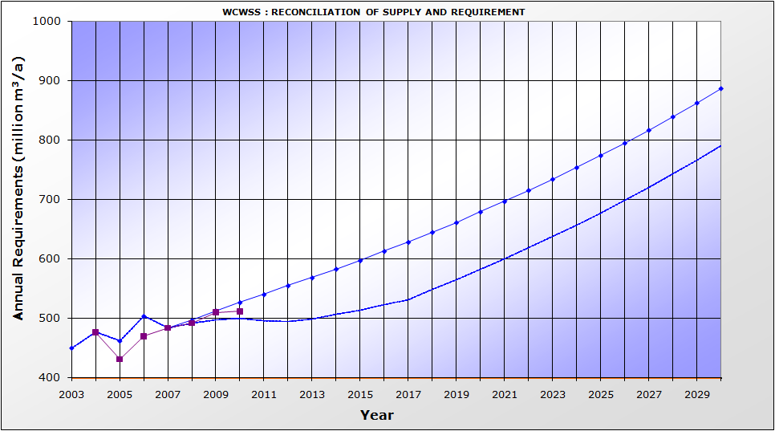
High Water Requirement Curve
Actual Water Requirement Curve
High Water Requirement Curve with WC/WDM

Water Conservation / Water Demand Management

The CCT’s comprehensive 10-year WC/WDM Strategy and programme was approved by the Mayoral Committee in May 2007. A budget of R759 million over this 10-year period was approved to target a saving of approximately 90 million m³/a by 2016/2017. Whilst the CCT’s budget allocation, approval and expenditure have been fairly closely aligned with the approved plan, the implementation of the strategy has not yet managed to curtail the growth in water requirements. A review of the WC/WDM strategy completed in August 2010 indicated that the CCT had achieved approximately 70% of the savings which were set out in the Strategy for the last 3 years. This 70% represents the saving which could be measured. The continued growth in water requirement could be as a result of increased population growth and/or improved levels of service.
Other municipalities are also implementing some WC/WDM measures, but funding remains a challenge.

Water Balance and Interventions

Should WC/WDM be successfully implemented by the CCT and other Water Service Authorities, the water requirements of the WCWSS are expected to remain in balance with available supplies until 2019. However, if only 50% successful, a new intervention would be required by 2017. At the moment the earliest date at which an intervention can be implemented, is in 2017 – provided a decision on which intervention to pursue is made by March 2012. The successful implementation of WC/WDM is therefore critical if the risk of water shortages prior to the implementation of the next supply intervention is to be kept within acceptable limits.

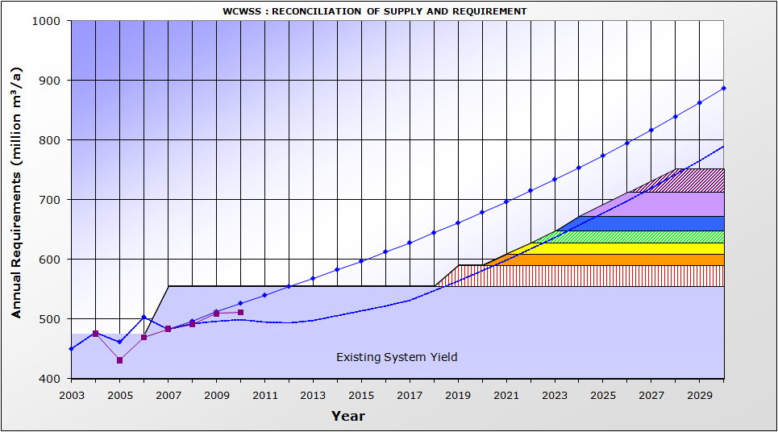
High Water Requirement Curve
Actual Water Requirement Curve
High Water Requirement Curve with WC/WDM
4
5
6
7
3
2
1

The table below shows the interventions required under this implementation scenario together with the first water delivery dates.

No | Intervention | Year of First  Water | Yield  (million m³/a)
1 | Voëlvlei Phase 1 | 2019 | 35
2 | Lourens River development | 2021 | 19
3 | Cape Flats Aquifer | 2022 | 18
4 | TMG Scheme 1 | 2023 | 20
5 | Raise Lower Steenbras Dam | 2024 | 25
6 | Water Re-use Scheme Generic 1 | 2025 | 40
7 | Water Re-use Scheme Generic 2 | 2027 | 40

The Reconciliation Strategy Study identified a range of potential supply interventions to meet future needs, and some of these are currently being investigated at feasibility level. The Molenaars Scheme and Upper Wit River Diversion Scheme were discarded as viable options after the conclusion of the pre-feasibility study. The Breede Overberg Catchment Management Strategy is also in the process of being develop. One of the preliminary recommendations from this strategy is that, given the uncertainty in terms of water availability, the hydrology of the Breede River catchment should be updated before any significant new water allocations are allowed, either to users in the catchment or for transfer to the WCWSS. A decision on investing in the development of a pilot TMG well-field will also only be made by the CCT early in 2011.

The only short-term options now available for augmenting the WCWSS are the augmentation of the Voëlvlei Dam from the Berg River (Voëlvlei Phase 1) or CCT’s water re-use or seawater desalination options. A decision on these options (taking into account unit costs, cost benefit figures and associated challenges and problems) will have to be made by March 2012. The raising of Steenbras Dam also remains an option to implement in the medium term.

The CCT is planning to commence with a full scale feasibility study into both seawater desalination and water re-use by the end of 2010 so that results are available by March 2012 in order for a decision to be taken on which scheme to implement first.

Invasive Alien Vegetation

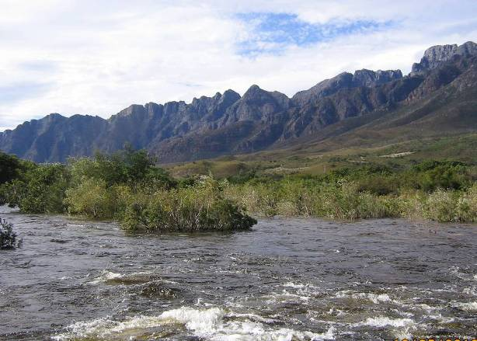
The removal of invasive alien vegetation is an important intervention to ensure sustainable water availability in the Western Cape. The effective clearing of invasive alien plants increases the yield of water resources and secures future water resource development options, whilst continued invasion results in a reduction in available supply.
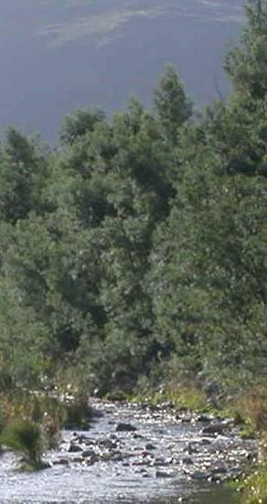
The judicious management of erosion in catchment areas is also a critically important intervention strategy to ensure acceptable levels of water quality, which includes sediment control.
Alien vegetation on riparian zones draws up water from water courses and should be removed responsibly to increase water flow

The Strategy Steering Committee will work together with Working for Water (WfW) in planning the control and eradication of invasive alien plants, prioritising the clearing of areas that would maximize water resource benefits.

Water use by agriculture

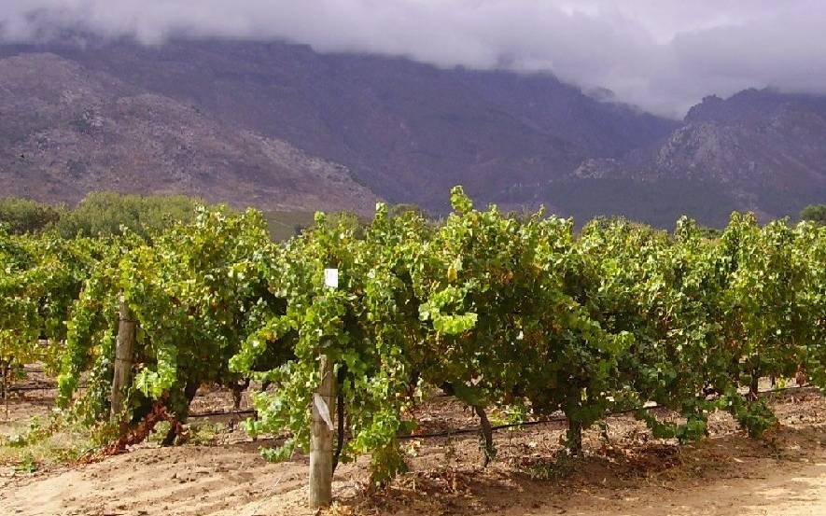
As most water used in the WCWSS is already being imported from neighbouring catchments and due to the significant cost of developing additional water resources, there can be no further allocations for irrigation development from the Berg River. By changing to less water-demanding crops and with more efficient use of water for irrigation, more land could, however, still be developed with the water saved.

Climate Change

The SSC is very concerned about the possible impacts of climate change on the yield of the system and has requested that both DWA and the CCT improve their monitoring networks so that the effects of weather pattern changes on rainfall and runoff in the area can be properly monitored. The Strategy is flexible enough to enable various interventions to be fast-tracked for implementation should any drastic and unexpected changes start to manifest. The SSC is also in the process of establishing a specialist task team to closely monitor the situation globally and locally.
Published on behalf of the Strategy Steering Committee for the
Western Cape Water Reconciliation Strategy
Enquiries: Bertrand van Zyl
Tel: (021) 950-7213  Email: vanzylb@dwa.gov.za
October 2010

