ANNEXURE 11

GROUNDWATER MANAGEMENT UNITS OF THE ELANDSFONTEIN AND LANGEBAAN ROAD AQUIFER SYSTEMS

Background

During the period 1974 to 1985, the Department conducted a number of hydro-geological investigations in the area between Velddrif, Hopefield, Darling and Langebaan to assess the potential of the groundwater resources as an alternative and/or supplementary water supply to the West Coast. The development potential of these primary aquifers was recognized from the outset and the Saldanha Subterranean Government Water Control Area was declared in 1976 to protect this strategic resource for future use.

Further investigations resulted in the sub-division of the Lower Berg River Super-Unit into four smaller aquifer systems, namely:
- Langebaan Road
- Elandsfonteyn
- Grootwater, and
- Adamboerskraal aquifers.

In 1998, the West Coast District Municipality (WCDM) applied to the Department for permission to pump 1.5 million-m3/ annum (4 000 m³/day) from the Langebaan road Aquifer System to supplement the water supply to the region. The Department and Cape Nature Conservation approved this application and the wellfield was commissioned in December 1999.

At that stage (1999) the groundwater-monitoring programme indicated that the system was in natural equilibrium with recharge and aquifer discharge responses. A wellfield in the centre of the aquifer system was developed in 1998, consisting of four production and six monitoring boreholes. The monitoring holes increased during time and now total about 140.

- Abstraction from the LRAS-A Groundwater Management Unit

The WCDM is licensed by the DWAF to pump 1.46 million m³/a (121,667 m³/month or 4,000 m³/day). On the 23rd November 2005, the Monitoring Committee agreed upon a 10% reduction in the volume abstracted from the WCDM Wellfield, to 1.314 million m³/a (109,500 m³/month or 3,600 m³/day). This step was taken as a precautionary measure after the water levels in a number of monitoring holes in the Lower Aquifer of the LRAS had declined to just above their ‘early-warning’ trigger-levels (as set in the AquiMon monitoring system). This reduced rate of abstraction will be maintained until water levels have recovered and stabilised above their trigger-levels.

- Water level monitoring

The water level monitoring status report is presented to the Monitoring Committee every second month showing water level fluctuations per monitoring hole over the previous 1, 6 and 12 months. This report also highlights those monitoring holes where the current water level exceeds the pre-determined ‘early-warning’ trigger-level.

In general, water levels in both the Upper and the Lower Aquifers of the LRAS Unit have risen dramatically since April 2007. The water table in the Upper Aquifer has risen in response to widespread rainfall recharge that took place between May and September 2007, whilst the cut-back in pumping from the WCDM Wellfield has resulted in significant rise in the piezometric surface in the Lower Aquifer.

Figure 1: Groundwater Management Units of the Elandsfontein and Langebaan Road Aquifer Systems

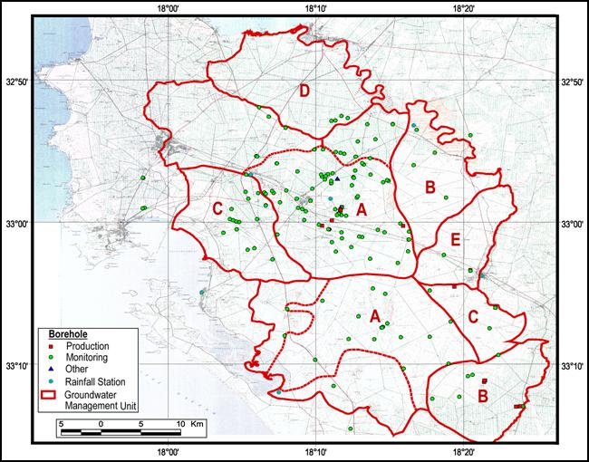

- Artificial recharge implementation

Artificial recharge through borehole injection has been identified by DWAF as a means to restore groundwater levels in the Langebaan Road aquifer which is used for town supplies (WCDM). A Screening Study has recently been undertaken to identify possible environmental concerns.

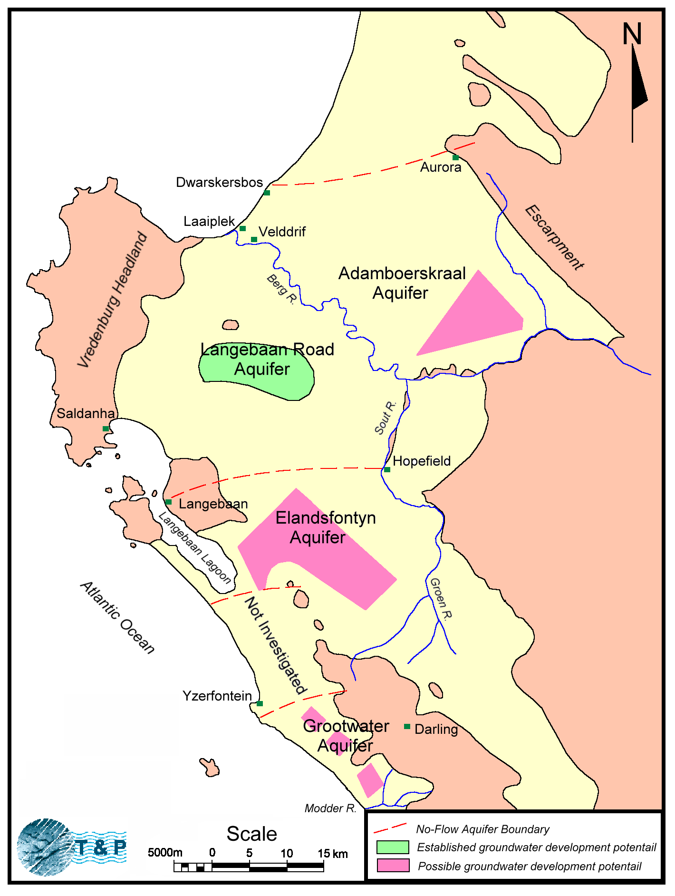
LRAS
EAS

