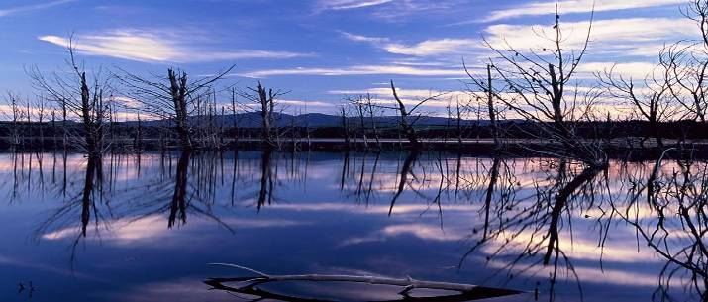

ANNEXURE 3

Western Cape Water Reconciliation Strategy
NEWSLETTER 5 March 2009

Does Cape Town have enough water?

NO: The Berg River catchment from which Cape Town should get all its water does not have enough water to provide in the required demand – this is why water is transferred from other catchment areas (e.g. from the Palmiet River via the Steenbras dams; and from the Theewaterskloof Dam on the Sonderend River via the Riviersonderend/ Berg/ Eerste River Tunnel System) into what is called the Western Cape Water Supply System (WCWSS). This intricate system of dams and bulk infrastructure components is mainly owned and operated by the Department of Water Affairs and Forestry (DWAF) and the City of Cape Town (CCT).

YES: At the moment… The above-mentioned transfer schemes and the Berg River Project which came on stream last year will be able to provide in the area’s water requirement until approximately 2013, after which additional resources will have to be implemented and/or developed.
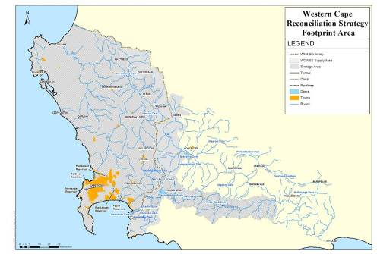
The WCWSS supports a strong and diversified economy (mainly industrial, agricultural and tourism) and provides water to more than 3 million people. Of the current available water in the system, 63% is being used for domestic and industrial purposes within the City of Cape Town.

A much smaller proportion of water (5%) is supplied to the towns of Stellenbosch, Paarl and Wellington, as well as to towns on the West Coast and in the Swartland region.
Area supplied with water from the Western Cape Water Supply System


Published by the Department of Water Affairs and Forestry  Enquiries: Bertrand van Zyl  Tel: (021) 950-7100  Email: vzylb@dwaf.gov.za

Approximately 32% of the total volume of water supplied by the WCWSS is used by irrigators along the Berg, Eerste and Sonderend Rivers.

At the moment the actual water usage from the WCWSS amounts to approximately 493 Mm³/a (2008), while the yield is 556 Mm³/a.

ensuring water for the future

In 2007 the DWAF and the CCT completed a strategy that should ensure the ongoing reconciliation of the supply in and demand for water from the Western Cape Water Supply System (WCWSS). Called the Western Cape Reconciliation Strategy (WCRS), it is used as a framework for timeous and informed decisions on those interventions that should be implemented to meet the future water requirements in the areas served by the WCWSS until 2030.

A scenario planning process is used to identify, evaluate and assess alternative groupings and phasing of interventions so as to determine the most appropriate combination of interventions that should be implemented. The objective is not to select one "favourable scenario", but to identify which interventions should be further assessed – thus allowing a range of possible scenarios to be considered. This will allow the DWAF, the CCT and other stakeholders the maximum flexibility in making informed decisions on which interventions to implement in future. The outcome of the process is a list of interventions that should be studied to feasibility level by specific dates, including timelines and the responsible organisations.

The scenarios are regularly updated and a Strategy Steering Committee, comprising of representatives from various water user sectors, local authorities and provincial departments such as Agriculture, Environmental Affairs and Development Planning, and Local Government and Housing, meet twice a year to discuss the scenarios and decide on those interventions that should be investigated and/or implemented, as well as by whom and when.

Current interventions being implemented and/or studied
CCT’s water conservation and water demand management (WC/WDM) strategy:

One of the most important interventions identified is the continuation of the CCT’s comprehensive WC/WDM strategy. The city started implementing its 10-year WC/WDM strategy in 2007 (required budget totalling R759 million) with the aim to significantly reduce its growth in water demand. The impact of this intervention has shown that the demand can be kept close to the 2008 level until approximately 2013 – in effect ‘buying’ 5 years. (It is, however, extremely important that CCT continues to make enough resources available for the successful implementation of the strategy.)

According to the scenario planning model, this means that, with the Berg River Dam now in operation and with the successful implementation of all WC/WDM measures, a new intervention should only be required to be on stream by 2019. As it takes a number of years to plan, approve, design and implement a large new scheme (the Berg River Dam took 18 years from inception to implementation and some of the less conventional methods may even take longer), decisions on new interventions must be made in the near future. Added to this urgency is the fact that external factors such as climate change, which could result in lower rainfall and thus less runoff in the Berg River, and the CCT’s WC/WDM strategy implementation not being as successful as anticipated, could bring forward the need for a new water source earlier than 2019.

WC/WDM strategies of other municipalities

Since the implementation of its WC/WDM strategy in 1999, the Drakenstein Municipality has decreased its annual water requirement from 21.84 Mm³ (1999) to 14.8 Mm³ (2006).

The Stellenbosch Municipality compiled a WC/WDM strategy for the Winelands District Municipality in 2008, and the recommendations are being implemented within the available budget and capacity constraints.

Saldanha Bay Municipality has brought down its “unaccounted for” water to 12% – a remarkable achievement in the view of their network of 561 km of pipelines, 22 reservoirs and 20 pumping stations it manages.

Other potential surface water interventions currently being studied by the DWAF
- Mitchell’s Pass Diversion
- Augmentation of the Voëlvlei Dam
- Upper Molenaars Diversion
- Upper Wit River Diversion
- Raising of Lower Steenbras Dam and possible further phases of the existing Palmiet Transfer Scheme

For more information on these potential surface water interventions, please refer to the article “The tap will not run dry” on page 4.

Intricate infrastructure network keeps the water flowing

The Western Cape Water Supply System (WCWSS) is an intricate system of dams, pipelines and tunnels which is cooperatively managed by the DWAF’s Regional Office in Bellville and the CCT. The underlying principle is to optimise available water resources by drawing preferentially from dams that are going to spill, thus ensuring that sufficient water is available during periods when water requirements are high (summer) and during periods of drought.

The largest component of the WCWSS is the Riviersonderend Government Water Scheme, which is a large inter-basin water transfer scheme that regulates the flow of the Sonderend, Berg and Eerste
Pilot studies on possible interventions

Desalination

The CCT has approved the construction of a pilot seawater desalination plant on the West Coast. A consultant will be appointed to assist with the investigation and implement-tation of the pilot scheme, as well as obtaining the environmental authorisations. Once operational, the cost-effectiveness of utilising desalinated water in the WCWSS, as compared to other interventions, will be determined.

TMG aquifer feasibility study
The Table Mountain Group (TMG) Aquifer (found in all the mountain ranges of the Western Cape) has been identified as a potential large-scale groundwater resource. The CCT started an exploratory drilling programme in 2008 to learn more about the aquifer and inform the siting of a pilot well-field. The first test results from the proposed pilot well-fields should be available in 2012. An ongoing monitoring protocol is being implemented to determine the possible effects of large-scale abstractions on existing boreholes (especially those used for agricultural purposes), and on the environment in general.

Rivers for urban, industrial and irrigation use. It consists of the Theewaterskloof Dam on the Sonderend River and a tunnel system through the Hottentots Holland Mountains. During winter, when water requirements are lower, this tunnel system conveys surplus flows from the Berg River Dam and the tributaries of the Berg River to the Theewaterskloof Dam, where the water is stored. In summer, when water requirements are high, water can be released back via the tunnel system into the catchments of the Berg and Eerste Rivers.

It is the relatively large capacity of DWAF’s tunnel system and of the CCT’s pipelines from their dams, as well as the flexibility of the CCT’s bulk water supply system, that enables all the major dams to be operated as an integrated system (WCWSS). Apart from preventing unnecessary spillage from any one dam during wetter years, the operation of the system also reduces the risk of shortages at any one point – thereby maximising the water resources for the benefit of all water users.
The main storage dams of the WCWSS are the Theewaterskloof and Voëlvlei Dams (owned and operated by the DWAF), the Berg River Dam (operated by the DWAF), and the Wemmershoek, the Upper and Lower Steenbras dams (owned and operated by the CCT). The DWAF also owns the Palmiet Pumped Storage Scheme dams, from which water can be transferred to the Steenbras dams.

the WCWSS
STEENBRAS LOWER
4%
STEENBRAS UPPER
4%
VOELVLEI
18%
BERG RIVER DAM
14%
THEEWATERSKLOOF
53%
WEMMERSHOEK
7%
Storage within

Artificial recharge

A pilot study is being undertaken by the DWAF near Saldanha to determine the feasibility and effect of artificially recharging the Langebaan Road Aquifer. This is done by pumping surplus surface water into the groundwater aquifer in times when such water is available during winter, and using the aquifer as an underground storage dam for use in times of high water requirements (summer).

The CCT’s water conservation and demand management strategy (WC/WDM) holds the key to when the next water supply option should be ready for implementation. Should the CCT continue to successfully implement its 10-year WC/WDM strategy and programme, the next supply intervention (following the implementation of the Berg Water Project last year) would need to deliver water only by 2019. Without the continuation thereof the water requirements in the area will exceed the available supply by 2013.
The
tap
will

not
run
dry
Big Brother is
watching…

Both the DWAF and the CCT, in conjunction with the Strategy Steering Committee (refer to pg 2), are keeping a watchful eye on the water requirement situation – hence the fast-tracking of the studies mentioned above. At the Strategy Steering Committee’s meeting held on 18 September 2008, it was therefore recommended that alternative water supply strategies should be developed to ensure the reconciliation of water supply and demand in case of the CCT’s WC/WDM strategy not being successfully implemented; or if a preferred supply scheme would not be able to deliver water by the required date.

Alternative strategies that are currently being considered include the re-use of water, desalination of seawater and the use of groundwater from the TMG Aquifer.

For various reasons, the study start dates for the supply side interventions are approximately 2 years behind what was originally recommended in the 2007 Reconciliation Strategy Study. This means that very few interventions can be implemented by 2019. In order to ensure that the DWAF and the CCT will have a choice of interventions to implement, some of the supply side intervention studies have been fast-tracked. The following pre-feasibility and feasibility studies have recently been commissioned:

Michell’s Pass Diversion: Diverting water during winter from a weir on the Upper Breede River into a canal, across the watershed to a tributary of the Klein Berg River, from where it is diverted to Voëlvlei Dam.

First Phase Augmentation of the Voëlvlei Dam: Pumping surplus winter water from the Berg River to the existing Voëlvlei water purification works.
Further Phases of the Voëlvlei Augmentation Scheme: Increasing the capacity of the Voëlvlei Dam by raising the dam wall and pumping surplus winter water from the Berg River to the dam.

Molenaars Diversion: Using the existing pipeline through the Huguenot Tunnel to take water from the Molenaars River to the Wemmershoek or Berg River Dams.

Upper Wit River Diversion: Abstracting winter flows at a proposed low diversion weir on the Upper Wit River via a tunnel into the Pombers River, a tributary of the Berg River.

Raising of Lower Steenbras Dam and possible further phases of the existing Palmiet Transfer Scheme: Raising the Lower Steenbras Dam to maximise abstraction from the Palmiet River by means of Eskom’s Pumped Storage Scheme.

At the moment the actual water usage from the WCWSS amounts to approximately 493 Mm³/a (2008). The yield of the existing WCWSS, with the inclusion of the Berg Water Project, is 556 Mm³/a.

Without the implementation of the CCT’s WC/WDM strategy, the city’s annual increase in water requirement is estimated to be approximately 8 Mm³/a. With only 63 Mm³/a to spare, Cape Town’s water requirements could soon exceed its available allocation from the WCWSS, with the increasing probability of stringent water restrictions being required thereafter.

