ANNEXURE 6
Western Cape Water Supply System Reconciliation Strategy
Recommended Approach to deal with Invasive Alien Plants impacting on the Western Cape Water Supply System
Submission to Strategy Steering Committee Meeting 11 March 2010

As stated in the Western Cape Water Supply System (WCWSS) Reconciliation Study Status Report (DWAF, 2009), the removal of alien vegetation is regarded as an important intervention to increase water availability. Substantial evidence has been put forward in various papers over the years indicating that clearing of invasive alien plants (IAPs) results in increases in streamflow (Versveld et al, 1998, Dye et al, 1995, Dye et al, 2004); and, if correctly targeted, can result in increased yields from existing and future water resource development options (Cullis et al, 2007, Larsen et al, 2001).
It has been the intention of the Strategy Steering Committee (SSC) to incorporate reconciliation scenarios based on the removal of IAPs in catchments of the WCWSS (DWAF, 2009), and it is recommended that this be implemented as the next step in the development of the reconciliation strategy.
The latest scheme yields for the WCWSS were determined as part of the Berg Water Availability Assessment Study (WAAS) and these results are now available for incorporation into the reconciliation strategy. The WAAS study took into account the clearing of IAPs undertaken by Wow prior to 2004, and the increase in flows as a result of this clearing activity are reflected in the yields reported in WAAS. The study area of the WAAS study is shown in Figure 1 (DWAF, 2008, Figure 1.1, pg 2).
The methods of calculating streamflow reduction by IAPs are still under development, and are being constantly improved as more data becomes available. Streamflow reductions by IAPs in the riparian zone have been closely studied, but uncertainties still exist in the modelling of reductions by IAPs in upland areas. The streamflow reductions caused by the IAPs were modelled in the WAAS study using the WRSM2000 monthly time step model. This makes use of age-biomass models and a proportional flow reduction model (WRSM Theory Guide, July 2008). Allowance is made for species, age, and riparian or upland location of the infestation. This method of estimating streamflow reduction differs from other models used by WfW, and it would be useful to undertake a comparison of results of the different methods.
Clarity is needed as to where the streamflow generated by the clearing of IAPs should be allocated, and DWA is in the process of determining policy regarding this.
A summary of the current (2004) areas of infestation by IAPs, the corresponding streamflow reduction, and the current yields of each component of the WCWSS is given in Table 1. A map showing the location of the IAPs is given in Figure 2 (DWAF, 2008, Figure 2.4, page 17).

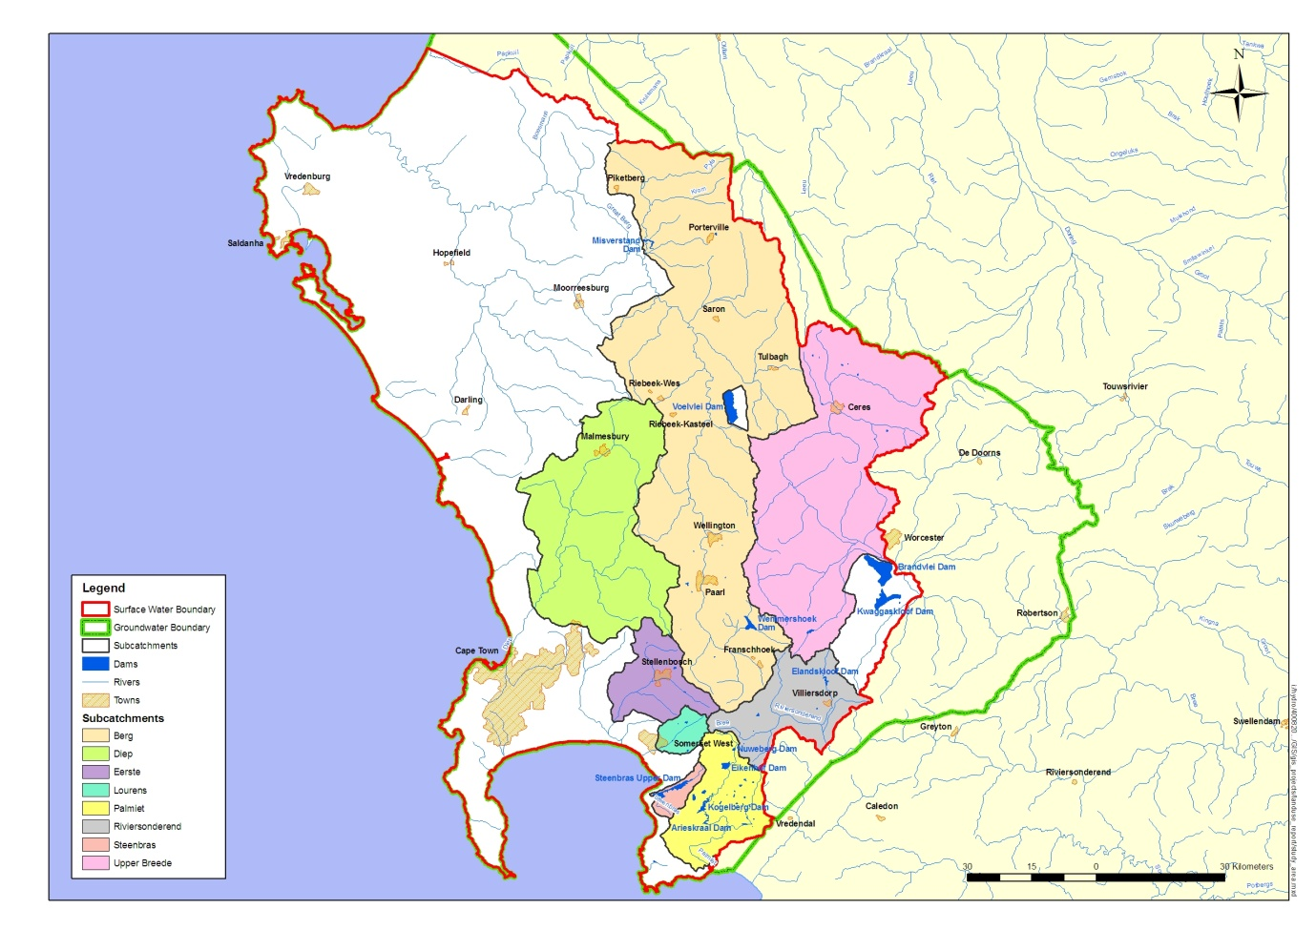
Figure 1: WAAS Study Area (Reproduced from DWAF, 2008, Figure 1.1, pg 2)

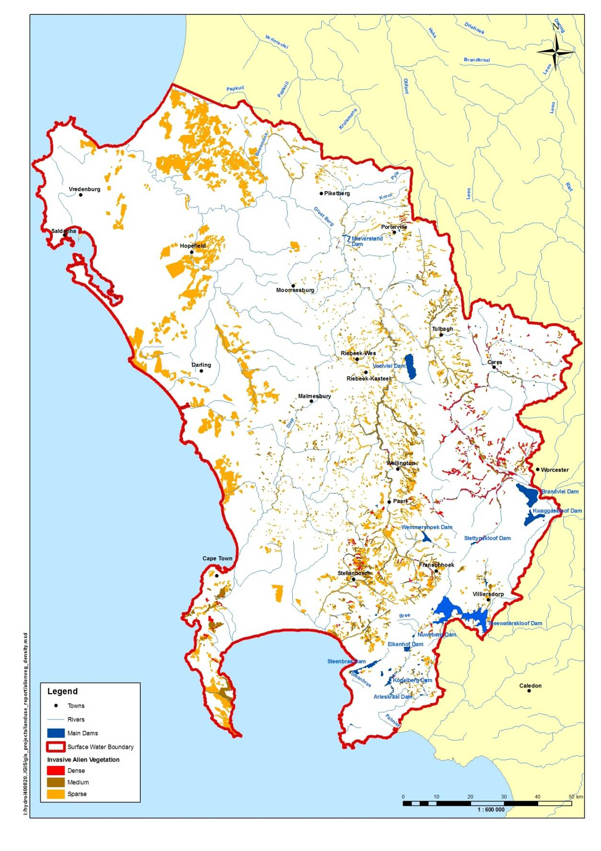Figure 2: Present day (2004) extent of Invasive Alien Plants in the WAAS study area
(Reproduced from DWAF, 2008, Figure 2.4, pg 17)
Table 1: Summary of IAP information upstream of major dams (WAAS results)
Catchment Management Area | Water Resource Development Option | Catchment MAP  (mm) | Catchment area  (km²) | Naturalised MAR (Mcm/a) 1927-2004 | Area of infestation by IAPs* ¹ |  | Streamflow Reduction
 |  |  |  |  | km² | % | m³x10⁶/a
Berg | Berg River Dam | 2576 | 68.9 | 137.2 | 1.28 | 1.9 | 1.96*²
Berg | Wemmershoek Dam | 1373 | 85.3 | 83.4 | 0.25 | 0.3 | 0.00*³
Berg | Voёlvlei Dam | 950 | 613.9*⁴ | 239.2 | 4.84 | 0.8 | 1.10
Breede | Theewaterskloof Dam | 1205 | 576.2 | 478.4 | 2.40 | 0.4 | 0.64
Palmiet | Steenbras Dam | 1430 | 125.8 | 101.2 | 0.29 | 0.2 | 0.00
Total upstream of major dams |  |  | 1470.1 | 818.8 | 9.06 | 0.6 | 3.7
*¹ Equivalent 100% area.
*² The catchment of the Berg River Dam (as well as an area downstream of the dam) was cleared before construction as part of the project cost.
*³ The catchment of the Wemmershoek Dam was recently cleared by WfW.
*⁴ This includes the catchment of rivers where flow is diverted into Voёlvlei Dam

The information in the above table shows that the current (2004) infestation of IAPs upstream of major dams is less than 1% by area, and that the overall streamflow reduction is estimated to be 3.7 Mm³/a (less than 1% of the naturalised MAR of 818.8 Mcm/a). This situation is extremely favourable, and the credit must go to WfW who has been actively clearing the catchment areas for many years.
The infestation levels of IAPS downstream of the major dams are shown in Table 2.
Table 2: Summary of IAP information downstream of major dams (WAAS results)
Catchment Management Area | Water Resource Development Option | Catchment MAP  (mm) | Catchment area (km²) | Naturalised MAR (Mm³/a) 1927-2004 | Area of infestation by IAPs* ¹ |  | Streamflow Reduction (m³x10⁶/a)
 |  |  |  |  | km² | % | Streamflow Reduction (m³x10⁶/a)
Berg | Berg River d/s of major dams | 622 | 2827.1 | 424.4 | 29.96*² | 1.1 | 6.73
Berg | Diep River | 402 | 2695.7 | 132.2 | 2.76 | 0.1 | 0.00
Berg | Lourens River | 1124 | 92.3 | 48.2 | 2.47 | 2.7 | 1.16
Berg | Eerste River | 903 | 504.2 | 183.9 | 9.48 | 1.9 | 1.86
Total downstream of major dams |  |  | 6521.6 | 984.7 | 45.88 | 0.7 | 9.75
*¹ Equivalent 100% area.
*² The catchment of the Berg River Dam (as well as an area downstream of the dam) was cleared before construction as part of the project cost.
Overall, there is a total of 45.88 km² of IAPs in the WAAS study area downstream of major dams, which is also approximately 0.7% of the total area. The total streamflow reduction is 9.75 Mm³/a, which is 0.7 % of the naturalised streamflow of 984.7 Mm³/a. The Lourens River has the highest percentage infestation by area (2.7%), closely followed by the Eerste River (1.9%). There is an estimated 30km² of IAPs in the remainder of the Berg River catchment (1.1% by area), with an associated streamflow reduction of 6.73 Mm³/a (1.6% of the naturalised flow of 424.4Mm³/a).
It would be interesting to determine the current levels of infestation upstream of potential future water resource options, and determine the effect on yield if current infestations of IAPs are left unchecked. Some examples of these potential future options are the diversions on the Eerste and Lourens Rivers, as well as a number of options in the catchment of the Breede River, namely diversions on the Molina’s River, the Upper Wit River, and the Mitchells Pass diversion. These all fall within the WAAS study area, and some of these potential future options are the focus of a feasibility study which will provide more detailed information.
Recommendations:
- The impact of IAPs on the yield of the WCWSS is recognised as potentially significant and it is therefore considered important to the Reconciliation Strategy.
- It is recommended that the effect of IAPs should form part of scenario planning.
- An initial assessment of the effect of IAPs on yield should be undertaken be DWA. It is recommended that this would include the following components:
- The current effect of IAPs on the yield of the WCWSS should be determined using the most recent WRYM setup from the WAAS study.
- Additionally, scenarios should be developed with WfW of the rate of infestation of IAP, should clearing not take place.
- The potential future yield losses should then be determined for these scenarios.
- Costs in the form of unit reference values (URV) should be determined.
- From the results of these investigations, the catchments which will result in the highest portion of the yield of the WCWSS being safeguarded should IAPs be cleared, can be identified and prioritised.
- Determine where the streamflow generated by clearing IAPs should be allocated.
- The ongoing process of IAP management is a function of the Catchment Management Agencies (CMAs), and should be financed through levies raised by CMAs. It is important that the results of the initial assessment be passed on to the CMAs so that business plans can be developed to finance clearing over a number of years. The formation and functioning of the CMAs forming part of the WCWSS should be facilitated so that these functions can be carried out as soon as possible.

References
Department of Water Affairs and Forestry, South Africa. 2008. The Assessment of Water Availability in the Berg Catchment (WMA 19) by Means of Water Resource Related Models: Report 4 (Land Use and Water Requirements): Volume 1 (Data in Support of Catchment Modelling). Prepared by Ninham Shand (Pty) Ltd in association with Umvoto Africa on behalf of the Directorate: National Water Resource Planning. DWAF Report No P WMA19/000/00/0408.
Department of Water Affairs and Forestry, 2009. Western Cape Water Supply System Reconciliation Strategy Status Report September 2009.
Versveld, DB., Le Maitre, DC., Chapman, RA., 1998. Alien Invading Plans and Water Resources in South Africa: A Preliminary Assessment, CSIR Division of Water, Environment and Forestry Technology, Stellenbosch.
Dye, PJ., Poulter, AG., 1995. A field demonstration of the effect on stream flow of clearing invasive pine and wattle trees from a riparian zone. South African Forestry Journal 173, 27-30.
Dye, PJ., Jarmaine, C., 2004. Water Use by Black Wattle (Acacia mearnsii) implications for the link between removal of invading trees and catchment stream flow response. South African Journal of Science 100, 40-44.
Cullis, JDS. Görgens, AHM., Marais, C., 2007. A strategic study of the impact of invasive alien plants in the high rainfall catchments and riparian zones of South Africa on total surface water yield. Water South Africa 33, 35-42.
Larsen, EJ., Marais, C., Görgens, AHM., 2001. Water resources planning with recognition of alien vegetation eradication. Tenth South African Hydrological Symposium, 26-28 September 2001.

