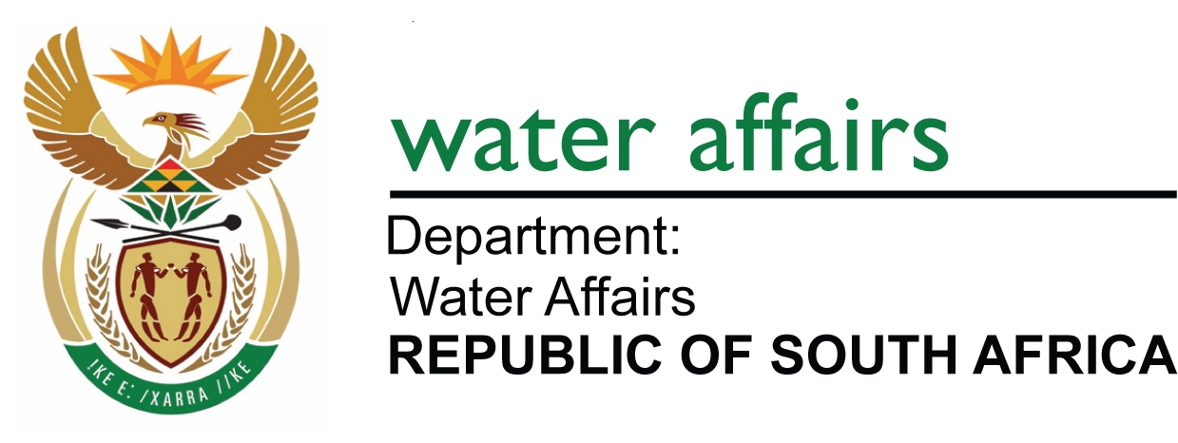

WESTERN CAPE RECONCILIATION STRATEGY:
STRATEGY STEERING COMMITTEE

Agenda for the 7th meeting to be held on 16 September 2010 at 09:00 at the Devon Valley Hotel, Stellenbosch (map attached)
09:00 – 15:00

AGENDA
- WELCOME AND CONSTITUTION OF MEETING | Chair
- ATTENDANCE AND INTRODUCTIONS | Chair
- APPROVAL OF THE AGENDA | Chair
- MINUTES OF MEETING HELD ON 11 March 2010 | Chair
  - Approval of minutes
- Matters arising (not on the agenda)  - Pg 2; Item 4.2.1: Lifting of water restrictions – Done  - Pg2; Item 4.2.3: Water requirements of Berg River irrigation farmers | Ashia Peterson
- ASPECTS THAT AFFECT THE WCWRS
  - BOCMA’s Catchment Management Strategy
- Presentation on water availability in Breede System | Guy Pegram
  - Water Conservation & Water Demand Management
- Report on CCT’s progress with WC/WDM – Annexure 1 | Zolile Basholo
- UPDATING THE STRATEGY
- Water balance update & scenario planning | Mike Killick
- UPDATING THE STRATEGY
- MONITORING THE PROGRESS WITH THE WCWRS
  - Recommendations from the Reconciliation Strategy Study: DWA studies
- Surface water feasibility studies: report back on options: – Annexure 2 | Menard Mugumo
- Atlantis & Langebaan resource management – Presentation | Fanus Fourie
- WC/WDM support to local authorities – Presentation | Simpiwe Mashicila
- Feedback from All Town Reconciliation Strategy Study – Annexure 3 | Gerrit van Zyl
  - Recommendations from the Reconciliation Strategy Study: CCT studies: Annexure 4
- Water re-use: development options | Paul Rhode
- Cape Flats & Newlands aquifer | Paul Rhode
- TMG Aquifer – Presentation | Paul Rhode
- Lourens River diversion | Arne Singels
- Desalination feasibility Study | Arne Singels
  - Other municipal studies: Annexure 5
- Drakenstein Municipality | André Kowalewski
- Witzenberg Municipality | Hendrik Kröhn
- Stellenbosch Municipality | Esias de Jager
- West Coast District Municipality (Bergrivier, Swartland, Saldanha) | Martiens Victor
  - Implementation of the WCWRS
- Progress report on individual interventions: presentation | Mike Killick
- COMMUNICATION
  - Interaction on provincial level and with MECs
- Status Quo Report, Current Status Report, Newsletter and Press release – Report from SSC members re dissemination thereof | All
- Liaison with PLC and MINMEC | Chair
  - Communication with general public
- 2-page Flyer – Annexure 6 | Mike Killick
- Administrative and Technical Support Group (ATSG) REPORT
- Climate change task team | Gerrit van Zyl
- Evaluation of invasive alien vegetation on water supply – Presentation | Mike Killick
- GENERAL
- NEXT MEETING | Chair
10 March 2011. Venue to be determined
- CLOSURE | Chair

Attachments to this agenda:

Minutes of the meeting held 11 March 2010
Annexure 1: CCT’s progress with WC/WDM (not received – to follow later)
Annexure 2: Surface water feasibility studies: report back on options
Annexure 3: Feedback from All Town Reconciliation Strategy Study
Annexure 4: Reconciliation Strategy Study: CCT studies (To follow later)
Annexure 5: Reconciliation Strategy Study: Other municipalities (not received – to follow later)
Annexure 6: 2-page Flyer (please note that this is only a proposal – the information may change with the new information obtained at the meeting of the 16th)

