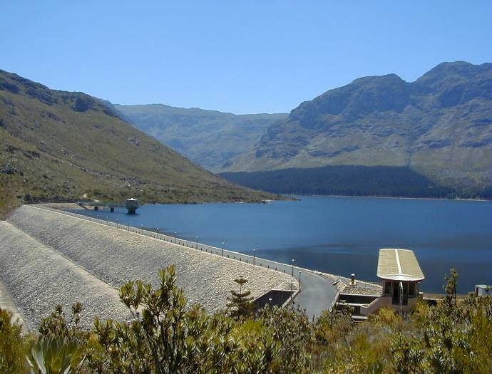

Western Cape
Water
Supply System

Published by the Department of Water Affairs  Enquiries: Bertrand van Zyl
Tel: (021) 950-7100  Email: vzylb@dwaf.gov.za
Published ??? 2010

The Western Cape Water Supply System (WCWSS) is an intricate system of dams, pipelines and tunnels which is cooperatively managed by the DWA’s Regional Office in Bellville and the CCT. The underlying principle is to optimise available water resources by drawing preferentially from dams that might spill, thus ensuring that sufficient water is available for all users during periods when water requirements are high (summer) and/or droughts.

The WCWSS serves more than 3 million people and provides water to the communities residing in the City of Cape Town (CCT) and in certain Overberg, Boland, West Coast and Swartland towns, to irrigators along the Berg, Eerste and Sonderend Rivers, and to rural and stock-watering schemes in the West Coast, Swartland and Overberg areas. The main storage dams of the WCWSS are the Theewaterskloof, Voëlvlei, Berg River, Wemmershoek, Upper Steenbras and Lower Steenbras dams. These dams are operated as an integrated system in order to optimise the supply of water to the users and to minimize spills.
Map of WCWSS and rest of caption

This area is the second largest contributor to the national economy and houses the third largest population concentration in the country. It is the economic hub of the Western Cape, with agricultural exports a significant component.

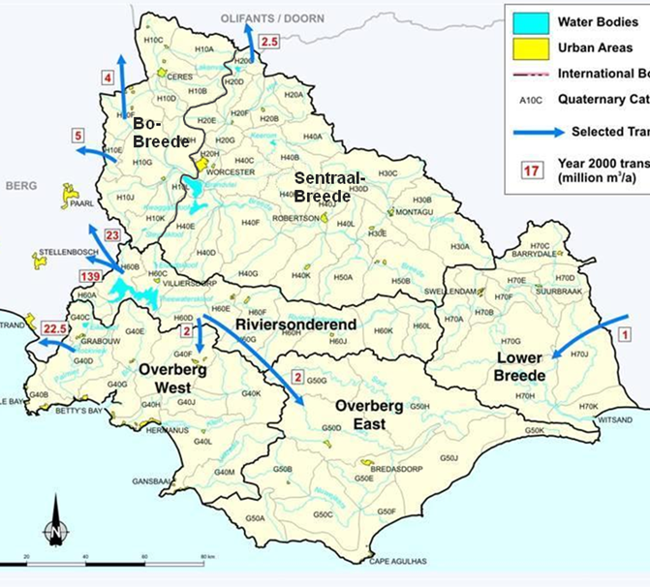
The increase in the water requirements of the area is driven by population and economic growth within all sectors. This necessitated the development of a strategy that could be used as a support framework for making timeous and informed decisions on those interventions that should be implemented to meet the future water requirements. The Strategy Steering Committee ensures that the strategy is implemented, updated and being adhered to, and makes strategic recommendations to the relevant authorities.

The Reconciliation Strategy Study for the Western Cape Water Supply System was developed over three years of close cooperation between the Department of Water Affairs (DWA) and the City of Cape Town (CCT), and was completed in 2007. The aim was to investigate the reconciliation of future water requirements with the supply from the Western Cape Water Supply System for a 25-year planning horizon. The Strategy provides a decision support framework that facilitates timeous decision-making for the implementation of appropriate water resource development interventions necessary to ensure that future water requirements can be met on a sustainable basis. These include water conservation and water demand management interventions.

On the completion of the Reconciliation Strategy Study a Strategy Steering Committee (SSC) was formed in September 2007. The SSC’s main functions are to:
  - monitor the implementation of strategy recommendations;
  - monitor the growth in water requirements in the System against the available supply;
  - make recommendations on further strategies and studies needed to ensure the continued reconciliation of water availability and requirements;
  - make recommendations to the decision makers on which interventions to implement; and
  - update the strategy as and when necessary.

The Strategy Steering Committee consists of the following representatives:
- all provincial government departments involved in water resources management;
- organised agriculture;
- the Catchment Management Agencies operational within the WCWSS;
- the CCT;
- relevant District and Local Municipalities; and the
- DWA’s regional and national offices.

Meetings are convened every six months. The SSC has made sure that the various stakeholders start with the necessary studies required, that water use is monitored and that progress with the implementation of WC/WDM measures receives high-level attention. The SSC is very effective in that it provides a forum where all relevant roleplayers interact to ensure the sustainable supply and water quality in the System and that each organisation takes up its required roles and responsibilities in this regard.

Current water use requirements and availability
In 2010 the water use from the WCWSS was approximately 505 million m³/a, comprising urban/industrial use (341 million m³/a) and irrigation use (164 million m³/a). The available yield of the WCWSS is 556 million m³/a.

The water use requirements of the CCT are growing at approximately 2.5% per annum; this despite the wide range of Water Conservation and Water Demand Management (WC/WDM) measures implemented as part of the CCT’s WC/WDM strategy. These measures were expected to stabilise water use for the next six years.

Future water requirements

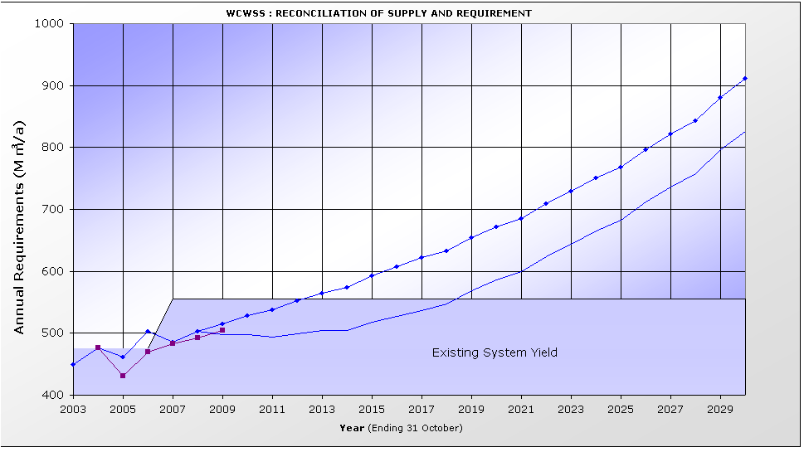
Increasing water requirements for the area served by the WCWSS have been driven by population growth, as well as strong economic growth within all sectors. In the Reconciliation Strategy Study both “High” and “Low” water requirement scenarios were developed as options for the future.
Water requirements with WC/WDM
Water requirements with no WC/WDM
Reference Scenario: High Water Requirement and WC/WDM
Actual Water required

Given high growth, the requirement for 2030 ranges between 800 and 900 million m³/annum with and without WC/WDM (see graph). This translates into an average growth in water requirement of 3% per annum. Under the low growth scenario the 2030 requirement would be 670 million m³ without WC/WDM and approximately 590 million m³ if WC/WDM is successfully implemented.

Should the CCT only achieve 50% success with the implementation of its WC/WDM Strategy and the current growth in water requirements continue, a new augmentation intervention would be required by 2015. However, no supply interventions are available for implementation by that date, even if fast-tracked. The successful implementation of WC/WDM is therefore critical if the risk of water shortages prior to the implementation of the next supply intervention is to be kept within acceptable limits.

Water Conservation / Water Demand Management

A comprehensive 10-year WC/WDM Strategy and programme was approved by the CCT Mayoral Committee in May 2007. A budget of R759 million over this 10-year period was approved to target a saving of approximately 90 million m³/a by 2016/2017. Whilst the CCT’s budget allocation, approval and expenditure has been in accordance with (even exceeding) the approved plan, the implementation of the strategy has not yet managed to curtail the growth in water requirements to the target of 0% over the first six years. This could be influence by various factors and is being assessed at the moment.

Other municipalities are also implementing WC/WDM measures, but funding remains a challenge.

Water Balance and Interventions

Should WC/WDM be successfully implemented by the CCT and other Water Service Authorities, the water requirements of the WCWSS are expected to remain in balance with available supplies until 2019. However, if only 50% successful, a new intervention would be required by 2016. At the moment the earliest date at which an intervention can be implemented, is in 2017 – provided a decision on which intervention to pursue is made by March 2012.

The Reconciliation Strategy Study identified a range of potential supply interventions to meet future needs, and these are currently being investigated at pre-feasibility level or feasibility level. A number of these have been screened out as short term options because various reasons. These include new findings on the non-availability of water from the Breede River system and the fact that a decision on a pilot TMG well-field will only be made by the CCT in 2011.

The only short term options now available are the augmentation of the Voëlvlei Dam from the Berg River (Voëlvlei Phase 1) or CCT’s water re-use or desalination options. A decision on these options (taking into account unit costs, cost benefit figures and associated challenges and problems) will have to be made by March 2012. The raising of Steenbras Dam remains an option to implement in the medium term.

The CCT is planning to commence with a full scale feasibility study into both desalination and re-use by the end of 2010 in order to ensure that the results are available by March 2012.

Invasive Alien Vegetation

The removal of alien vegetation is an important intervention to increase water availability in the Western Cape. The effective clearing of invasive alien plants increases yields and secures future water resource development options, whilst continued invasion results in a further reduction in available supply.

The Strategy Steering Committee will work together with Working for Water (WfW) in planning the control and removal of alien invasive plants, prioritising the clearing of areas that would maximize water resource benefits.

Water use by agriculture

As most water used in the WCWSS is already being imported from neighbouring catchments at considerable cost, there can be no further allocations for irrigation development. By changing to less water-demanding crops and with more efficient use of water for irrigation, more land could possibly be developed with the water saved.

Climate Change

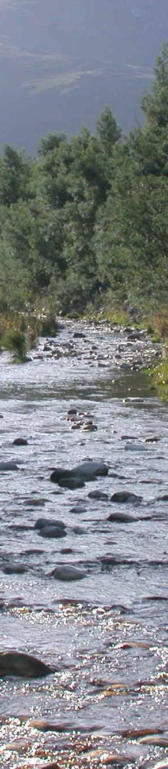
The SSC is very concerned about climate change and has requested that both DWA and the CCT improve their monitoring networks so that the effects of weather pattern changes on rainfall and runoff in the area can be properly monitored. The Strategy is flexible enough to enable various interventions to be fast-tracked for implementation should any drastic and unexpected changes start to manifest. The SSC is also in the process of establishing a specialist task team to closely monitor the situation globally and locally.

