Western Cape Water Supply System Reconciliation Strategy
Report – January 2011
The Impact of Invasive Alien Plants on the Yield of the Western Cape Water Supply System

- Introduction
An initial assessment of the effect of invasive alien plants on the yield of the Western Cape Water Supply System (WCWSS) was undertaken by Aurecon for the Strategy Steering Committee of the Western Cape Reconciliation Strategy. This document provides a summary of the presentation made at the Strategy Steering Committee meeting in September 2010.
The objective of the study was:
- To undertake an initial assessment of the effect of invasive alien plants on the combined yield of the WCWSS, upstream of the existing dams.
- To consider the effect of invasive alien plants downstream of the dams.

- Summary of Work Undertaken

The work undertaken as part of the initial assessment is summarised in this section. Each item is described in more detail in the sections that follow.

Current Day Levels of Invasive Alien Plant Infestation:
- The current extent of invasion by invasive alien plants was determined based on the two most recent available sets of mapping, which are:
      - The invasive alien plant coverage (2004) created during the Berg Water Availability Assessment Study (WAAS).
      - The recently released National Invasive Alien Plant Survey (NIAPS).
- The streamflow reduction associated with the current infestations of invasive alien plants was estimated.
- The impact of the streamflow reduction caused by the current level of invasive alien plants on yield of the WCWSS was estimated.

Potential Future Scenarios of Invasive Alien Plant Infestation:
- The potential future spread of invasive alien plants was estimated in the form of three scenarios.
- The streamflow reduction and associated impact on the yield of the WCWSS for these possible scenarios were estimated.
Other Aspects
- Estimates of effect of invasive alien plants downstream of WCWSS dams.
- Discussion of uncertainties
      - Streamflow reduction methodology
      - Mapping
- Describe scope of work of the recently commissioned Working for Water study.

- Current Day Levels of Infestation of Invasive Alien Plants
The most recent mapping of invasive alien plants available for the entire area upstream of the dams forming part of the WCWSS was undertaken for the Berg WAAS study. This was based on identifying existing stands of invasive alien plants on 1 : 10 000 scale colour aerial photographs and digitising these in GIS. Verification by means of field visits was undertaken. According to this methodology, there is a total condensed area of 7.9 km² upstream of the dams forming part of the WCWSS. The areas of invasive alien plants determined for WAAS are illustrated in Figure 1, and the areas upstream of individual dams are shown numerically in Table 1.
Recently the NIAPS information has become available (Kotze et al, 2008). This was based on a study commissioned by Working for Water and was undertaken by the Agricultural Research Council. The objective of the study was to establish and implement a cost effective, objective and statistically sound invasive alien plant monitoring system for South Africa at a quaternary catchment level. It was undertaken on a national level, and therefore used a relatively coarse scale (250x250m grid) covering the entire country. Invasive alien plant occurrence was not actually mapped, but was determined using a computer model linked to rainfall, soil depth and terrain. The presence of invasive alien plants was estimated initially on a tertiary level, and then later disaggregated to a quaternary level. A total of 74 000 sample points were used, and verification was undertaken by field survey using fixed wing aircraft and helicopter. According to this methodology, there is a total condensed area of 218 km² upstream of the dams forming part of the WCWSS. Maps showing the areas of invasive alien plants as determined by the NIAPS are given in Figures 2 and 3. The numerical areas upstream of individual dams are also shown in Table 1.
There is a substantial difference in the area of invasive alien plants between the two methods. It is difficult to determine which is the more realistic area because very different scales and methodologies were used in the two exercises. This introduces a high degree of uncertainty into the further steps in this investigation which unfortunately cannot be resolved until the actual area of invasive alien plants is verified.
Table 1: Comparison of WAAS and NIAPS areas of infestation by invasive alien plants
Upstream of dams | Condensed area of invasive alien plants (km²)
Upstream of dams | WAAS (2004) | NIAPS (2008)
Berg River | 1.7 | 1.1
Steenbras | 0.0 | 0.1
Theewaterskloof | 1.9 | 138.8
Voёlvlei | 3.8 | 57.1
Wemmershoek | 0.5 | 20.9
Total | 7.9 | 218.0

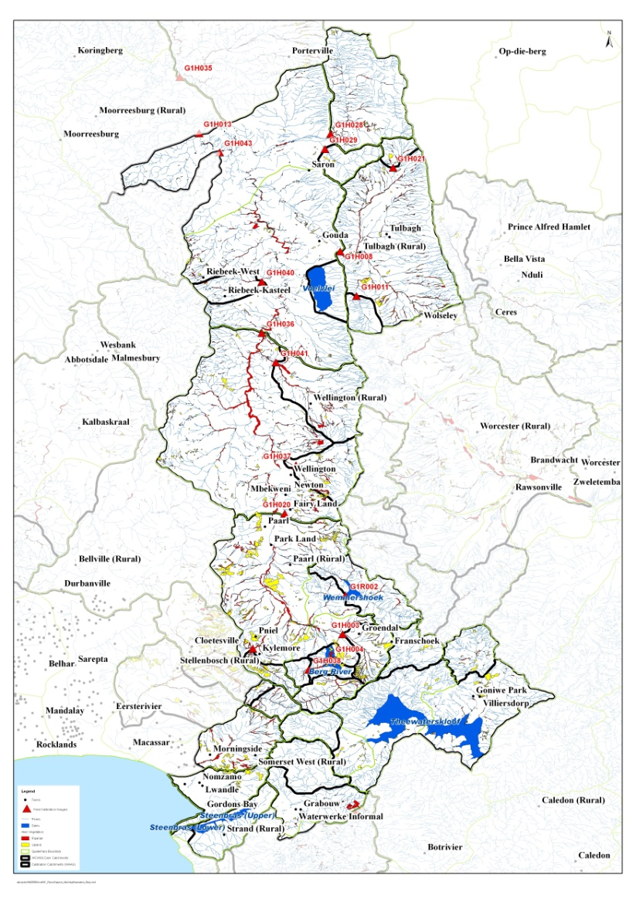
Figure 1: Mapping of invasive alien plants from the Berg WAAS (2004)
Figure 2: Landscape coverage from the National Invasive Alien Plant Survey (NIAPS)
Figure 3: Riparian coverage from the National Invasive Alien Plant Survey (NIAPS)
Estimation of Streamflow Reduction by Invasive Alien Plants
The WAAS study made use of the WRSM2000 software for modelling the hydrology of the Berg WAAS. This software incorporates a module for estimating the streamflow reduction caused by invasive alien plants. This module uses the Biomass curves which are the accepted methodology for this purpose. These curves are shown in Figure 4 (Eucalypts) and Figure 5 (Pines).
There are limitations associated with this methodology, which introduce uncertainties into the streamflow reductions obtained. One of these limitations is that the Biomass curves are percentage reductions based on catchment MAP and tend to overestimate streamflow reductions in high MAP catchments (like upstream of the WCWSS dams). A cap or upper limit needs to be placed on the streamflow reduction. The other limitation is the substantial difference in streamflow reduction obtained, depending of the choice of age of the invasive alien plants being modelled. This information is not often available, so needs to be estimated.

Figure 4: Biomass curve for Eucalypts
Figure 5: Biomass curve for Pines

Working for Water has initiated a study to revise the curves, and the improved “Biomass II” version of the curves should be available during 2010. It is recommended that these should be assessed once they become available, and should be incorporated into the WRSM 2000 if they provide better estimates of streamflow reduction.
In addition to the limitations of the Biomass curves within WRSM 2000, there are also aspects of the way in which the software is configured that need to modified to allow greater flexibility in modelling invasive alien plants. These are listed below:
- Guidelines are required for the selection of an upper limit or ‘cap’ for streamflow reduction in high MAP catchments.
- Allow modelling of areas <0.5km².
- Allow modelling of riparian and landscape infestations separately.
- Riparian invasive alien plants need to have access to upstream runoff.
The streamflow reductions associated with the Berg WAAS invasive alien plant areas were obtained from the results of the WAAS study, and are summarised in Table 2 (see Section 5). The total reduction in streamflow from the 7.9 km² of invasive alien plants upstream of dams was estimated to be 4.1 million m³/a.
Estimates of streamflow reductions from the invasive alien plant areas in the NIAPS are also summarised in Table 2 (see Section 5). The total reduction in streamflow from the 218 km² of invasive alien plants upstream of dams was estimated to be 35.3 million m³/a.

- Estimation of Impact on Yield
The impact of invasive alien plants on the yield of the WCWSS was estimated by making use of the Berg WAAS setup of the Water Resources Yield Model (WRYM). The available historic firm yield of the total system determined in the Berg WAAS was 550 million m³/a, and the streamflow reduction of 4.1 million m³/ did not reduce this yield. The results are shown in Table 2.
The streamflow reductions associated with the NIAPS invasive alien plant data set were used as inputs to a separate run of the WRYM and the revised yield was noted. A reduction in yield of 18 million m³/a was obtained from the streamflow reduction of 35.3 million m³/a (also shown in Table 2). This is equivalent to the estimated yield that would be obtained from one of the smaller augmentation options being considered, for example the Lourens River development (19 million m³/a) and the Cape Flats Aquifer (18 million m³/a).
Table 2: Effect of invasive alien plants on yield of WCWSS based on Berg WAAS mapping
Upstream of Dams | Invasive Alien Plant Condensed Area (km²) |  | Streamflow Reduction (million m³/a) |  | Reduction in Yield of WCWSS(million m³/a)
Upstream of Dams | WAAS | NIAPS | WAAS | NIAPS | WAAS | NIAPS
Berg River | 1.7 | 1.1 | 1.8 | 0.5 | - | 0.3
Steenbras | 0.0 | 0.1 | 0.0 | 0.0 | - | 0.0
Theewaterskloof | 1.9 | 138.8 | 1.0 | 22.1 | - | 11.5
Voёlvlei | 3.8 | 57.1 | 1.1 | 8.3 | - | 3.5
Wemmershoek | 0.5 | 20.9 | 0.2 | 4.5 | - | 2.7
Total | 7.9 | 218.0 | 4.1 | 35.3 | 0 | 18.0

- Possible Future Scenarios of Invasive Alien Plant Spread

Currently there is no standard, recommended methodology to determine the potential spread of invasive alien plants. This is one of the areas of focus of the latest Working for Water study. In the absence of such a methodology, scenarios of potential future growth of invasive alien plants upstream of the dams in the WCWSS were determined as follows.

The area of land suitable for infestation was estimated by using GIS to determine the area of untransformed land with a slope of less than 45 degrees. Transformed land included the following land uses: dams, afforested areas, cultivated land (irrigated and dryland), and urban development including roads. The 45 degree slope was chosen fairly arbitrarily to exclude those areas with very steep slopes where streamflow reduction by invasive alien plants is likely to be significantly lower than that of invasive alien plants on flatter ground. The results of this exercise are summarised in Table 3.

Table 3: Estimates of land likely to be invaded by invasive alien plants upstream of dams in the WCWSS
Upstream of Dams | Total catchment area (km²) | Area of untransformed land (km²) | Area of untransformed land with slope < 45 degrees (km²)
Berg River | 77 | 76 | 66
Steenbras | 67 | 45 | 45
Theewaterskloof | 493 | 347 | 337
Voёlvlei | 656 | 452 | 437
Wemmershoek | 85 | 81 | 67
Total | 1 379 | 1001 | 952

If one assumes that the total area of untransformed land with slope <45% (952 km²)represents the total area open to invasion by invasive alien plants, approximately 1% (7.9 km²)of the area is currently infested according to the WAAS mapping, and approximately 25% (218.0 km²) is currently infested according to the NIAPS mapping. This is a significant difference and has been discussed previously.

It was decided to select three levels of infestation covering a range between these two levels of infestation and to model the effect on streamflow reduction and yield. Percentages of 5%, 10% and 25% were chosen as the three scenarios. The cut-off at 25% was chosen since it coincided with the NIAPS data, and showed enough of an impact on yield to indicate that intervention was worthwhile. Estimates of ‘maximum invadable area’ and ‘maximum yield reductions’ were believed to be premature at this stage, based on the uncertainties mentioned. Results are shown in Table 4.

Table 4: Effect of invasive alien plants on yield of WCWSS: possible future scenarios
Scenario | Percentage Invasive Alien Plant Infestation of Untransformed Land with Slope of <45 degrees | Total area of Invasive Alien Plant (km²) | Streamflow Reduction  (million m³/a) | Reduction in Yield of WCWSS (million m³/a)
WAAS | Approx 1% | 7.9 | 4.1 | 0
1 | 5% | 47.6 | 8.2 | 2
2 | 10% | 95.2 | 16.6 | 6
3 | 25% | 238.1 | 41.6 | 19
NIAPS | Approx 25% | 218.0 | 35.3 | 18

- Estimates of effect of Invasive Alien Plants Downstream of WCWSS Dams

It was initially envisaged that an assessment of the impact of invasive alien plants downstream of the WCWSS dams in the Berg River would form part of this study. In the light of the uncertainties regarding the different sources of mapping, it was decided that this would be premature. The pertinent readily available information has been summarised in Table 5 below. It shows that there is also a substantial difference between the two data sets which requires verification.

Table 5: Effect of invasive alien plants downstream of Berg River Dam

Source of information | Condensed area of invasive alien plants (km²) | Streamflow reduction  (million m³/a)
Berg WAAS | 23.1 | 7.95
NIAPS | 665.1 | Not determined

- Latest Initiatives to Improve Understanding of the Impacts of Invasive Alien Plants

Working for Water has initiated a study entitled “Improving Understanding of the Rate of Spread and Impacts of Invasive Alien Plants”. Some of the aims of the study are as follows:
- Revised assessment of water use by invasive alien plants (Biomass II curves)
- Comparison of riparian and non-riparian invasion
- Impacts of invasive alien plants on groundwater
- Impacts of invasive alien plants on water quality
- Case studies of spread rates and modelling spread rates.
The results of this study should provide a valuable contribution to the accuracy with which the impact of invasive alien plants on water resources can be determined. It is recommended that the assessment be revisited once these results are available.

- Conclusions and Recommendations

- The impact of invasive alien plants on the yield of the WCWSS is uncertain at present, due to uncertainties in the available mapping, the calculation of streamflow reductions and the spread rates of invasive alien plants.

- Despite these uncertainties, it is clear that the potential future impact on yield will be significant if clearing is not undertaken on an on-going basis, and continued attention to this aspect of the Western Cape Reconciliation Strategy is important.

- The process of refining estimates of the level, spread and streamflow reduction of invasive alien plants is on-going, and significant effort is being invested at present with the current Working for Water study. It is recommended that the assessment of impact of invasive alien plants on the yield of the WCWSS be revisited once the results of this study are available. The most significant contribution is likely to be the revised biomass model.

- In addition to the potential revision of the Biomass model, other changes to WRSM2000 are recommended to introduce greater flexibility in modelling streamflow reduction by invasive alien plants:
    - Guidelines are required for the selection of an upper limit or ‘cap’ for streamflow reduction in high MAP catchments.
    - Allow modelling of areas <0.5km².
    - Allow modelling of riparian and landscape infestations separately.
    - Riparian invasive alien plants need to have access to upstream runoff.

- Verification of invasive alien plant areas of infestation in WCWSS catchments is needed.
END

